1:i.Mx websit

<http://www.freescale.com/imx>

<http://www.freescale.com/webapp/sps/site/homepage.jsp?code=IMX_HOME&tid=vanIMX>

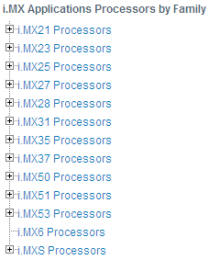

2:i.Mx6 websit

<http://www.freescale.com/webapp/sps/site/taxonomy.jsp?code=IMX6X_SERIES>

|  |  |  |  |  |  |  |  |  |  |  |  |  |  |  |  |  |  |  |  |  |  |  |  |  |  |  |
| --- | --- | --- | --- | --- | --- | --- | --- | --- | --- | --- | --- | --- | --- | --- | --- | --- | --- | --- | --- | --- | --- | --- | --- | --- | --- | --- |
| |  |  | | --- | --- | |  | [**i.MX6Q**](javascript:getUrl('http://www.freescale.com/webapp/sps/site/prod_summary.jsp?code=i.MX6Q&webpageId=129226228141673454B24A')) **(6)** | | |  |  | | --- | --- | | **[DataSheet](http://www.freescale.com/webapp/sps/site/prod_summary.jsp?code=i.MX6Q&tab=Documentation_Tab&linkline=Data%20Sheets&fpsp=1)** | **[Part Number Table](http://www.freescale.com/webapp/sps/site/prod_summary.jsp?code=i.MX6Q&tab=Buy_Parametric_Tab)** | | |  | | --- | | **[Distributor](http://www.freescale.com/webapp/sps/site/prod_summary.jsp?code=i.MX6Q&tab=Buy_Parametric_Tab)** | | **[Buy Direct](http://www.freescale.com/webapp/sps/site/prod_summary.jsp?code=i.MX6Q&tab=Buy_Parametric_Tab)** | | **[Sample](http://www.freescale.com/webapp/sps/site/prod_summary.jsp?code=i.MX6Q&tab=Buy_Parametric_Tab)** | | i.MX 6Quad Family of Applications Processors | Active | ARM Cortex A9 | 1000 800 | 4 | -40 to 125 -40 to 105 -20 to 105 | 32 | 1000 | 256 | DDR3 DDR3L FLASH LPDDR2 | eCSPI I2C UART USB I2S ESAI SDIO | - | MMC (Multimedia Card) SD (Secure Digital Controller) | Integrated PHY USB 2.0 USB OTG HS | FlexCAN | 1 Gbps + IEEE 1588 | LVDS MLB150 (Media Local Bus) PCIe 2.0 1x Lane SATA 2.0 Tamper Detect Temperature |

2:i.Mx6 q websit

<http://www.freescale.com/webapp/sps/site/prod_summary.jsp?code=i.MX6Q&webpageId=129226228141673454B24A&nodeId=018rH3ZrDRB24A&fromPage=tax>

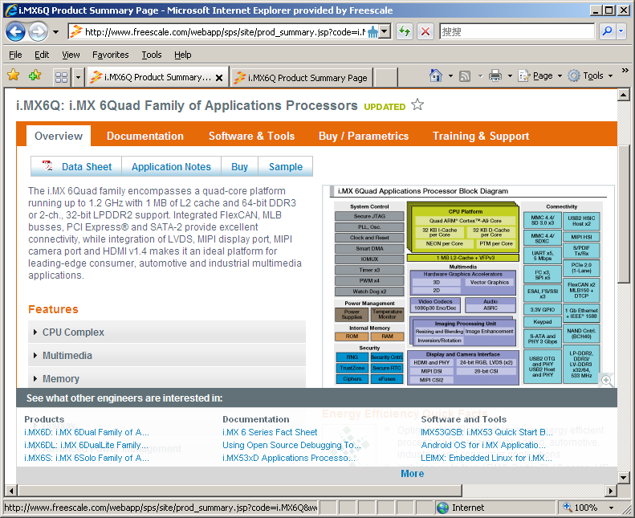

3.1: Documentation

http://www.freescale.com/webapp/sps/site/prod_summary.jsp?code=i.MX6Q&nodeId=018rH3ZrDRB24A&fpsp=1&tab=Documentation_Tab

3.1.1: DataSheet

[IMX6DQAEC](http://cache.freescale.com/files/32bit/doc/data_sheet/IMX6DQAEC.pdf?fpsp=1&WT_TYPE=Data%20Sheets&WT_VENDOR=FREESCALE&WT_FILE_FORMAT=pdf&WT_ASSET=Documentation) http://www.freescale.com/site_cons/images/new_green.gif  
i.MX 6Dual/6Quad Automotive and Infotainment Applications Processors

[IMX6DQCEC](http://cache.freescale.com/files/32bit/doc/data_sheet/IMX6DQCEC.pdf?fpsp=1&WT_TYPE=Data%20Sheets&WT_VENDOR=FREESCALE&WT_FILE_FORMAT=pdf&WT_ASSET=Documentation) http://www.freescale.com/site_cons/images/new_green.gif  
i.MX 6Dual/6Quad Applications Processors for Consumer Products

[IMX6DQIEC](http://cache.freescale.com/files/32bit/doc/data_sheet/IMX6DQIEC.pdf?fpsp=1&WT_TYPE=Data%20Sheets&WT_VENDOR=FREESCALE&WT_FILE_FORMAT=pdf&WT_ASSET=Documentation) http://www.freescale.com/site_cons/images/new_green.gif  
i.MX 6Dual/6Quad Applications Processors for Industrial Products

3.1.2: Errata

[IMX6DQCE](http://cache.freescale.com/files/32bit/doc/errata/IMX6DQCE.pdf?fpsp=1&WT_TYPE=Errata&WT_VENDOR=FREESCALE&WT_FILE_FORMAT=pdf&WT_ASSET=Documentation) http://www.freescale.com/site_cons/images/new_green.gif  
Chip Errata for the i.MX 6Dual/6Quad

3.1.3: Application Notes.

[AN4397](http://cache.freescale.com/files/32bit/doc/app_note/AN4397.pdf?fpsp=1&WT_TYPE=Application%20Notes&WT_VENDOR=FREESCALE&WT_FILE_FORMAT=pdf&WT_ASSET=Documentation) http://www.freescale.com/site_cons/images/new_green.gif  
Common Hardware Design for i.MX 6Dual/6Quad and i.MX 6Solo/6DualLite

[AN4581](http://cache.freescale.com/files/32bit/doc/app_note/AN4581.pdf?fpsp=1&WT_TYPE=Application%20Notes&WT_VENDOR=FREESCALE&WT_FILE_FORMAT=pdf&WT_ASSET=Documentation) http://www.freescale.com/site_cons/images/new_green.gif  
Secure Boot on i.MX50, i.MX53, and i.MX 6 Series using HABv4

[AN4509](http://cache.freescale.com/files/32bit/doc/app_note/AN4509.pdf?fpsp=1&WT_TYPE=Application%20Notes&WT_VENDOR=FREESCALE&WT_FILE_FORMAT=pdf&WT_ASSET=Documentation) http://www.freescale.com/site_cons/images/new_green.gif  
i.MX 6Dual/6Quad Power Consumption Measurement

[AN4553](http://cache.freescale.com/files/32bit/doc/app_note/AN4553.pdf?fpsp=1&WT_TYPE=Application%20Notes&WT_VENDOR=FREESCALE&WT_FILE_FORMAT=pdf&WT_ASSET=Documentation)   
Using Open Source Debugging Tools for Linux on i.MX Processors

[AN4467](http://cache.freescale.com/files/32bit/doc/app_note/AN4467.pdf?fpsp=1&WT_TYPE=Application%20Notes&WT_VENDOR=FREESCALE&WT_FILE_FORMAT=pdf&WT_ASSET=Documentation) http://www.freescale.com/site_cons/images/new_green.gif  
i.MX 6 Series DDR Calibration

[AN4589](http://cache.freescale.com/files/32bit/doc/app_note/AN4589.pdf?fpsp=1&WT_TYPE=Application%20Notes&WT_VENDOR=FREESCALE&WT_FILE_FORMAT=pdf&WT_ASSET=Documentation) http://www.freescale.com/site_cons/images/new_green.gif  
Configuring USB on i.MX 6 Series Processors

3.1.4: Chipset reference manual

[IMX6DQRM](http://cache.freescale.com/files/32bit/doc/ref_manual/IMX6DQRM.pdf?fpsp=1&WT_TYPE=Reference%20Manuals&WT_VENDOR=FREESCALE&WT_FILE_FORMAT=pdf&WT_ASSET=Documentation) http://www.freescale.com/site_cons/images/new_green.gif  
i.MX 6Dual/6Quad Applications Processor

3.1.5: Fact Sheet

[IMX6SRSFS](http://cache.freescale.com/files/32bit/doc/fact_sheet/IMX6SRSFS.pdf?fpsp=1&WT_TYPE=Fact%20Sheets&WT_VENDOR=FREESCALE&WT_FILE_FORMAT=pdf&WT_ASSET=Documentation)   
i.MX 6 Series Fact Sheet

3.1.6: BSP/Codec Software Document

[IMX6_120901_LINUXDOCS_BUNDLE](https://www.freescale.com/webapp/Download?colCode=IMX6_120901_LINUXDOCS_BUNDLE&location=null&fpsp=1&WT_TYPE=Supporting%20Information&WT_VENDOR=FREESCALE&WT_FILE_FORMAT=gz&WT_ASSET=Documentation) http://www.freescale.com/files/graphic/SECURITYINFOIMAGE.gif http://www.freescale.com/site_cons/images/new_green.gif  
i.MX 6Quad and i.MX 6Dual Linux GA BSP Documentation. Includes Release Notes, Reference Manual, User guide. API...

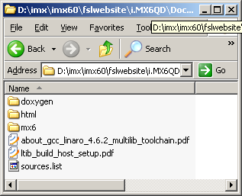

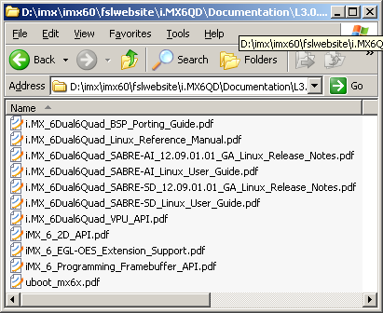

[IMX6_120901_LINUX_MMDOCS](https://www.freescale.com/webapp/Download?colCode=IMX6_120901_LINUX_MMDOCS&location=null&fpsp=1&WT_TYPE=Supporting%20Information&WT_VENDOR=FREESCALE&WT_FILE_FORMAT=gz&WT_ASSET=Documentation) http://www.freescale.com/files/graphic/SECURITYINFOIMAGE.gif http://www.freescale.com/site_cons/images/new_green.gif  
Linux Multimedia Codecs Documentation. Includes CODECs Release Notes and User's Guide.

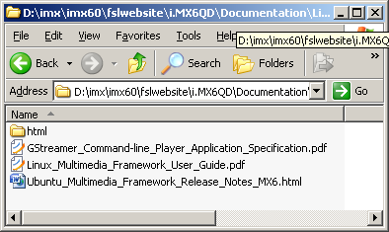

[IMX6_R13.4_ANDROID_DOCS_BUNDLE](https://www.freescale.com/webapp/Download?colCode=IMX6_R13.4_ANDROID_DOCS_BUNDLE&location=null&fpsp=1&WT_TYPE=Supporting%20Information&WT_VENDOR=FREESCALE&WT_FILE_FORMAT=gz&WT_ASSET=Documentation) http://www.freescale.com/files/graphic/SECURITYINFOIMAGE.gif http://www.freescale.com/site_cons/images/new_green.gif  
i.MX 6Quad and i.MX 6Dual Android GA BSP Documentation. Android BSP Documentation. Includes Release Notes and User's...

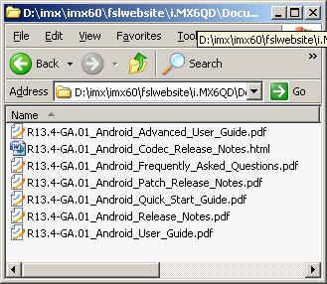

3.1.7: FSL TIC(technology information Center)

[IMX_INFOCTR](http://cache.freescale.com/files/infocenter/IMX_INFOCTR.html?fpsp=1&WT_TYPE=Supporting%20Information&WT_VENDOR=FREESCALE&WT_FILE_FORMAT=html&WT_ASSET=Documentation) http://www.freescale.com/site_cons/images/new_green.gif  
i.MX Applications Processors

3.2: Software&Tools

<http://www.freescale.com/webapp/sps/site/prod_summary.jsp?code=i.MX6Q&nodeId=018rH3ZrDRB24A&fpsp=1&tab=Design_Tools_Tab>

3.2.1:Reference Designs website

[SABRE Platform for Smart Devices Based on the i.MX 6 Series](http://www.freescale.com/webapp/sps/site/prod_summary.jsp?code=RDIMX6SABREPLAT) Favorite  
The Smart Application Blueprint for Rapid Engineering (SABRE) platform for smart devices allows you to hold in your hands and evaluate the full multimedia performance capabilities of i.MX 6 series applications processors based on ARM® Cortex™-A9 technology.  Targeted towards any device ...

Enter it:

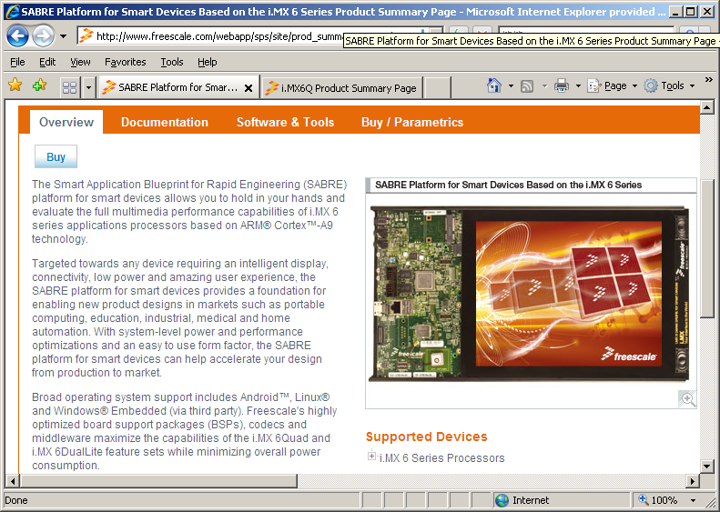

Buy:

|  |  |  |  |  |  |  |  |  |  |  |  |
| --- | --- | --- | --- | --- | --- | --- | --- | --- | --- | --- | --- |
| |  | | --- | | [Buy Direct](javascript:%20addItem(%22/webapp%22,%20%22PART_NUMBER=MCIMX6Q-SDP&QUANTITY=1&ITEM_TYPE=TOOL_HW&RETURN_URL=http%253A%252F%252Fwww.freescale.com%252Fwebapp%252Fsps%252Fsite%252Fprod_summary.jsp%253Fcode%253DRDIMX6SABREPLAT%2526tab%253DBuy_Parametric_Tab%2526nodeId%253D018rH3ZrDRB24A%2526pspll%253D1%2526fromSearch%253Dfalse%2523orderables%22);) | | [Distributor](javascript:%20buyfromdistributor('MCIMX6Q-SDP','Y')) | | |  | | --- | | MCIMX6Q-SDP | | Hardware Only MCIMX6Q-SDP, Smart Device Platform | Hardware | Active | 1 @ $999.00 each | - | [http://www.freescale.com/shared/images/RoHS_image_transparent.gif](javascript:%7b%7d) | - |

[SABRE Board for Smart Devices Based on the i.MX 6 Series](http://www.freescale.com/webapp/sps/site/prod_summary.jsp?code=RDIMX6SABREBRD) Favorite  
Freescale's Smart Application Blueprint for Rapid Engineering (SABRE) board for smart devices introduces developers to quad-core processing, low-power consumption and bleeding-edge multimedia and graphics applications on the i.MX 6Quad ARM ® Cortex ™ -A9 applications processor. The SABRE board for smart ...

Enter it:

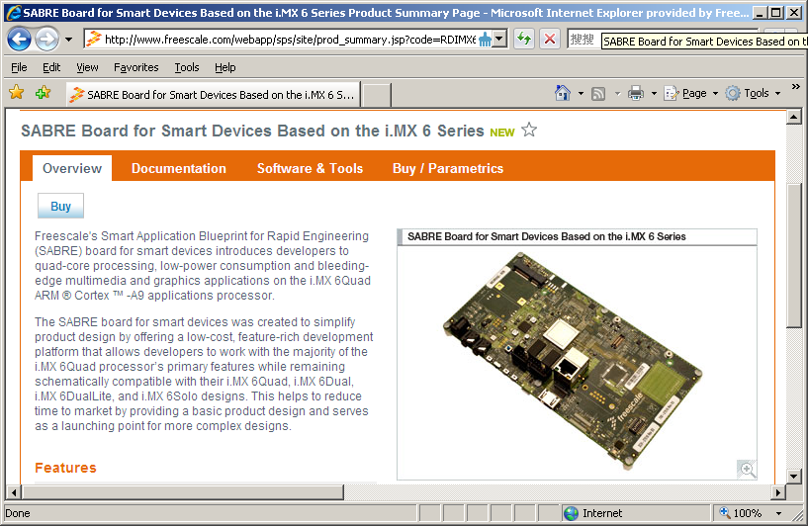

Buy:

|  |  |  |  |  |  |  |  |  |  |  |  |
| --- | --- | --- | --- | --- | --- | --- | --- | --- | --- | --- | --- |
| |  | | --- | | [Buy Direct](javascript:%20addItem(%22/webapp%22,%20%22PART_NUMBER=MCIMX6Q-SDB&QUANTITY=1&ITEM_TYPE=TOOL_HW&RETURN_URL=http%253A%252F%252Fwww.freescale.com%252Fwebapp%252Fsps%252Fsite%252Fprod_summary.jsp%253Fcode%253DRDIMX6SABREBRD%2526tab%253DBuy_Parametric_Tab%2526nodeId%253D018rH3ZrDRB24A%2526pspll%253D1%2526fromSearch%253Dfalse%2523orderables%22);) | | [Distributor](javascript:%20buyfromdistributor('MCIMX6Q-SDB','Y')) | | |  | | --- | | MCIMX6Q-SDB | | Hardware Only MCIMX6Q-SDB, Smart Device Board | Hardware | Active | 1 @ $399.00 each | - | [http://www.freescale.com/shared/images/RoHS_image_transparent.gif](javascript:%7b%7d) | - |

[SABRE for Automotive Infotainment Based on the i.MX 6 Series](http://www.freescale.com/webapp/sps/site/prod_summary.jsp?code=RDIMX6SABREAUTO) Favorite  
The Smart Application Blueprint for Rapid Engineering (SABRE) for automotive infotainment offers a solid foundation for next-generation converged telematics and infotainment platform designs. Based on i.MX 6 series of applications processors, Freescale's most scalable implementation of the ARM® Cortex™-A9 CPU ...

Enter it:

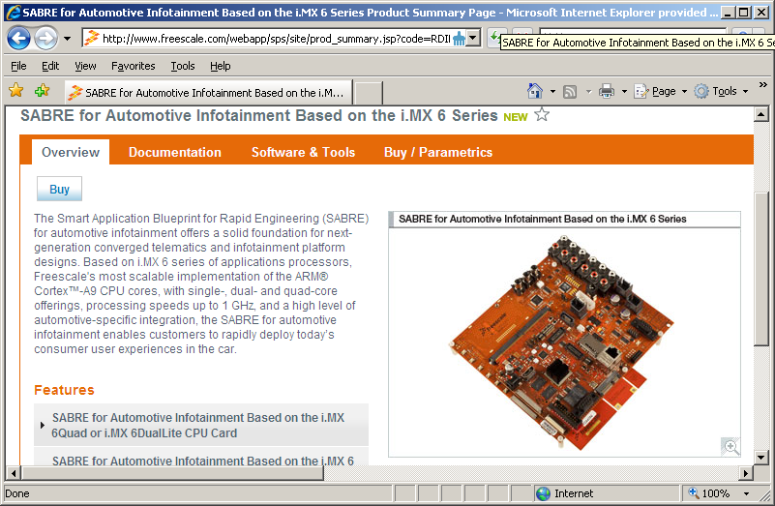

Buy:

|  |  |  |  |  |  |  |  |  |  |  |  |
| --- | --- | --- | --- | --- | --- | --- | --- | --- | --- | --- | --- |
| |  | | --- | | [Buy Direct](javascript:%20addItem(%22/webapp%22,%20%22PART_NUMBER=MCIMX6QAICPU1&QUANTITY=1&ITEM_TYPE=TOOL_HW&RETURN_URL=http%253A%252F%252Fwww.freescale.com%252Fwebapp%252Fsps%252Fsite%252Fprod_summary.jsp%253Fcode%253DRDIMX6SABREAUTO%2526tab%253DBuy_Parametric_Tab%2526nodeId%253D018rH3ZrDRB24A%2526pspll%253D1%2526fromSearch%253Dfalse%2523orderables%22);) | | [Distributor](javascript:%20buyfromdistributor('MCIMX6QAICPU1','Y')) | | |  | | --- | | MCIMX6QAICPU1 | | Hardware Only Automotive Reference Des | Hardware | Active | 1 @ $799.00 each | - | [http://www.freescale.com/shared/images/RoHS_image_transparent.gif](javascript:%7b%7d) | - |

3.2.2: BSDL

[IMX6_DQ_BSDL](http://www.freescale.com/webapp/sps/site/prod_summary.jsp?code=i.MX6Q&nodeId=018rH3ZrDRB24A&fpsp=1&tab=Design_Tools_Tab) http://www.freescale.com/files/graphic/SECURITYINFOIMAGE.gif http://www.freescale.com/site_cons/images/new_green.gif: i.MX 6Quad and i.MX 6Dual BSDL File.   
**Size (K):** 82 **Format:** html **Rev #:** 1 **Modified:** 11/9/2012

3.2.3: IBIS

[IMX6_DQ_IBIS](http://www.freescale.com/webapp/sps/site/prod_summary.jsp?code=i.MX6Q&nodeId=018rH3ZrDRB24A&fpsp=1&tab=Design_Tools_Tab) http://www.freescale.com/files/graphic/SECURITYINFOIMAGE.gif http://www.freescale.com/site_cons/images/new_green.gif: i.MX 6Quad and i.MX 6Dual IBIS File.   
**Size (K):** 19173 **Format:** zip **Rev #:** 1 **Modified:** 11/9/2012

3.2.4: Programmers tools

[IMX_MFG_TOOL_V2](http://www.freescale.com/webapp/sps/site/prod_summary.jsp?code=i.MX6Q&nodeId=018rH3ZrDRB24A&fpsp=1&tab=Design_Tools_Tab) http://www.freescale.com/files/graphic/SECURITYINFOIMAGE.gif http://www.freescale.com/site_cons/images/new_green.gif: Tool and documentation for downloading OS images to the i.MX 6 Series.   
**Size (K):** 89095 **Format:** gz **Rev #:** 12.10.02 **Modified:** 11/9/2012

3.2.5: PCB and schematics

[i.MX6_SABRE_AI_DESIGNFILES](http://www.freescale.com/webapp/sps/site/prod_summary.jsp?code=i.MX6Q&nodeId=018rH3ZrDRB24A&fpsp=1&tab=Design_Tools_Tab) http://www.freescale.com/files/graphic/SECURITYINFOIMAGE.gif http://www.freescale.com/site_cons/images/new_green.gif: Design files, including hardware schematics and BOM.   
**Size (K):** 4411 **Format:** zip **Rev #:** 1.0 **Modified:** 11/13/2012

[i.MX6_SABRE_SDP_DESIGNFILES](http://www.freescale.com/webapp/sps/site/prod_summary.jsp?code=i.MX6Q&nodeId=018rH3ZrDRB24A&fpsp=1&tab=Design_Tools_Tab) http://www.freescale.com/files/graphic/SECURITYINFOIMAGE.gif http://www.freescale.com/site_cons/images/new_green.gif: Design files, including hardware schematics, Gerbers, and OrCAD files..   
**Size (K):** 11691 **Format:** zip **Rev #:** 1 **Modified:** 11/12/2012

[iMX6_SABRE_SDB_DESIGNFILES](http://www.freescale.com/webapp/sps/site/prod_summary.jsp?code=i.MX6Q&nodeId=018rH3ZrDRB24A&fpsp=1&tab=Design_Tools_Tab) http://www.freescale.com/files/graphic/SECURITYINFOIMAGE.gif http://www.freescale.com/site_cons/images/new_green.gif: Design files, including hardware schematics, Gerbers, and OrCAD files..   
**Size (K):** 9567 **Format:** zip **Rev #:** 1 **Modified:** 11/12/2012

3.2.5: BSP

[IMX6_DQ_SDB_SD_DEMO_IMAGE](http://www.freescale.com/webapp/sps/site/prod_summary.jsp?code=i.MX6Q&nodeId=018rH3ZrDRB24A&fpsp=1&tab=Design_Tools_Tab) http://www.freescale.com/files/graphic/SECURITYINFOIMAGE.gif http://www.freescale.com/site_cons/images/new_green.gif: Demo Image Flashed on the i.MX 6Quad SDB SD Cards.   
**Size (K):** 802942 **Format:** zip **Rev #:** R13.4 **Modified:** 11/9/2012

[IMX6_DQ_SDP_SD_DEMO_IMAGE](http://www.freescale.com/webapp/sps/site/prod_summary.jsp?code=i.MX6Q&nodeId=018rH3ZrDRB24A&fpsp=1&tab=Design_Tools_Tab) http://www.freescale.com/files/graphic/SECURITYINFOIMAGE.gif http://www.freescale.com/site_cons/images/new_green.gif: Demo Image Flashed on the i.MX 6Quad SDP SD Cards.   
**Size (K):** 803199 **Format:** zip **Rev #:** R13.4 **Modified:** 11/9/2012

[IMX6_R13.4_ANDROID_DEMO_IMAGE](http://www.freescale.com/webapp/sps/site/prod_summary.jsp?code=i.MX6Q&nodeId=018rH3ZrDRB24A&fpsp=1&tab=Design_Tools_Tab) http://www.freescale.com/files/graphic/SECURITYINFOIMAGE.gif http://www.freescale.com/site_cons/images/new_green.gif: i.MX 6Quad and i.MX 6Dual Android GA BSP Binary Demo Files.   
**Size (K):** 284059 **Format:** gz **Rev #:** R13.4 **Modified:** 11/9/2012

[IMX6_R13.4_ANDROID_SOURCE_CODE](http://www.freescale.com/webapp/sps/site/prod_summary.jsp?code=i.MX6Q&nodeId=018rH3ZrDRB24A&fpsp=1&tab=Design_Tools_Tab) http://www.freescale.com/files/graphic/SECURITYINFOIMAGE.gif http://www.freescale.com/site_cons/images/new_green.gif: i.MX 6Quad and i.MX 6Dual Android GA BSP Documentation and Source Code for BSP and Codecs..   
**Size (K):** 181110 **Format:** gz **Rev #:** R13.4 **Modified:** 11/9/2012

[L3.0.35_12.09.01_DEMO_IMAGE](http://www.freescale.com/webapp/sps/site/prod_summary.jsp?code=i.MX6Q&nodeId=018rH3ZrDRB24A&fpsp=1&tab=Design_Tools_Tab) http://www.freescale.com/files/graphic/SECURITYINFOIMAGE.gif http://www.freescale.com/site_cons/images/new_green.gif: Linux Binary Demo Files for i.MX 6Quad and i.MX 6Dual Linux GA BSP.   
**Size (K):** 440382 **Format:** gz **Rev #:** 12.09.01.01 **Modified:** 11/9/2012

[L3.0.35_12.09.01_ER_SOURCE](http://www.freescale.com/webapp/sps/site/prod_summary.jsp?code=i.MX6Q&nodeId=018rH3ZrDRB24A&fpsp=1&tab=Design_Tools_Tab) http://www.freescale.com/files/graphic/SECURITYINFOIMAGE.gif http://www.freescale.com/site_cons/images/new_green.gif: i.MX 6Quad and i.MX 6Dual Linux GA BSP 3.0.35 Source Code Files..   
**Size (K):** 870719 **Format:** gz **Rev #:** 12.09.01.01 **Modified:** 11/9/2012

[L3.0.35_12.09.01_UBUNTU_RFS](http://www.freescale.com/webapp/sps/site/prod_summary.jsp?code=i.MX6Q&nodeId=018rH3ZrDRB24A&fpsp=1&tab=Design_Tools_Tab) http://www.freescale.com/files/graphic/SECURITYINFOIMAGE.gif http://www.freescale.com/site_cons/images/new_green.gif: File System for the Ubuntu Images for i.MX 6Quad and i.MX 6Dual Linux GA BSP.   
**Size (K):** 811425 **Format:** tgz **Rev #:** 12.09.01.01 **Modified:** 11/9/2012

3.2.6:Lab and Test Software

[i.MX6_PLATFORM_SDK](http://www.freescale.com/webapp/sps/site/prod_summary.jsp?code=i.MX6Q&nodeId=018rH3ZrDRB24A&fpsp=1&tab=Design_Tools_Tab) http://www.freescale.com/files/graphic/SECURITYINFOIMAGE.gif http://www.freescale.com/site_cons/images/new_green.gif: i.MX 6Series Platform SDK.   
**Size (K):** 20566 **Format:** zip **Rev #:** 1 **Modified:** 11/12/2012

3.2.7:Codecs

[AACP_CODECS_ANDROID_13.4](http://www.freescale.com/webapp/sps/site/prod_summary.jsp?code=i.MX6Q&nodeId=018rH3ZrDRB24A&fpsp=1&tab=Design_Tools_Tab) http://www.freescale.com/files/graphic/SECURITYINFOIMAGE.gif http://www.freescale.com/site_cons/images/new_green.gif: AAC Plus Codec for i.MX 6Quad and i.MX 6Dual Android GA BSP.   
**Size (K):** 64 **Format:** gz **Rev #:** R13.4 **Modified:** 11/9/2012

[AACP_CODECS_LINUX_12.09.01](http://www.freescale.com/webapp/sps/site/prod_summary.jsp?code=i.MX6Q&nodeId=018rH3ZrDRB24A&fpsp=1&tab=Design_Tools_Tab) http://www.freescale.com/files/graphic/SECURITYINFOIMAGE.gif http://www.freescale.com/site_cons/images/new_green.gif: AAC Plus Codec for i.MX 6Quad and i.MX 6Dual Linux GA BSP  
**Size (K):** 1372 **Format:** gz **Rev #:** 12.09.01.01 **Modified:** 11/9/2012

[MM_CODECS_LINUX_12.09.01](http://www.freescale.com/webapp/sps/site/prod_summary.jsp?code=i.MX6Q&nodeId=018rH3ZrDRB24A&fpsp=1&tab=Design_Tools_Tab) http://www.freescale.com/files/graphic/SECURITYINFOIMAGE.gif http://www.freescale.com/site_cons/images/new_green.gif: Multimedia Codecs Sources for i.MX 6Quad and i.MX 6Dual Linux GA BSP.   
**Size (K):** 42504 **Format:** gz **Rev #:** 12.09.01.01 **Modified:** 11/9/2012

3.2.8:Tools

[IMX6_IOMUX_TOOL](http://www.freescale.com/webapp/sps/site/prod_summary.jsp?code=i.MX6Q&nodeId=018rH3ZrDRB24A&fpsp=1&tab=Design_Tools_Tab) http://www.freescale.com/files/graphic/SECURITYINFOIMAGE.gif http://www.freescale.com/site_cons/images/new_green.gif: Interactive i.MX Pin Mux Tool..   
**Size (K):** 5254 **Format:** zip **Rev #:** 3.4 **Modified:** 11/12/2012

3.2.9:Updates and Patches

[IMX6_R13.4_ANDROID_PATCHES](http://www.freescale.com/webapp/sps/site/prod_summary.jsp?code=i.MX6Q&nodeId=018rH3ZrDRB24A&fpsp=1&tab=Design_Tools_Tab) http://www.freescale.com/files/graphic/SECURITYINFOIMAGE.gif http://www.freescale.com/site_cons/images/new_green.gif: Add-on patches to resolve issues in i.MX 6Quad and i.MX 6Dual Android GA BSP.   
**Size (K):** 8 **Format:** gz **Rev #:** R13.4 **Modified:** 11/9/2012