Assignment No. 2

Title:

Consider a suitable dataset. For clustering of data instances in different groups, apply different clustering techniques (minimum 2). Visualize the clusters using suitable tool.

Objective:

- Understand the various clustering types and how to implement the same using suitable tool (R Studio)
- Use R functions to create K-means Clustering models and hierarchical clustering models

Problem Statement:

Develop any two types clustering algorithm and visualize the same using R Studio.

Outcomes:

1. Students will be able to demonstrate Installation of R Studio

2. Students will be able to demonstrate different Clustering Algorithm

3. Students will be able to demonstrate & Visualize the effectiveness of the K-means Clustering algorithm and hierarchical clustering using graphic capabilities in R

Hardware Requirement: Any CPU with Pentium Processor or similar, 256 MB RAM or more,1 GB Hard Disk or more

Software Requirements: 32/64 bit Linux/Windows Operating System, latest R Studio

Theory:

What is K-means clustering?

K-means clustering is a type of unsupervised learning, which is used when you have unlabeled data (i.e., data without defined categories or groups). The goal of this algorithm is to find groups in the data, with the number of groups represented by the variable K. The algorithm works iteratively to assign each data point to one of K groups based on the features that are provided. Data points are clustered based on feature similarity. The results of the K-means clustering algorithm are:
- The centroids of the K clusters, which can be used to label new data
- Labels for the training data (each data point is assigned to a single cluster)
Rather than defining groups before looking at the data, clustering allows you to find and analyze the groups that have formed organically. The "Choosing K" section below describes how the number of groups can be determined. Each centroid of a cluster is a collection of feature values which define the resulting groups. Examining the centroid feature weights can be used to qualitatively interpret what kind of group each cluster represents.

Algorithm:

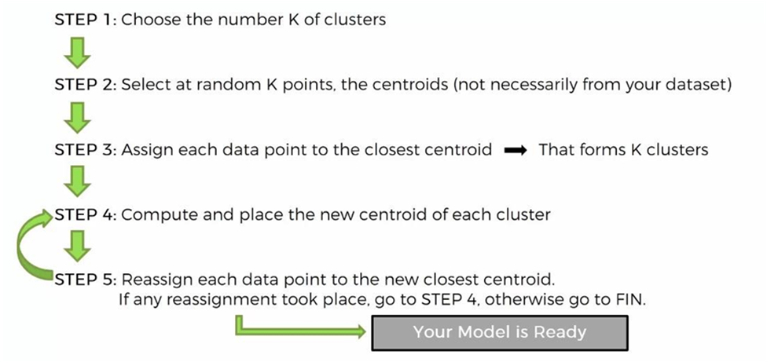

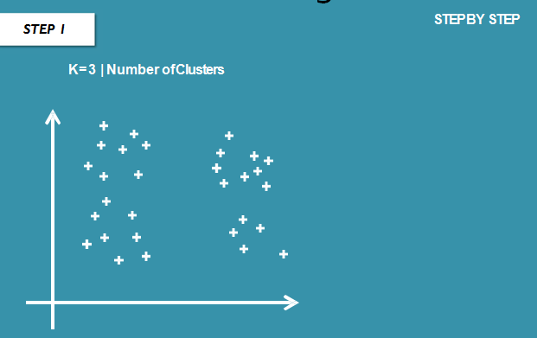

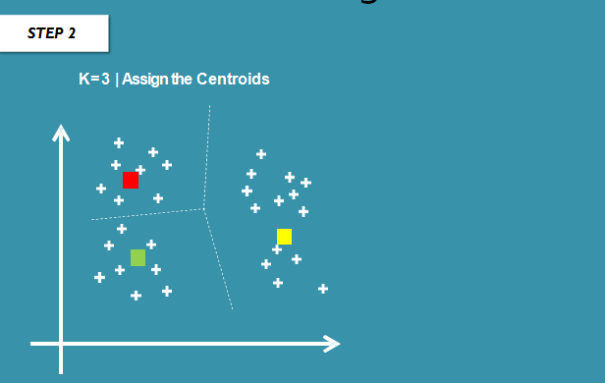

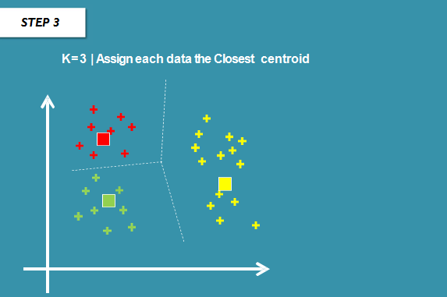

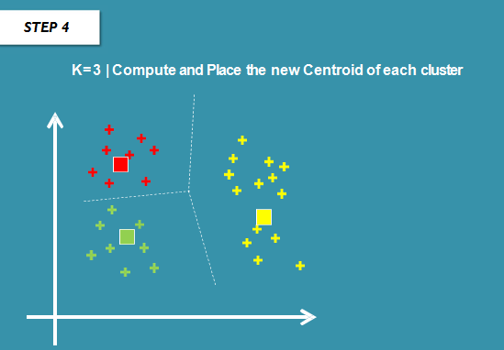

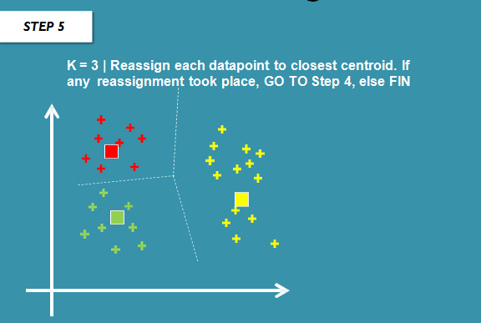

WITHIN CLUSTER SUM of SQUARES
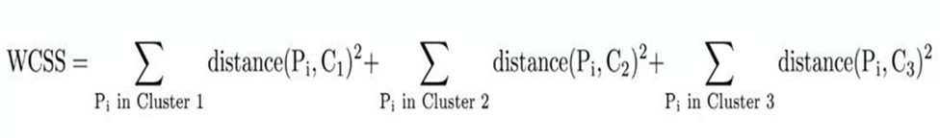
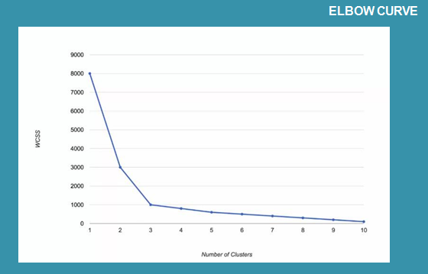

Numerical Example

Steps to Perform K-Means Clustering
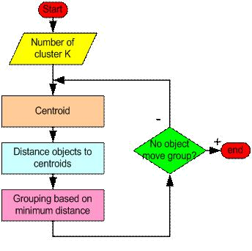

As a simple illustration of a k-means algorithm, consider the following data set consisting of the scores of two variables on each of seven individuals:

Subject | A | B
1 | 1.0 | 1.0
2 | 1.5 | 2.0
3 | 3.0 | 4.0
4 | 5.0 | 7.0
5 | 3.5 | 5.0
6 | 4.5 | 5.0
7 | 3.5 | 4.5

This data set is to be grouped into two clusters. As a first step in finding a sensible initial partition, let the A & B values of the two individuals furthest apart (using the Euclidean distance measure), define the initial cluster means, giving:

 | Individual | Mean Vector
 |  | (centroid)
Group 1 | 1 | (1.0, 1.0)
Group 2 | 4 | (5.0, 7.0)

The remaining individuals are now examined in sequence and allocated to the cluster to which they are closest, in terms of Euclidean distance to the cluster mean. The mean vector is recalculated each time a new member is added. This leads to the following series of steps:

 | Cluster 1 |  | Cluster 2
 |  | Mean |  | Mean
Step | Individual | Vector | Individual | Vector
 |  | (centroid) |  | (centroid)
1 | 1 | (1.0, 1.0) | 4 | (5.0, 7.0)
2 | 1, 2 | (1.2, 1.5) | 4 | (5.0, 7.0)
3 | 1, 2, 3 | (1.8, 2.3) | 4 | (5.0, 7.0)
4 | 1, 2, 3 | (1.8, 2.3) | 4, 5 | (4.2, 6.0)
5 | 1, 2, 3 | (1.8, 2.3) | 4, 5, 6 | (4.3, 5.7)
6 | 1, 2, 3 | (1.8, 2.3) | 4, 5, 6, 7 | (4.1, 5.4)

Now the initial partition has changed, and the two clusters at this stage having the following characteristics:

 | Individual | Mean Vector
 |  | (centroid)
Cluster 1 | 1, 2, 3 | (1.8, 2.3)
Cluster 2 | 4, 5, 6, 7 | (4.1, 5.4)

But we cannot yet be sure that each individual has been assigned to the right cluster. So, we compare each individual’s distance to its own cluster mean and to that of the opposite cluster. And we find:

 | Distance to | Distance to
Individual | mean | mean
Individual | (centroid) of | (centroid) of
 | Cluster 1 | Cluster 2
1 | 1.5 | 5.4
2 | 0.4 | 4.3
3 | 2.1 | 1.8
4 | 5.7 | 1.8
5 | 3.2 | 0.7
6 | 3.8 | 0.6
7 | 2.8 | 1.1

Only individual 3 is nearer to the mean of the opposite cluster (Cluster 2) than its own (Cluster 1). In other words, each individual's distance to its own cluster mean should be smaller that the distance to the other cluster's mean (which is not the case with individual 3). Thus, individual 3 is relocated to Cluster 2 resulting in the new partition:

 | Individual | Mean Vector
 |  | (centroid)
Cluster 1 | 1, 2 | (1.3, 1.5)
Cluster 2 | 3, 4, 5, 6, 7 | (3.9, 5.1)

The iterative relocation would now continue from this new partition until no more relocations occur. However, in this example each individual is now nearer its own cluster mean than that of the other cluster and the iteration stops, choosing the latest partitioning as the final cluster solution.

R implementation

The K-Means function, provided by the cluster package, is used as follows:

kmeans(x, centers, iter.max = 10, nstart = 1)
  - Where,
  - _{x}
numeric matrix of data, or an object that can be coerced to such a matrix (such as a numeric vector or a data frame with all numeric columns).
  - centers
either the number of clusters, say k, or a set of initial (distinct) cluster centres. If a number, a random set of (distinct) rows in x is chosen as the initial centres.
  - iter.max
the maximum number of iterations allowed.
  - nstart
if centers is a number, how many random sets should be chosen?

IRIS dataset

This is perhaps the best known database to be found in the pattern recognition literature. The data set contains 3 classes of 50 instances each, where each class refers to a type of iris plant.
Attribute Information:

- sepal length in cm
- sepal width in cm
- petal length in cm
- petal width in cm
- class:
- Iris Setosa
- Iris Versicolour
- Iris Virginica
Steps

- Set working directory
- Get data from datasets

- Execute the model
- View the output

- Plot the results
CODE:

library(ggplot2)
ggplot(iris, aes(Petal.Length, Petal.Width, color
= Species)) + geom_point()
set.seed(20)
irisCluster <- kmeans(iris[, 3:4], 3, nstart = 20) irisCluster

Output-

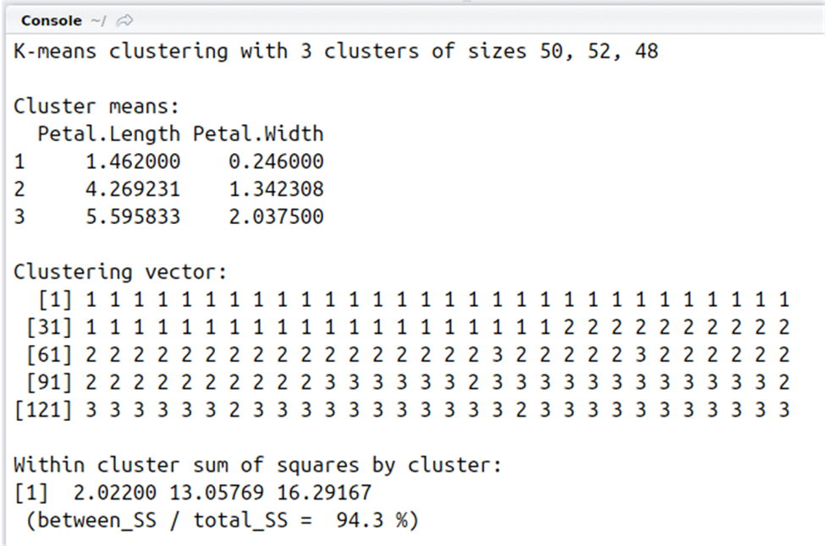

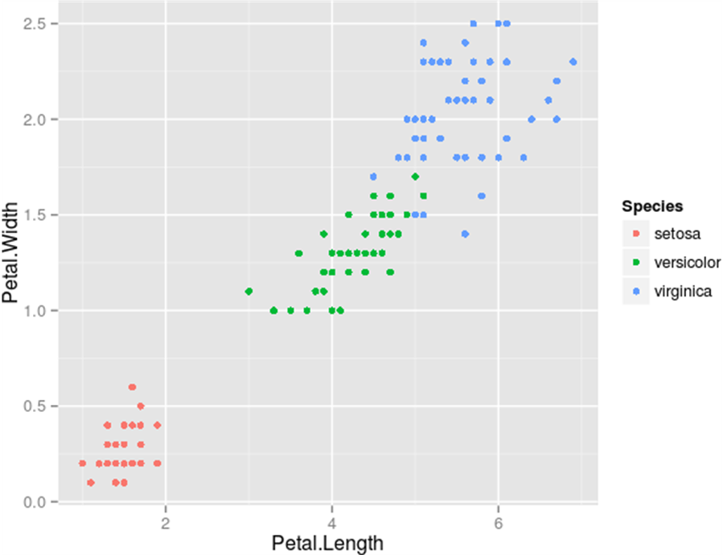

Hierarchical Clustering

What is Hierarchical clustering?

Given a set of N items to be clustered, and an NxN distance (or similarity) matrix, the basic process of

Johnson's (1967) hierarchical clustering is this:

Start by assigning each item to its own cluster, so that if you have N items, you now have N clusters, each containing just one item. Let the distances (similarities) between the clusters equal the distances (similarities) between the items they contain.

Find the closest (most similar) pair of clusters and merge them into a single cluster, so that now you have one less cluster.

Compute distances (similarities) between the new cluster and each of the old clusters.

Repeat steps 2 and 3 until all items are clustered into a single cluster of size N.

R Implementation

hclust(d, method = "complete", members = NULL)

## S3 method for class 'hclust'
plot(x, labels = NULL, hang = 0.1, check = TRUE,
axes = TRUE, frame.plot = FALSE, ann = TRUE,
main = "Cluster Dendrogram",
sub = NULL, xlab = NULL, ylab = "Height", ...)

Arguments
d | a dissimilarity structure as produced by dist.
method | the agglomeration method to be used. This should be (an unambiguous abbreviation of)
 | one of "ward.D", "ward.D2", "single", "complete", "average" (= UPGMA), "mcquitty" (=
 | WPGMA), "median" (= WPGMC) or "centroid" (= UPGMC).
members | NULL or a vector with length size of d. See the ‘Details’ section.
x | an object of the type produced by hclust.
hang | The fraction of the plot height by which labels should hang below the rest of the plot. A
 | negative value will cause the labels to hang down from 0.
check | logical indicating if the x object should be checked for validity. This check is not
 | necessary when x is known to be valid such as when it is the direct result of hclust(). The
 | default is check=TRUE, as invalid inputs may crash R due to memory violation in the
 | internal C plotting code.
labels | A character vector of labels for the leaves of the tree. By default the row names or row
 | numbers of the original data are used. If labels = FALSE no labels at all are plotted.
axes, | logical flags as in plot.default.
frame.plot,
ann
main, sub, | character strings for title. sub and xlab have a non-NULL default when there's a
xlab, ylab | tree$call.
... | Further graphical arguments. E.g., cex controls the size of the labels (if plotted) in the
 | same way as text.

Step 3 can be done in different ways, which is what distinguishes single-link from complete-link and average-link clustering

Mtcars dataset

The data was extracted from the 1974 Motor Trend US magazine, and comprises fuel consumption and 10 aspects of automobile design and performance for 32 automobiles (1973–74 models)
A data frame with 32 observations on 11 variables.

[, 1] mpg Miles/(US) gallon

[, 2] cyl Number of cylinders

[, 3] disp Displacement (cu.in.)

[, 4] hp Gross horsepower

[, 5] drat Rear axle ratio

[, 6] wt Weight (lb/1000)

[, 7] qsec 1/4 mile time

[, 8] vs V/S

[, 9] am Transmission (0 = automatic, 1 = manual)

[,10] gear Number of forward gears

Number of carburetors

[,11] carb

In general, there are many choices of cluster analysis methodology. The hclust function in R uses the complete linkage method for hierarchical clustering by default. This particular clustering method defines the cluster distance between two clusters to be the maximum distance between their individual components. At every stage of the clustering process, the two nearest clusters are merged into a new cluster.

With the distance matrix found in previous tutorial, we can use various techniques of cluster analysis for relationship discovery. For example, in the data set mtcars, we can run the distance matrix with hclust, and plot a dendrogram that displays a hierarchical relationship among the vehicles.

> d <- dist(as.matrix(mtcars)) # find distance matrix

> hc <- hclust(d) # apply hirarchical clustering > plot(hc) # plot the dendrogram
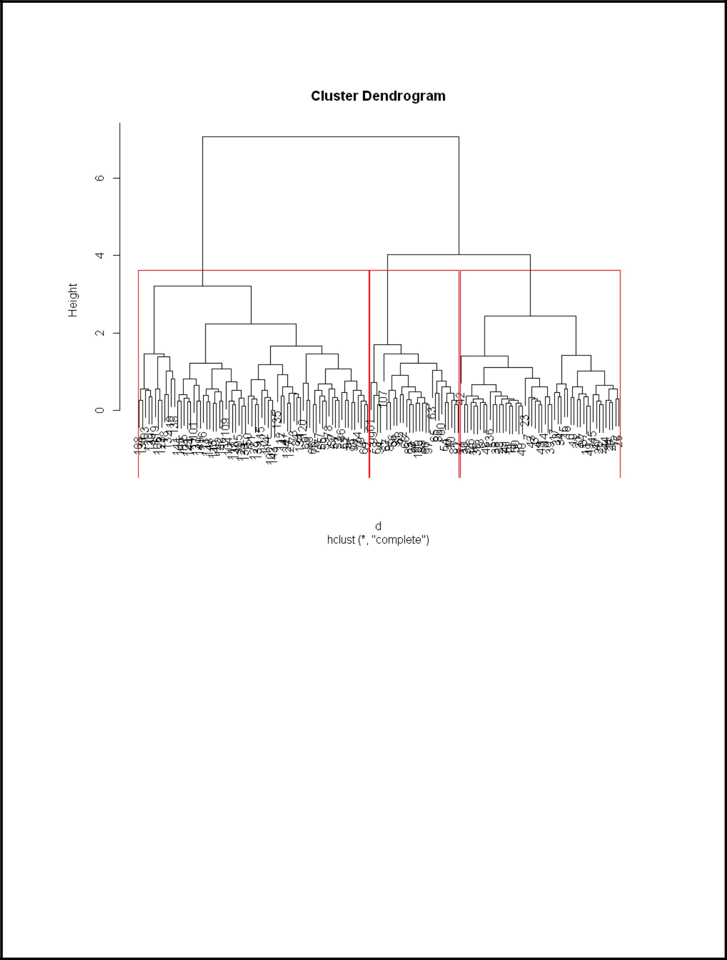

Conclusion: Hence we are able to demonstrate various clustering method using R Tool.

