Assignment No. 3

Title

Apply a-priori algorithm to find frequently occurring items from given data and generate strong association rules using support and confidence thresholds.

Objective:

- Model associations between products by determining sets of items frequently purchased together and building association rules to derive recommendations.
- Learn Market Basket Analysis using A-priori & FP growth Algorithm using Rapideminer

Problem Statement:

Demonstrate Market Basket Analysis using a-priori algorithm to find frequently occurring items from given data and generate strong association rules using support and confidence thresholds..

Outcomes:

1. Students will be able to demonstrate Market Basket Analysis using Rapidminer

2. Students will be able to demonstrate A-priori & FP Growth Algorithm to find Frequent item set.

3. Students will be able to generate strong association rules using support and confidence thresholds.

Hardware Requirement: Any CPU with Pentium Processor or similar, 256 MB RAM or more,1 GB Hard Disk or more

Software Requirements: 32/64 bit Linux/Windows Operating System, latest Rapidminer Tool

Theory:

Association rule for mining:

- Proposed by R Agrawal and R Srikant in 1994.
- It is an important data mining model studied extensively by the database and data mining community.
- Assume all data are categorical.
- Initially used for Market Basket Analysis to find how items purchased by customers are related.

The Apriori algorithm:

- The best known algorithm
- Two steps:
  - Find all item sets that have minimum support (frequent item sets, also called large item sets).
  - It Create Association rule with support and Confidence.
  - E.g. if we buy tooth brush : it suggest Colgate and tongue cleaner

- MILK > BREAD
- MILK > EGGS
- MILK > BREAD > EGGS

Support :

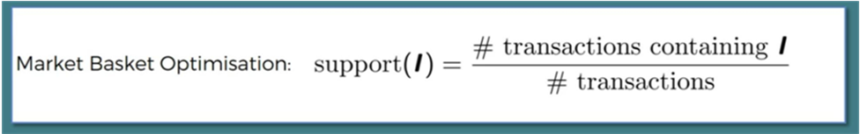



- How many people have seen X-Machina
  - A: 10 / 100
  - Support = 10%

Confidence:

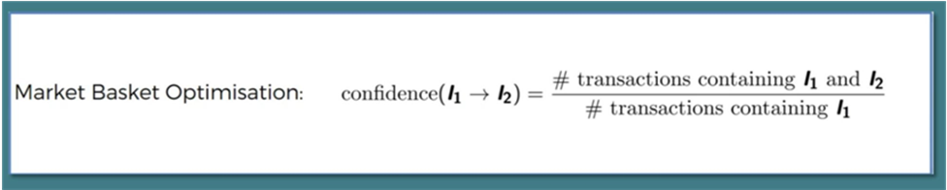

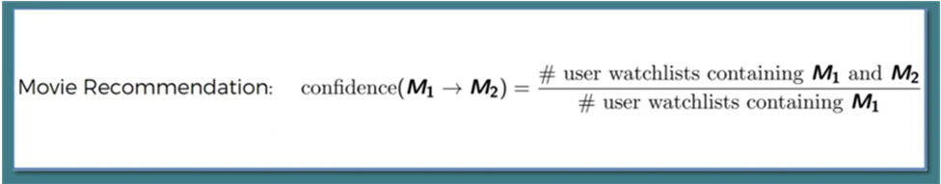

- People who have Watched Interstellar, are likely to like Ex-Machine as well
  - A: 40 watched Interstellar
  - out of 40, only 7 watched Ex-Machina
  - Confidence = 7 / 40 = 17.5%

Lift :

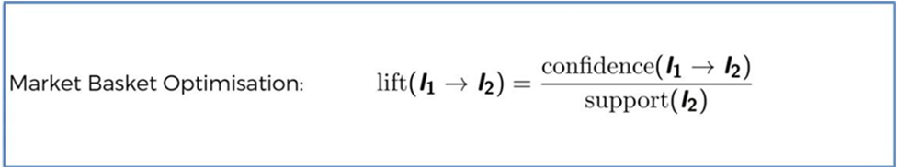

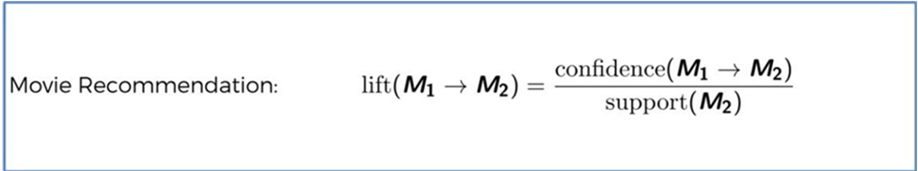

- People who watched
  - Interstellar 40 / 100
  - Ex-Machina 07 / 40
  - What is the Likely hood if we recommend Ex-machina to person who has watched Interstellar?
- LIFT = Confidence / Support
=17.5% / 10%
= 1.75

Algorithm:

- Set a min support & confidence
- Take all the Subsets in transactions
- Take all the rules these subsets having higher confidence than minimum confidence
- Sort the rules by decreasing lift

Data Set

T-Id | Item Set
T-1000 | M,O,N,K,E,Y
T-1001 | D,O,N,K,E,Y
T-1002 | M,A,K,E
T-1003 | M,U,C,K,Y
T-1004 | C,O,O,K,E
Table 1: Data Set

Given: Minimum Support = 60%
Minimum Confidence = 80%

Candidate Table C1: Now find support count of each item set

Item Set | Support Count
M | 3
O | 4
N | 2
E | 4
Y | 3
D | 1
A | 1
U | 1
C | 2
K | 5
Table 2 : Candidate Table C1

- Now find out minimum Support
- Support = 60/100*5
=3
- Where 5 is Number of entry
- Compare Min Support with each item set

L1 Support Count

Item Set | Support Count
M | 3
O | 4
K | 5
E | 4
Y | 3
Table 3: L1 Support Count

Candidate Table C2:

Item Set | Support Count
MO | 1
MK | 3
ME | 2
MY | 2
OK | 3
OE | 3
OY | 2
KE | 4
KY | 3
EY | 2

Table 4: Candidate Table C2

- Now again Compare C2 with Min Support 3

L2 Support Count

Item Set | Support Count
MK | 3
OK | 3
OE | 3
KE | 4
KY | 3

Table 5: L2 Support Count

- After satisfied minimum support criteria

- Make Pair to generate C3

Candidate Table C3

Item Set | Support count
M,K,O | 1
M,K,E | 2
M,K,Y | 2
O,K,E | 3
O,K,Y | 2

Table 6: Candidate Table C3

Support Count

Now again compare the item set with min support 3

Item Set | Support Count
O,K,E | 3
Table 7: L3 Support Count

Now create association rule with support and Confidence for {O,K,E}
- Confidence =Support/No. of time it Occurs

Association Rule | Support | Confidence | Confidence (%)
O ^ K ⇒ E | 3 | 3/3 = 1 | 1*100=100
O ^ E ⇒ K | 3 | 3/3 = 1 | 1*100=100
K ^ E ⇒ O | 3 | 3/4 = 0.75 | 0.75*100=75
E⇒ O ^ K | 3 | 3/4 = 0.75 | 0.75*100=75
K⇒ O ^ E | 3 | 3/5 = 0.6 | 0.6*100=60
O⇒ K ^ E | 3 | 3/4 = 0.75 | 0.75*100=75
Table 8: Association Rule

- Compare this with Minimum Confidence=80%

Rule | Support | Confidence
O ^ K ⇒ E | 3 | 100
O ^ E ⇒ K | 3 | 100
Table 9: Support and Confidence

Hence final Association rule are

{O ^ K ⇒ E}
{O ^ E ⇒ K}

- From first observation we predict that if the customer buy item O and item K then defiantly he will by item E
- From Second observation we predict that the customer buy item O and item E then defiantly he will by item K

-- ---------------------------------------------------------------------------------------------------------------------------- Market Basket Analysis using Rapid Miner

Rapid Miner is a data science software platform developed by the company of the same name that provides an integrated environment for data preparation, machine learning, deep learning, text mining, and predictive analytics. It is used for business and commercial applications as well as for research, education, training, rapid prototyping, and application development and supports all steps of the machine learning process including data preparation, results visualization, model validation and optimization Rapid Miner is developed on an open core model. The Rapid Miner Studio Free Edition, which is limited to 1 logical processor and 10,000 data rows, is available under the AGPL license.

Commercial pricing starts at $2,500 and is available from the developer.

MARKET BASKET ANALYSIS
Model associations between products by determining sets of items frequently purchased together and building association rules to derive recommendations.

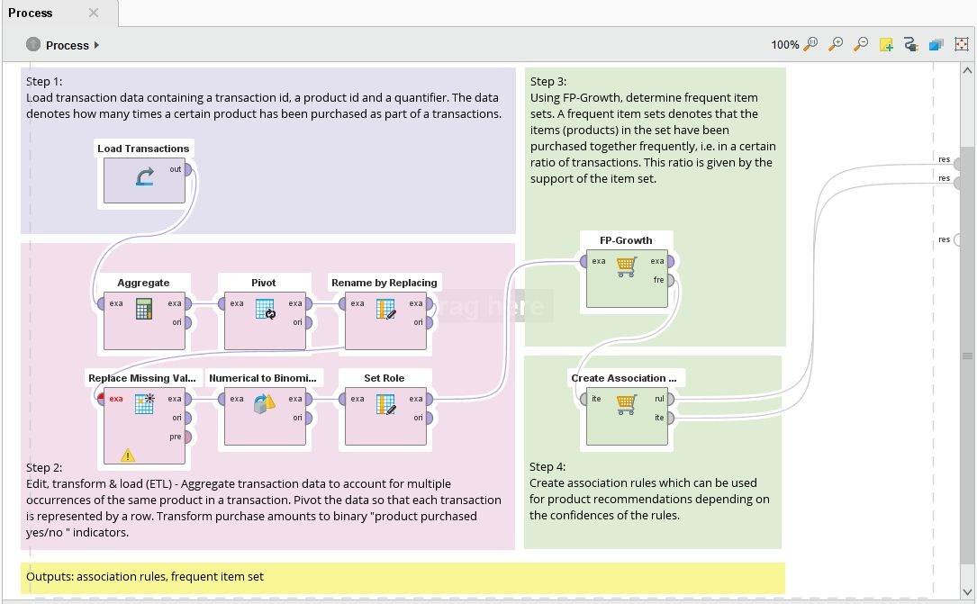
Figure 1: MARKET BASKET ANALYSIS

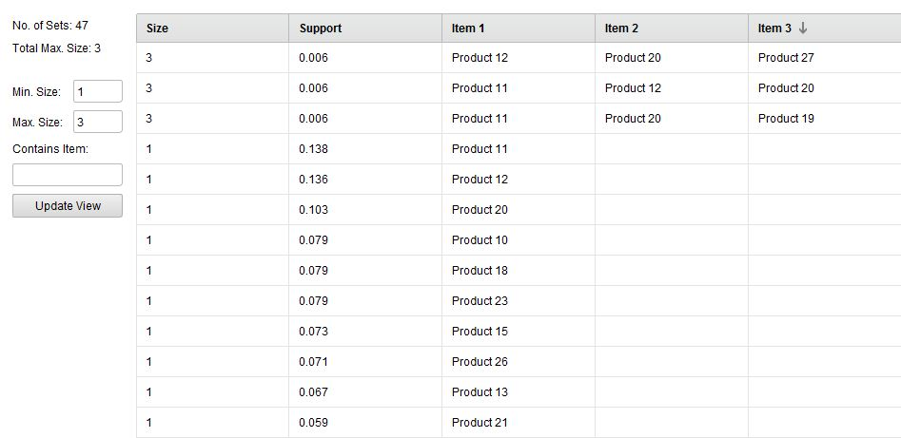

Figure 2: Frequent Item Sets (FP Growth)

Conclusion: Thus we learn that to find frequently occurring items from given data and generate strong association rules using support and confidence thresholds using a-priori algorithm

