Step 1. Open SAP DI 3.0 Launchpad and click on ML Data Manager

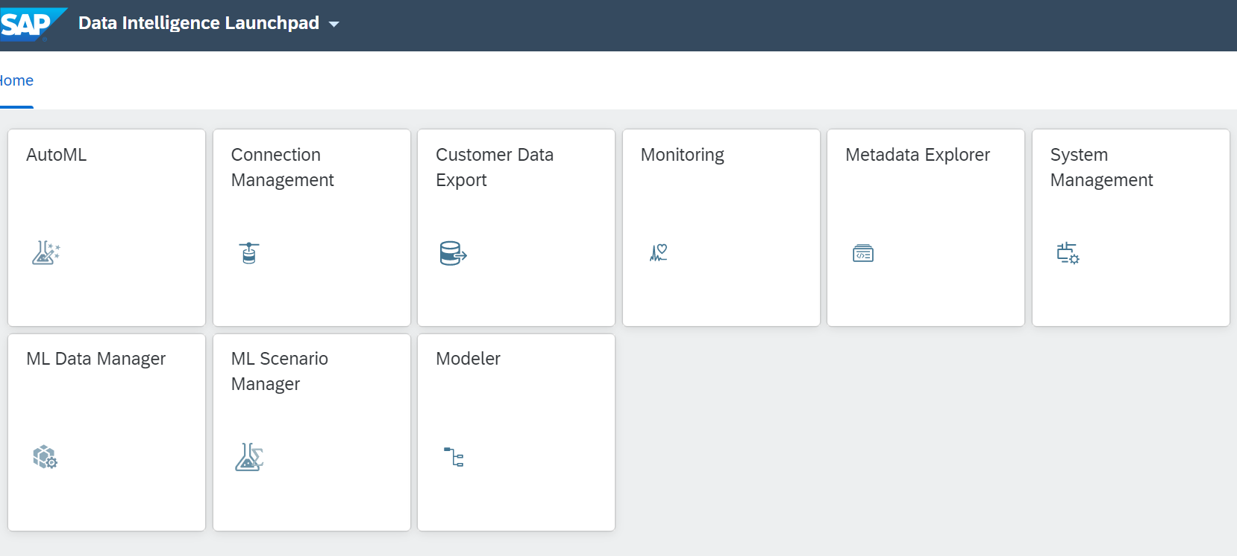

Step 2. ML Data Manager window will open then click on create button

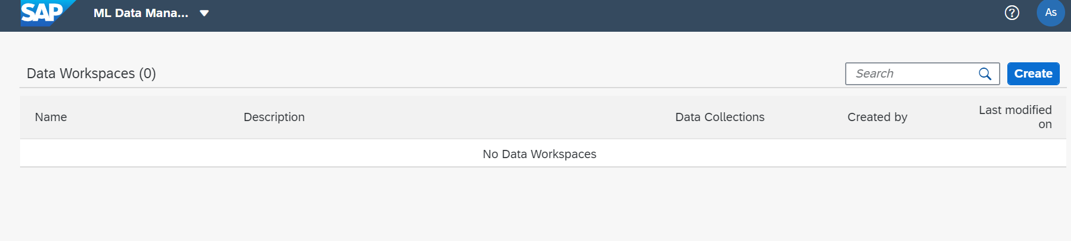

Step 3. Enter the name of Workspace and click on create button.

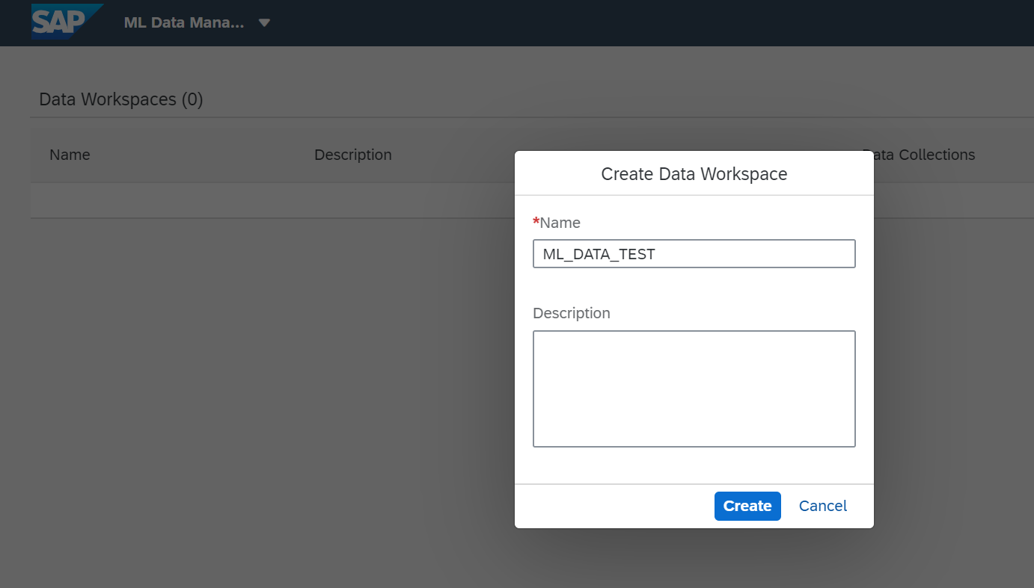

Step4: Once you click on create it will give the error Message :

