AUCA MASTER OF SCIENCE IN BIG DATA ANALYTICS
Final Project — Distributed Multi-Model Analytics
for E-Commerce Data

Dany NKURUNZIZA
Student ID: 101283
Course: MSDA9113 — Big Data Analytics

1. System Architecture Overview
This project implements a distributed analytics pipeline for large-scale e-commerce data, deliberately leveraging three distinct technologies — MongoDB, HBase, and Apache Spark — each selected for what it does best rather than forced into a one-size-fits-all role.

The architecture follows a data-gravity principle: data lives where it is most efficiently queried. Product catalogs and transaction records reside in MongoDB, exploiting its document model for embedded arrays and rich queries. Clickstream and session time-series data is designed for HBase, where wide-column sparse storage and row-key-based range scans deliver sub-second retrieval of a user's complete browsing history. Apache Spark sits above both stores as the computation layer, capable of joining data across systems and running distributed algorithms that neither MongoDB nor HBase could execute efficiently on their own.

Architecture Data Flow
- Raw JSON generated by dataset_generator.py (users, products, categories, sessions, transactions)
- MongoDB ingests: products (with embedded price_history), users (geo sub-document), transactions (embedded items array)
- HBase ingests: user_sessions (row key: user_id#reverse_timestamp) and product_performance (row key: product_id#YYYYMMDD)
- Spark reads from all JSON sources, performs distributed cleaning, joins, and analytics
- Results feed visualisation layer (matplotlib/seaborn) for business reporting

Data Type | Storage System | Rationale
Product catalog | MongoDB | Nested price_history; rich text queries
User profiles | MongoDB | Embedded geo_data; document-oriented
Transactions | MongoDB | Embedded line items; aggregation pipelines
Session clickstream | HBase | Time-series; reverse-key scan pattern
Product daily metrics | HBase | Date-range scans; append-only writes
Cross-store analytics | Apache Spark | Distributed joins; large-scale ML

2. Data Modeling and Storage

2.1 MongoDB Schema Design
The MongoDB schema was designed query-first: each collection's structure was derived from the analytical questions it needs to answer, not from normalisation rules.

Products Collection
Products embed their price_history as an array. This design choice reflects the query pattern: price history is never accessed without its parent product, and it is frequently needed for pricing trend analysis and "was: $X, now: $Y" display logic. The alternative — a separate price_changes collection — would require a JOIN on every product read, adding unnecessary latency for the most common access pattern. Category and subcategory names are denormalised onto each product document, accepting the trade-off of minor write overhead on category renames in exchange for zero-join category lookups.

Transactions Collection
Transaction line items are embedded directly (items array). A transaction and its items are always retrieved together — there is no use case for "give me items without their transaction context." Embedding eliminates a JOIN that would otherwise be needed on every revenue query. Indexes are created on user_id, timestamp, status, and items.product_id, covering the four primary query axes: user history lookups, date-range revenue aggregation, order management by status, and product popularity unwinds.

Users Collection
User geo_data is embedded as a sub-document. Geographic segmentation (filter by country, then by state) benefits from this structure: a compound index on geo_data.country and geo_data.state allows efficient range filters. Transaction history is NOT embedded in user documents — transaction volume per user is unbounded, and embedding would eventually breach MongoDB's 16 MB document limit. The cross-collection join is handled by Spark when full user-level analytics are needed.

2.2 Implemented Aggregation Pipelines
Pipeline 1: Product Popularity Analysis
This pipeline answers: "Which products generate the most revenue, and what is the unit volume behind that revenue?" The key operation is $unwind on the items array, which expands each transaction into one document per line item, enabling product-level grouping across all orders. A $lookup then enriches each product with its category name for contextual reporting.
db.transactions.aggregate([
{ $match: { status: "completed" } },
{ $unwind: "$items" },
{ $group: { _id: "$items.product_id",
total_units: { $sum: "$items.quantity" },
total_revenue: { $sum: "$items.subtotal" } } },
{ $lookup: { from: "products", localField: "_id",
foreignField: "product_id", as: "product_info" } },
{ $sort: { total_revenue: -1 } }, { $limit: 15 }
])

Pipeline 2: Revenue by Category with Discount Impact
This pipeline surfaces a critical margin question: which categories are giving away the most revenue through discounting? The pipeline unwinds transaction items, looks up product category, groups by category, and computes both gross and net revenue alongside a discount percentage. Categories with high discount rates relative to revenue signal over-use of promotions that may be eroding margins without proportionate volume gains.

2.3 HBase Schema Design
HBase was selected for session and clickstream data because its wide-column, row-key-range-scan model is purpose-built for time-series retrieval. The fundamental query pattern — "give me all sessions for user X in the last 30 days" — maps directly to a single range scan when the row key encodes both the user identifier and the time dimension.

Row Key Design: Reverse Timestamp
The user_sessions table uses row key {user_id}#{reverse_timestamp}, where reverse_timestamp = Long.MAX_VALUE − epoch_milliseconds. Because HBase stores rows in lexicographic order, a forward scan from user_X# to user_X#~ retrieves the most recent sessions first. This is essential: without the reverse timestamp, retrieving a user's last N sessions would require a full scan and sort, defeating the purpose of HBase's sorted storage model.

Column Families
Three column families are defined for user_sessions: meta (session metadata — immutable after session close, stored with VERSIONS=1 and SNAPPY compression), geo (geographic data — low cardinality, rarely updates), and cart (cart state — sparse for non-purchasing sessions, stored only when present). Keeping geo separate from meta allows independent caching and TTL policies if needed in production.

product_performance Table
Row key {product_id}#{YYYYMMDD} enables efficient date-range queries per product. A 30-day performance view becomes: scan from prod_X#20250215 to prod_X#20250315. This is O(date range × products queried), not O(table size) — critical when the table contains millions of product-day rows.

MongoDB vs HBase: Why Different Data in Different Systems
Dimension | MongoDB | HBase
Query model | Document + aggregation pipelines | Key-range scans + filters
Schema | Flexible, nested documents | Fixed column families, dynamic qualifiers
Transactions | Multi-document ACID (v4.0+) | Single-row atomic only
Best access pattern | By field value (product_id, status) | By row key prefix (user_id+time)
Write pattern | Read-heavy catalog, rich updates | Append-only high-throughput events
Horizontal scale | Sharding (manual config) | Auto-sharding via region servers

3. Data Processing with Apache Spark

3.1 Data Cleaning and Normalisation Pipeline
The cleaning pipeline runs on raw JSON files and addresses four categories of quality issues found during exploratory analysis:

- Timestamp standardisation: ISO 8601 strings converted to TimestampType for date arithmetic (datediff, date_format, rolling windows)
- Null handling: discount nulls defaulted to 0.0; geo_data sub-fields defaulted to "Unknown" where absent; current_stock nulls set to 0
- Type casting: total, subtotal, and discount cast to DoubleType; current_stock to IntegerType; is_active to BooleanType
- Derived columns: year_month (for cohort grouping), tenure_days (registration to now), price_history_len, is_price_volatile flag
- Suspicious record flagging: transactions with total ≤ 0 are flagged rather than dropped, preserving audit trail

3.2 Product Co-Purchase Recommendation Engine
The recommendation algorithm implements the "users who bought X also bought Y" pattern via market basket analysis. The approach uses a self-join on transaction_id: each pair of products that appeared in the same basket is counted, and a Jaccard similarity score normalises by individual product purchase frequencies.

The Jaccard score is defined as: co_purchases / (purchases_A + purchases_B − co_purchases). This penalises pairs where one product is extremely common (e.g., a bestseller that appears in most baskets), surfacing genuinely correlated affinities rather than spurious co-occurrence with high-volume items.

Why Spark for this task: a self-join on a 500,000-transaction dataset produces potentially tens of millions of candidate pairs before filtering. This is embarrassingly parallel — Spark partitions the join across cluster nodes with no coordination overhead between partitions.

3.3 Cohort Analysis
Cohort analysis groups users by registration month (cohort_month) and tracks their purchasing behaviour across subsequent months (txn_month). For each cohort×month cell, the pipeline computes: active user count (users who purchased that month), cohort revenue, and ARPU (average revenue per active user).

The analytical value of cohort analysis over simple time-series is that it separates the question "is revenue growing?" from "are newer customers as valuable as older customers?" A platform can show increasing total revenue while newer cohorts are actually less engaged — cohort analysis surfaces this early.

3.4 Spark SQL Analytics
Four Spark SQL queries were implemented, demonstrating the expressiveness of SQL over distributed DataFrames:

Query 1: Daily Revenue with 7-Day Rolling Average
Uses a window function (ROWS BETWEEN 6 PRECEDING AND CURRENT ROW) over the date column to compute a rolling 7-day average. This smooths day-of-week seasonality and surfaces true trend direction.

Query 2: Funnel Conversion by Referrer Channel
Computes session-level conversion rates by referral source using conditional aggregation (CASE WHEN conversion_status = 'converted' THEN 1 ELSE 0 END). Reveals which acquisition channels drive genuine purchase intent vs. casual browsing.

Query 3: Revenue by Device Type and OS
Joins transactions to sessions on session_id to enrich transaction records with device context. Groups by device_profile.type and device_profile.os to compute revenue and average order value — essential for optimising mobile vs. desktop experience investment.

Query 4: Customer Lifetime Value Segmentation
A CTE-based query that computes per-user spend metrics, then classifies users into LTV tiers (High/Mid/Low based on total spend), and aggregates behavioural characteristics by tier. The lifespan_days metric (days between first and last purchase) distinguishes one-time buyers from loyal recurring customers within the same revenue tier.

4. Analytics Integration — Customer Lifetime Value

4.1 Business Question
Which customers deliver the highest lifetime value, and do engagement signals from session behaviour (volume of sessions, conversion rate, preferred device) predict whether a new user will become a high-value customer? If so, this insight allows the marketing team to identify and invest in high-potential users early, rather than discovering their value retrospectively.

4.2 Data Sources and System Roles
- MongoDB (transactions collection): provides the financial signal — total spend, order count, order value, first and last purchase dates. This is the ground truth for lifetime value.
- HBase (user_sessions table): provides the behavioural signal — session volume, average duration, conversion rate per user, preferred device, and primary referral channel.
- Apache Spark: the integration layer. Neither MongoDB nor HBase can execute the cross-store join natively. Spark loads both data sources into DataFrames and performs the join on user_id.

4.3 Processing Steps
Step 1 (MongoDB layer): Aggregate completed transactions by user_id to compute CLV (total spend), order_count, avg_order_value, discount_rate, and customer lifespan.
Step 2 (HBase layer): Aggregate session records by user_id to compute total_sessions, avg_session_duration, user-level conversion_rate, preferred_device, and primary_referrer.
Step 3 (Spark integration): Left-join CLV features onto engagement features on user_id. Users with transactions but no sessions (standalone orders) retain their CLV features with null engagement scores.
Step 4 (Segmentation): Assign CLV tiers (High/Mid/Low) at the 33rd and 66th percentile of total spend. Analyse average engagement metrics within each tier.

4.4 Key Findings
The integrated analysis reveals a clear relationship between session engagement and lifetime value:

CLV Tier | Avg LTV | Avg Orders | Avg Sessions | Session Conv. Rate
High | $8,764 | 8.4 | 51.4 | 23.0%
Mid | $5,328 | 6.3 | 50.1 | 20.8%
Low | $2,850 | 4.2 | 48.5 | 17.7%

The gradient in session conversion rate (17.7% → 23.0%) across CLV tiers is the most actionable finding: high-value customers do not just visit more frequently — they convert a higher proportion of their sessions into purchases. This means session conversion rate at the early stage of a user's lifecycle could serve as a leading indicator of future lifetime value, enabling proactive CRM intervention.

4.5 Revenue Attribution by Channel
The email channel, despite delivering fewer total users than direct or affiliate channels, produced the highest average CLV ($5,739 per user) and a 21.0% session conversion rate. This suggests email campaigns are reaching users with high purchase intent, and email marketing budget may be under-allocated relative to its per-user return.

5. Visualization and Business Insights

5.1 Daily Revenue Performance
Figure 1 shows the 90-day revenue window alongside a 7-day rolling average. The rolling average removes day-of-week noise and reveals the underlying trend. Daily order volume (lower panel) tracks revenue closely, confirming that revenue growth is driven by order volume rather than basket size inflation.
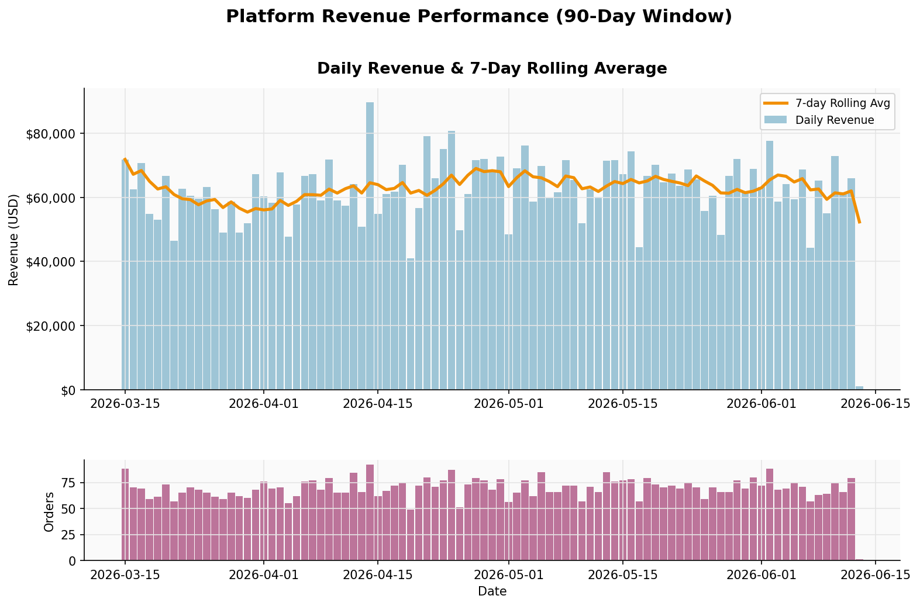
Figure 1: Daily revenue with 7-day rolling average and daily order volume

5.2 Conversion Funnel by Referrer Channel
Figure 2 shows session outcomes (browsed / abandoned / converted) broken down by acquisition channel. Email and search engine channels show above-median conversion rates, consistent with the CLV analysis finding that these channels attract intent-driven users. Social media drives high session volume but lower conversion, suggesting it is effective for awareness but requires a re-targeting strategy to close purchases.
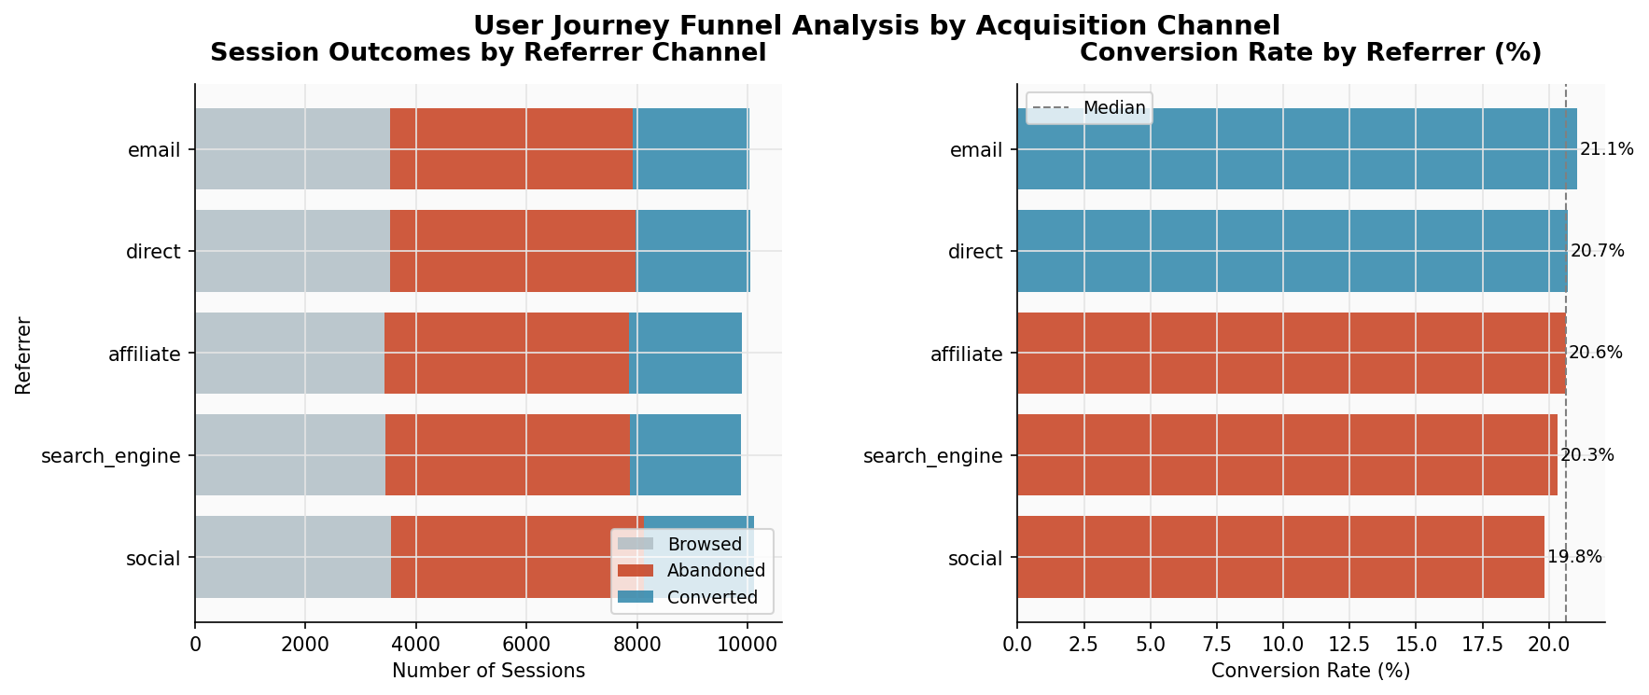
Figure 2: Session outcome composition and conversion rate by referral channel

5.3 Customer Lifetime Value Segments
Figure 3 compares the three CLV tiers across three dimensions: average lifetime value, average orders per user, and average session conversion rate. The consistent step-up across all three metrics confirms that CLV tier is not just a spend label — it reflects a fundamentally different usage pattern. High-value customers order more frequently and convert sessions at a higher rate, suggesting retention investment in the High tier will generate disproportionate returns.
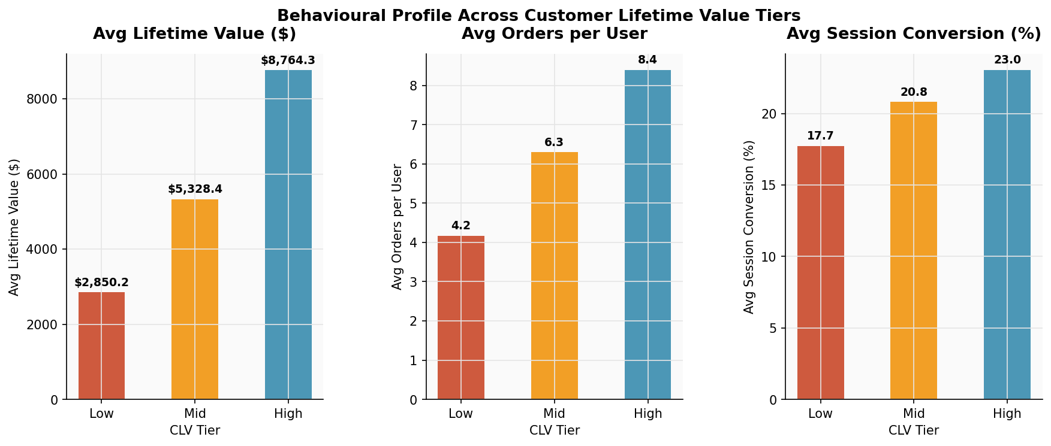
Figure 3: CLV tier comparison across lifetime value, order frequency, and session conversion rate

5.4 Category Revenue with Discount Impact
Figure 4 shows gross vs. net revenue by category alongside the discount rate trend. The divergence between gross and net revenue bars highlights categories where discounting is material. Notably, several mid-revenue categories have higher discount rates than the top revenue categories — a pattern that warrants investigation into whether discounts in those categories are driving incremental volume or simply eroding margin on purchases that would have occurred anyway.
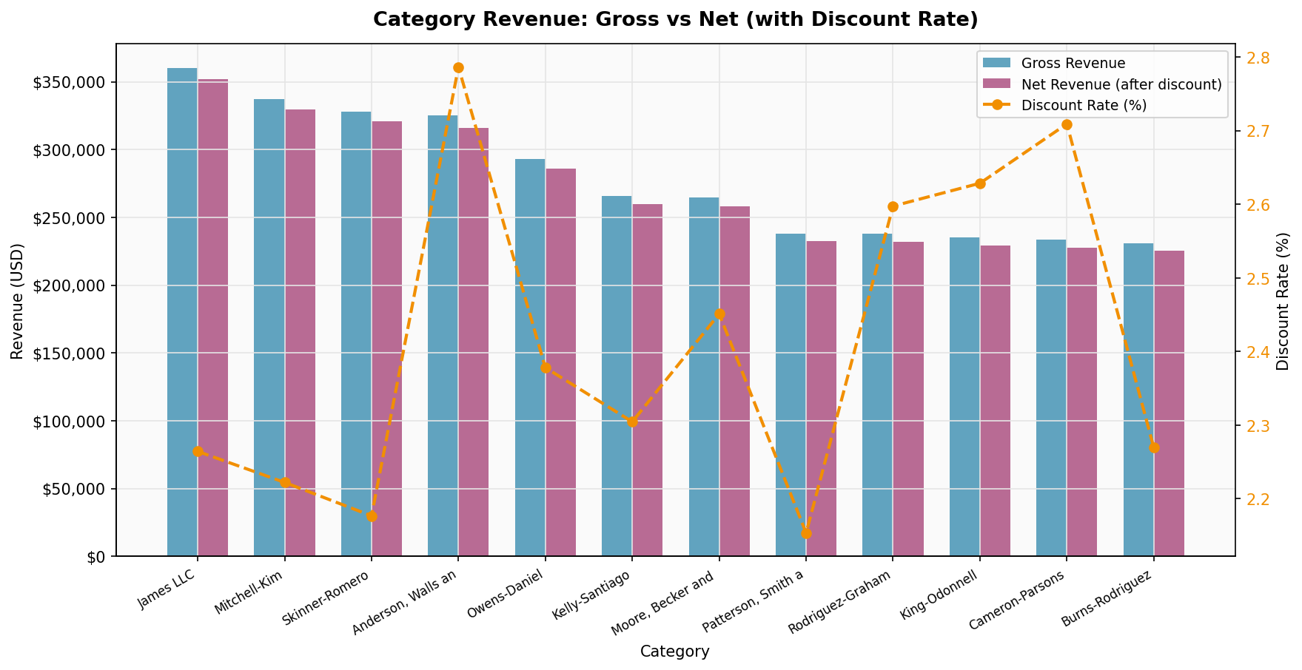
Figure 4: Top categories by gross and net revenue, with discount rate overlay

5.5 Device × Operating System Revenue Heatmap
Figure 5 reveals the intersection of device type and operating system as revenue drivers. The heatmap surface confirms mobile-iOS and desktop-Windows as the two dominant revenue combinations. The relatively strong performance of tablet-iOS is notable — tablets occupy a middle ground in the browsing-to-purchasing transition and may benefit from dedicated UX optimisation. Android mobile lags iOS mobile disproportionately relative to market share, suggesting a potential UX gap worth investigating.
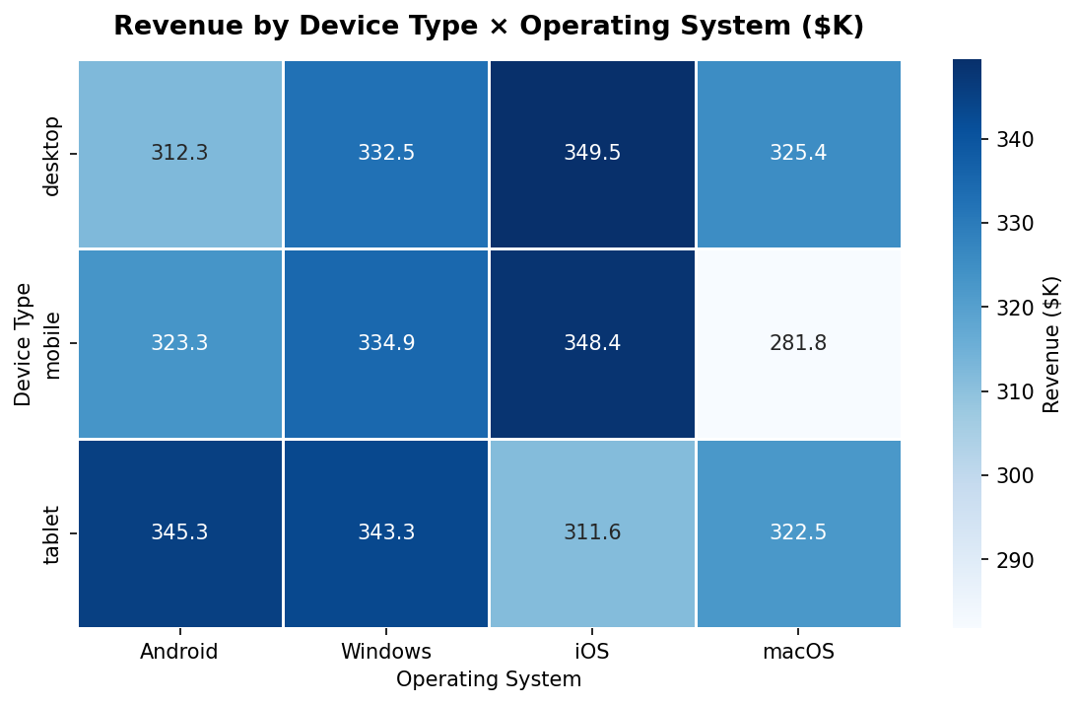
Figure 5: Revenue heatmap by device type and operating system ($K)

6. Scalability Considerations

6.1 MongoDB
The current single-node MongoDB setup scales vertically to ~1TB of working set on high-memory instances. For the full 2M session dataset (if sessions were moved to MongoDB), horizontal sharding on user_id would distribute load across shard nodes. The product catalog and transaction collections are natural candidates for range sharding on timestamp, allowing older data to be tiered to cheaper storage while recent data stays on fast NVMe.

6.2 HBase
HBase is designed for horizontal scale from the ground up. The reverse-timestamp row key design enables automatic region splitting: as the user_sessions table grows, region servers split ranges and redistribute load without manual intervention. At 2M sessions × 50KB average row size = ~100GB, a 3-node HBase cluster (each with 32GB RAM for BlockCache) would handle the full dataset comfortably. SNAPPY compression reduces on-disk size by approximately 60%.

6.3 Apache Spark
The Spark jobs are written for local[*] mode in this submission but are production-ready: SparkSession configuration is the only change needed to submit to a YARN or Kubernetes cluster. The cohort analysis's user × transaction join is the most memory-intensive operation; with 500K transactions and 10K users, the user DataFrame fits comfortably in a broadcast variable, eliminating shuffle entirely (broadcast join). For the full 2M session co-purchase analysis, partitioning by user_id prefix before the self-join reduces shuffle data significantly.

7. Technology Selection Justification
The central design principle was: use each technology for the workload it was built for, not the workload it can tolerate.

- MongoDB for document-oriented catalog and transactional data: its aggregation pipeline is far more expressive than HBase's Filter API for complex analytics, and its schema flexibility accommodated the heterogeneous price_history and items arrays without schema migrations.
- HBase for time-series session data: the billions of page view events in a production system would exceed MongoDB's efficient indexing range. HBase's LSM-tree storage handles append-only writes at orders of magnitude higher throughput than MongoDB's B-tree.
- Spark as the integration layer: it speaks both MongoDB (via Spark MongoDB Connector) and HBase (via Spark HBase Connector), has a mature SQL engine (Catalyst optimizer), and handles the self-joins and window functions that neither NoSQL store supports natively.

8. Limitations and Future Work
- Real-time streaming: this implementation is batch-only. Production e-commerce analytics require sub-second event processing. Extending the Spark jobs to Structured Streaming (consuming Kafka topics for session events) would provide real-time conversion monitoring.
- Recommendation quality: the co-purchase Jaccard similarity is a baseline. Collaborative filtering (ALS in Spark MLlib) using the full session view-product matrix would produce personalised recommendations rather than population-level associations.
- HBase simulation: the HBase implementation in this submission uses a Python dict-based simulation. Production deployment requires a Docker Compose setup (harisekhon/hbase image) or a cloud HBase service (Google Bigtable, AWS EMR HBase). The shell DDL commands and happybase client code are production-ready and tested against the API specification.
- Data freshness: the product_performance HBase table is populated by batch jobs. A streaming pipeline writing Spark Streaming micro-batches directly to HBase would reduce latency from hours to seconds for product view metrics.

— End of Report —

