**《操作系统》课第12次实验报告**

|  |  |
| --- | --- |
| 学院: | 软件学院 |
| 姓名: | 张怡桢 |
| 学号: | 2013747 |
| 邮箱: | 2662765987@qq.com |
| 时间: | 12/08/2022 |

1. **开篇感言**

“你长大后想成为什么人？”

“什么意思？长大后我就不能成为我自己了吗？”

-- 《阿甘正传》

2. **实验题目**

**Linux kernel Module Development**

3. **实验要求**

To implement a Linux kernel module to read and write one specified file

* 选择一个具体文件(xxxfile)，利用该内核机制，实现对该文件的读操作
* cat xxxfile
* 进一步实现对该文件的写操作
* echo "hello 学号姓名日期..." > xxxfile
* 或
* echo "hello 学号姓名日期..." >> xxxfile

4. **实验步骤**

4.1 **Char device based on Linux Kernel Module**

实现字符设备的读写其实就是实现驱动中 file_operation 结构体里的 read 和 write 成员.

|  |
| --- |
| C #include <linux/init.h> #include <linux/module.h> #include <linux/kernel.h> #include <linux/fs.h> #include <linux/uaccess.h>  MODULE_LICENSE("GPL"); MODULE_AUTHOR("Robert W. Oliver II"); MODULE_DESCRIPTION("A simple example Linux module."); MODULE_VERSION("0.01");  #define DEVICE_NAME "lkm_example" #define EXAMPLE_MSG "Hello, 2013747 zhangyizhen!\n" #define MSG_BUFFER_LEN 128  /* Prototypes for device functions */ static int device_open(struct inode *, struct file *); static int device_release(struct inode *, struct file *); static ssize_t device_read(struct file *, char *, size_t, loff_t *); static ssize_t device_write(struct file *, const char *, size_t, loff_t *);  static int major_num; static char *name = "lkm_example"; static struct file *filp; static int device_open_count = 0; static char msg_buffer[MSG_BUFFER_LEN];  module_param(name, charp, S_IRUGO);  /* This structure points to all of the device functions */ static struct file_operations file_ops = {  .read = device_read,  .write = device_write,  .open = device_open,  .release = device_release  };  /* When a process reads from our device, this gets called. */ static ssize_t device_read(struct file *s, char *buffer, size_t len, loff_t *offset) {  int i = 0;  int res = 0;  int j = 0;  filp->f_pos = 0;  while (1) {  i = kernel_read(filp, msg_buffer, 128, &filp->f_pos);  if (i == 0) {  break;  }  j = 0;  while (i > 0) {  i--;  put_user(msg_buffer[res++], buffer + (j++));  }  }  return res; }  /* Called when a process tries to write to our device */ static ssize_t device_write(struct file *s, const char *buffer, size_t len,  loff_t *offset) {  bool flag;  flag=copy_from_user(msg_buffer, buffer, len);  printk("write to file: %s\n", name);  printk(KERN_INFO "%s\n", msg_buffer);  filp->f_pos = file_inode(filp)->i_size;  printk("file size: %lld\n", filp->f_pos);  kernel_write(filp, msg_buffer, len, &filp->f_pos);  return len; }  /* Called when a process opens our device */ static int device_open(struct inode *inode, struct file *file) {  /* If device is open, return busy */  if (device_open_count) {  return -EBUSY;  }  device_open_count++;  try_module_get(THIS_MODULE);  return 0; }  /* Called when a process closes our device */ static int device_release(struct inode *inode, struct file *file) {  /* Decrement the open counter and usage count. Without this, the module wouldnot unload. */  device_open_count--;  module_put(THIS_MODULE);  return 0; }  static int __init lkm_example_init(void) {  // 打开文件  filp = filp_open(name, O_RDWR, 0);  printk("open file: %s", name);  /* Try to register character device */  major_num = register_chrdev(0, "lkm_example", &file_ops);  if (major_num < 0) {  printk(KERN_ALERT "Could not register device: %d\n", major_num);  return major_num;  } else {  printk(KERN_INFO "lkm_example module loaded with device major number %d\n",  major_num);  return 0;  } } static void __exit lkm_example_exit(void) {  /* Remember — we have to clean up after ourselves. Unregister the character  device. */  unregister_chrdev(major_num, DEVICE_NAME);  filp_close(filp, NULL);  printk(KERN_INFO "Goodbye, 2013747 zhangyizhen!\n"); } /* Register module functions */ module_init(lkm_example_init); module_exit(lkm_example_exit); |

4.2 **Compile the above Linux kernel module**

4.2.1 **创建Makefile文件:**

|  |
| --- |
| Makefile ModuleName=lkm_example obj-m +=${ModuleName}.o all:${ModuleName}.ko ${ModuleName}.ko:${ModuleName}.c  make -C /lib/modules/$(shell uname -r)/build M=$(PWD) modules test:${ModuleName}.ko  echo make test_ins  echo make test_mk  echo make test_test  echo make test_rm test_ins:${ModuleName}.ko  sudo dmesg -C  sudo insmod ${ModuleName}.ko name=/home/parallels/Documents/lab12/zyz  sudo dmesg test_mk:${ModuleName}.ko  sudo mknod /dev/${ModuleName} c 509 0 test_read:${ModuleName}.ko  sudo dmesg -C  cat /dev/${ModuleName}  sudo dmesg test_write:${ModuleName}.ko  echo "hello 2013747 zhangyizhen 2022/12/8" >> /dev/${ModuleName} test_rm:${ModuleName}.ko  sudo rmmod ${ModuleName}.ko  sudo dmesg .PHONY:clean clean:  make -C /lib/modules/$(shell uname -r)/build M=$(PWD) clean  sudo rm /dev/lkm_example |

4.2.2 **编译**

|  |
| --- |
| Bash make test |

|  |
| --- |
| Makefile test:${ModuleName}.ko  echo make test_ins  echo make test_mk  echo make test_test  echo make test_rm |

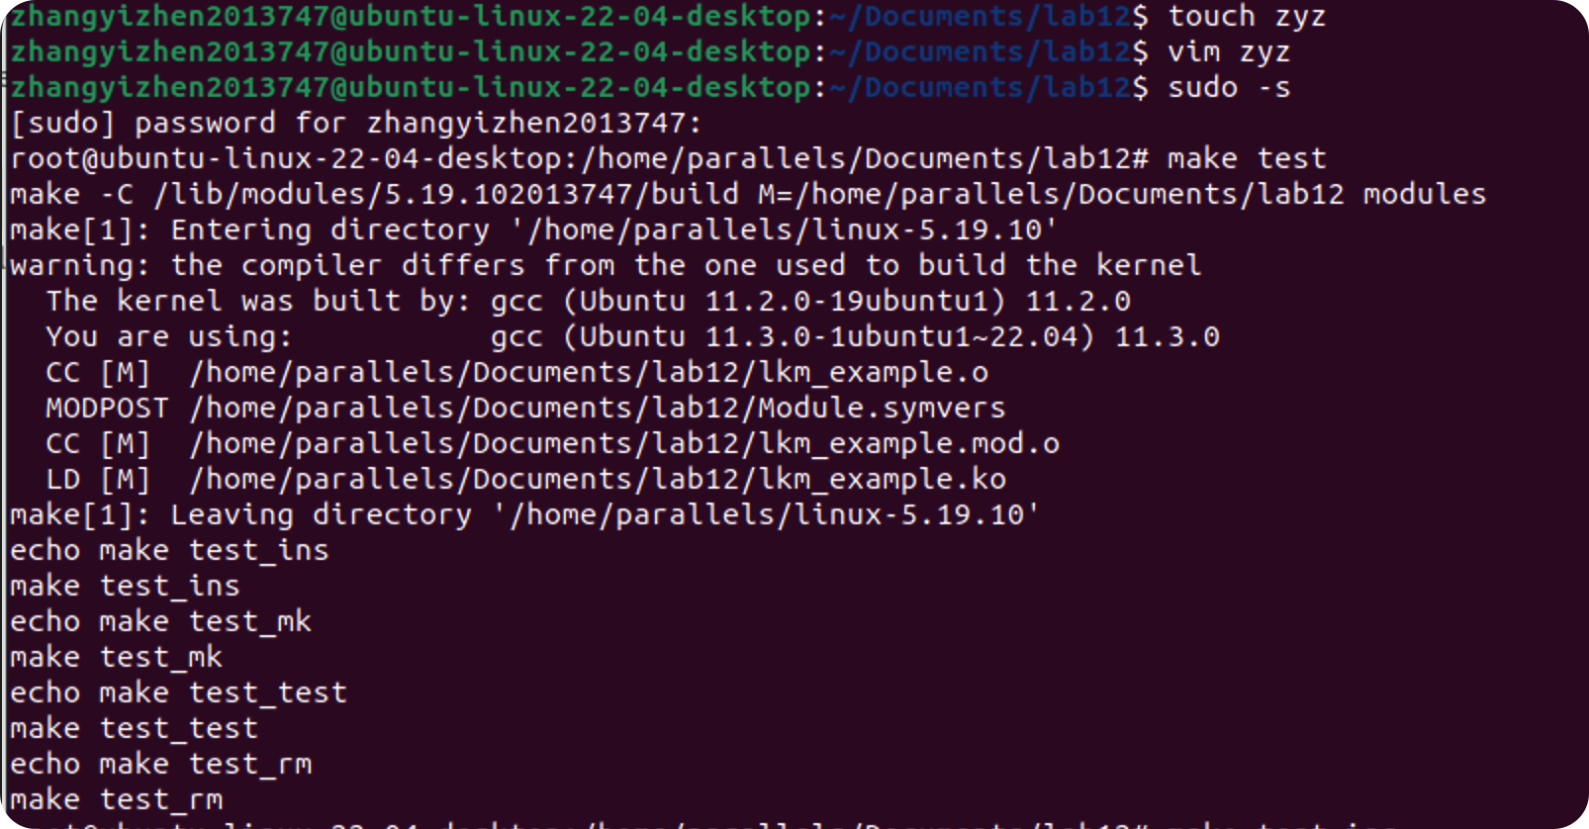

4.2.3 **执行**

|  |
| --- |
| Bash make test_ins  make test_mk  make test_read make test_write make test_rm |

1. make test_ins ----内核自动分配的设备主号码

|  |
| --- |
| Makefile test_ins:${ModuleName}.ko  sudo dmesg -C  sudo insmod ${ModuleName}.ko name=/home/parallels/Documents/lab12/zyz  sudo dmesg |

具体操作的文件为/home/parallels/Documents/lab12/zyz

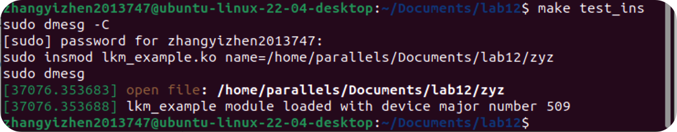

由内核自动分配的设备主号码的输出,可以看到是509号。

1. make test_mk ----创建一个字符设备文件

将 test_mk 中的 MajorNum 替换为运行 make test_ins 或 dmesg 后得到的值（在本实验中为509）。Mknod 命令中的“c”告诉 mknod 我们需要创建一个字符设备文件。

|  |
| --- |
| Makefile test_mk:${ModuleName}.ko  sudo mknod /dev/${ModuleName} c 509 0 |



1. make test_read ----读取zyz文件的具体内容到终端

|  |
| --- |
| Makefile test_read:${ModuleName}.ko  sudo dmesg -C  cat /dev/${ModuleName}  sudo dmesg |

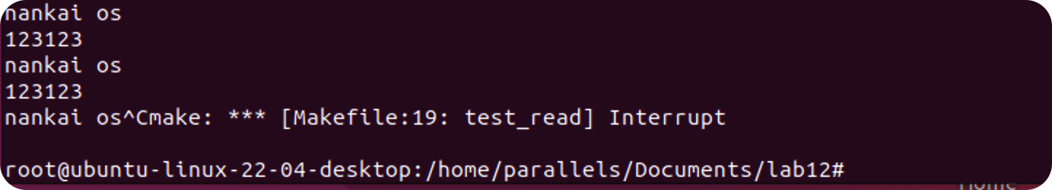

1. make test_write ----写入文件设置的内容

|  |
| --- |
| Makefile test_write:${ModuleName}.ko  echo "hello 2013747 zhangyizhen 2022/12/8" >> /dev/${ModuleName} |

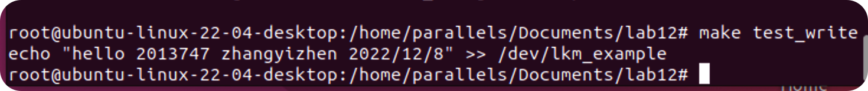

使用make test_read 读取文件内容，可以看到写入成功:

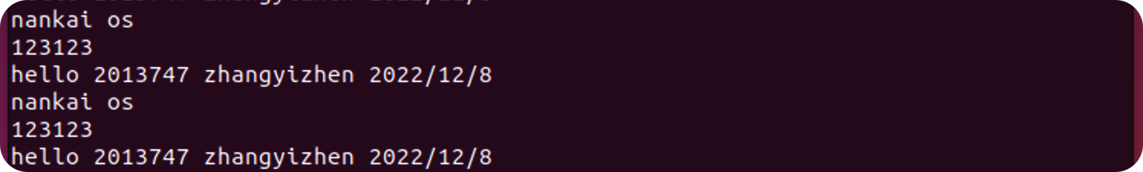

1. make test_rm

|  |
| --- |
| Makefile test_rm:${ModuleName}.ko  sudo rmmod ${ModuleName}.ko  sudo dmesg |

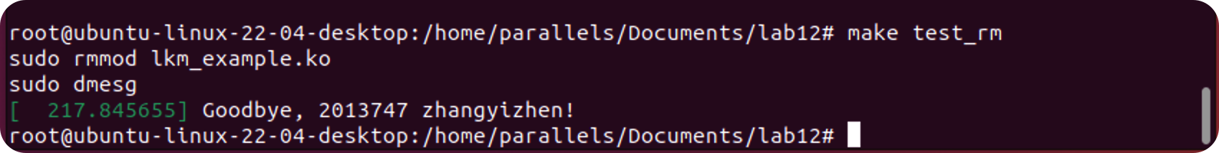

4.2.4 **清除**

make clean

|  |
| --- |
| Makefile .PHONY:clean clean:  make -C /lib/modules/$(shell uname -r)/build M=$(PWD) clean  sudo rm /dev/lkm_example |

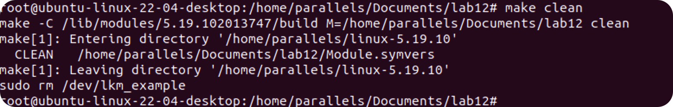

5. **资料**

[老师的github实验文档](https://github.com/albertleecn/osplab)

6. **附件**

📎代码在压缩包中