HPWHsim Technical Explanation

**HPWHinit_resTank**

The UA is calculated from a given Energy Factor using the following equation:

| $$UA=\frac{\frac{1}{\text{EF}}+\frac{1}{\text{RE}}}{67.5⋅\left(\frac{24}{41094}-\frac{1}{\text{RE}⋅\text{Power}}\right)}$$ | (1) |
| --- | --- |

Where EF is the Energy Factor, RE is the Recovery Efficiency, set to 0.98, and Power is the power of the lower element in BTU per Hour.

**Update Tank Temperatures**

The temperatures of the nodes in each tank are updated at the beginning of each step. The temperature profile changes due to draws and UA losses are calculated in this step.

The fractional number of nodes drawn is calculated as in Equation (1):

| $$drawFraction=\frac{volumeofdraw}{volumeperNode}$$ | (1) |
| --- | --- |

The draw fraction is then divided into its whole part and its fractional part. In a typical HPWH, with a volume per node of approximately 4 gallons, most draws will be less than one node. The whole nodes are “moved upwards” in the tank by assigning the temperature of each node to the node above it and filling in the bottom node with water at the specified inlet temperature. Then the remaining partial node draw is calculated using Equation (2).

| $$tankTemps\left[i\right]=tankTemps\left[i\right]*\left(1-fractionofnode\right)+tankTemps\left[i-1\right]*fractionofnode$$ | (2) |
| --- | --- |

Where *i* is the number of the node in the node array. The bottom node, where *i - 1* is negative, is mixed with water at the inlet temperature. The correctness of this calculation relies on the relative invariance of the specific heat of water with respect to temperature and the equality of node volumes.

The temperature and volume of any water shifted out of the tank is tracked and averaged to calculate the outlet temperature.

If the “mix on draw” feature is enabled for this HPWH, the bottom third of the tank experiences mixing. This is done by finding the average temperature of the bottom third. Then for each node, one third of the difference between the average and the current temperature is subtracted:

| $$tankTemps\left[i\right]=tankTemps\left[i\right]+\left({\left(average-tankTemps\left[i\right]\right)}/{3.0}\right);$$ | (3) |
| --- | --- |

Next, the temperatures of the nodes are adjusted for standby losses. The average temperature of the tank is found, then the total energy lost by the tank is calculated by Equation (4):

| $$\left(tankUA*\left(averagetanktemperature-ambienttemperature\right)*\left(minutesper{step}/{60.0}\right)\right)$$ | (4) |
| --- | --- |

Where *tankUA* is measured kJ / hrC. The total losses are split equally amongst all nodes, and then the affect on temperature is calculated by Equation (5):

| $$nodetemperatureloss=\frac{nodeenergyloss}{\left(\left(volumepernode*densityofwater\right)*specificheatofwater\right)}$$ | (5) |
| --- | --- |

**Heat Source Choice Logic**

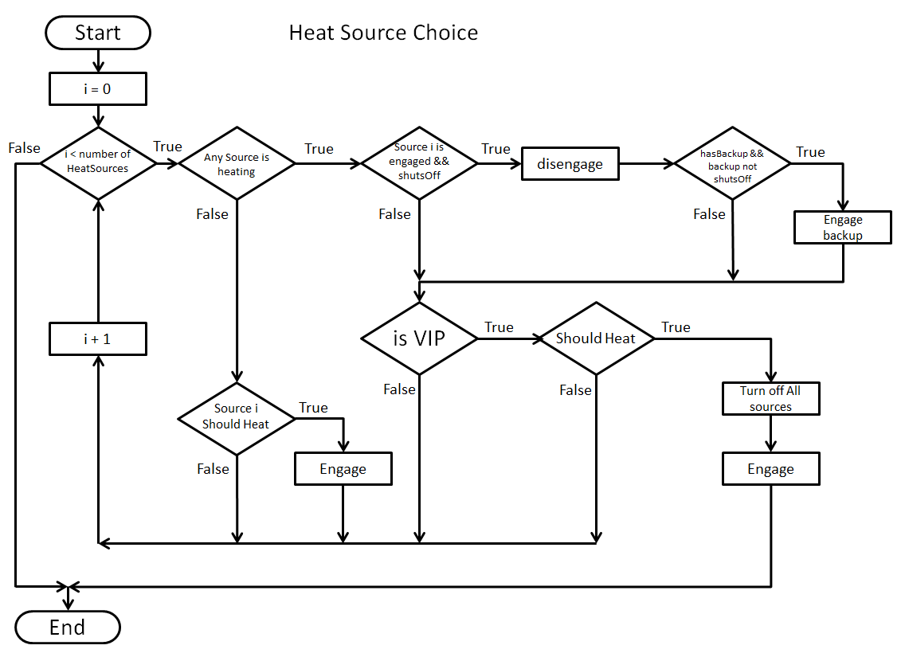

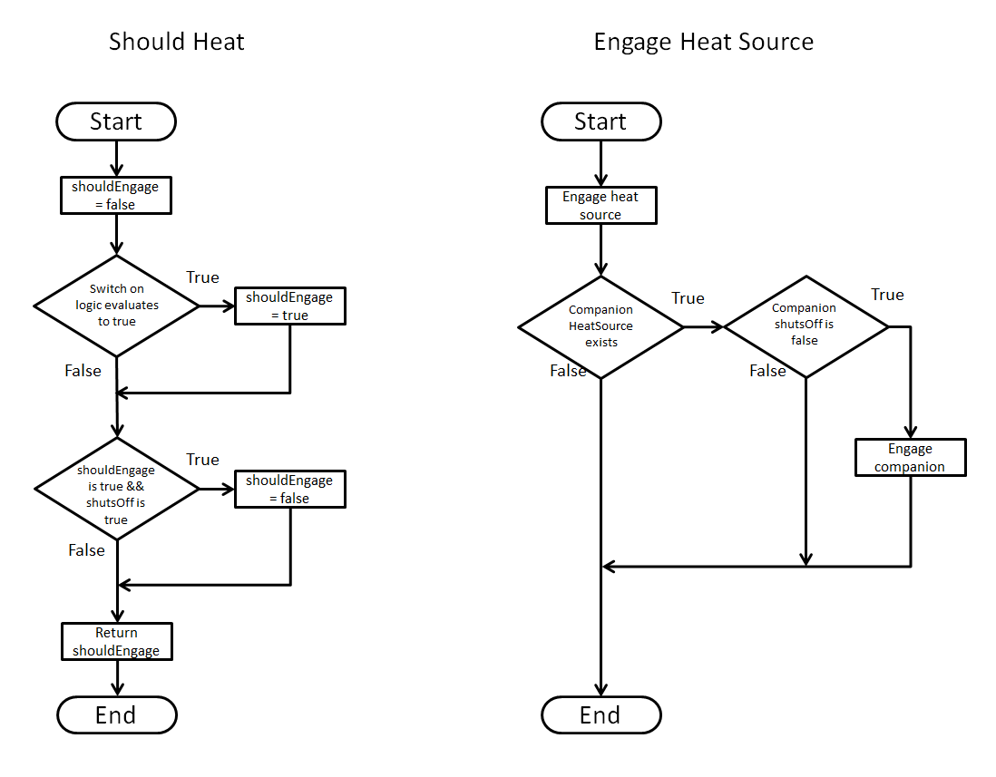

**Heating Logic**

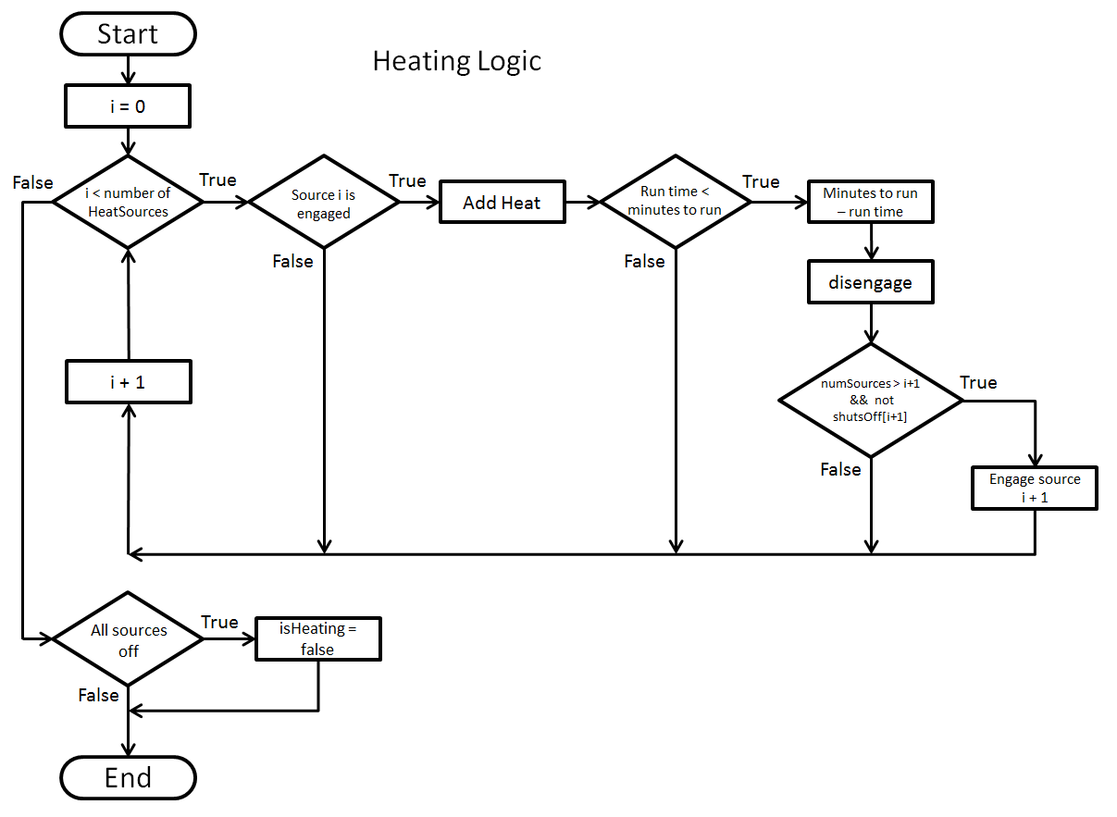

The addHeat function begins by choosing between two paths to take, one for “submerged” and “wrapped” configurations, and the second for “external” configurations. The first path proceeds as follows:

Each node is assigned a weighting that will determine what fraction of heat will be assigned to that node. (mention approximation)

The capacity of the heat source is calculated using different methods for “submerged” or “wrapped” configurations. In common for both, no heat is added below the lowest node where the heat source has non-zero condensity. For “submerged” configurations, the distribution is the same as the condensity (the number of nodes must be a multiple of 12 so that the condensity divides it evenly). The case for “wrapped” configurations is more complicated. The *i*th node heatDistribution is found by Equation (6)

| $$\frac{\left(setpoint-{temp}_{i}\right)*1}{1+e^{\left(\left({\left({temp}_{i}-{temp}_{lowestNode}\right)}/{shrinkage}\right)-offset\right)}}$$ | (6) |
| --- | --- |

Where *shrinkage* is a parameter derived from the condensity by Equation (7) and *offset* is 5/1.8.

| $$alpha+beta*∑-{condensity}_{i}*log\left({condensity}_{i}\right)$$ | (7) |
| --- | --- |

Where *alpha* and *beta* are 1 and 2 respectively.

The heat is added, starting from the top node and moving down node by node. The amount of heat to be added to a node is defined by Equation (8).

| $$capacity=\left(capacityperhour*\left({minutesToRun}/{60.0}\right)*{heatDistribution}_{i}\right)$$ | (8) |
| --- | --- |

Where the *i* subscript denotes the *i*th node.

This heat is combined with any heat leftover from the last step and used as input to the addHeatAboveNode function. This function starts with the given node and searches upwards for a node that is not at the same temperature. The temperature at that node becomes the target temperature, and all nodes below it receive heat until all the heat is used, or until all the nodes are at the target temperature. Then the target temperature becomes the temperature of the next node up. If there is no node further up, the target temperature becomes the setpoint. If all nodes above the given node are at setpoint, any remaining heat is returned to be used for the next node down.

For the “external” configuration, the addition of heat is simpler. The capacity is determined and adjusted for the amount of time remaining in the step. The fraction of the bottom node that can be heated with the capacity is calculated. If it is greater than one all nodes are shifted down and a node at setpoint is added at the top. The amount of time run to create that amount of heat is calculated and subtracted from the available time, and then, if a shutOff logic is not achieved, the process is repeated. If the fraction of the bottom node that can be heated in the remaining time is less than one, all nodes are shifted down by that fraction, mixing in the same way as Equation (2).