6CS005

High Performance Computing

Week 3 Workshop
Revision on Multithreading

Student Number: 2408869
Name: Narayan Lohani
Group: L6CG15

Table of Contents
Explanation 2
Output of Program 3 4
Output of Program 4 4
Source Code of Program 3 5
Source Code of Program 4 7
Uni file execution 9

Explanation
3. Write a multithreaded C program that creates multiple threads (prompt user for number of threads to use) to find all prime numbers between 1 and 10,000. Each thread must count how many primes it finds and returns that count to the main thread using pthread_exit(). The main thread should then print how many prime numbers each thread finds.
To solve this problem, a thread routine was created in which an integer variable, namely count, was dynamically allocated and initialized to 0. The thread routine then typecasted the argument from which the start and stop of number to find the primes from were extracted. Iteratively from start to stop, a user-defined function is_prime() was called which returns 0 if the number is composite and 1 if the number is prime. If the iterating number is prime, then the value count is increased by 1. When the iteration was completed, the total number of primes found would be stored in count variable and the routine would exit with the count variable using pthread_exit().
The program begins by prompting the user to enter the number of threads to create. Memory is allocated for arrays to store thread identifiers and their respective number ranges. The total range of numbers from 1 to 10,000 is divided among the threads so that each thread processes a roughly equal subset. The last thread handles any remaining numbers to ensure the entire range is covered. Each thread is created using pthread_create() and executes the prime-finding routine in parallel.
After all threads are started, the main function waits for their completion using pthread_join(). A pointer is used to receive the count returned by each thread. The program prints the number of primes found by each thread and then frees the dynamically allocated memory for the count variable. Finally, the memory allocated for the thread and range arrays is also released to prevent memory leaks.
Output of Program 3 Source of Program 3

4. Write a multithreaded C program that uses multiple threads (prompt user for number of threads to use) to find prime numbers between 1 and 10,000. As soon as the 5th prime number is found, the program should cancel all other threads as soon as possible using pthread_cancel().
To solve this problem, following components were used:
Global Variables
- prime_counts (int): to count number of prime numbers found combinedly by all threads
- lock (pthread_mutex_t): to protect global variables from race condition
Structures
- typedef – start_stop: start (int), stop (int), threads (pthread_t*), total_threads (int)
User Defined Function
- is_prime(int n): returns 1 if a number is prime, 0 otherwise
- main(): handles flow of the program
Thread Routine
- print_five_primes(void* args)
The main function prompts user for number of threads to use. Using malloc memory for threads and ranges(start_stop) are created. Number to be calculated each thread are divided roughly equally, the remaining numbers are taken by last thread. It also initializes the mutex using pthread_mutex_init().
For each thread, range which store start and stop numbers, threads pointer, thread_size are calculated and assigned. Then finally threads are created using pthread_create() and respective ranges are passed as arguments.
The thread routine firstly typecasts the argument into start_stop. Then cancellation point is set at the beginning of the loop. Inside loop, for each number between start and stop, is_prime() function is called. If the number is not prime, then it simply skips this number and goes to next one. However, if the number is prime then,
mutex is locked, and prime_count is checked if it is less than 5. If the prime_count is less than 5 then, prime_count is increased by one. After increasing the prime_count again, the prime_count is checked, has the recent increment cause the prime_count to be 5? Because our goal is to print only first 5 print numbers. If the recent increment indeed was the fifth prime number, then in a loop, call pthread_cancel all other threads using pthread_cancel. Unlock the mutex and exit itself too using pthread_exit().
Output of Program 4 Source of Program 4

Output of Program 3
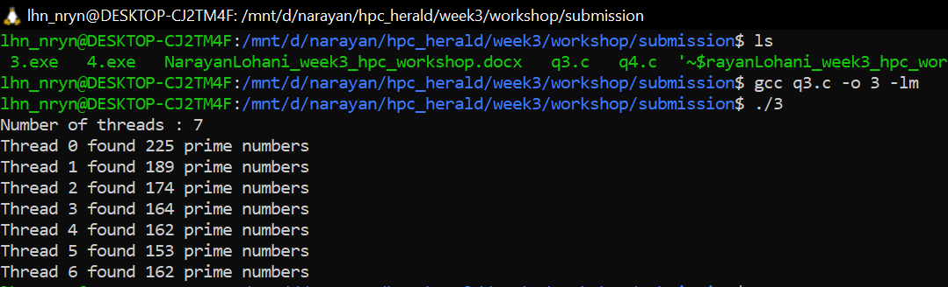

Output of Program 4
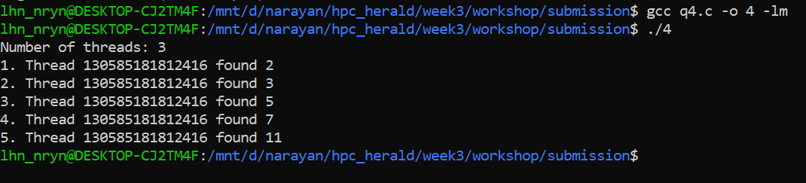

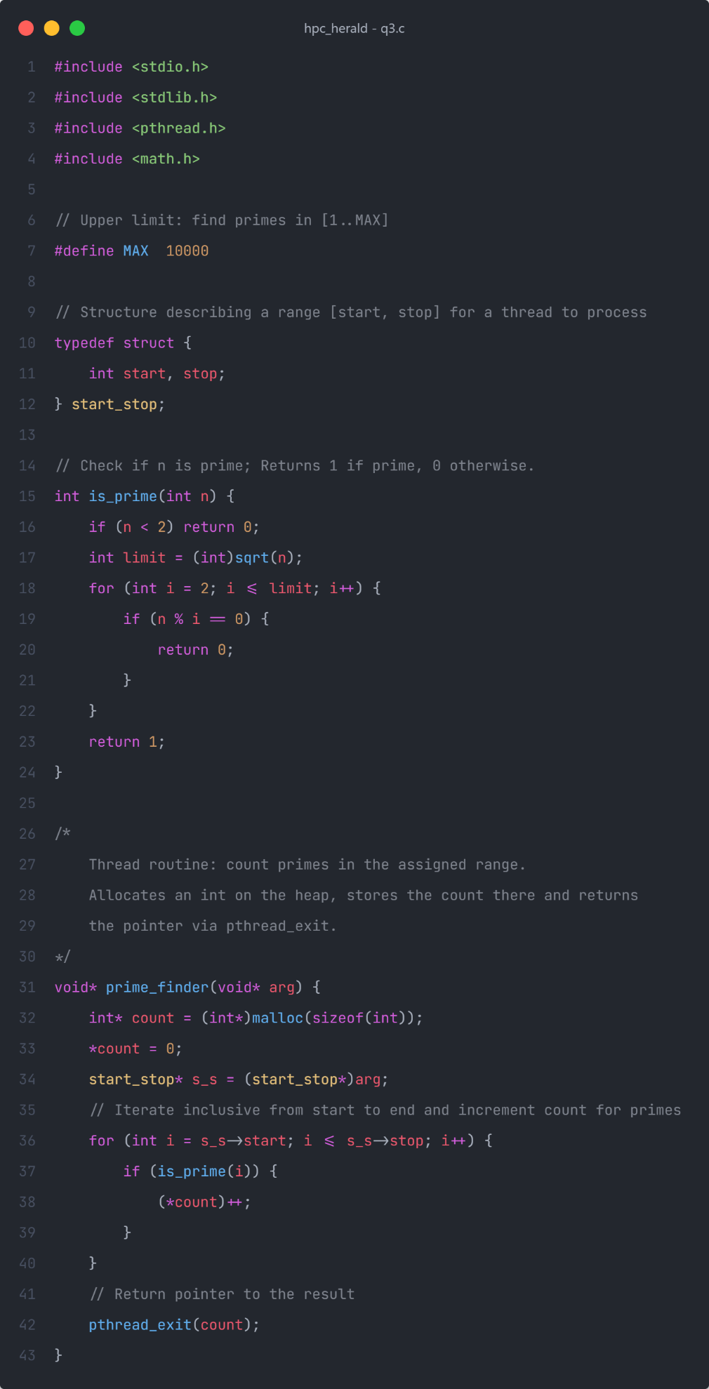
Source Code of Program 3

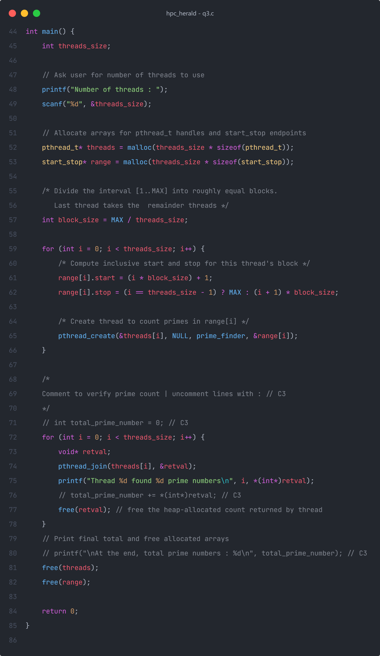

Source Code of Program 4
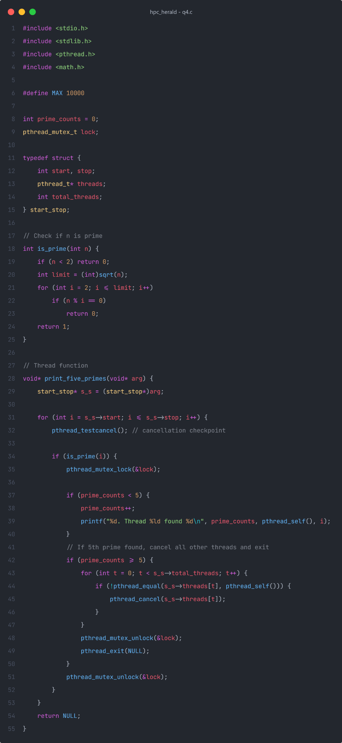
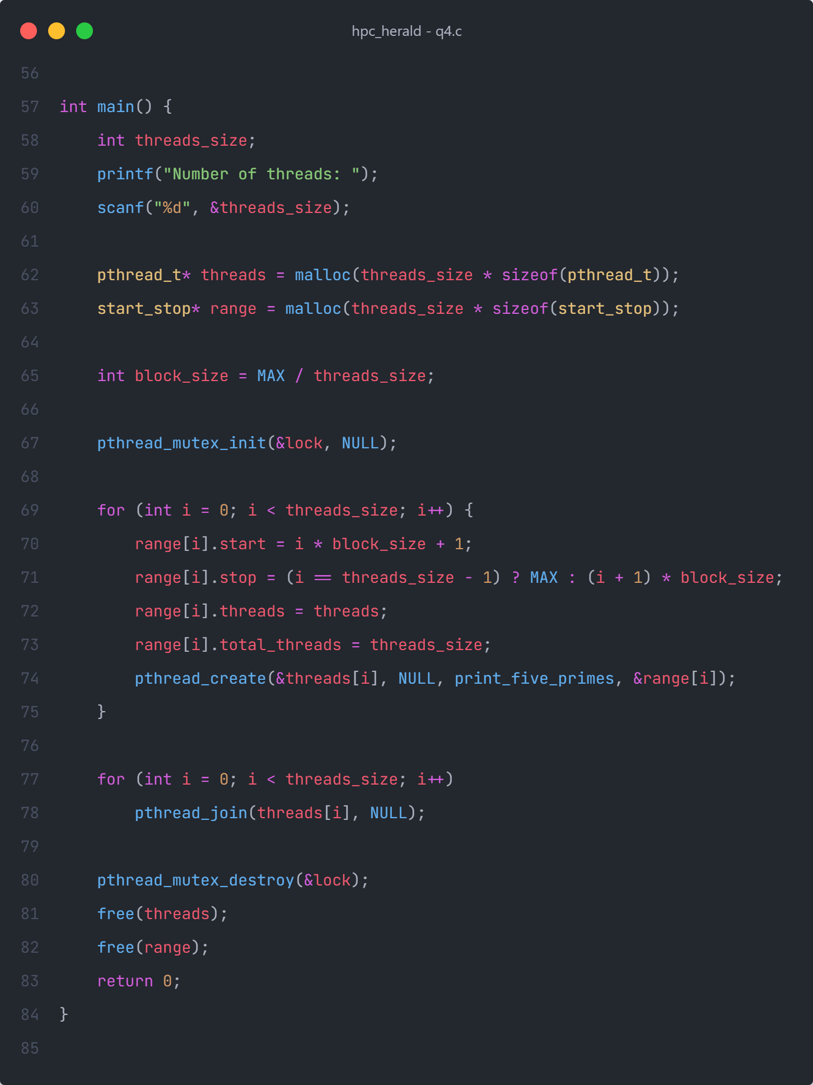

Uni file execution
Factorise_3_0
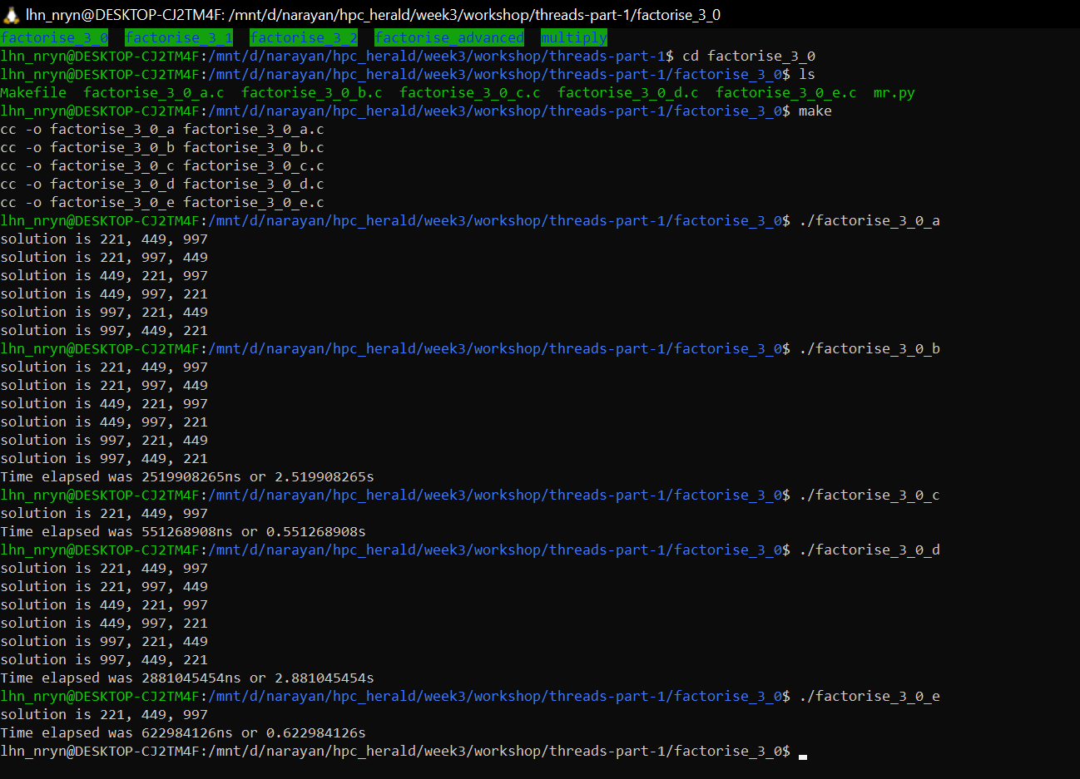

Factorise_3_1
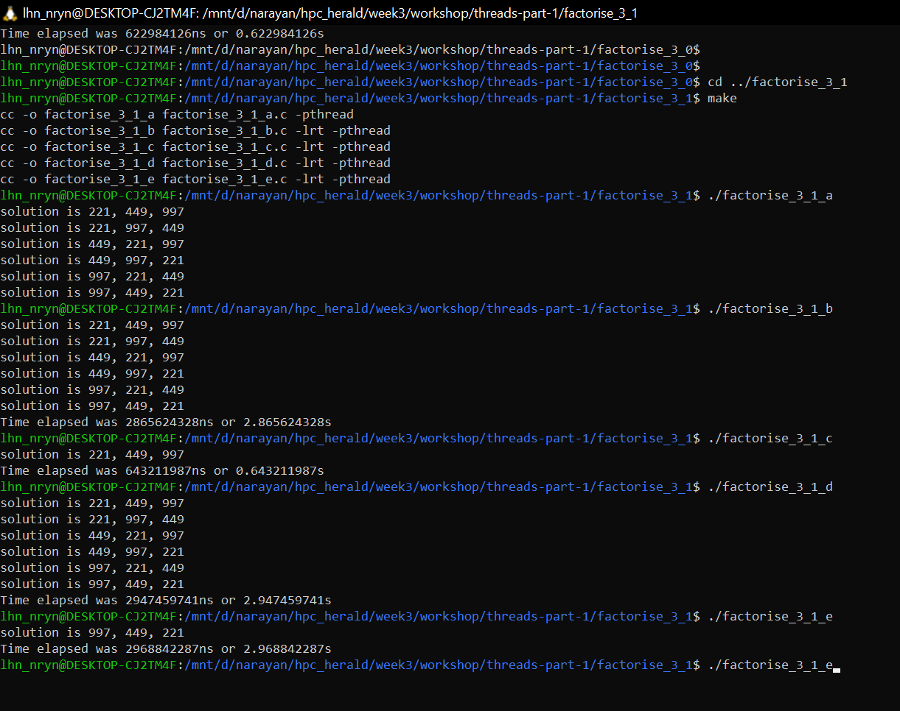

Factorise_3_2
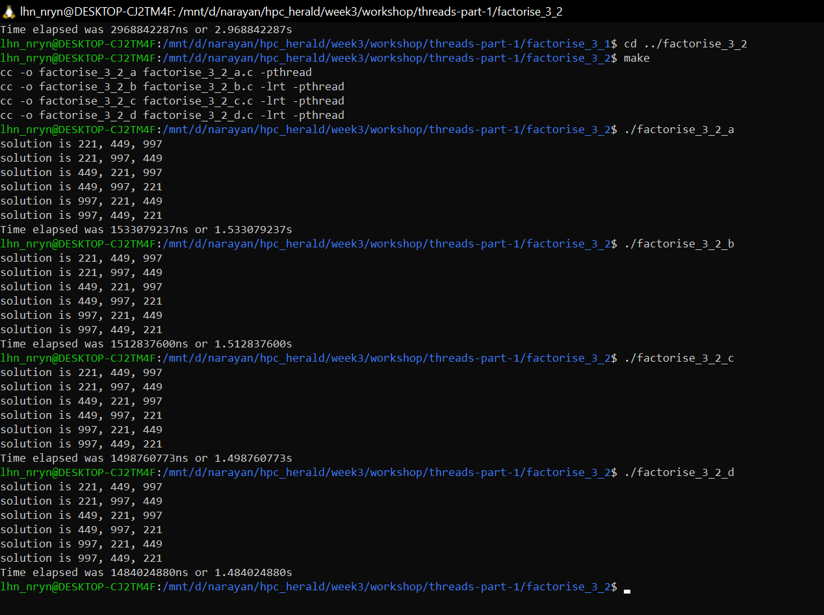

Factorise_advanced
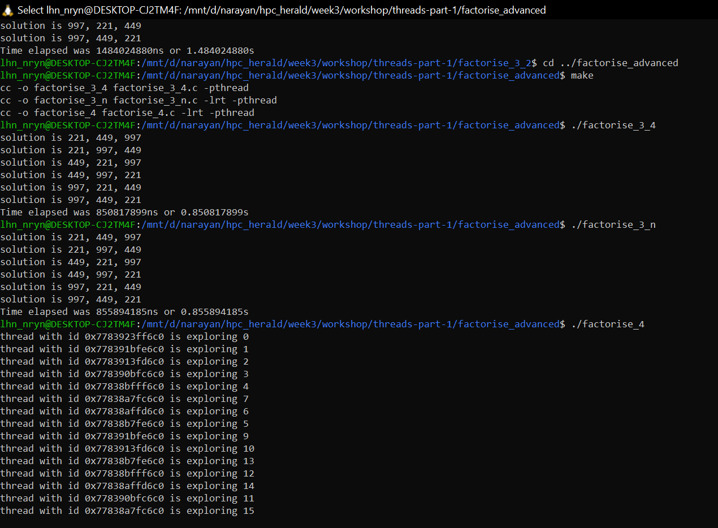

Multiply
