Sieberdam/ROCS Specifications for Design 1.0
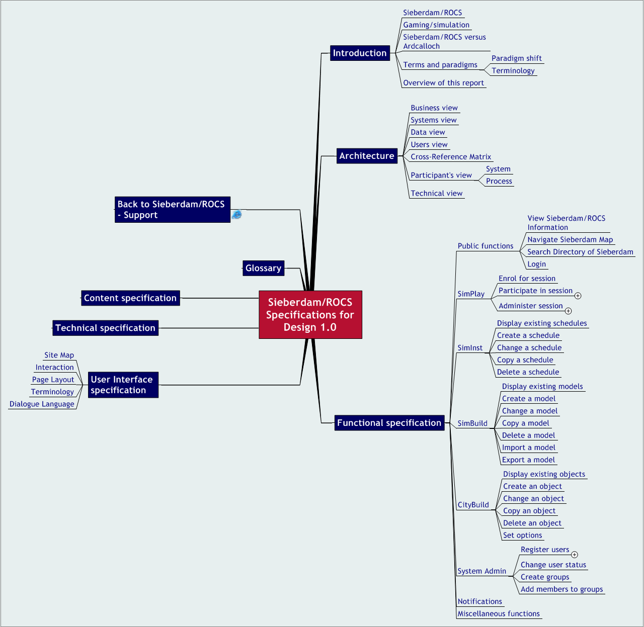
‘let’s build your future...’

e-government, e-learning, spelsimulatie, xml

Pieter van der Hijden
Sofos Consultancy
Amsterdam, December 30th 2004

sofos
consultancy
adviesbureau voor organisatie en informatie
p postbus 94874, 1090 gw amsterdam
b b. stokvisstraat 38, 1097 hz amsterdam
t 020 – 694 12 22
e pvdh@sofos.nl
w www.sofos.nl


Opdrachtgever:
VSNU RechtenOnline
Afnemer:
Stichting RechtenOnline
VSNU RechtenOnline
Ardcalloch by Paul Maharg inspired the VSNU Program RechtenOnline to fund three projects aimed at the development of a Dutch equivalent: 1. the Dutch virtual City of Sieberdam, 2. the e-learning suite for asynchroneous workflow based group simulations ROCS, and 3. the integrated Sieberdam/ROCS. Rudi Holzhauer (project management, content authorship, and design), Martin de Wit (Flash programming), Willem Mieras (visual design), and Sander Gellaerts (student-assistant) developed Sieberdam. Aernout Schmidt and Jeroen Leijen (project management and design), Lokman Tsui (design), Peter van Schijndel (design), and Collaboraid ApS København (software development) developed ROCS. Pieter van der Hijden (consultant to both projects) integrated Sieberdam and ROCS into Sieberdam/ROCS and extended the system (project management and design), together with Jarkko Laine (software development) and the former Sieberdam and ROCS project teams. The Dutch Foundation RechtenOnline (Law-Online) now is the owner of the product.
Table of Contents
1 Introduction 4
1.1 Sieberdam/ROCS 4
1.2 Gaming/simulation 4
1.3 Sieberdam/ROCS versus Ardcalloch 5
1.4 Terms and paradigms 6
1.5 Overview of this report 8
2 Architecture 9
2.1 Business view 9
2.2 Systems view 9
2.3 Data view 11
2.4 Users view 11
2.5 Cross-Reference Matrix 12
2.6 Participant's view 13
2.7 Technical view 16
3 Functional specification 17
3.1 Public functions 17
3.2 SimPlay 17
3.3 SimInst 21
3.4 SimBuild 23
3.5 CityBuild 29
3.6 System Admin 34
3.7 Notifications 35
3.8 Miscellaneous functions 35
4 User Interface specification 37
4.1 Site Map 37
4.2 Interaction 37
4.3 Page Layout 37
4.4 Terminology 37
4.5 Dialogue Language 37
5 Technical specification 38
6 Content specification 39
7 Glossary 40

- Introduction
Sieberdam/ROCS is an electronic learning suite for (parallel) computer-supported asynchroneous gaming/simulations in the context of a virtual city. It has been inspired by the Scottish Arcalloch system and might be called Ardcalloch's Dutch equivalent. However, there exist major differences between Ardcalloch and Sieberdam/ROCS as well. Sieberdam/ROCS has been developed for the Dutch Law Faculties; the source code is available under General Public Licence version 2.
  - Sieberdam/ROCS
Ardcalloch by Paul Maharg inspired the VSNU Program RechtenOnline to fund three projects aimed at the development of a Dutch equivalent:
1. the Dutch virtual City of Sieberdam,
2. the e-learning suite for asynchroneous workflow based group simulations ROCS,
3. the integrated Sieberdam/ROCS.
The Dutch Foundation RechtenOnline (Law-Online) now is the owner of the product.

Sieberdam/ROCS aims to be:
- a stable product and/or service
- intended for the juridical faculties in The Netherlands
- aimed to improve their educational practice
- by delivering an authoring environment as well as a player environment
- for (parallel) computer-supported group simulations
- in the context of a virtual city
with a first series of applications that could be extended in the near future.

The technical name of the Sieberdam/ROCS software is "OpenACS Simulation Package". It is available under General Public License version 2.
  - Gaming/simulation
Simulation means imitation, i.e. imitation of the real world. The simulated world is a reduction of reality to serve specific educational needs. Although a simulated world is less real than reality, it may offer an authentic learning environment. This environment can be controlled as far as desirable. Different roles in reality can be played by different individual participants or teams of participants (gaming). In interaction with each other and guided by the rules of the game, they observe, discuss, make deals, learn from the effects, etceteras. Participants can learn in a safe environment without causing any real damage. When the simulation tools do not require face-to-face contact nor meetings at the same time, the simulations can be played asynchronously and participants are no longer bound by space and time.
Most gaming/simulation applications are synchronous, i.e. participants are active at the same time and usually at the same place. This forces game developers to define roles in such a way that all participants have something to do all the time. The participants will get more or less the same workload, even if this does not correspond with reality. Further, in synchronous games it is more difficult to involve faculty or external experts to play different roles. It is simply too time consuming to have these people around during the whole session. Asynchroneous games have the advantage that different participants may play different roles with different intensity. Participants are active at the time and place that is most convenient for them.
Computers can support asynchronous gaming/simulation by providing communication and information management tools, by enforcing the rules of the game and by logging the whole session history. Further, they could help to schedule gaming sessions and to enrol the participants. Ultimately, they could help the designers of such applications to prepare all the materials and to program the rules.
Computer-supported asynchronous games offer the opportunity for authentic learning, independent of time and place and with efficient contributions by faculty or external experts. Setting-up a simulation could be quite a job. Once they have been built, they can be run many times without substantial additional costs.
  - Sieberdam/ROCS versus Ardcalloch
Ardcalloch was a source of inspiration for the developers of Sieberdam/ROCS. Both systems use the metaphor of a town populated with characters. Both are examples of mainly asynchronous group simulations. During simulation sessions, student teams play roles corresponding with city characters.
However, Sieberdam/ROCS is not the Dutch translation of Ardcalloch. There are major differences as well. The following table will list the most important ones.
 | Ardcalloch | Sieberdam/ROCS
number of city characters | about 20 regular ones plus 60 law firms each with their own identity and name | about 80, some of them are law firms
student team | each student team plays one law firm | - each student (team) plays a certain role that could correspond to any city character;  - different teams of students may play different roles within the same simulation session;  - different simulation sessions are possible at the same moment.
tutors | tutors play all other roles | tutors might play any role as well
case | each law firm deals with a slightly different case | each role deals with the same case; different simulation sessions are possible at the same moment
communication structure | open, a law firm can (try to) communicate with any other character | workflow, a session is subdivided into separate stages; in each stage roles have certain communication activities; executing them might bring the session in the next stage; nevertheless, a role may send a message to any other role
context | fixed law program | open, may be used as alternative for a lecture or for a whole course, not bound to law domain
product | one application that might be loaded with new sets of documents | an e-learning suite to build applications and resources for applications
software | based on MS-Office and other Microsoft products | based on OpenACS and other Open Source products

  - Terms and paradigms
The Sieberdam/ROCS integration project decided to shift some paradigms and terms originating from the eralier separated Sieberdam and ROCS projects.
    - Paradigm shift
Sieberdam/ROCS has been based on a set of assumptions that needs some adjustments. Although this report mainly reflects the current assumptions, a paradigm shift will be discussed soon. The following table gives a summary of possible changes.
concept | current paradigm | future paradigm
ROCS | ROCS is a communication system, the subdivision of user responsibilities depends on the complexity of certain tasks. | ROCS is an e-learning suite; the subdivision of user responsibilities corresponds with the usual distinction between e- learning authoring systems, learning comtent management systems, learning management systems and e- learning players.
Sieberdam | Sieberdam is a virtual city consisting of an interactive city map, a city directory ("yellow pages") of locations, characters, and props, home pages of locations, characters, and props, and a written city history. | Many virtual environments could represent a knowledge domain to be used during simulations. Sieberdam is only one of them, albeit the first, the most elaborated and the most preferred one. Such a virtual environment consists of a topic map (in Sieberdam the interactive city map and the "yellow pages" and the resources the topic map is pointing to (in Sieberdam the home pages of locations, characters and props).
Integration | ROCS and Sieberdam are integrated. ROCS has outgoing links to and incoming links from Sieberdam. | ROCS and the virtual environment might have been integrated in different degrees: mode 0 = no mutual hyperlinks, mode 1 = ROCS has outgoing links only, mode 2 = ROCS has incoming and outgoing links. Sieberdam has mode = 2.
Terminology | Simulation is an application of workflow management. | Simulation is an application of experiencing, exploring and learning.

    - Terminology
Terminology is an issue. For those who have been involved in the earlier Sieberdam and ROCS projects, we summarise some new terms that will be used in Sieberdam/ROCS and its documentation. We tried to transform the earlier terminology from its object oriented programming and workflow management context to a gaming/simulation and electronic learning context.
The transformation table lists old and new terms.
old term | new term | comment
actor | participant | conforms to gaming/simulation context
case | session | conforms to gaming/simulation context
case author | session administrator | the authoring role of this user should be minimal
portfolio | archive or workspace | better fits the real function
simulation | either simulation model or simulation session | simply using the term "simulation" might be confusing
task | activity | better fits the real function
template | model | conforms to gaming/simulation context
template author | author | conforms to e-learning context
yellow pages | city directory | avoids the use of a trademark

  - Overview of this report
Both the Sieberdam and the ROCS projects did result in various documents, although none of them summarised in one place all design considerations and specifications. The purpose of this report is to fill this gap. From now, this report can serve as the top-level single source of reference for the Sieberdam/ROCS design specifications. This report has been used as the basis for testing version 1.0 and may be used as the basis for further improvements.
While combining the information from various documents, we found some overlaps, some inconsistencies, and some white spots. We have filled in the white spots and tried to resolve any inconsistencies and overlaps.
Apart from consolidating the design efforts from the past, some new insights have evolved. We summarised them in the previous sections on "Paradigm Shift" and "Terminology". This shift only partially has been implemented in version 1.0.
The report describes:
- Basic concepts
- Content specification,
- Functional specification (the major part of this report),
- User Interface specification,
- Technical specification,
- Glossary
Although Sieberdam/ROCS has been composed from numerous components, each with their own version numbering scheme, we will introduce a single version numbering scheme for the package as a whole:
- Actual: Release 1st December 2004: version 1.0 (final).
- Architecture
The following sections describe the Sieberdam/ROCS architecture from four different perspectives:
- Business view
- Systems view
- Users view
- Data view
A cross-reference matrix summarises these four views.
We complete the architectural description with two more views:
- Participant's view - the ultimate user of Sieberdam/ROCS is the user who participates in simulation sessions
- Database view
- Technical view
  - Business view
From a business point of view, Sieberdam/ROCS is a learning production process consisting of six organisational processes.
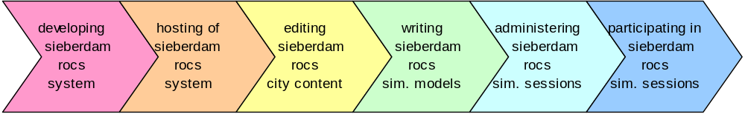
The six processes are:
- developing the Sieberdam/ROCS system, - developing the software and writing its technical documentation; this is the responsibility of the software developers;
- hosting of the Sieberdam/ROCS system, - making the system available for all types of users; the system administrator takes care for it; unregistered users may get read-access to the Sieberdam city map and related information;
- editing the Sieberdam/ROCS city content - filling the virtual city of Sieberdam with virtual inhabitants; this is a task of the city editors;
- writing Sieberdam/ROCS models - defining the communication structure of an intended simulation session (roles, states, activities), writing instructions for the participants, etceteras; people writing models are called the authors of the models;
- administering Sieberdam/ROCS simulation sessions, - scheduling sessions, allocating participants to roles, intervene during ongoing sessions, etceteras; this is what session administrators do;
- participating in Sieberdam/ROCS simulation sessions - the actual occurrence of simulation sessions which involves participants playing certain roles; finally this is what students and tutors do; together we call them the participants.
  - Systems view
The Sieberdam/ROCS system is a webbased application. It consists of an interactive environment that enables registered and unregistered users to visit the virtual city of Sieberdam and have read- access to the Sieberdam city map and related information.
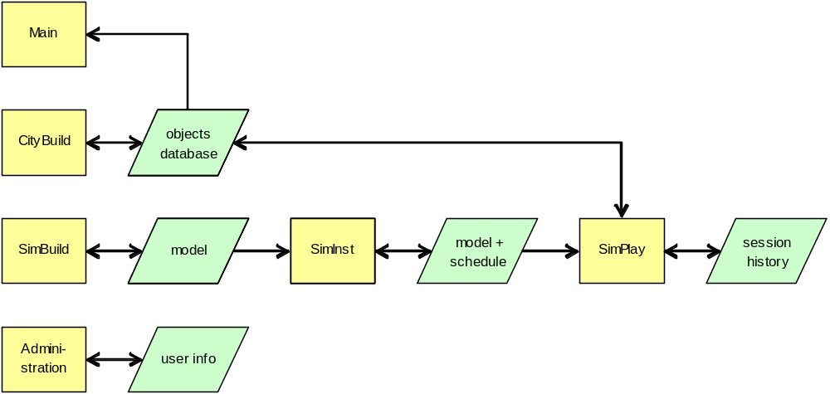
Depending on their priviliges, registered users may have access to one or more of the following subsystems:
- SimPlay - an interactive environment that enables participants (e.g. students, tutors) to participate in a simulation session. It enables session administrators to monitor sessions, even after they have been completed. Session administrators can intervene during sessions by changing the role-allocation of participants and by taking over a role for some time. A simulation session is governed by a schedule (including enrolment rules) and a simulation model. During a session participants have read-access to resources stored in the objects database. They may upload documents to their workspace that will be stored in the objects database as well. The session is logged in the session history.
- SimInst - an interactive environment that enables session administrators to prepare a schedule and enrolment rules for one or more simulation sessions based on a certain simulation model. In fact SimInst mainly is a Learning Management System.
- SimBuild - an interactive environment that enables authors to prepare a simulation model and to store and to retrieve simulation models; in fact it is both an authoring system and a Learning Content Management System.
- CityBuild - an interactive environment that enables city editors to maintain the virtual city of Sieberdam, represented by an interactive city map, a directory of city objects, basic information (texts and pictures) and hyperlinks. All city objects are stored in the objects database which stores other objects as well. CityBuild is used to manage these other objects too.
- Administration - an interactive environment to enable system administrators to register users, user groups and access rights. It enables users to inspect and change some personal settings, like dialogue language and notification preferences.
Note
In version 1.0 session administrators also may use SimInst to adapt the instructions for the participants and to attach documents to these instructions. In future versions this function will be moved to SimBuild.

  - Data view
The figure in the previous section also describes the relation between the Sieberdam/ROCS subsystems and the data objects involved.
The Sieberdam/ROCS database contains the following data objects:
- User profile and personal settings - personal data on users, the groups to which they belong, the access rights of these groups, and personal settings like the preferred dialogue language. Via the Administration Subsystem, the System Adminstrator may set and change these data. All registered users may change their personal settings. All other subsystems use these data (not shown in the figure).
- Simulation session history - the logging of a simulation session. Via SimPlay, the participants of a simulation session create history, the session administrator may monitor it, the simulation administrator too.
- Simulation schedule - the plan for a session, including enrolment rules (and actual enrolment). Via SimInst, the session administrator (or the simulation administrator) creates a schedule and/or changes a schedule that has not been completed. In fact, the schedule contains a copy of the simulation model. SimPlay executes the actual simulation session, driven by schedule and model.
- Simulation model - the whole of roles, activities, and resources and the workflow connecting them. Via SimBuild, the author creates the model and/or copies and changes an existing model. Via SimInst, the Session Administrator copies into the schedule.
- City objects and archived documents - the resources like texts and pictures describing city objects, documents to be attached to instructions for participants, as well as the documents produced by participants themselves. The city editors produce the city objects and the participants may produce documents of their own.
  - Users view
Sieberdam/ROCS makes a distinction between the following types of users:
- Public - The public (i.e. unregistered users) has read access to the interactive city map of Sieberdam, the directory of Sieberdam objects, the basic information on these city objects and any information linked to it.
- Participant - Every registered user may participate in a simulation session, i.e. play a role. A role can be played individually or by a team. Normally, participants are students. However, some roles maybe allocated to faculty or even to external professionals. The author of the simulation model defines the roles, the session administrator schedules the session and specifies the enrolment rules based on user groups. The system administrator creates these groups and allocates their members (users).
- Session Administrator (old name Case Author) - A Session Administrator may select any stored simulation model that has been set "ready to run" by its author. The Session Administrator schedules the session and specifies the enrolment rules. During the session, the Session Administrator can monitor its progress and intervene in a limited way. If more elaborate interventions are desirable, the author may build a role of facilitator into the model which the session administrator might allocate to a tutor. A Session Administrator can only monitor her own sessions.
- Author (old name Template Author) - An author creates a simulation model consisting of roles, activities, resources and a workflow connecting them. An author can copy any stored simulation model and use it as starting point for a new one. An author can only change and/or delete the simulation models of her own.
- City Editor - The City Editor can change the contents of the virtual city of Sieberdam and any other objects that are stored into the same objects database. However, a city editor can only change or delete her own objects.
- Simulation Administrator - The Simulation Administrator can act as city editor, author, session administrator and participant and has access to all sessions, models and objects.
- System Administrator - The System Administrator installs the "simulation"- service (i.e. Sieberdam/ROCS) and administers all underlying software. The System Administrator can register users and make them members of the appropriate user groups and/or create new user groups to facilitate the role allocation of simulation sessions.
Note
In version 1.0, the session administrator gives the model it's finishing touch by (optionally) changing the instructions for participants and attaching additional documentation to these instructions. In future versions, the model author will do this.

  - Cross-Reference Matrix
The following figure presents a cross-reference matrix for business processes, subsystems, users and data classes.
 | S1 | S2 | S3 | S4 | S5 | S6 | Business Processes | A7 | A6 | A5 | A4 | A3 | A2 | A1
P1 |  |  |  |  |  | X | P1 - hosting of sieberdam/rocs system | X |  |  |  |  |  |  | P1
P2 |  |  |  |  | X |  | P2 - editing sieberdam/rocs city content |  | X | X |  |  |  |  | P2
P3 |  |  |  | X |  |  | P3 - writing sieberdam/rocs sim. models |  | X |  | X |  |  |  | P3
P4 |  |  | X |  |  |  | P4 - administering sieberdam/rocs sim. sessions |  | X |  |  | X |  |  | P4
P5 |  | X |  |  |  |  | P5 - participating in sieberdam/rocs sim. sessions |  | X |  |  |  | X |  | P5
P6 | X |  |  |  |  |  | P6 - browsing the sieberdam city map |  | X |  |  |  |  | X | P6
Systems | S1 - Main | S2 - SimPlay | S3 - SimInst | S4 - SimBuild | S5 - CityBuild | S6 - Administration | CROSS-REFERENCE MATRIX | U7 - System Administrator | U6 - Simulation Administrator | U5 - City Editor | U4 - Author | U3 - Session Administrator | U2 - Participant | U1 - Public | Users
D5 | R | R | R | R | R | RW | D5 - User profiles and personal settings | RW | RW | RW | RW | RW | RW |  | D5
D4 |  | RW |  |  |  |  | D4 - Simulation Session History |  | RW |  |  | RW | RW |  | D4
D3 |  | R | RW |  |  |  | D3 - Simulation Schedules |  | RW |  |  | RW | R |  | D3
D2 |  | R | RW | RW |  |  | D2 - Simulation Models |  | RW |  | RW | RW | R |  | D2
D1 | R | RW | RW | RW | RW |  | D1 - Objects database |  | RW | RW |  | RW | RW | R | D1
 | S1 | S2 | S3 | S4 | S5 | S6 | Data Objects | U7 | U6 | U5 | U4 | U3 | U2 | U1

  - Participant's view
    - System
From the perspective of a participant in a simulation session, Sieberdam/ROCS is a simulated city consisting of two parts: a static part and a dynamic part.
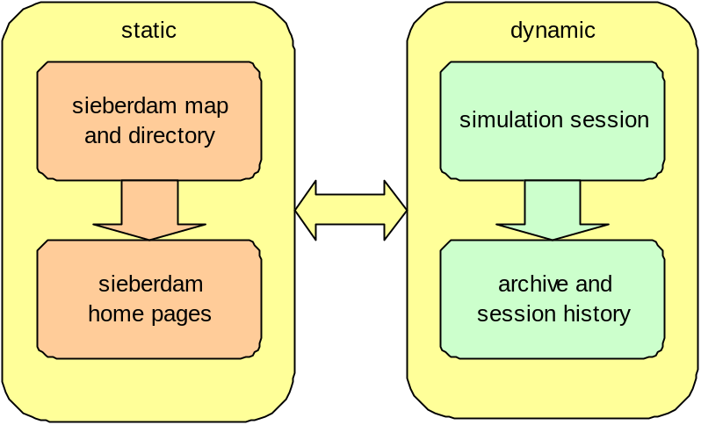
The static part consists of the Sieberdam website. Here, the participant will find an interactive city map as well as a directory of city institutes and inhabitants (as well as external institutes). Both refer to a collection of home pages describing the items on the map and/or in the directory. The Sieberdam website is static. It does not change during a simulation session.
The dynamic part best can be compared with a dashboard. It contains both indicators and controls that the participant may observe or handle.During the session the participants "produce" a session history and documents that can be referenced. The dynamic part of Sieberdam/ROCS is different for every role in every (parallel) session and varies over time as well.
The static and the dynamic part are linked. A participant can switch from a session to the background information on the Sieberdam website. The other way round is possible as well. Some Sieberdam objects will be linked to participants playing a certain role during a certain session.
    - Process
Depending on the number of participants, Sieberdam/ROCS can start a number of concurrent simulation sessions. For each participant the general pattern of a session is the same.
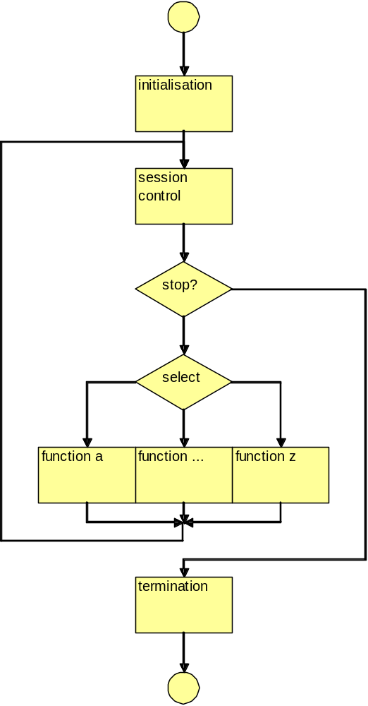
From a participant's point of view a session starts with an initialisation phase during which the system is waiting until all enrolment processes have been completed.
The kernel of the session consists of a cyclic process that might be repeated many times. During each cycle, the system first determines if the session should be terminated and if not, which activities (tasks) will be available for the participant. Subsequently, the participant may either choose to execute one of the activities or use some of the regular functions of the participant's interface. The availability of the activities depends on the actual state of the session and has been defined in the simulation model. The set of available activities does not have to be the same for every role. The regular functions of the user interface are sending messages, uploading a document, browsing Sieberdam.
The session can end in a normal way (as predefined in the model) and in an abnormal way (by Session Administrator's intervention). During the termination phase the system waits for other parallel sessions to be completed.
  - Technical view
In technical sense Sieberdam/ROCS is a client-server system. Client and server subsystems are connected via the Internet.
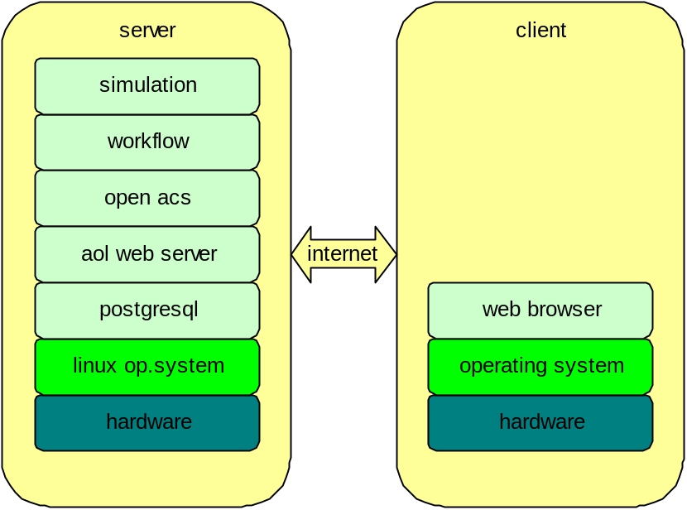
The server subsystem consists of a stack of software packages. At the top of it runs the Sieberdam/ROCS application. In technical sense it is called "simulation", an application of OpenACS. This application uses "workflow" software, another application of OpenACS for both the setting-up of simulation sessions and the inner working of these sessions themselves. The next lower level is taken by the OpenACS kernel. It uses the AOLwebserver and the PostgreSQL database management system. The whole rests on the Linux operating system and underlying hardware.
The client subsystem is nothing more than a device running a web browser. Although in general, Sieberdam/ROCS could work with arbitrary web browsing devices, the user interface will be based on regular PC-screen sizes and the most popular browsers like FireFox and MS Internet Explorer.
- Functional specification
Sieberdam/ROCS has public as well as private functions. Public functions do not require users to log in, private functions do.
The private functions have been arranged hierarchically. The main topics are:
- SimPlay
- SimInst
- SimBuild
- CityBuild
- Simulation Administration
- System Administration
- Notifications
- Miscellaneous
  - Public functions
The Public functions are available for everybody, logged in or not.
    - View Sieberdam/ROCS Information
The system displays the following information:
- information on Sieberdam/ROCS
- information on Sieberdam/ROCS availability
- contact information
- colophon
    - Navigate Sieberdam Map
Users can navigate through the city map, zoom in and zoom out. When they click on a marked location, a small popup window appears and displays a thumbnail picture of the object, a short description, and a link to the object's home page.
    - Search Directory of Sieberdam
The system displays a list of Sieberdam objects that have home pages. For each item it lists the type (location, prop, character), the name and a short description. The name is hyperlinked to the object's home page. The user may sort the list by type, name or description.
    - Login
The login function only is available when no user has been logged in. By entering login name and password, a user may may gain access to non-public functions. Although the system administrator may give unregistered visitors the possibility to register themselves, this is not recommended.
  - SimPlay
The SimPlay function is available for every registered user.
SimPlay is a Simulation Player, i.e. a server that runs simulation sessions based on a simulation model, and according to a schedule. Users of SimPlay are (potential) participants. They mostly are students, although certain roles might be allocated to faculty or even external professionals. Some SimPlay functions are for Session Administrators only.
A simulation session follows the workflow as specified in the simulation model. At the start of the session, it is said to be in its initial state. The workflow determines which activities now are enabled for each role. It further determines whether the completion of an activity will bring the session in another state, where (possibly) other activities will be enabled. The whole might look rather deterministic. However, alternative routes certainly are possible. As an example, a role may have two optional activities where the first leads to another point in the workflow than the second.
Roles will have impact on other roles in two ways. The first is via the content of messages they are exchanging. The second is via the impact of a completed activity. After all, a completed activity might transfer the workflow to another state which affects the activities enabled for other roles. Any activity is logged, any message stored and any upload conserved in the session archive.
    - Enrol for session
This function is for Participants only.
The system displays a list of sessions a participant may enrol for. The participant may select a session and enrol for it. Depending on the settings by the session administrator, the participant also may choose the role to play.
A session is indicated by a name and a sequence number. Depending on the number of participants and the number of roles, the system may have generated more parallel sessions. These have the same name, but have a different sequence number.
    - Participate in session
This function is for Participants only.
The system displays a list of sessions the participant has been enrolled for (session name and number, role, session status, number of activities). The session status may be active, completed, or aborted. The participant may select a session. Then the system displays the Session Home Page with a set of subfunctions for that session. In active sessions the participant may operate in an active way (i.e. sending messages), in completed or aborted sessions the participants may only browse the available information and not execute activities (tasks) nor send messages anymore.
View status information
The system displays the following information:
- name of the model,
- name and number of this session (the name is specified by the Session Administrator, the number is allocated by the system),
- role and character of this participant (roles and characters are prescribed by the simulation model, characters can be changed by the session administrator; casting of roles by participants has been organised by the Session Administrator,
- state of this session (the author of the simulation model has specified the possible states, the initial state, the conditions for state transition and the final state; the author may have switched off the display of the state.
Note
In version 1.0 session administrators may switch on and off the display of the session status. In future versions the author will do.

Execute archive-type activity
The system displays a list of available activities (tasks). In V1.0 two types of activities are possible:
- archive-type activities,
- message-type activities.
The system does not indicate which item on the list belongs to which type. Participants derive this information from the name of the activity.
In the case the participant selects an archive-type activity, the system displays an instruction for that activity (the author has entered this instruction in the simulation model). This instruction may be accompanied by some attachments which the participant may open or download.
The participant may upload a local file to become an archive item. The participant closes the archive- type activity by confirming the upload or cancelling it. When confirming, the file will be added to the participant's archive. The session may reach another state then (depending on the simulation model).
Execute message-type activity
The system displays a list of available activities (tasks). Two types of activities are possible: archive- type activities and message-type activities. The system does not indicate which item on the list belongs to which type. Participants derive this information from the name of the activity.
In the case the participant selects a message-type activity, the system displays an instruction for that activity (the author has entered this instruction in the simulation model. This instruction may be accompanied by some attachments, the participant may open or download.
The participant may prepare a message to one or more roles (predefined by the simulation model). It is possible to attach an archive item to this message.
The participant completes the activity by either sending or cancelling the message. When sending, the message will be added to the messages lists of both sender and recipient(s). The session may reach another state then (depending on the simulation model).
Read a message
The system displays a list of messages. The participant may select a message which the system then displays. It is possible to reply to any message read.
Send a message
The participant may prepare a message to one or more roles. All roles in the session may be selected. It is possible to attach an archive item to the message. The participant closes this function by either sending or cancelling the message.
The participant may send a message to the own role. This is the preferred vehicle for the internal communication between participants sharing the same role (as a team).
Download archive item
The system displays a list of archive items. Each entry consists of the following fields: item name, upload date and time, mime type and file size. The list may be ordered by any field. The participant may select an item that will be opened or downloaded subsequently.
Upload archive item
The participant selects a local file for uploading and confirms or cancels the uploading. After confirming, the uploading takes place and the file is added as an archive item.
Once uploaded, the participant cannot delete an item, nor change its name.
View contact home page
A contact is a combination of a role and its associated Sieberdam character. The system displays a list of contacts (a role-character combination). The participant may select a contact, the system then displays that contact's home page in Sieberdam. The Home Page of a Sieberdam object contains backgound information for that object (text, picture) and possibly links to other Sieberdam objects. The home page might contain hyperlinks to other internal or external documents.The home page displays the option to send a message to the contact. The new message has the participant's role as sender and the role associated to the Sieberdam object as recipient.
Search directory of Sieberdam
The system displays a list of Sieberdam objects that have home pages. For each item it lists the type (location, prop, and character), the name and a short description. The name is hyperlinked to the object's home page. The user may sort the list by type, name or description.
Navigate map of Sieberdam
Participants can navigate through the city map, zoom in and zoom out. When they click on a marked location, a small popup window appears and displays a thumbnail picture of the object, a short description, and a link to the object's home page.
View "about-info"
The system displays a static description of the current simulation model.
    - Administer session
This function is for Session Administrators only.
The system displays a list of sessions the System Administrator is administering (name, number, session status, number of roles). A session can have status enrolment, ready-to- run, active, completed or aborted.
For each session a few subfunctions are available.
Display information per role
The system displays for each role:
- the role title, the session administrator can enter the role's session home page and act as that role.
- the participants login name(s) and registration data,
- the actual number of participants for the role,
- the target number of participants for the role,
- the item count of the role's archive,
- the item count of the role's list of messages.
- the actual simplay functions for that role.
Change role settings
The System Administrator has the following options:
- add a participant to the role,
- move a participant to another role,
- remove a participant from the session,
- view the role's simplay functions,
- view the role's archive,
- view the role's messages,
- view the participant's registration data.
Display log
The system displays different loggings for activities, messages, and archive items. Each entry contains date and time, item name, and participant's name.
Abort session
The system aborts the session.
  - SimInst
The SimInst function is available for authors and session administrators.
The purpose of SimInst is the planning of a simulation session. Depending on the number of participants also a set of concurrent simulation sessions is possible. The SimInst result is called a schedule. In fact SimInst is a Learning Management System.
Whether a schedule maybe changed, copied and/or deleted depends on its life cycle phase: planning, enrolment, ready-to-run, active (=running), completed, or aborted.
Phase | Change | Copy | Delete
Planning Phase | Allowed | Allowed | Allowed
Enrolment Phase | Not allowed | Allowed, actual enrolment will not be copied, copy will be in planning phase | Allowed, enrolled participants receive notification
Ready-to-run Phase | Not allowed | Allowed, actual enrolment will not be copied, copy will be in planning phase | Allowed, enrolled participants receive notification
Running Phase | Not allowed | Allowed, actual enrolment will not be copied, copy will be in planning phase | Not allowed
Completed Phase | Not allowed | Allowed, actual enrolment will not be copied, copy will be in planning phase | Allowed
Aborted Phase | Not allowed | Allowed, actual enrolment will not be copied, copy will be in planning phase | Allowed

    - Display existing schedules
The system displays a list of existing schedules (schedule name, schedule phase) created by the current System Administrator.
The System Administrator may select a schedule for changing, copying or deleting.
    - Create a schedule
The system creates an empty schedule and opens it for editing.
Editing a schedule implies that the Session Administrator updates a complex datastructure while the system executes some consistency checks. As long as the System Administrator does not not complete the datastructure, the schedule remains in the planning phase. Once it has been completed, the schedule enters the enrolment phase.
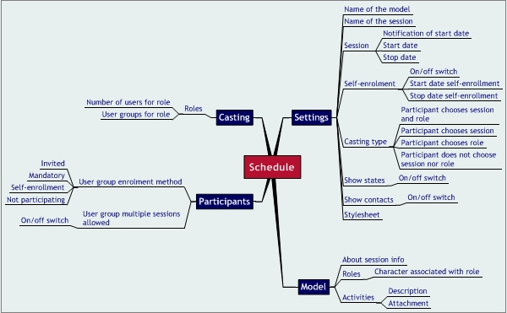
The datastructure has been subdivided into four sections: settings, model, participants and matching:
- Settings:
- the name of the simulation model used
- the name of the schedule = the name of the resulting session(s) (must be unique),
- the dates for the start and stop of the sessions and a date to send an early notification (before the start date),
- a switch to set self-enrolment on or off; if on, the periode for self-enrolment may be specified (start date and stop date),
- the casting type (indicates whether the participants may choose their own session and/or their own role or not),
- a switch to set the display of the state on or off during the sessions,
- a switch to set the display of a list of contacts (pairs of roles and actors) on or off during the sessions,
- model:
- the information to be displayed as "About this session" (will be derived from the simulation model, but can be edited for the current session(s)),
- the characters that are associated with each of the roles,
- the description of the activities and the attachments involved (will be derived from the simulation model, but can be edited for the current session(s)),
- participants:
- for each user group, the enrolment method has to be set: invited, mandatory, self- enrolment, non-participating,
- for each user group, a switch is available to set whether multiple sessions are allowed or not (enabling a tutor to be enrolled in more than one concurrent session),
- matching:
- for each role, the number of participants playing that role (team size) has to be set,
- for each role, the user groups that might supply the participants have to be set.
Note
In version 1.0, the session administrator gives the model it's finishing touch by (optionally) changing the instructions for participants and attaching additional documentation to these instructions, setting the status on/off and the lists of contacts on/off, and linking roles to characters. In future versions, the model author has to do this.

    - Change a schedule
Only schedules that are in the planning phase can be changed.
The system opens an existing schedule for editing. See: create a schedule.
    - Copy a schedule
The system creates a new schedule based on an existing one. No actual enrolments will be copied. Regardless the phase of the original schedule, the copy will be in the planning phase. Once copied, the System Administrator may open the copy for editing.
    - Delete a schedule
Only the user who has created the schedule is allowed to delete it. It depends on the schedule's life cycle phase whether it is allowed to delete the schedule.
Phase | Delete
Planning Phase | Allowed
Enrolment Phase | Allowed, enrolled participants receive notification
Ready-to-run Phase | Allowed, enrolled participants receive notification
Running Phase | Not allowed
Completed Phase | Allowed
Aborted Phase | Allowed

  - SimBuild
The SimBuild function is available for users authors.
SimBuild is an authoring environment that enables authors to prepare a simulation model in an interactive way and to store and to retrieve simulation models; in fact SimBuild is both an authoring system and a Learning Content Management System.
The Business Process Modeling Language (BPML) defines a formal model for expressing executable processes that address all aspects of enterprise busines processes, including activities of varying complexity, transactions and their compensation, data management, concurrency, exception handling and operational semantics. The following table lists the activity types as defined by BPML and their availability in Sieberdam/ROCS.
Cat. | Type | Description | Sieberdam/ROCS availability
Simple | Action | Performs or invokes an operation involving the exchange of input and output messages. | The message action results in an output message, which may be followed by input. The other way (first input, then output) has to be modelled as two separate activities.
Simple | Assign | Assigns a new value to a property. | Not available.
Simple | Call | Instantiates a process and waits for it to complete. | Both the parallel activity and the workflow activity will do.
Simple | Compensate | Invokes compensation for the named processes. | Has to be modelled explicitly as dummy message actions resetting the session's state.
Simple | Delay | Expresses the passage of time. | The time-out activity.
Simple | Empty | Does nothing. | Not available.
Simple | Fault | Throws a fault in the current context. | Only possible as a manual intervention by a certain role, i.e. the facilitator and has to be modelled explictly.
Simple | Raise | Raises a signal. | The only signal available is the completion of an activity.
Simple | Spawn | Instantiates a process without waiting for it to complete. | Not available.
Simple | Synch | Synchronizes on a signal. | Yes, although the only signal available is the completion of an activity.
Complex | All | Executes activities in parallel. | Yes.
Complex | Choice | Executes activities from one of multiple sets, selected in response to an event. | Only possible as an activity of a certain role and has to be modelled explictly.
Complex | Foreach | Executes activities once for each item in an item list. | Only possible as an activity of a certain role and has to be modelled explictly.
Complex | Sequence | Executes act. in sequential order. | Yes
Complex | Switch | Executes activities from one of multiple sets, selected based on the truth value of a condition. | Only possible as an activity of a certain role and has to be modelled explictly.
Complex | Until | Executes activities once or more based on the truth value of a condition. | Only possible as an activity of a certain role and has to be modelled explictly.
Complex | While | Executes activities zero or more times based on the truth value of a condition. | Only possible as an activity of a certain role and has to be modelled explictly.

    - Display existing models
The system displays a list of existing models (model name, model status, author name, description) of all authors.
Every author may select a model for copying or exporting. Only the creator may select it for changing or deleting.
    - Create a model
The system creates an empty model and opens it for editing. The model gets automatically the "under construction" status.
Editing a model implies that the Author updates a complex datastructure while the system executes some consistency checks. As long as the Author does not not set the "model ready" field to "yes", the model keeps the "under construction" status. Once it has been set to "ready", the model is ready to simulate and van be accessed by the SimInst function.
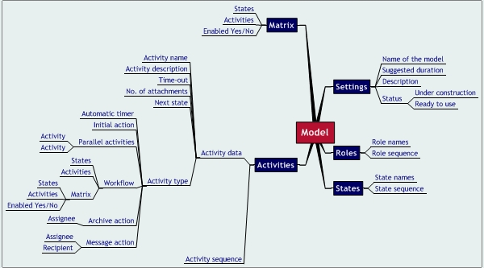
The datastructure has been subdivided into five sections: settings, roles, states, activities (former: tasks), and matrix:
- Settings:
- mode:
- Mode = 0 (no relations with topic map, i.e. ROCS stand- alone)
- Mode = 1 (hyperlinks from ROCS roles to topic map)
- Mode = 2 (hyperlinks from ROCS roles to topic map and vice versa)
- Mode = 3 (mode 2 applied to Sieberdam)
- switch to determine whether session status should be visible for participants (may be overruled by Session Administrator)
- switch to determine whether contact list shoulde be visible for participants (may be overrruled by Session Administrator)
- metadata [between brackets, the corresponding IMS metadata entryfield code is shown]:
- the title of the model used [1.2]
- catalogue entry (catalogue and entry) [1.3]
- language [1.4]
- description [1.5]; will be presented to the Session Participants as "About this session"- information)
- aggregation level [1.9] (1 = atomic model part, 2 = submodel, 3 = equivalent of lecture, 4 = equivalent of course)
- version [2.1]
- status (draft or final) [2.2]; the author can switch from "draft" (= under construction) to "final" (= ready to run) and vice versa; when a template is "ready", a Session Administrator can build a schedule for it
- contribute (authorname, affiliation and date) [2.3]
- intended user role [5.5]
- context [5.6]
- difficulty [5.8]
- typical learning time [5.9]; the time an average user will spend (will be brought to the attention of future Session Administrators)
- roles:
- names of the roles
- sequence of the roles, i.e. order in which roles will be presented during sessions
- if mode = 1 or 2: hyperlinks to topic map
- if mode = 3: associated Sieberdam character.
- states:
- names of the states
- sequence of the states, i.e. order in which states will be presented in matrix (see below)
- activities:
For each activity:
- name of the activity
- description of the activity (maybe edited by the Session Administrator and will be presented to the Session Participants)
- time-out
- attachments
- next state
- activity type, one of the following:
- automatic timer - this activity is nothing more than an alarm clock
- initial action - this activity only indicates the start of a workflow
- parallel activities - this activity consists of a number of concurrent sub-activities and ends when all sub-activities have ended
- workflow - this activity is a sub-model for the same roles, but with its own states, activities and matrix
- archive action - this activity requires a role to add a certain file to the role archive
- message action - this activity requires a role to send a message to specified recipients; a default text for the message maybe provided.
- sequence of the activities, i.e. order in which tasks will be presented in matrix (see below)
- matrix:
- the matrix shows the availabiliy of an activity (row) during a certain state (column); a state without activities marks the end of a workflow.
- within the matrix an activity may be deleted
- within the matrix, an activity may be copied to save input efforts
- within the matrix, another model may be joined with the current model
Note
In version 1.0 only mode=3 is available, no metadata can be entered and no switches for status information and contacts lists have been implemented. However, the switches are available via SimInst. In future versions the switches will be moved to SimBuild, metadata will be implemented and mode=0, mode=1, and mode=2 might be implemented.

    - Change a model
The system opens an existing model for editing. Regardless the actual status of the model, it now gets the "under construction" status. See: create a model.
Changing a model does not effect any existing schedules or sessions that have been based on that model.
    - Copy a model
The system creates a new model ("copy of x") based on an existing one. Regardless the status of the original model, the copy will have the "under construction" status. Once copied, the new author can open the copy for editing.
    - Delete a model
Only the user who has created the model, is allowed to delete it. After confirming an "Are you sure?" message, the system deletes the model.
Deleting a model does not effect any existing schedules or sessions based on that model.
    - Import a model
A model can be imported from a xml file. The xml file is validated before use.
Note
In version 1.0 the model is not an XML file but text in a proprietary format. In future versions a XML format may be implemented, prefarably as a subset of IMS Learning Design.

    - Export a model
A model can be exported as validated XML-file. When the same file is imported again, it results in exactly the same model. The schema for the XML file is fully documented.
Note
In version 1.0 the model is not an XML file but text in a proprietary format. In future versions a XML format may be implemented, prefarably as a subset of IMS Learning Design.

  - CityBuild
The CityBuild function is available for city editors.
CityBuild is a management module to maintain a database with so-called simulation objects, the most of them are objects constituting the virtual city of Sieberdam (hence the name of the module). In fact CityBuild is a part of a Learning Content Management System.
Sieberdam is a virtual city that forms the entourage for simulations. Sieberdam consists of locations (e.g. the Post Office), characters (virtual persons, e.g. John Smith) and props (stage accessories, e.g. the Canal Bridge).
A location can be contained in another location (e.g. the Cash Counter at the Post Office). A character may reside at a certain location and work at (another) location. A prop simply may be "associated" with a certain location.
The figure below shows the relations between these concepts.
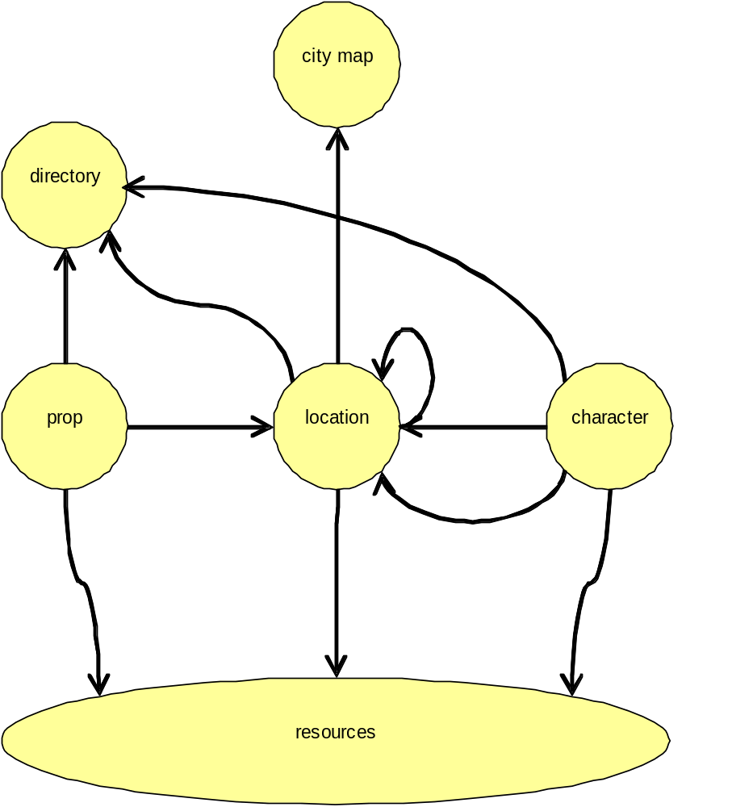
The Sieberdam web site consists of a map and a directory (yellow pages), both giving access to the home pages of locations, characters and even props. It is up to the editor of the city to decide:
- whether a location is shown on the map and/or listed in the directory (thereby making its home page accessible),
- whether a character is listed in the directory (a character is never shown on the map),
- whether a prop is shown on the map (a prop is never listed in the directory).
Possible simulation objects are locations, characters and props, but also style sheets, images, text documents, powerpoint presentations, pdf files, video files etceteras.
Note
In version 1.0 all the difference between characters and locations does not exist. Characters are shown on the map. In future versions the original approach might be followed.

    - Display existing objects
The system displays a list of all existing objects (object type, object name, object description, object ID) .
Every city editor may select an object for copying. Only the creator may select it for changing or deleting.
    - Create an object
The system creates an empty object and opens it for editing.
Editing an object implies that the city editor updates a datastructure while the system executes some consistency checks. The same datastructure accomodates quite different types of objects.

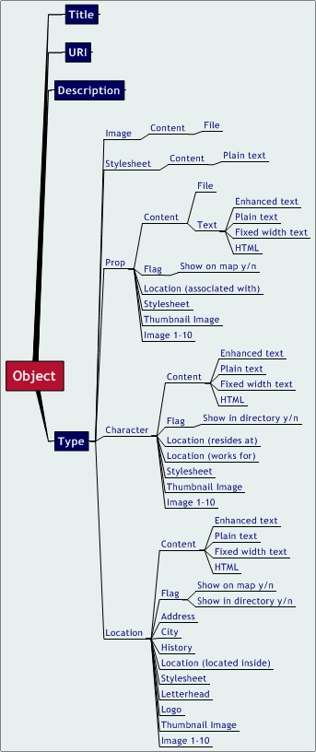
The datastructure has some identical elements for all object types:
- Title
- URI
- Description
The other elements depend on the type of the object: image, stylesheet, prop, character, location:
- Image:
- Content
- File
- Stylesheet
- Content (plain text)
- Prop (stage assessory):
- Content, a file to be uploaded or text (plain text, fixed width text, enhanced text, html)
- Flag to indicate whether the prop should be shown on the map
- Location on the map associated with this prop
- Stylesheet
- Thumbnail Image
- Image 1-10
- Character:
- Content (plain text, fixed width text, enhanced text, html)
- Flag to indicate whether the character should be shown in the directory
- Location on the map where the character resides
- Location on the map where the character works for
- Stylesheet
- Thumbnail Image
- Image 1-10
- Location:
- Content (plain text, fixed width text, enhanced text, html)
- Flag to indicate whether the location should be shown on the map
- Flag to indicate whether the location should be shown in the directory
- Address
- City
- History
- Location on the map where the location is a part of (nested locations)
- Stylesheet
- Letterhead
- Logo
- Thumbnail Image
- Image 1-10
    - Change an object
The system opens an existing object for editing. See: create an object.
    - Copy an object
The system creates a new object based on an existing one.
    - Delete an object
Only the user who created an object, is allowed to delete it. After confirming an "Are you sure?" message, the system deletes the object.
Deleting an object does immediately effect Sieberdam.
    - Set options
Set options (e.g. frequency of notifications of changes in Map-XML, export Map-XML, display map-XML).
  - System Admin
The System Admin function is available for OpenACS system administrators only.
The specification of System Admin functions belongs not to the scope of this report. Only a mindmap of the functions will be presented.
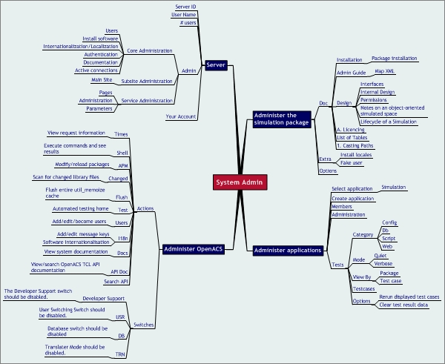
    - Register users
The System Administrator can register new users, one-by-one or as a batch.
Single
The System Administrator can register a new user by specifying the e-mail address (that will be used as login name), first name and last name, (optionally) the initial password, and (optionally) a group the user will belong to. When no password is given, the system generates a random one.
Batch
The System Administrator can register a series of new users by specifying a comma-separated-list of e- mail addresses, first names, last names, (optionally) an initial password and (optionally) the user groups they will belong to.
    - Change user status
The System Administrator can change the user status from active to banned and vice versa and to deleted. Also the user password can be changed.
    - Create groups
The System Administrator can create new user groups.
    - Add members to groups
The System Administrator can add users as members to a group.
  - Notifications
At various occasions the system may send an e-mail message to the user. Examples are:
- Invitation to participate in simulation session
- Confirmation of the completion of a simulation session
- E-mail Confirmation
- Notification of an event during a simulation session
- Approve user
- Ban user
- Start of simulation session
- Confirmation of changes in the Sieberdam map
- Added as a user
- Password changed
The user may set the frequency of these notifications and the preferred dialogue language and date format.
  - Miscellaneous functions
Generic functions are available at any time for any registered user (i.e. after login):
- View server name and version number - Automatically, the system displays the name of the server, i.e. "Sieberdam/ROCS v1.0 Production Server.
- View user name - Automatically, the system displays the name of the user currently logged in.
- View number of users online - Automatically, the system displays the actual number of online users. On request, it displays a list of user names which gives access to user details.
- Control Panel - This function only is accessible for system administrators.
- View current user account - The system shows the administrative details of the current user account. The user can: change the password, select the preferred dialogue language, select the preferred date format, set the frequency of notifications (immediately, daily, never).
- Navigating through function hierarchy - The Sieberdam/ROCS functions have been ordered hierarchically. Especially for users belonging to several user groups (thus having various access rights), it might be convenient to see their actual position in the function hierarchy and to move to a higher level quickly.
- Manage Notifications - The Notifications function is available for all registered users. The system distributes notification by e-mail. At various occasions e-mail will be sent.
- Log out - When a user logs out, only the public functions are available.
- User Interface specification
- All Sieberdam/ROCS pages have the same style. The only exceptions are the home pages of the Sieberdam objects. It is functional that they have their own styles.
- The title bar of the browser window displays the name of the server, i.e."Sieberdam/ROCS vx.x Production Server", where vx.x. has been substituted by the actual version number.
  - Site Map
- The user interface to Sieberdam/ROCS is presented as a hierarchically ordered website. The page hierarchy corresponds with the function hierarchy.
- The Sieberdam/ROCS home page corresponds with the root level of he Sieberdam/ROCS function hierarchy. Lower level functions correspond to lower level web pages. However, it is not necessarily to limit one page to one function level. If space permits two levels may be combined in one page.
- To avoid confusing the users, cross-linking (linking outside the function hierarchy) will be kept to the minimum.
- Functions only will be visible for users who have access rights to them.
  - Interaction
Although a web interface is used, interaction follows as much as possible the guidelines for windows user interfase design.
  - Page Layout
- Sieberdam/ROCS determines the page lay-out. There should be one basic pattern for page layout. Screen pages should be printable.
- Page lay-out reflects the hierarchical ordering of functions and data.
- The style is identical for all Sieberdam/ROCS pages, the only exceptions are the home pages of Sieberdam objects; tehy should follow their own stile conventions.
- The style is sober, professional, neutral colours.
- Page lay-out is optimised for regular windows (width=800 pixels) on PC-displays.
- Page height is not fixed, although more than one long list per page will be avoided; scroll bars are not used to avoid printing problems.
  - Terminology
All pages use consistent terminology.
  - Dialogue Language
The texts that the system displays are either belonging to the content of a certain simulation model or generated by the Sieberdam/ROCS system itself. The language of the former texts depends on the language used by their creators. The language of the system generated texts depends on user preferences. At least, English and Dutch texts are available for the Sieberdam/ROCS functions; serrvice administrator and system administrator functions may use English texts only.
- Technical specification
The datamodel as produced by Collaboraid (2003).
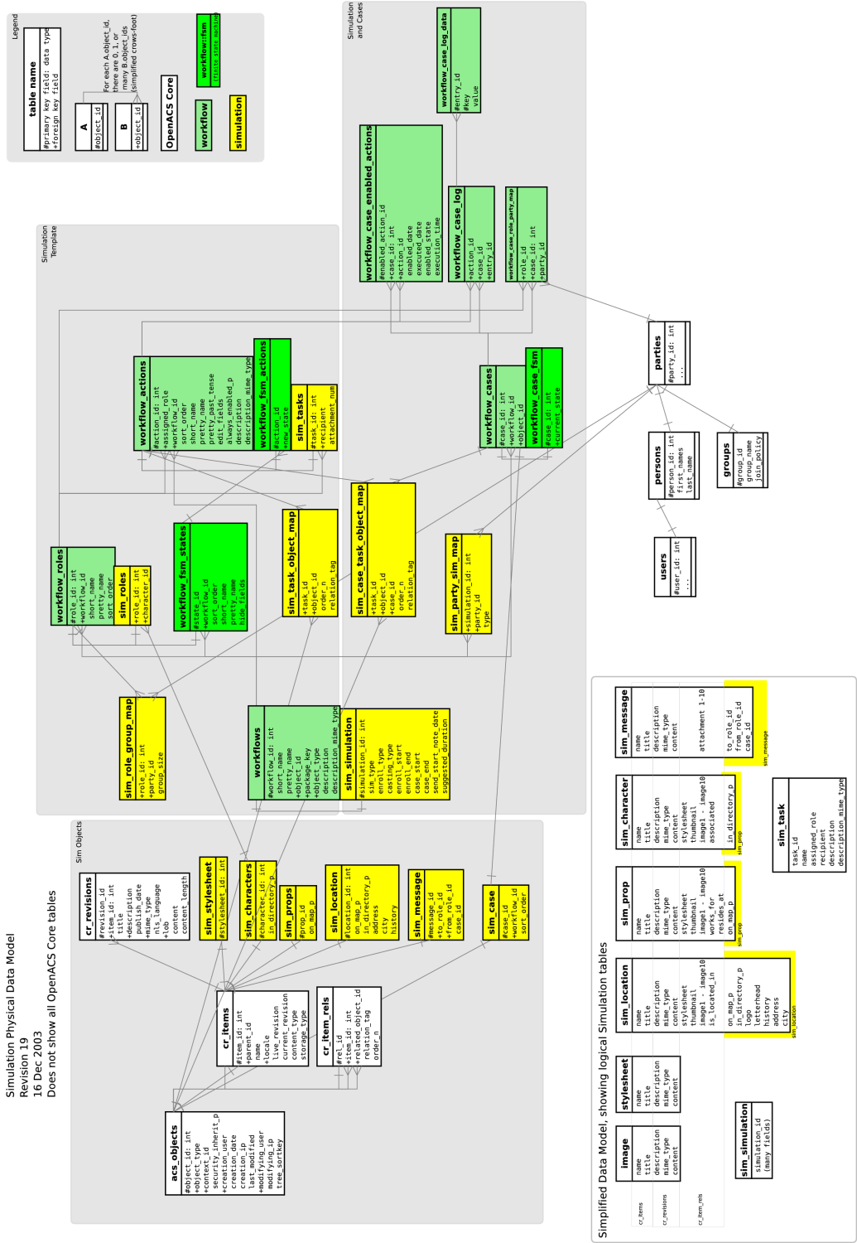
- Content specification
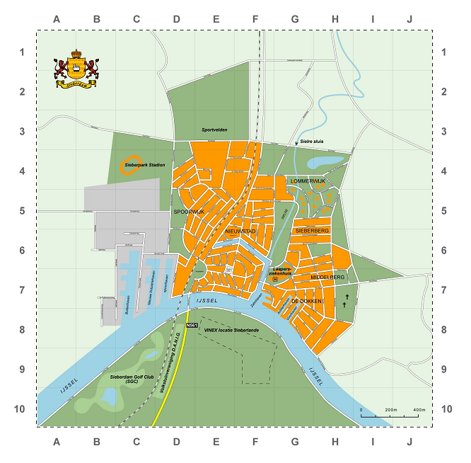
The virtual city of Sieberdam consists of:
- city arms
- a written history
- a geographical city map
- about 100 streets on the map and another 100 street names reserved for future extensions
- a directory with 85 city objects (locations, characters and props) and homepages (in Dutch) for the city objects
- assets to prepare 55 more city objects (source material for texts, 250 pictures)
- Glossary
The glossary lists the definition of the Sieberdam/ROCS terminology.
Activity
An activity is a specific act during a simulation session. An activity may have been assembled from smaller activities. Activities that are not subdived further, atomic activities, are allocated to a role.
Authors define activities for a certain simulation model with SimBuild. Session administrators may slightly change the description of activities with SimInst. Roles (i.e. participants) execute activities during the simulation sessions.
The execution of an activity ends normally or abnormally, e.g. when the participant sends a message, or uploads a document, the corresponding activity ends normally. An activity ends abnormally by a time-out or by becoming obsolete due to the completion of some other activity.
The normal termination of an activity may or may not change the state of the simulation session. Every execution of an activity is logged.
Activities performed by participants are either archive actions or message actions:
- archive action - the activity consists of adding a file to the role's archive,
- message action - the activity consists of sending a message by a role to one or more other roles.
Archive
A collection of files belonging to a role during a simulation session.
Author
The creator or editor of a simulation model. An author uses SimBuild to create or change a simulation model.
Character
A character is an inhabitant of the virtual city of Sieberdam. A role in a simulation is always linked to a character. A character lives on a certain location and works for (another) location in Sieberdam.
City Object
A city object is a location, a character or a prop.
Condition
Situation in which a certain activity can take place. The author of a simulation model specifies the conditions for an activity to take place, i.e. during which state it is available and which state will be reached after its completion.
Contact
A contact is a role plus the character associated to it.
Citybuild
The management of the virtual city of Sieberdam (changing the map, adding Sieberdam objects).
City Administrator
The user who administers the virtual city of Sieberdam, i.e. the "burgomaster" of Sieberdam.
Directory
A list of Sieberdam objects (locations, characters, props). The list items are hyperlinked to the Sieberdam objects' home pages.
Home Page
The base page for a Sieberdam object (location, character, or prop).
Location
A position on the Sieberdam map that may have its own home page. A location can contain other locations. Characters reside at a certain location and work for (another) location. Props are associated with a certain location.
User Group
A set of users with some common characteristic. Sieberdam/ROCS uses the user group concept as an efficietnt tool to manage access rights and to allocate participants to simulation sessions.
Multi-session
A set of concurrent simulation sessions based on the same simulation model and the same simulation schedule.
Model
The recipe for a simulation session, not the session itself. Also used: simulation model. A simulation model describes states, roles and activities and their mutual relations. A model has either the status "under construction" or "ready to simulate". When the Author has set it to "ready to simulate", a Session Administrator may use it to plan and execute sessions with it. At any moment an author may set a model "not ready". This does not effect any planned or active sessions.
Participant
A user who participates in a simulation session by playing a certain role; the role may be shared by a team of participants.
Player
Software to run a simulation based on a model, i.c. the SimPlay function of Sieberdam/ROCS.
Prop
A stage accessory. A prop might have a home page. It is associated with a location in Sieberdam.
ROCS
Originally, RechtenOnline Communication System, in fact an e-learning suite completed by a visualised knowledge domain, i.c. Sieberdam.
Role
A position or function in a simulation session, executed by either one or more human participants.
Schedule
The planning for a certain (set of) simulation session(s) including the adjusted simulation model, the enrolment rules and eventually the actual role allocations.
Session
A run of a simulation model. Also used: simulation session.
The life-cycle of a simulation session consists of the following phases:
- planning phase - the system administrator may adjust some details of the simulation model (for this session only), enter start and finish dates and enrolment rules;
- enrolment phase - the system organises the participants' enrolment according to the rules set by the system administrator, the result may be a set of sessions (multi-session),
- ready-to-start phase - the system waits for the start date, the system administrator may overrule the predefined start date and let the session(s) start immediately,
- active phase - the simulation session is running,
- completed phase - the simulation session has been completed, the results are accessible.
The Session Administrator uses the SimInst functions to start the planning phase for a simulation based on a model that is ready to simulate. The same functions are used to go through the enrolment phase and the ready-to-start phase. Once the sessions are active the Session Administrator uses the SimPlay functions to administer them.
Session Administrator
A user responsible for the scheduling of simulation sessions. This user has access to the SimInst functions.
Sieberdam
A virtual city, in fact the visualised knowledge domain used by ROCS.
Simbuild
Subsystem of Sieberdam/ROCS to build a simulation model.
Siminst
Subsystem of Sieberdam/ROCS to schedule a simulation session.
The SimInst process is broken down in two phases:
- planning phase - the system administrator may adjust some details of the simulation model (for this session only), enter start and finish dates and enrolment rules;
- enrolment phase - the system organises the participants' enrolment according to the rules set by the system administrator, the result may be a set of sessions (multi- session).
Simplay
A subsystem of Sieberdam/ROCS to run (simulate) a simulation model.
Simulation
The concept of simulation has three different meanings:
- I. The technical name of the Sieberdam/ROCS software package in the OpenACS context,
- II. A shortcut for simulation model,
- III.A shortcut for simulation session.
Simulation Administrator
The user who administers the OpenACS package called "simulation", i.c. the Sieberdam/ROCS software.
State
A condition during a simulation session.
System Administrator
The user responsible for the OpenACS system.
User
A person registered as such in the OpenACS system, identified by a login name and a pasword. Users can be members of groups. Access rights can be assigned to users, but normally will be assigned to groups.

