Sieberdam/ROCS v1.0 User Manual
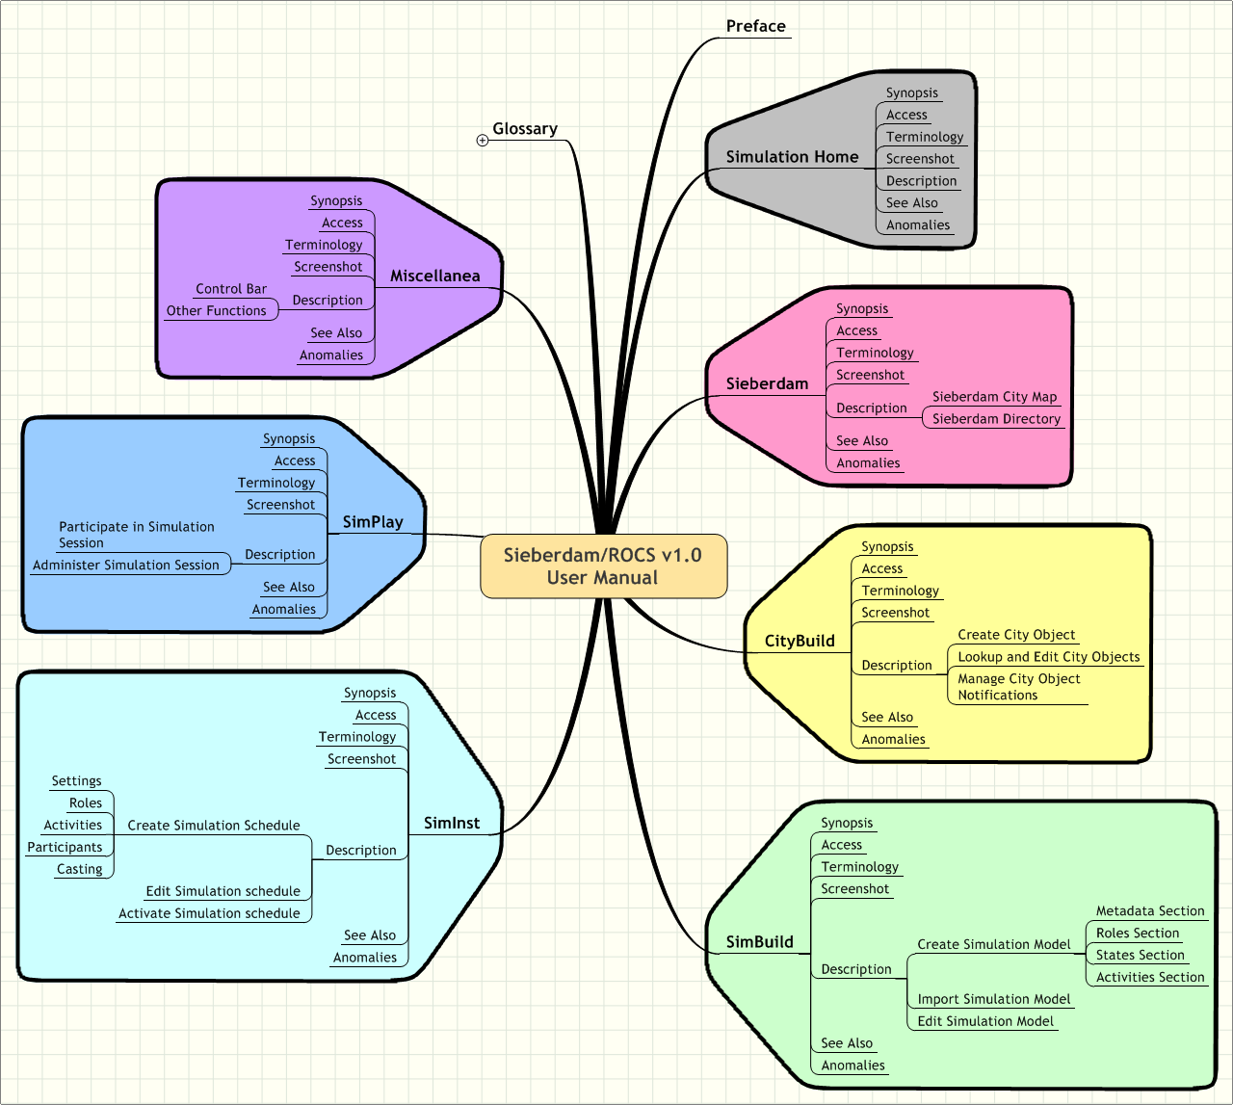
sofos
consultancy
adviesbureau voor organisatie en informatie
p postbus 94874, 1090 gw amsterdam
b b. stokvisstraat 38, 1097 hz amsterdam
t 020 – 694 12 22
e pvdh@sofos.nl
w www.sofos.nl


Opdrachtgever:
VSNU RechtenOnline
Afnemer:
Stichting RechtenOnline
VSNU RechtenOnline
‘let’s build your future...’

e-government, e-learning, spelsimulatie, xml

Project Manager:
Pieter van der Hijden
Sofos Consultancy
Amsterdam, December 30th 2004
Ardcalloch by Paul Maharg inspired the VSNU Program RechtenOnline to fund three projects aimed at the development of a Dutch equivalent: 1. the Dutch virtual City of Sieberdam, 2. the e-learning suite for asynchroneous workflow based group simulations ROCS, and 3. the integrated Sieberdam/ROCS. Rudi Holzhauer (project management, content authorship, and design), Martin de Wit (Flash programming), Willem Mieras (visual design), and Sander Gellaerts (student-assistant) developed Sieberdam. Aernout Schmidt and Jeroen Leijen (project management and design), Lokman Tsui (design), Peter van Schijndel (design), and Collaboraid ApS København (software development) developed ROCS. Pieter van der Hijden (consultant to both projects) integrated Sieberdam and ROCS into Sieberdam/ROCS and extended the system (project management and design), together with Jarkko Laine (software development) and the former Sieberdam and ROCS project teams. The Dutch Foundation RechtenOnline (Law-Online) now is the owner of the product.
Preface
Sieberdam/ROCS is an electronic learning suite for (parallel) computer-supported asynchroneous gaming/simulations in the context of a virtual city. Sieberdam/ROCS has been developed for the Dutch Law Faculties; the source code is available under General Public Licence version 2. Its technical name is OpenACS Application Simulation. The Dutch Foundation RechtenOnline (Law-Online) now is the owner of the product.
Ardcalloch by Paul Maharg inspired the VSNU Program RechtenOnline to fund three projects aimed at the development of a Dutch equivalent: 1. the Dutch virtual City of Sieberdam, 2. the e-learning suite for asynchroneous workflow based group simulations ROCS, and 3. the integrated Sieberdam/ROCS. Rudi Holzhauer (project management, content authorship, and design), Martin de Wit (Flash programming), Willem Mieras (visual design), and Sander Gellaerts (student-assistant) developed Sieberdam. Aernout Schmidt and Jeroen Leijen (project management and design), Lokman Tsui (design), Peter van Schijndel (design), and Collaboraid ApS København (software development) developed ROCS. Pieter van der Hijden (consultant to both projects) integrated Sieberdam and ROCS into Sieberdam/ROCS and extended the system (project management and design), together with Jarkko Laine (software development) and the former Sieberdam and ROCS project teams.
The Sieberdam/ROCS User Manual describes the actual working of Sieberdam/ROCS V 1.0 december 2004 following the default System Administrator settings. The manual uses the preferred terminology. Where the system itself still uses older terms, this will be noted. Known anomalies in system functioning will be noted as well.
The manual is intended for different categories of users. The following table lists which chapters are relevant for which user categories.
 | User Category
Chapter | Simulation Session Participants (students) | Simulation Session Administra- tors (tutors) | Simulation Model Authors (teachers) | City Editors (teachers)
Simulation Home | x | x | x | x
Sieberdam | x | x | x | x
CityBuild |  |  |  | x
SimBuild |  |  | x
SimInst |  | x | x
SimPlay | x | x | x
Miscellanea | x | x | x | x

Pieter van der Hijden
Sofos Consultancy
Amsterdam, December 30th 2004.
Inhoudsopgave
1 Simulation Home 6
1.1 Synopsis 6
1.2 Access 6
1.3 Terminology 6
1.4 Screenshot 7
1.5 Description 7
1.6 See Also 8
1.7 Anomalies 8
2 Sieberdam 9
2.1 Synopsis 9
2.2 Access 9
2.3 Terminology 9
2.4 Screenshot 10
2.5 Description 10
2.5.1 Sieberdam City Map 10
2.5.2 Sieberdam Directory 11
2.6 See Also 11
2.7 Anomalies 11
3 CityBuild 12
3.1 Synopsis 12
3.2 Access 12
3.3 Terminology 12
3.4 Screenshot 12
3.5 Description 13
3.5.1 Create City Object 13
3.5.2 Lookup and Edit City Objects 14
3.5.3 Manage City Object Notifications 15
3.6 See Also 15
3.7 Anomalies 15
4 SimBuild 16
4.1 Synopsis 16
4.2 Access 16
4.3 Terminology 16
4.4 Screenshot 16
4.5 Description 17
4.5.1 Create Simulation Model 17
4.5.2 Import Simulation Model 23
4.5.3 Edit Simulation Model 24
4.6 See Also 24
4.7 Anomalies 24
5 SimInst 26
5.1 Synopsis 26
5.2 Access 26
5.3 Terminology 26
5.4 Screenshot 26
5.5 Description 27
5.5.1 Create Simulation Schedule 27
5.5.2 Edit Simulation schedule 34
5.5.3 Activate Simulation schedule 34
5.6 See Also 34
5.7 Anomalies 34
6 SimPlay 35
6.1 Synopsis 35
6.2 Access 35
6.3 Terminology 35
6.4 Screenshot 36
6.5 Description 36
6.5.1 Participate in Simulation Session 37
6.5.2 Administer Simulation Session 38
6.6 See Also 40
6.7 Anomalies 40
7 Miscellanea 41
7.1 Synopsis 41
7.2 Access 41
7.3 Terminology 41
7.4 Screenshot 41
7.5 Description 41
7.5.1 Control Bar 42
7.5.2 Other Functions 43
7.6 See Also 43
7.7 Anomalies 43
- Simulation Home
  - Synopsis
Sieberdam/ROCS is an electronic learning suite for concurrent computer-supported asynchroneous gaming/simulations in the context of a virtual city. Participants to a simulation session will play a certain role (either individually or as a team). Each role refers to a character (organisation, particular person) in the virtual city of Sieberdam. During a simulation session, a role may freely exchange messages with other roles, i.e. other participants. Depending on the state of the session a role may execute certain activities (sometimes optional, sometimes compulsory) that could bring the session in another state.
The Simulation Home page is the portal to Sieberdam/ROCS functions. The main functions are: the Sieberdam City Map and the Sieberdam Directory that give access to the home pages of Sieberdam characters, the CityBuild gunction to maintain the virtual city, the SimBuild functions to write simulation models (roles, states, activities), the SimInst function to set-up simulation sessions and the SimPlay function to run the simulation sessions.
  - Access
The Simulation Home page is the start page of Sieberdam/ROCS. All users have access to it. Users who have not been logged in, do not see the CityBuild, SimBuild, and SimInst functions.
  - Terminology
preferred term | old term
Sieberdam Directory | Yellow Pages

  - Screenshot

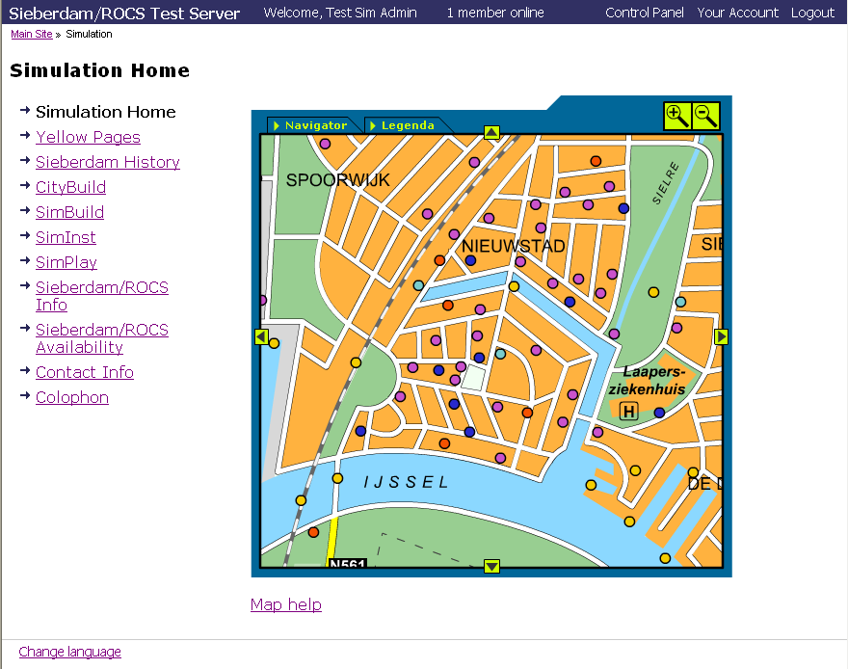
The Simulation Home page shows a control bar (top), a menu (left), the Sieberdam city map (right) and two more menu items (Map Help and Change Language) (bottom).

  - Description
The menu lists the following items:
- Simulation Home (current page),
- Sieberdam Directory,
- Sieberdam History,
- CityBuild - to edit city objects (only visible for users who have been logged in and are members of the City Admin Group or the Simulation Admin group),
- SimBuild - to write simulation models (only visible for users who have been logged in and are members of the Template Author group or the Simulation Admin group),
- SimInst - to schedule simulation sessions (only visible for users who have been logged in and are members of the Case Author group or the Simulation Admin group),
- SimPlay - to administer simulation sessions and/or to participate in them,
- Sieberdam/ROCS info,
- Sieberdam/ROCS availability,
- Contact Info,
- Colophon.
When the user clicks a menu item, the system displays the corresponding page.
The Control Bar (top) and the menu item Change Language (bottom) are visible on all Sieberdam/ROCS pages.
  - See Also
- Sieberdam City Map or the Sieberdam Directory → chapter Sieberdam.
- CityBuild, SimBuild, SimInst, SimPlay → corresponding chapters.
- Other Menu Items, Control Bar, Language Settings → chapter Miscellanea.
  - Anomalies
- The name Simulation Home should be replaced by Sieberdam/ROCS home.
- English dialogue texts should use the preferred terms only.
- Dutch dialogue texts have to be prepared yet.
- Sieberdam
  - Synopsis
The Sieberdam City Map is an interactive page element. It shows a part of the city map and popup windows and home pages with information on city objects. The Sieberdam Directory is a list of city objects that gives access to the home pages with information as well.
  - Access
There exist two ways to have access to the Sieberdam City Map and the Sieberdam Directory:
- for everybody: via the Simulation Home page; the page displays the City Map as an interactive page element and contains a hyperlink to the Sieberdam directory;
- for participants to a specificic simulation session: via the Simulation Session Home page of that session; the page contains hyperlinks to both City Map and Directory.
  - Terminology
preferred term | old term
Sieberdam Directory | Yellow Pages

  - Screenshot
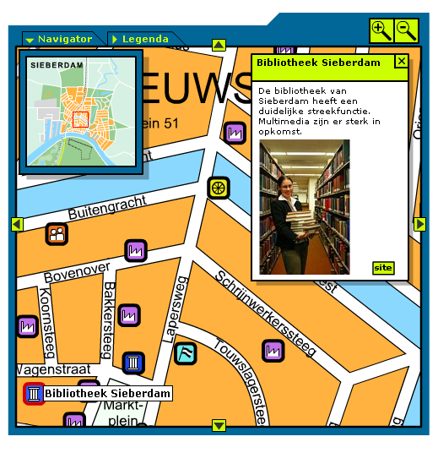
The screenshot shows an enlarged (zoomed-in) part of the city map with streets, street names and icons. Apparently, the mouse points to an icon (lower left corner). The corresponding city object's name is displayed ("Bibliotheek Sieberdam") and a popup window with a short description, a thumbnail picture and a hyperlink called "site" has been opened (upperright corner). The navigator popup window is open (upper left corner), the legenda popup window is closed. The Navigor Tab and the Legenda Tab act as controls to open and close these popups. The other controls are a zoom-in (+) button, a zoom-out (-) button and arrows in four directions. Not visible is the fact that the key's A and (big) "+" also behave as zoom- in, while the key's "Z" and "-" behave as zoom- out. Outside the map is a hyperlink to the Map Help text.

  - Description
Sieberdam consists of a City Map and a Directory. Both have hyperlinks to the home pages of City Objects.
    - Sieberdam City Map
The interactive City Map window has the following functions:
- Navigator - Clicking the Navigator tab opens a popup window showing an overview map and a cursor. Moving the cursor results in moving the whole map, in the map window i.e. changing the part of the map that is visible. Clicking the Navigator tab again, closes the popup window.
- Legenda - Clicking the Legenda tab opens a popup window showing an overview of the icons used on the map. Clicking the Legenda tab again, closes the popup window.
- Move - Clicking one of the four arrows (up, right, down, left) moves the visual part of the map in the indicated direction.
- Zoom-in - Clicking on the zoom-in button or pressing the "A" key or the big "+" key enlarges the map. At a certain level, street names become visible.
- Zoom-out - Clicking on the zoom-out button or pressing the "Z" key or the big "- " key diminishes the map. At a certain level, street names become invisible.
- Drag - Dragging on the map moves the whole map.
- Hover - Hovering a map icon displays the name of the corresponding object.
- Select - Clicking on a map icon opens a popup window with the name of the city object, a short description of it, a thumbnail picture and a hyperlink to a "site". By pointing at the title bar and dragging, the popup window is moved. By pressing the "X" button, the popup window is closed. By clicking on the hyperlink "Site", the system displays the home page of the selected City Object (text plus picture).
Clicking on the hyperlink to the help text for this map, displays this very text.
    - Sieberdam Directory
The Sieberdam Directory lists all Sieberdam city objects. For each city object, it displays the type (location, character or prop), the name, and a short description. The user may sort this list by type, by name or by description.
The user can filter the list to select city objects matching a certain word or phrase, and clear the filter subsequently. Both the name and the description of the city objects are included into the filtering operation.
Clicking on an item's hyperlink, displays the home page of the selected City Object (text plus picture).
  - See Also
- Simulation Home page → chapter Simulation Home.
- Simulation Session Home page → chapter Simplay, section Participate in Simulation Session
  - Anomalies
- The Sieberdam City Map only displays characters. It should display locations and props as well.
- CityBuild
  - Synopsis
The purpose of CityBuild is to manage city objects like locations, characters and props. It is also used to manage additional data for these objects, like images and stylesheets. CityBuild further serves the upload of documents that will be attached to instructions for participants during simulation sessions.
  - Access
CityBuild is accessible for users the have been logged-in. They should be members of the City Admin user group or the Simulation Admin user group. Members of the City Admin group may create new city objects, lookup all objects and see their contents. They may edit or delete the objects they created themselves. Members of the Sim Admin group also are permitted to edit or delete city objects created by other users.
  - Terminology
preferred term | old term
City Object | Sim Object

  - Screenshot
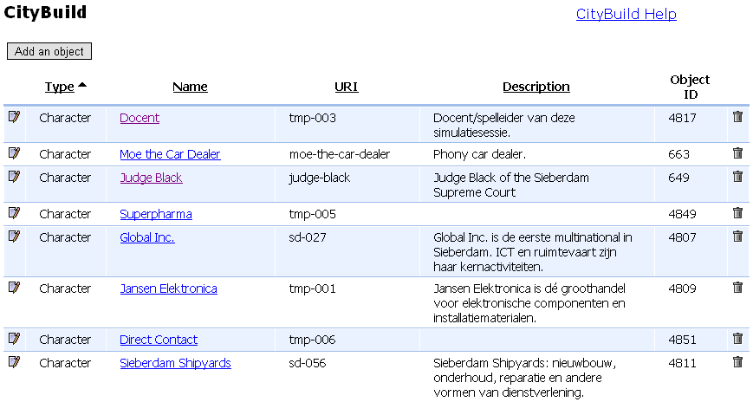
= edit - = delete
The CityBuild home page contains a hyperlink to the CityBuild Help text, a button to create a new city object, and a list of city objects. For each city object, the type, name, URI, description and object ID are listed. Sorting of the list is possible by type, by name, by URI and by description. Item names are hyperlinks. Items may have an icon for editing or deleting. The URI is a unique resource identifier which might be set by the user who created the city object. The object ID is an integer number determined by the system.

  - Description
CityBuild has the following subfunctions:
- Create a City Object
- Lookup and Edit City Objects
- Manage City Objects Notifications
The user executes these subfunctions via the CityBuild page. The subfunctions have their own pages, The City Build Home page also contains a Help hyperlink which displays this very text and a hyperlink to Return to the Simulation Home page.
    - Create City Object
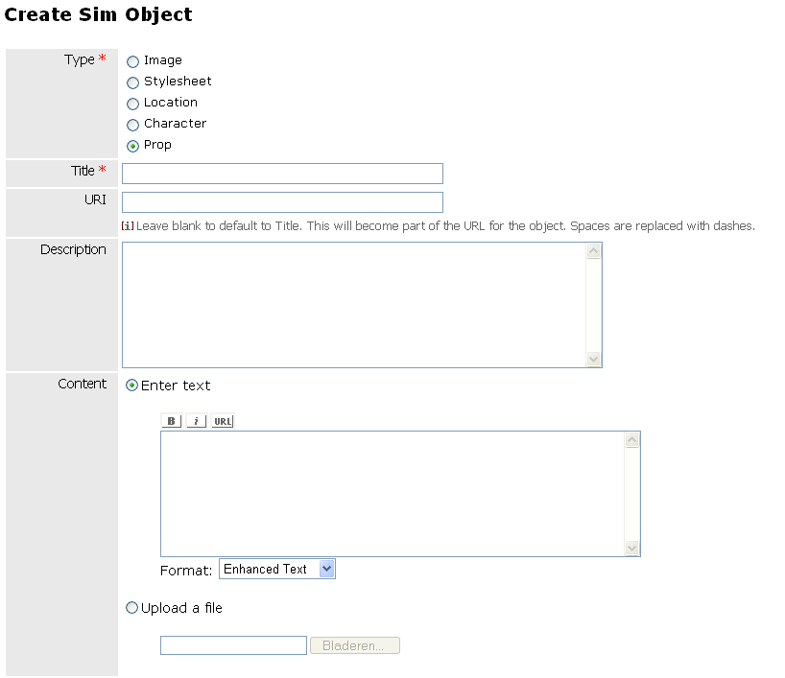
* = required - = Bold - = Italic - = Insert Hyperlink - Enhanced Text | Plan Text | Fixed Width Text | HTML = Text Format |
The screenshot shows the first part of the Create City Object form. The first entryfield is the type of the object (image, stylesheet, location, character of prop). Dependant on the type, some other fields become visible/unvisible.
When a user activates the Create City Object subfunction an empty form is displayed. This form is used to enter various types of Sim Objects into the Sim Object database:
- Image - The user may upload an image file from her hard disk. Note that an image has to be entered (i.e. uploaded) before it can be referred to by locations, characters or props.
- Stylesheet - The user may paste the content of a stylesheet.
- Location - The user may enter information on a location in Sieberdam.
- Character - The user may enter information on a character in Sieberdam (institute, firm, person). Each role in a simulation session will be linked to a character.
- Prop (stage accessory) - The user may enter information on a prop in Sieberdam, either literally (by entering text) or by uploading a document from her hard disk.
The fields on the form depend on the type of the object to be entered. The following table gives an overview.
hor.: object type  vert.: fields | image | style- sheet | prop | character | location
title | req | req | req | req | req
uri | y | y | y | y | y
description | y | y | y | y | y
content | file | plain | e or f | enh | enh
flag: show on map | n | n | y | n | y
flag: show in directory ( y.p.) | n | n | n | y | y
address | n | n | n | n | y
city | n | n | n | n | y
history | n | n | n | n | y
located inside | n | n | n | n | loc
resides at | n | n | n | loc | n
works for | n | n | n | loc | n
associated with | n | n | loc | n | n
stylesheet | n | n | sts | sts | sts
letterhead | n | n | n | n | img
logo | n | n | n | n | img
thumbnail | n | n | img | img | img
image 1-10 | n | n | img | img | img
Legenda: e or f = enhanced or file (exclusive), enh = enhanced text, plain text, fixed width text, html, file = file to be uploaded, img = image object, loc = location object, n = no, plain = plain text, sts = style sheet object, req = required, y = yes.

    - Lookup and Edit City Objects
A user may lookup any city objects by sorting and filtering the tabular listing of city objects. Depending on her access rights, the user may edit or delete a city object. When editing, the same form appears as used during the creation of the object.
    - Manage City Object Notifications
At regular intervals, the system generates the City Map XML file. This file tells the interactive city map which City Objects to display. However, when no City Objects have been added, changed, or deleted, no new City Map XML file will be generated. The system can send an e-mail notification when a new City Map XML file has been created.
The user has various options to manage these City Object notifications:
- Switch notification frequency to instantly, hourly or daily, or switch the notifications off,
- View the actual City Map XML file,
- Generate a new version of the City Map XML file and let the system distribute any notifications about that fact.
  - See Also
- Linking simulation roles to city characters → chapter SimInst, section Roles.
  - Anomalies
- The system distinguishes various types of city objects: locations, characters and props (stage accessories), which might be linked (e.g. character lives at certain location, works for another location, locations may be part of another location). However, in version 1.0 the city map only shows characters. Either the city map should make a distinction between locations and characters (and their relations) or the city objects database might be made simpler.
- The city map does not use the generated City Map XML file but a human produced XML file.
- Generating a new city map XML file results in a notification message signalling a syntax error.
- CityBuild is not only used for the management of city objects in the city object database. The latter in fact is a Simulation Object Database to store not only city opbjects, but also attachments for instructions to simulation session participants and to store any documents uploaded by participants during simulation sessions. Although, from a technical point of view, it might be practical to use the same database for all these "objects", for the users the current solution is confusing and errorprone.
- SimBuild
  - Synopsis
The purpose of SimBuild is the creation and editing of simulation models. A model consists of roles, states, and activities.
  - Access
SimBuild is accessible for users the have been logged-in. They should be members of the Template Author user group or the Simulation Admin user group. Members of the Template Author group may create new simulation models, lookup and/or copy all simulation models and edit or delete the models they created themselves. Members of the Sim Admin group also are permitted to edit or delete simulation models created by other users.
  - Terminology
preferred term | old term
activity | task
archive | portfolio
author | template author
role activity | user task
simulation model | simulation template

  - Screenshot
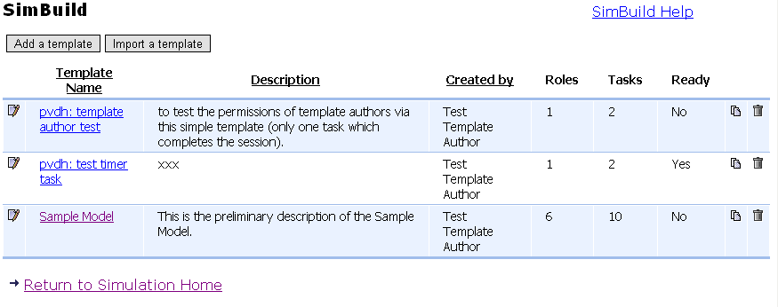
= edit - = copy - = delete
The SimBuild home page contains a link to the SimBuild help text, a pushbutton to create a new simulation model, a pushbutton to import an existing simulation model, a table of existing simulation models. The table lists the simulation models the user may edit, copy and/or delete. It displays the model name, the model description, the author name (the user who created the model), the number of roles, the number of tasks and the current state (ready to simulate or not). The table may be sorted by model name, by description and by author name.

  - Description
SimBuild has the following subfunctions:
- Create a Simulation Model
- Import a Simulation Model
- Lookup and Edit Simulation Models
The user activates these subfunctions via the SimBuild page. This page also contains a Help hyperlink which displays this very text and a hyperlink to Return to the Simulation Home page.
The subfunctions have their own pages. Via a hyperlink the user can return to the SimBuild home page or to the Simulation home page.
    - Create Simulation Model
When a user clicks the Create a Simulation Model pushbutton a blank form is displayed.
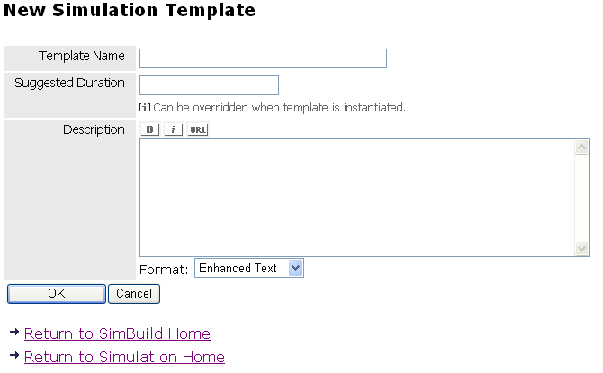
* = required - = Bold - = Italic - = Insert Hyperlink - Enhanced Text | Plan Text | Fixed Width Text | HTML = Text Format - hh:mm:ss = Duration
The screenshot shows a form to enter metadata for a new simulation model. Three fields have to be entered: the model name, the suggested duration of simulation sessions and a short description of the model.

This form is used to enter the metadata for a new simulation model:
- Model name - The model name should be unique.
- Suggested duration - This information only is metadata and does not influence the actual simulation sessions duration. It may be left empty.
- Description - A short description of the simulation model. The Session Administrator may change this text via SimInst. The Session Participants will see this text via the SimPlay option "About this simulation".
Once the user presses OK, a new form is opened, the simulation model editing form.
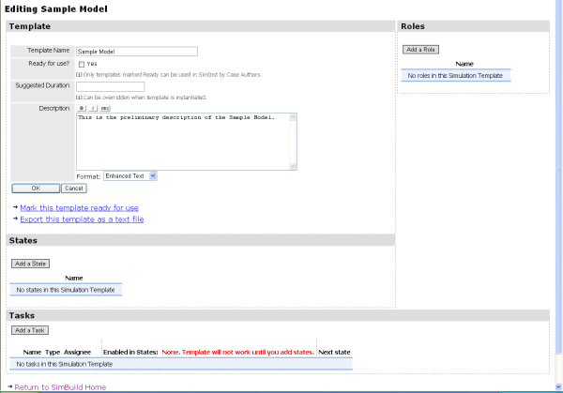
= Bold - = Italic - = Insert Hyperlink - Enhanced Text | Plan Text | Fixed Width Text | HTML = Text Format
The screenshot shows the Simulation Model Edit form.It consists of four sections: metadata, roles, states and activities. The metadata section has an extra field "ready to simulate", and "OK" and "Cancel" pushbuttons, and hyperlinks to mark the model ready to simulate and to export the model as a text file. The other sections have pushbuttons to create new roles, states and activities.
The Edit form consists of the following elements:
- Metadata section,
- Roles section,
- States section,
- Activities section
- Hyperlink "Mark this model ready-for-use" - This is a shortcut to set the "Ready for use?" field in the metadata section to "yes".
- Hyperlink "Export this model as a text file" - This hyperlink displays a page with the software listing of the model content. The user can copy this text and paste it into a text file for backup reasons or for moving the model to another Sieberdam/ROCS server. The opposed operation is "Import a simulation model".
- Hyperlink "Return to SimBuild Home"
- Hyperlink "Return to Simulation Home"
The Simulation Model Edit form has no explicit OK or Cancel buttons at its bottom. In fact every change is saved immediately.
Metadata Section
The metadata section of the edit model form can be open or closed. Initially, it is open. By pressing OK or Cancel, it is closed. Then, by pressing the Edit button, it may be opened again.
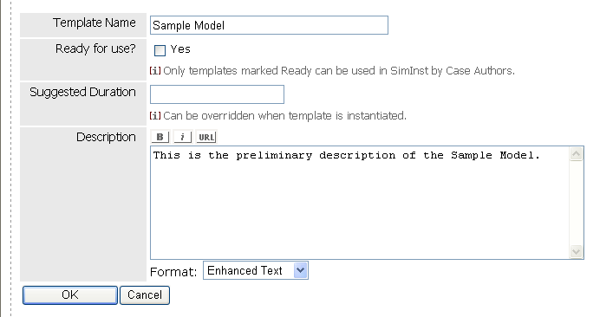
The screenshot shows the open metadata section.

The meaning od the fields Model Name, Suggested Duration and Description is explained before. See Create Simulation Model.
Now, an additional field is displayed: "Ready to simulate?", with a check box to indicate "yes" (check mark) or "no" (no check mark).
A new model always has the check box unchecked (e.g. "not ready"). The user has to check it explicitly in order to make simulation sessions with the model possible. When the model has apparent shortcomings, the system will not let the user mark the check box. Even when the check box has been marked, the system will reset it every time the user opens the model for editing.
Roles Section
The Roles Section of the Simulation Model Edit form is intended to enter the roles that during simulation sessions have to be played by human participants. Each role should have a unique name. Role names may be changed. Roles may be deleted. The sequence within the list of roles may be changed as well.
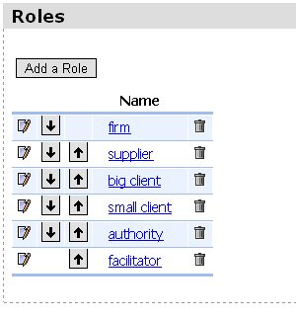
= edit - = move downwards - = move upwards- = delete
In a sample model six roles are distinguished: supplier, firm, big client, small client, authority and facilitator. The first four normally will be played by student teams, the authority will be played by an external consultant, the facilitator by the tutor.The figure shows the roles section of the model form for this sample model.

States Section
The States Section of the Simulation Model Edit form is intended to enter the states that during simulation sessions may be reached. Each state should have a unique name. State names may be changed. States may be deleted. The sequence within the list of states may be changed as desired. The actual sequence has no effect on simulation sessions; it serves presentation purposes only.
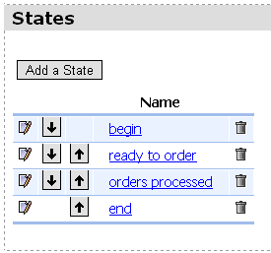
= edit - = move downwards - = move upwards- = delete
The screenshot shows the states section of the Simulation Model Edit form for a sample model.

A simulation session starts in a certain state. The actual state determines which activities can be executed. The execution of an activity may change the state. The session ends when a state is reached in which no further activities are possible.
In a simple sample model four states are distinguished: begin, ready to order, orders processed, and end. Note that the sample model states suggests a linear sequence of states. That is not necessary however.
Activities Section
The Activities Section of the Simulation Model Edit form is intended to enter activities and to enable activities in certain states.
When the user clicks the Create New Activity pushbutton a blank form is displayed.
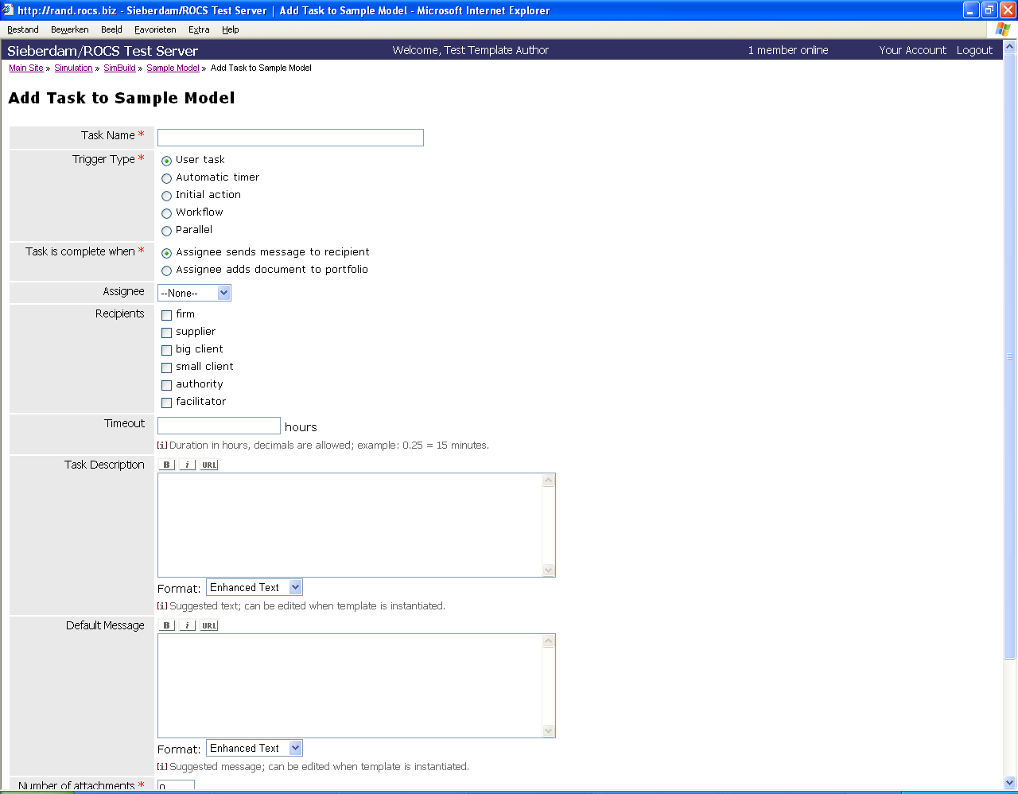
Screenshot of the Create New Activity form.

This form is used to enter various types of activities:
- Role Activity - A role executes a certain activity during a simulation session. Participants to a session play a role. Technically they are users of the system. Two types of role activity are possible: 1. a role sends a message to another role (or roles), 2. a role uploads a document to its document archive (old term: portfolio). Sending the message or uploading the file terminates the user activity.
- Automatic timer - An automatic timer only takes time. After a certain amount of time it terminates automatically.
- Initial action - The initial action is a fake activity that brings the session into its initial state.
- Workflow - A workflow is a complete model of its own, a submodel. This submodel uses the same roles as the upper level model, but has its own sub-states and sub-activities (which again might be workflows etceteras). The workflow starts in its own initial state end ends when a sub-state is reached that does not have any activities enabled.
- Parallel - The parallel activity consists of a series of sub-activities. The parallel activity terminates when all the sub-activities have been terminated.
The fields on the form depend on the type of the object to be entered. The following table gives an overview.
hor.: activity type | user activity |  | automatic timer | initial action | workflow | parallel
vert.: fields | message | archive
activity name | y | y | y | y | y | y
assignee | y | n | n | n | n | n
recipients | y | n | n | n | n | n
time-out | y | y | y | n | y | y
activity description | y | y | y | n | y | y
default message | y | n | n | n | n | n
# of attachments | y | y | n | n | n | n
next state | y | y | y | y | y | y

A role activity is assigned to a role. The activity description field contains the instruction for the participant who will play that role. The "# of attachments" field indicates the maximum number of attachments that will accompany the instruction for the participants. In the case of a message type role activity, the recipients field lists the recipients of the message and the "default message" field may contain a default text for that message.
All activities have a "next state" field. This field indicates the state of the session after completion of the activity. It might be "unchanged".
As an example we enter the pseudo role activity "start of the session", i.e. an initial action.
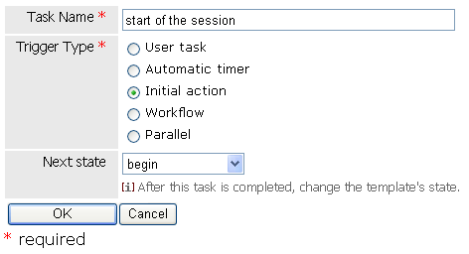
The screenshot shows the Create New Activity form for an initial action.

Next, we enter the following activities:
- A parallel activity consisting of a role activities for supplier, firm, big client, and small client. They all have to prepare a document with their internal policy for the session and have to store it in their own archive. It brings the session from the begin state to the ready-to-order state.
- A workflow activity to let the clients order some goods or services, to let the firm process these orders, to let the firm eventually process a purchase order and to wait until the supplier has shipped that order. It brings the session from the ready to order state to the orders processed state.
- A role activity for the firm to deliver the goods or services to both clients at once. It brings the session from the orders processed state to the end state.
- A role activity for supplier, firm, big client and small client to ask advice from an authority is available in every state. It does not change the state of the session. (Each role always can send a message to each other role. However, in this sample model we explicitly model it as an option for each role.)
- A role activity for the facilitator to set the session back from the orders processed state to the ready for orders state and have that noticed to all other roles.
Once these activities have been entered, the model form displays a matrix which relates tasks to states. Each cell contains a checkbox. Marking a chackbox enables an activity during a certain state. The figure below shows the matrix for the sample model.
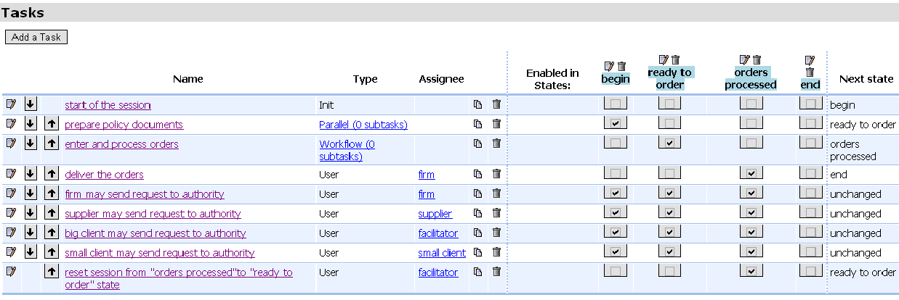
= edit - = move downwards - = move upwards - = copy - = delete
The screenshot shows the Activities Section of the Create New Activity form.

Note, that the matrix also offers the opportunity to arrange the order of activities, to open the activities for editing, to copy or delete them, and to rename or delete states.
    - Import Simulation Model
When the user clicks the Import a Simulation Model pushbutton a blank form is displayed.
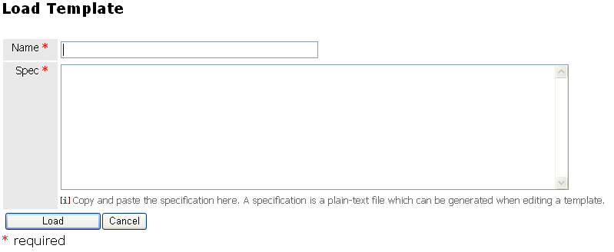
Screenshot of the Import a Simulation Model form.

In the spec field the software listing of a simulation model may be pasted. It could be a backup for a model, e.g. from another Sieberdam/ROCS server. This import function is the opposite of the export function on the Create Simulation Model page (hyperlink "Export this template as a text file").
    - Edit Simulation Model
The system displays a table with models. The creator of a model and the Simulation Administrators may edit the model form or even delete it. All users may copy the model (making the copy their own) and change its content subsequently.
Each entry of the list contains the following fields:
- Model name
- Description
- Author
- Number of roles
- Number of tasks
- Ready to simulate [yes/no]
The user can sort the list by model name, description, author.
  - See Also
- Scheduling a simulation session based on a simulation model → SimInst.
- Linking simulation roles to city characters → chapter SimInst, section Roles.
  - Anomalies
- SimBuild should be able to handle the data entry of a complete simulation model. In V1.0 some details of a simulation model have to be entered via SimInst: the relation between roles and characters, and the attachments to instructions for the participants.
- The set of metadata should cover the full set of metadata used by the owner of the system (a subset of the IMS metadata for learning objects).
- A user only sees her own models, should be: all models.
- When the listing of models increases in size, it will be difficult to retrieve a model; more metadata describing the models are necessary, all could be used for retrieving a model.
- SimInst
  - Synopsis
The purpose of SimInst is the creation and editing of simulation schedules, i.e. schedules for simulation sessions and to have these sessions started (either manually or automatically).
  - Access
SimInst is accessible for users the have been logged-in. They should be members of the Case Author user group or the Simulation Admin user group. Members of the Case Author group may create new simulation schedules and to edit or delete their existing ones as long as the sessions have not been started. Members of the Sim Admin group also are permitted to edit or delete simulation schedules created by other users.
  - Terminology
preferred term | old term
simulation schedule | simulation case
session administrator | case author
simulation session | simulation
activity | task

  - Screenshot
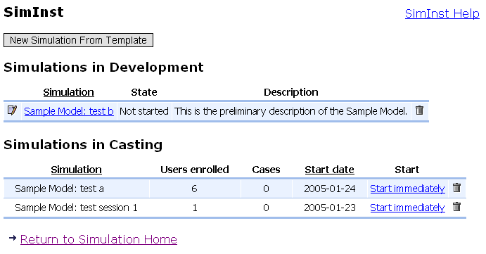
= edit - = delete
The SimInst home page contains a link to the SimInst help text, a button to create a new simulation schedule, and two tables. The first table lists the simulation schedules that have not been completed. The fields displayed are: the session name, the state (of the scheduling process), the model description. The second table shows the simulation schedules that are ready to run. It displays the session name, the number of users that have been enrolled as participants, the number of parallel sessions that will be created, the planned start date of the simulation session(s) and a hyperlink to start immediately.

  - Description
SimInst has the following subfunctions:
- Create a Simulation Schedule,
- Edit a Simulation Schedule,
- Activate a Simulation Schedule, i.e. start a simulation session.
The user activates these subfunctions via the SimInst page. This page also contains a Help hyperlink which displays this very text and a hyperlink to Return to the Simulation Home page.
The subfunctions have their own pages. Via a hyperlink the user can return to the SimInst home page or to the Simulation home page.
    - Create Simulation Schedule
When the user clicks the Create Simulation Schedule button, the system displays a list of models to choose from. Only models "ready to simulate" are listed.
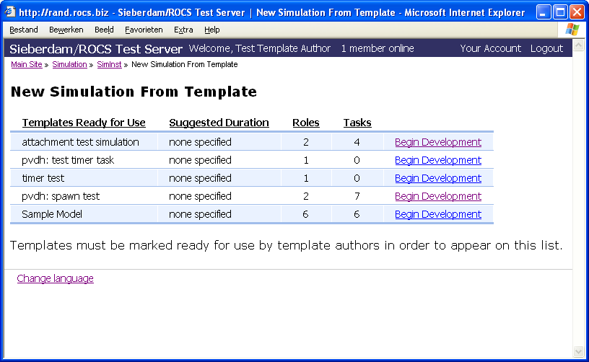

The list contains all templates from all authors that have been set ready to simulate. For each model it displays the name, the suggested duration, the number of roles, the number of tasks and a hyperlink to start preparing the schedule.
When the user selects a model, a new page opens and the user has to enter a unique name for the new schedule.
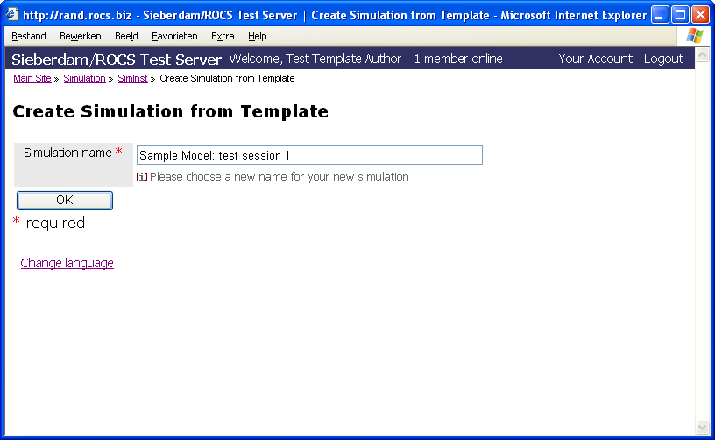

Next, the user has to fill in five forms which will be described in the next paragraphs. The names of these foms are:
- Settings
- Roles
- Activities
- Participants
- Casting
The forms do not have OK or Cancel buttons. Every change is saved immediately. When a user stops filling in these forms and returns to the SimInst page, the List of Simulation Schedules under Construction displays the state of the scheduling process (not started, settings completed, roles completed, activities completed, participants completed, ready for casting. Only the last form has a finish button.
Settings
The first form the user has to fill is the Settings form.
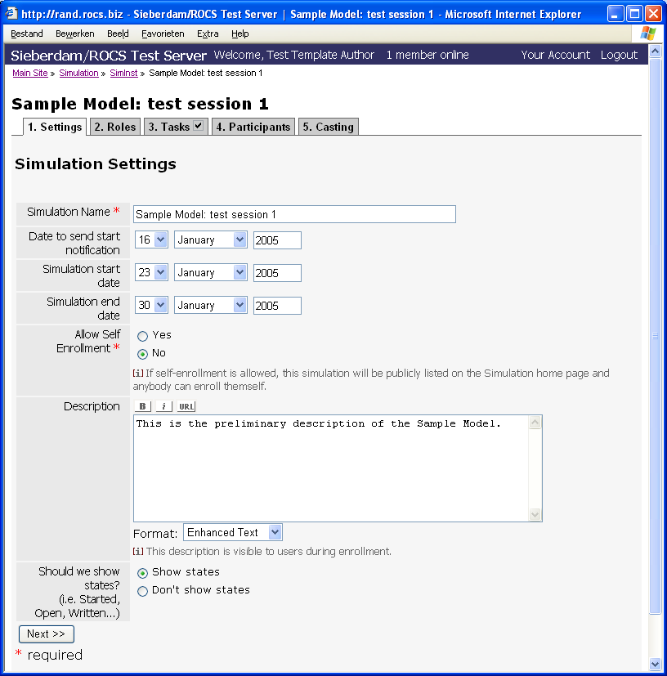

The Settings form consists of a number of entry fields that all have been filled with a default value:
- Session Name - The name of the session as specified during the creation of the schedule.
- Date to send start notification - The default value is today plus 7 days.
- Simulation session start data - The default value is today + 14 days.
- Simulation session stop date - The default value is today + 21 days.
- Allow self-enrollment yes/no - Self-enrollment implies that every registered user can enroll to become a participant in a simulation session. The oppositie is that users have to be invited to do so.The default value is "no".
- Model description - The default description as entered via SimBuild.
- States visible (yes/no) - A switch to make the name of the actual state visible during the sessions. The default value is "yes".
- A pushbutton to go to the next form. The state of the schedule changes to "Settings completed".
Roles
The second form the user has to fill is the Roles form.
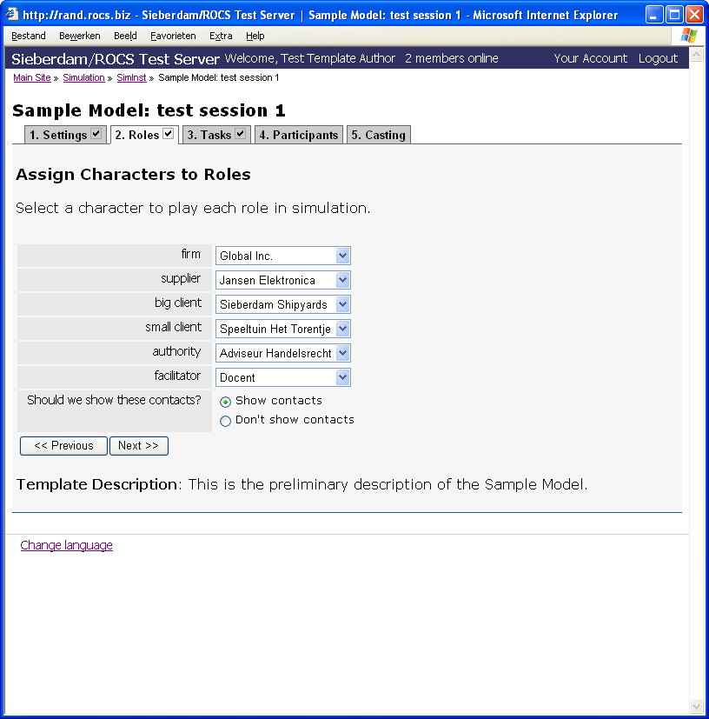

The Roles form consists of the following entry fields:
- Each role belonging to the simulation model is listed. The user has to link each role to a character of Sieberdam.
- Show contacts [yes/no] - The Show Contacts switch determines whether during simulation sessions participants will see a list of contacts (roles+characters).
- Pushbutton Previous - Go to the previous form.
- Pushbutton Next - Go to the next form, the state of the schedule changes to "Roles Completed".
Activities
The third form the user has to fill is the Activities form.
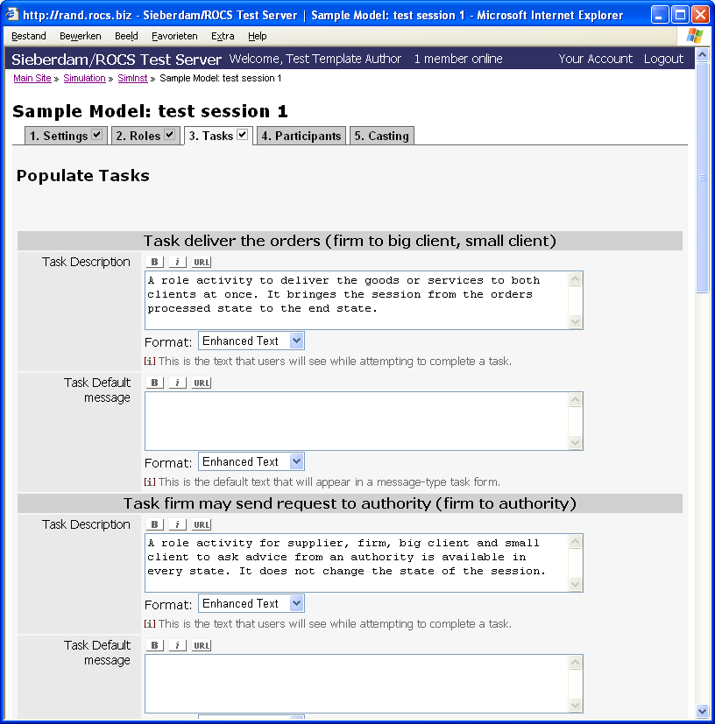
* = required - = Bold - = Italic - = Insert Hyperlink - Enhanced Text | Plan Text | Fixed Width Text | HTML = Text Format

The Activities form consists of the following entry fields:
- Each activity belonging to the simulation model is listed. The user may change the activity description and, for message activities, the default message text. If the activity may have attachments (has been set during SimBuild), the user may specify these attachments now. The attachments themselves should have been uploaded before (via CityBuild).
- Pushbutton Previous - Go to the previous form.
- Pushbutton Next - Go to the next form, the state of the schedule changes to "Tasks Completed".
The Roles form lists the roles that belong to the simulation model. The user has to link each role to a character of Sieberdam.
The form contains pushbuttons to go to the previous or to the next form. When going to the next form, the state of the schedule changes to "Roles Completed".
Participants
The fourth form the user has to fill is the Participants form.
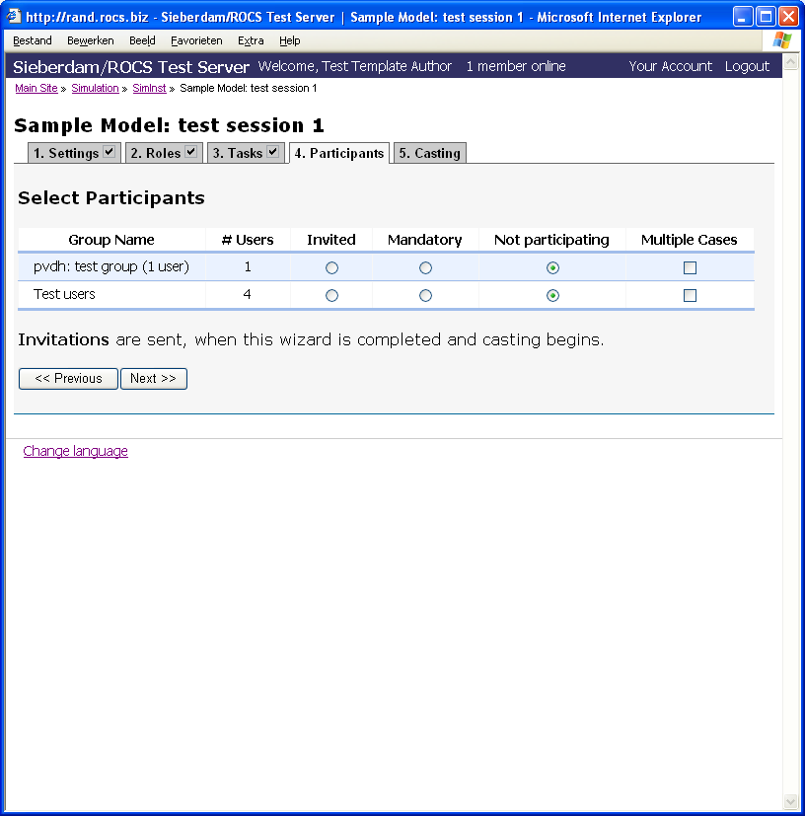

The Participants form consists of the following entry fields:
- Each user group is listed. The user may indicate whether the members of these group may or should participate in the simulation sessions. The user may also mark a checkbox when members of a certain group are allowed to participate in more than one simulation session at the same time.
- Pushbutton Previous - Go to the previous form.
- Pushbutton Next - Go to the next form, the state of the schedule changes to "Ready for Casting".
Casting
The fifth form the user has to fill is the Casting form.
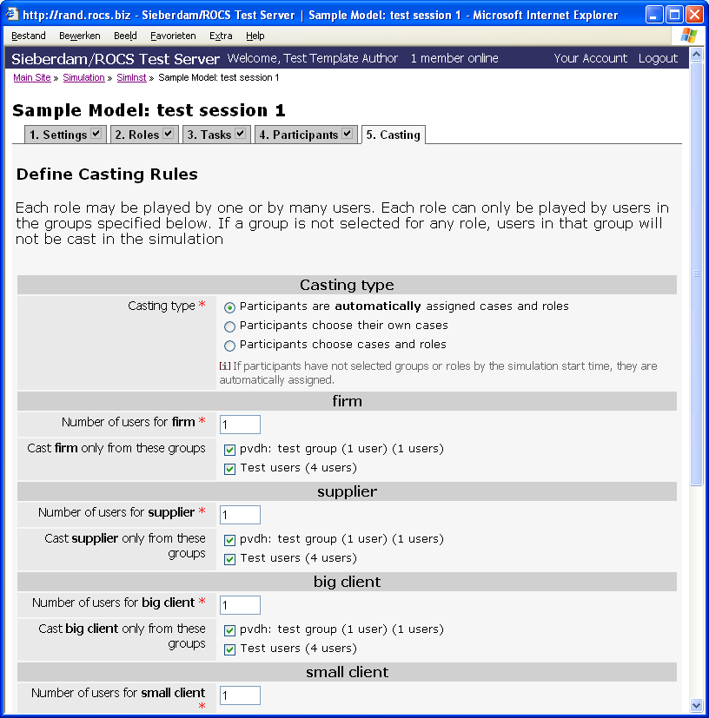

The Casting form consists of the following entry fields:
- Casting type - The system offers three ways for casting participants to roles. 1. automatically, i.e. the system decides, 2. the user may select the session, 3. the user may select the session and the role.
- Each role is listed. The user may indicate how many participants will play a certain role as a team. Further, she markes the user groups the participants are originating from.
- Pushbutton Previous - Go to the previous form.
- Pushbutton Finish - The casting is complete. The system displays the SimInst main page page. The new schedule has now been listed as simulation schedule ready to run.
    - Edit Simulation schedule
The system displays a table with schedules under construction.
Each entry of the list contains the following fields:
- Schedule name
- State
- Description
The user can sort the list by schedule name. The user can open a schedule for editing or delete it.
    - Activate Simulation schedule
The system displays a table with schedules ready-to-run:
Each entry of the list contains the following fields:
- Schedule name
- Users enrolled
- Number of Sessions
- Start date
- Start - The hyperlink start will cause the simulation session(s) to start immediately.
The user can sort the list by schedule name or start date. The user can start a session immediately.
  - See Also
- Running a simulation session based on a simulation model → SimPlay.
- Uploading attachments → CityBuild.
- Overview of characters → Chapter Sieberdam.
  - Anomalies
- Some details of a simulation model still have to be entered via SimInst: the relation between roles and characters, and the attachments to instructions for the participants. SimBuild should be able to handle the data entry of a complete simulation model.
- System testing mainly concentrated on casting type 1.
- SimPlay
  - Synopsis
The purpose of SimPlay is to let users participate in simulation sessions (either as a participant or as a session administrator). A simulation session follows a certain simulation schedule and is driven by a simulation model. SimPlay supports participants and Session Administrators.
  - Access
SimPlay is accessible for users that have been logged-in. Depending on the enrolment rules included into the simulation schedule, users are enrolled as parrticipants. Members of the Case Author group may administer their own simulation sessions. Members of the Simulation Admin group may administer all simulation sessions.
  - Terminology
preferred term | old term
simulation model | simulation template
simulation session | case
session administrator | case author
author | template author
directory | yellow pages
archive | portfolio
activity | task

  - Screenshot
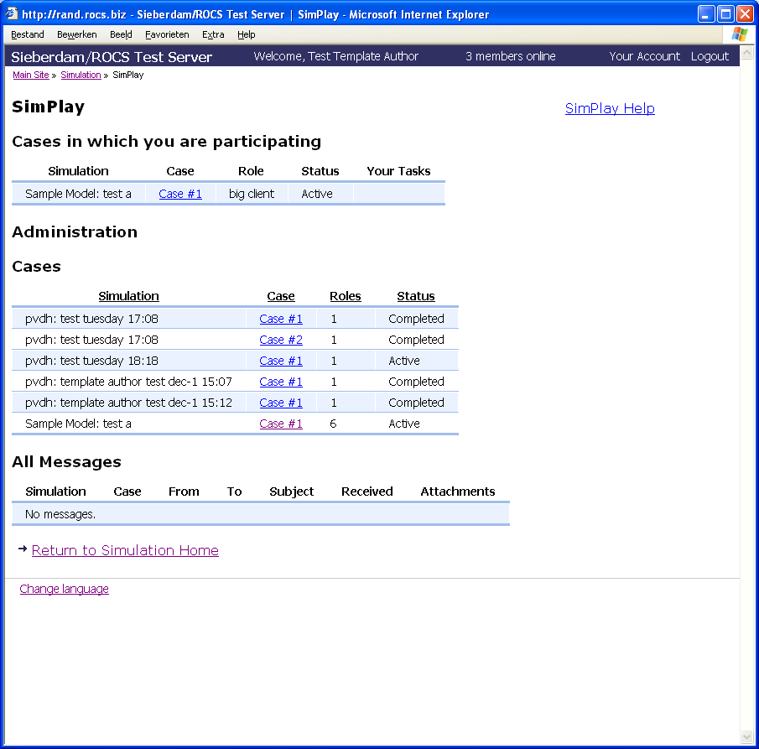
= edit - = delete
The SimPlay home page contains a link to the SimPlay help text, and three tables. The first table lists the simulation sessions in which the user is participating (playing a role), the second table lists the simulation sessions the user is administering, the third table lists all messages that have been generated in the sessions the user is administering.

  - Description
Simplay has the following subfunctions:
- Participate in a Simulation Session - On the SimPlay home page, the user may select a session from the list of sessions she is participating in. For every session the user is participating in, the system displays the session name, the session number, the role the user is playing, the status of the session (active or completed), the number of actual activities the user may execute.The user may sort this table by session name, session number, role name and status. Each session in the list has a hyperlink to the corresponding session's home page.
- Administer a Simulation Session - On the SimPlay home page, the user may select a session to administer. The system displays two tables for this purpose.
- List of Sessions Administering - When the user is administering session, for every session she is administering, the system displays the session name, the session number, the number of roles, the status of the session (active or completed), and a hyperlink to go to that session's administration page. The user may sort this table by session name, session number, number of roles and status.
- List of Messages - When the user is administering session, for every session she is administering, the system displays a list af all messages generated during the sessions. Each entry consists of the session name, the session number, the contact (role + character) that sent the message, the recipient of the message, the subject, date and time, the number of attachments, and a hyperlink. The hyperlink opens the Session Home page of the recipient of the message and displays the message's content.
The SimPlay home page also contains a Help hyperlink which displays this very text and a hyperlink to Return to the Simulation Home page.
The subfunctions have their own pages. Via a hyperlink the user can return to the SimPlay home page or to the Simulation home page.
In the case a user only participates in a single session and does not administer any sessions, the SimPlay home page is skipped entirely. The user goes directly to the Session Home page.
    - Participate in Simulation Session
The Session Home page is the start page for session participants.
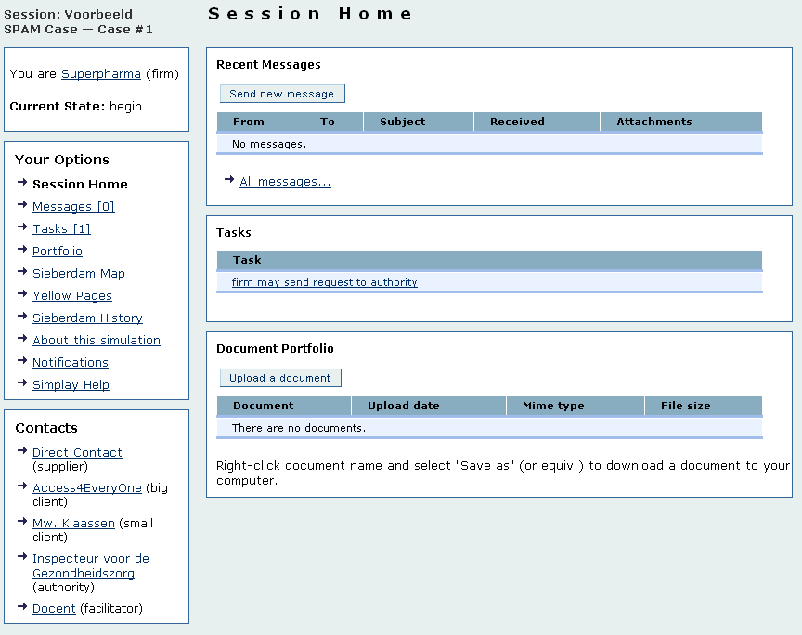
The Session Home page has two sections: a navigation section (left) and a content section (right). By clicking on an option in the navigation section (left), the content (right) will change. The left part always remains the same.

The navigation section displays the name of the simulation session and its number, the role the participant is playing and the actual state of the session (if not switched off during SimInst). Further, it lists the following menu items:
- Session Home - Clicking results in the display of three subsections;
- Listing of new messages (with the possibility to see a list of all messages, to send a new one, or to read an existing one),
- List of actual activities (with the option to read their instruction and to take action),
- Overview of the document archive (and the possibility to open or to download items, and to upload a new item). The items may be sorted by Document Name, Upload Date, Mime Type and File Size.
- Messages - Clicking results in a list of all messages (sent or received) with the option to send a new one, or to read an existing one and/or to reply to it.
- Activities - Clicking leads to a list of all activities. They may be opened to read the instruction and act accordingly.
- Archive - Clicking produces a list of the archived documents. They may be opened and/or downloaded. A new document may be uploaded to the archive as well. The items may be sorted by Document Name, Upload Date, Mime Type and File Size.
- Sieberdam Map - Clicking lets the Sieberdam map appear.
- Sieberdam directory - Clicking results in the display of a directory of Sieberdam city objects. The list may be sorted by Type, Name, or Description. The list may be filtered as well. Clicking on an object shows the home page of that object.
- About this session - Clicking displays the default text belonging to the simulation model.
- Notificatons - Clicking displays the current settings and the possibility to change them.
- Simplay Help - Clicking shows this very text.
The navigation section ends with a list of all contacts (role + character) involved in the session (if not switched off during SimInst). When clicking on a contact, the character's home page appears in the right section. It contains a button to letthe current participant send a message to the contact.
    - Administer Simulation Session
The Session Administration page belongs to a specific simulation session.
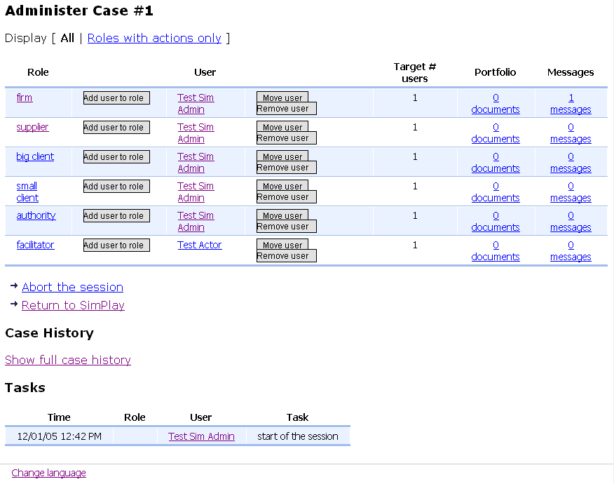

The Session Administration page has the following elements:
- List of roles - The user may limit this list to roles with activities only. By default all roles are displayed. Each entry on the list consists of a role name, a user name, the target number of users,the number of archive docuyments and the number of messages. The following hyperlinks are provided:
- Role - The Session Home page for the role is opened.
- Add user to role - A new user may be selected to play the role.
- Move user - A user may be moved to another role.
- Remove user - A user may be removed from a role. The system responds with a "list" of uncasted roles. The user may select a new participant for the role.
- Archive Documents - A list op archive documents is displayed. Each document may be opened or downloaded.
- Messages - A list of messages is displayed. Each may be opened.
- Menu item "Abort the session" - After confirmation, the session is aborted.
- Menu item "Return te SimPlay"
- Menu item "Show full session history" - A new page is displayed which lists all activities, messages, and documents of the session.
- List of activities - A list of executed activities is displayed.
  - See Also
- Switch off state and/or list of contacts Uploading attachments → SimInst.
- Sieberdam City Map and Directory → Sieberdam.
  - Anomalies
- Some details of a simulation model still have to be entered via SimInst: the relation between roles and characters, and the attachments to instructions for the participants. SimBuild should be able to handle the data entry of a complete simulation model.
- Miscellanea
  - Synopsis
The miscellaneous functions server different functions, mainly regarding user settings and user documentation.
  - Access
Every user has access to the miscellaneous functions.
  - Terminology
preferred term | old term

  - Screenshot
The Simulation Home page shows a control bar (top), a menu (left), the Sieberdam city map (right) and two more menu items (Map Help and Change Language) (bottom).

  - Description
The Simulation Home page gives access to the following miscellaneous functions:
- Control Bar
- Change Language
- Sieberdam History
- Sieberdam/ROCS Info
- Sieberdam/ROCS Availability
- Contact Info
    - Control Bar
The control bar contains the following displays and controls:
- the name of the system, its version number and the environment, e.g. Sieberdam/ROCS V1.0 Production Server,
- a message saying either that the user has not been logged in, or "Welcome <full name of user>,
- for users that have been logged in only: a hyperlink displaying the number of users logged in at the moment, clicking this hyperlink displays a list of user names, clicking a user name displays basic user information and a link to send e-mail to that user.
- for Simulation Administrators only: a hyperlink called Control Panel giving access to administrative functions
- for users that have been logged in only: a hyperlink Your Account gives access to a page where users have a number of options.
- Basic Information - the user may change her first names, last name, e-mail address (= log-in name), screen name (not used), home page, and some personal text ("about you"). This information will be visible for other users.
- Group memberships - The system displays the names of the groups the user is a member of. Group memberships determine the access rights to Sieberdam/ROCS functions and the allocation rules for Sieberdam/ROCS sessions. The System Administrator creates groups and allocates users to groups. The following groups are especially important:
- Case Author group is intended for Session Administrators and gives access to SimInst and SimPlay.
- City Admin group is intended for city editors and gives access to CityBuild.
- Sim Admin group is intended for Simulation Administrators and gives access to CityBuild, SimBuild, SimInst and SimPlay, not only to own objects, but also to objects created by other users.
- Template Author group is intended for authors of simulation models and gives access to SimBuild.
- Change my Password - the user may change her password and will be notified by e-mail.
- Manage your notifications - the user may subscribe or unsubscribe to notifications and set the frequency (instantly, hourly, daily). The following types of notifications are possible:
- Map XML, i.e. the change of the City Map XML will be notified. The user can subscribe to this notification via Notify me / stop notifying me of changes to City Map XML.
- SimPlay message, i.e. all messages a session participant receives in any session will be notified. The user can subscribe to this notification via the Notifications menu option of a simulation session.
- Workflow, i.e. all tasks in all simulation sessions will be notified. The user can subscribe to this notification via the Notifications menu option of a simulation session.
- Workflow assignee, i.e. all tasks the user is assigned to will be notified. The user can subscribe to this notification via the Notifications menu option of a simulation session.
- Make yourself (in)visible - the user decides whether her online status is visible for other users or not.
- What other people see when they click your name - the system displays the visible information.
- Change language - When the user clicks the Change Language hyperlink, the system offers the possibility to select a different dialogue language and a different time zone. Version 1.0 offers English and Dutch dialogue texts.
- Upload a portrait - the user may upload a portrait and some comment; this will be visible for other users.
- Close your account - The user closes the account which implies that she is no longer visible in lists of users and will not receive any notifications any more. By logging-in again the user re- opens her account.
- Users currently online - The system displays a list of the users currently online. Clicking a user name displays basic information and portrait of the selected user.
- For Simulation Admins only: a hyperlink Control Panel gives access to a full range of administrative functions.
- Depending on the log-in status: Hyperlink to log-in or hyperlink to log-out.
- At a separate line below the control bar, the path to the current page is displayed, offering hyperlinks to other pages on the same path.
    - Other Functions
- Change Language - When the user clicks the Change Language hyperlink, the system offers the possibility to select a different dialogue language. Version 1.0 offers English and Dutch dialogue texts.
- Sieberdam History - The Sieberdam History page displays a text describing Sieberdam's history.
- Sieberdam/ROCS Info - The Sieberdam/ROCS info page displays information on the Sieberdam/ROCS system.
- Sieberdam/ROCS Availability - The Sieberdam/ROCS Availability page displays information on the availabity of the Sieberdam/ROCS system.
- Contact Info - The Contact Info page displays information on how to contact the owner of the Sieberdam/ROCS system.
- Colophon - The Colophon page displays the names of the major contributors to the Sieberdam/ROCS system.
  - See Also
  - Anomalies
- Control Bar: Number of Users: this function is also available for users that have not been logged in.
- Control Bar: Control Panel: only the System Administrator should have access to the full range of these functions.)
- Control Bar: Your Account: the pages to change the settings do not have a Cancel option.
- Control Bar: Your Account: the Actors and Service Admin groups are not in use anymore and may be deleted.
- Control Bar: Your Account: the names of the notification types are confusing, the resulting messages too.
- Change Language: the English texts are not using the preferred terms and the translation of Dutch texts has not been completed).
Glossary
Activity
An activity is a specific act during a simulation session. An activity may have been assembled from smaller activities. Activities that are not subdived further, atomic activities, are allocated to a role.
Authors define activities for a certain simulation model with SimBuild. Session administrators may slightly change the description of activities with SimInst. Roles (i.e. participants) execute activities during the simulation sessions.
The execution of an activity ends normally or abnormally, e.g. when the participant sends a message, or uploads a document, the corresponding activity ends normally. An activity ends abnormally by a time-out or by becoming obsolete due to the completion of some other activity.
The normal termination of an activity may or may not change the state of the simulation session. Every execution of an activity is logged.
Activities performed by participants are either archive actions or message actions:
- archive action - the activity consists of adding a file to the role's archive,
- message action - the activity consists of sending a message by a role to one or more other roles.
Archive
A collection of files belonging to a role during a simulation session.
Author
The creator or editor of a simulation model. An author uses SimBuild to create or change a simulation model.
Character
A character is an inhabitant of the virtual city of Sieberdam. A role in a simulation is always linked to a character. A character lives on a certain location and works for (another) location in Sieberdam.
City Object
A city object is a location, a character or a prop.
Condition
Situation in which a certain activity can take place. The author of a simulation model specifies the conditions for an activity to take place, i.e. during which state it is available and which state will be reached after its completion.
Contact
A contact is a role plus the character associated to it.
Citybuild
The management of the virtual city of Sieberdam (changing the map, adding Sieberdam objects).
City Administrator
The user who administers the virtual city of Sieberdam, i.e. the "burgomaster" of Sieberdam.
Directory
A list of Sieberdam objects (locations, characters, props). The list items are hyperlinked to the Sieberdam objects' home pages.
Home Page
The base page for a Sieberdam object (location, character, or prop).
Location
A position on the Sieberdam map that may have its own home page. A location can contain other locations. Characters reside at a certain location and work for (another) location. Props are associated with a certain location.
User Group
A set of users with some common characteristic. Sieberdam/ROCS uses the user group concept as an efficietnt tool to manage access rights and to allocate participants to simulation sessions.
Multi-session
A set of concurrent simulation sessions based on the same simulation model and the same simulation schedule.
Model
The recipe for a simulation session, not the session itself. Also used: simulation model. A simulation model describes states, roles and activities and their mutual relations. A model has either the status "under construction" or "ready to simulate". When the Author has set it to "ready to simulate", a Session Administrator may use it to plan and execute sessions with it. At any moment an author may set a model "not ready". This does not effect any planned or active sessions.
Participant
A user who participates in a simulation session by playing a certain role; the role may be shared by a team of participants.
Player
Software to run a simulation based on a model, i.c. the SimPlay function of Sieberdam/ROCS.
Prop
A stage accessory. A prop might have a home page. It is associated with a location in Sieberdam.
ROCS
Originally, RechtenOnline Communication System, in fact an e-learning suite completed by a visualised knowledge domain, i.c. Sieberdam.
Role
A position or function in a simulation session, executed by either one or more human participants.
Schedule
The planning for a certain (set of) simulation session(s) including the adjusted simulation model, the enrolment rules and eventually the actual role allocations.
Session
A run of a simulation model. Also used: simulation session.
The life-cycle of a simulation session consists of the following phases:
- planning phase - the system administrator may adjust some details of the simulation model (for this session only), enter start and finish dates and enrolment rules;
- enrolment phase - the system organises the participants' enrolment according to the rules set by the system administrator, the result may be a set of sessions (multi-session),
- ready-to-start phase - the system waits for the start date, the system administrator may overrule the predefined start date and let the session(s) start immediately,
- active phase - the simulation session is running,
- completed phase - the simulation session has been completed, the results are accessible.
The Session Administrator uses the SimInst functions to start the planning phase for a simulation based on a model that is ready to simulate. The same functions are used to go through the enrolment phase and the ready-to-start phase. Once the sessions are active the Session Administrator uses the SimPlay functions to administer them.
Session Administrator
A user responsible for the scheduling of simulation sessions. This user has access to the SimInst functions.
Sieberdam
A virtual city, in fact the visualised knowledge domain used by ROCS.
Simbuild
Subsystem of Sieberdam/ROCS to build a simulation model.
Siminst
Subsystem of Sieberdam/ROCS to schedule a simulation session.
The SimInst process is broken down in two phases:
- planning phase - the system administrator may adjust some details of the simulation model (for this session only), enter start and finish dates and enrolment rules;
- enrolment phase - the system organises the participants' enrolment according to the rules set by the system administrator, the result may be a set of sessions (multi- session).
Simplay
A subsystem of Sieberdam/ROCS to run (simulate) a simulation model.
Simulation
The concept of simulation has three different meanings:
- I. The technical name of the Sieberdam/ROCS software package in the OpenACS context,
- II. A shortcut for simulation model,
- III.A shortcut for simulation session.
Simulation Administrator
The user who administers the OpenACS package called "simulation", i.c. the Sieberdam/ROCS software.
State
A condition during a simulation session.
System Administrator
The user responsible for the OpenACS system.
User
A person registered as such in the OpenACS system, identified by a login name and a pasword. Users can be members of groups. Access rights can be assigned to users, but normally will be assigned to groups.

