Value of Information Analysis Tool User’s Guide

Table of Contents

1. Overview 1

2. User inputs and choices 1

2.1. Decision Rules and Prior Uncertainty 2

2.1.1. Decision Rules 2

2.1.2. Prior Hyperparameters – Toxicity 3

2.1.3. Prior Hyperparameters – Exposure 4

2.2. Toxicity Testing Information 4

2.2.1. Test A 5

2.2.2. Test B 5

2.3. Economic Parameters 5

3. Importing Data and Running the Analysis 6

4. Output 8

4.1. VOI Summary Table 1 8

4.2. VOI Summary Table 2 8

4.3. VOI Summary Table 3 9

4.4. Response Surface Analysis 9

4.5. List of input parameters 9

# Overview

The flow of the value of information (VOI) framework and its components are given in Figure 1. Briefly, the VOI analysis compares the expected costs by (1) making regulatory decisions solely based on currently available toxicity and exposure information, or (2) making regulatory decisions after additional toxicity information is collected and analyzed. The additional toxicity testing information will affect the risk assessment and hence the corresponding regulatory decision, as the uncertainty about the toxicity of a chemical of interest is reduced. The expected costs based on *a priori-* and *a posteriori* decisions will then be compared, incorporating additional factors such as delay in decision-making due to additional testing, and the cost of such testing. The framework then calculates VOI metrics such as the expected net benefit of sampling (ENBS) and return on investment (ROI) to determine whether collecting additional toxicity information is favourable, and if there is more than one toxicity testing methodology, which methodology yields the greatest value.

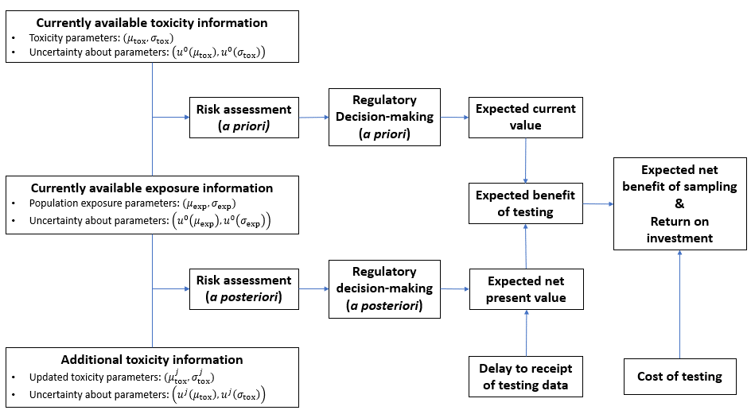

Figure 1: Components for a value of information analyses of toxicity-testing methodologies and associated information flows.

# User inputs and choices

The sections below refer to tabs.



Figure 2: User interface tabs.

## Decision Rules and Prior Uncertainty

### Decision Rules

In this application, the user can choose from 2 decision-making styles: target-risk based, and benefit-risk based decision-making.

The target-risk decision maker (TRDM) focuses on reducing risk when it exceeds the target risk level (TRL), while the benefit-risk decision maker (BRDM) is motivated to minimize the total social cost (TSC) by balancing the control cost and the achieved health benefit.

In order to be confident that the population risk is below the TRL, the TRDM would decide that no regulation is required if the upper quantile of the uncertainty distribution ($q_{UCL}$) of the average population risk to be below the TRL. Conversely, if the lower quantile of this distribution ($q_{LCL}$) was above the TRL, the TRDL would take action to reduce risk. If the uncertainty interval between the $\left(q_{LCL},q_{UCL}\right)$ includes the TRL, the TRDM would require additional data to decide whether risk reduction action is required.

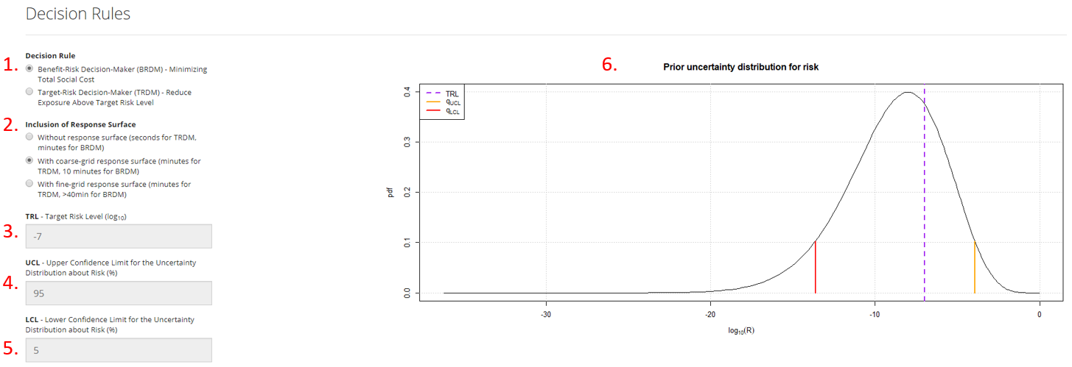

Figure 3: User inputs regarding decision rules and a plot of prior uncertainty distribution about risk.

1. **Decision Rule:** choose the decision-making style used for VOI analysis.
2. **Inclusion of Response Surface:** Choose whether response surface analysis be included. Response surface provides a visual representation of how the EVDSI changes across varying level of uncertainty reduction and testing time. If decision rule is set to BRDM, coarse-grid response surface will require about 10 minutes to compile, while fine-grid response surface will take more than 40 minutes to produce the report. For the choice of TRDM, inclusion of a response surface will result in minimal delay regardless of the level of resolution.
3. $TRL$**–Target Risk Level ($\log_{10}$):** *This parameter is used only under TRDM decision rule*. Specify the TRL to which the risk estimate is compared to determine whether exposure mitigation is required. Specified on the $\log_{10}$ scale.
4. $UCL$**– Upper Percentile for the Uncertainty Distribution about Risk:** *This parameter is used only under TRDM decision rule*. Specify the value to which the risk of a chemical is deemed “safe” compared to the TRL. When $q_{UCL}≤TRL$, the exposure mitigation is implemented under TRDM decision rule.
5. $LCL$**– Lower Percentile for the Uncertainty Distribution about Risk:** *This parameter is used only under TRDM decision rule*. A user-specified value to which the risk of a chemical is deemed “unsafe” compared to the TRL. When $q_{LCL}>TRL$, the exposure mitigation is implemented under TRDM decision rule.
6. **Prior Uncertainty Distribution for risk:** A plot of uncertainty distribution about $R$ without performing additional toxicity testing about a chemical. Given in $\log_{10}$ scale.

### Prior Hyperparameters – Toxicity

The population average risk ($R$) of a chemical is given as a function of its toxicity and population exposure. In this application we assume that the toxicity (i.e., dose-response model) is based on log-normal distribution with its geometric mean $μ_{tox}$ and geometric standard deviation $σ_{tox}$. Then, the toxicity of a chemical $G_{tox}(x|μ_{tox},σ_{tox})$– the probability of an adverse effect to be present at an exposure level $x$– is given by the CDF of a lognormal distribution with parameters $(μ_{tox},σ_{tox})$.

Furthermore, we also assume that we do not have perfect information about the toxicity of the chemical of interest at this point. The uncertainty surrounding these parameters is assumed also to follow a lognormal distribution. For the unknown parameter $μ_{tox}$, this means that the standard deviation of this uncertainty distribution is given by $u^{0}(μ_{tox})$.

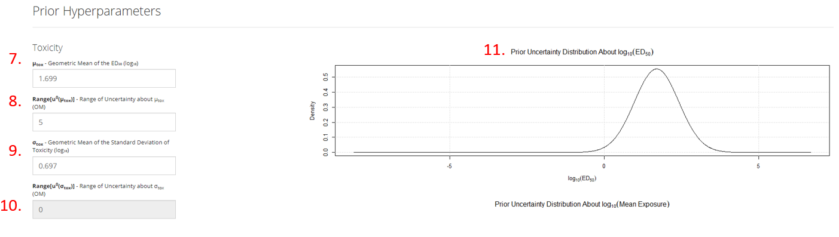

Figure 4: User inputs about toxicity parameters and a plot of prior uncertainty distribution about mean toxicity.

1. $μ_{tox}$**– Geometric Mean of the $ED_{50} (\log_{10})$:** The dose corresponding to the population average risk of 50%. Given in $\log_{10}$ scale.
2. $Range\left[u^{0}\left(μ_{tox}\right)\right]$**– Range of Uncertainty about the $ED_{50}$ (OM):** The range is defined to cover 99.975% of the uncertainty distribution, corresponding to $7.32u^{0}\left(μ_{tox}\right)$. Under the assumption that the uncertainty about $μ_{tox}$ follows a lognormal distribution, this range translates to $range=u^{0}(μ_{tox})$.
3. $σ_{tox}$**– Geometric Mean of the Standard Deviation of Toxicity $(\log_{10})$:** Under the assumption that the toxicity (i.e., dose-response model) follows the CDF of a lognormal distribution, this parameter governs the steepness of the dose-response curve. Given in $\log_{10}$ scale.
4. $Range\left[u^{0}\left(σ_{tox}\right)\right]$**– Range of Uncertainty about the Standard Deviation of Toxicity (OM):** The range is defined to cover 99.975% of the uncertainty distribution (corresponding to $7.32u^{0}\left(σ_{tox}\right)$). Under the assumption that toxicity of a chemical follows a lognormal distribution, this range translates to $range=u^{0}(σ_{tox})$. In the current iteration of the application, this value is set to 0 (i.e., no uncertainty present).
5. **Prior Uncertainty Distribution About $\log_{10}({ED}_{50})$:** A plot of uncertainty distribution about $μ_{tox}$ without performing additional toxicity testing about a chemical. Given in $\log_{10}$ scale.

### Prior Hyperparameters – Exposure

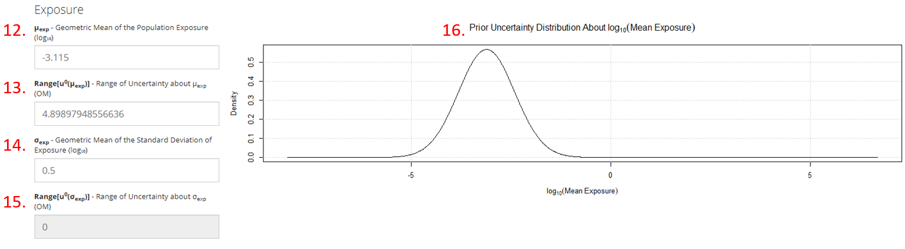

Figure 5: User inputs about population exposure and a plot of prior uncertainty distribution about mean exposure level.

1. $μ_{exp}$**– Geometric Mean of the Mean of Exposure $(\log_{10})$:** Geometric mean of the average population exposure to the chemical. Given in $\log_{10}$ scale.
2. $Range\left[u^{0}\left(μ_{exp}\right)\right]$**– Range of Uncertainty about the Mean of Exposure (OM):** The range is defined to cover 99.975% of the uncertainty distribution. Under the assumption that the population exposure follows a lognormal distribution, this range translates to $range=7.32σ$.
3. $σ_{exp}$**– Geometric Mean of the Standard Deviation of Exposure $(\log_{10})$:** Under the assumption that the population exposure follows a lognormal distribution, this parameter indicates the individual variation in exposure. Given in $\log_{10}$ scale.
4. $Range\left[u^{0}\left(σ_{exp}\right)\right]$**– Range of Uncertainty about the Standard Deviation of Toxicity (OM):** The range is defined to cover 99.975% of the uncertainty distribution. Under the assumption that population exposure to a chemical of interest follows a lognormal distribution, this range translates to $range=7.32σ$. In the current iteration of the application, this value is set to 0 (i.e., no uncertainty present).
5. **Prior Uncertainty Distribution About $\log_{10}(Mean Exposure)$:** A plot of uncertainty distribution about $μ_{exp}$. Given in $\log_{10}$ scale.

## Toxicity Testing Information

Figure 6: User inputs about toxicity tests A and B.

### Test A

1. $Range\left[u^{A}\left(μ_{tox}\right)\right]$**– Range of the Residual Uncertainty in Mean Toxicity (OM):** This parameter corresponds to the amount of uncertainty remained about $ED_{50}$ once the toxicity test A is conducted. The range is defined to cover 99.975% of the uncertainty distribution. Under the assumption that $ED_{50}$ follows a lognormal distribution, this range translates to $range=7.32σ$.
2. **Delay (Years):** The delay in decision-making process due to conducting and analyzing an additional toxicity test A.
3. **Cost Per Test (USD):** The cost of conducting a toxicity test A.

### Test B

1. $Range\left[u^{B}\left(μ_{tox}\right)\right]$**– Range of the Residual Uncertainty in Mean Toxicity (OM):** This parameter corresponds to the amount of uncertainty remained about $ED_{50}$ once the toxicity test B is conducted. The range is defined to cover 99.975% of the uncertainty distribution. Under the assumption that $ED_{50}$ follows a lognormal distribution, this range translates to $range=7.32σ$.
2. **Delay (Years):** The delay in decision-making process due to conducting and analyzing an additional toxicity test B.
3. **Cost Per Test (USD):** The cost of conducting a toxicity test B.

## Economic Parameters

In this tab, users can change a variety of parameters controlling the total health cost (THC), total control cost (TCC), and total social cost (TSC).

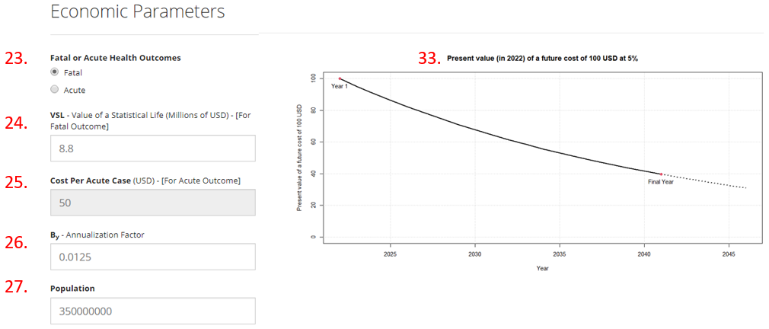

Figure 7: User inputs about adverse health outcomes and a plot of present value of a future value.

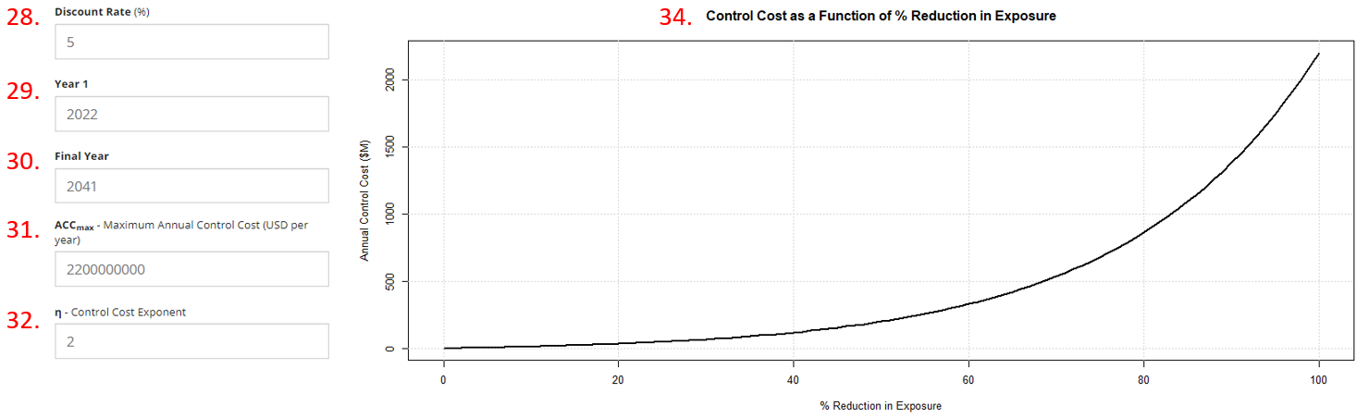

Figure 8: Remaining user inputs about economic parameters and a plot of control cost as a function of percentage reduction in exposure.

1. **Fatal or Acute Health Outcomes:** The user can choose whether the adverse effect due to exposure to a chemical is fatal or acute.
2. **VSL – Value of a Statistical Life (Millions of USD) – [For Fatal Outcome]:** *This value is used only when fatal outcome is chosen*. The default value of $8.8M is chosen as the standard VSL values accepted by USEPA, converted into 2016$.
3. **Cost Per Acute Case (USD) – [For Acute Outcome]:** *This value is used only when acute outcome is chosen*.

The default value of $50 is chosen to represent a restricted airway event, at a value of $50 per event.

1. $B_{y}$**– Annualization Factor:** A factor that converts the population average risk $R$ into annualized risk. For example, if the risk is defined as daily risk, then $B_{y}=365$ converts the risk into annualized risk.
2. **Population:** the default value of 350M represents the entire US population.
3. **Discount Rate (%):** The rate in which the present value of a future cost is discounted. The default value is set to 5%.
4. **Year 1:** This value represents the year in which the VOI calculation starts. The default value is set to 2022.
5. **Final Year:** This value represents the year in which the VOI calculation ends. The default value is set to 2041. The difference between Final Year and Year 1 gives the time horizon (20 years in this case).
6. $ACC_{max}$**– Maximum Annual Control Cost (USD per year):** The annual control cost to eliminate the chemical exposure.
7. $η$**– Control Cost Exponent:** Assuming that the control cost is a monotonically increasing function with respect to the proportional reduction in exposure, this parameter represents the steepness of such function. In particular, we set annualized control cost (ACC) be given by $ACC_{k}=ACC_{max}\left[{\left({10}^{ηk}-1\right)}/{\left({10}^{η}-1\right)}\right]$, where $k$ represents the percentage of reduction in exposure.
8. **Present value of a future cost of 100 USD:** A plot of present value of a future cost of 100 USD based on **Year 1**, **Final Year**, and **Discount Rate**.
9. **Control Cost as a Function of % Reduction in Exposure:** A graphical representation of control cost that increases with the increase in the proportional reduction in exposure. The relationship depends on parameters $ACC_{max}$ and $η$ as described in **item** **34**.

# Importing Data and Running the Analysis

1. **Select a Scenario:** Choose a scenario to run the analysis. If user adds additional scenarios, they will be added here.
2. **Load my Scenarios (optional):** Import additional scenarios by uploading own set of scenarios from the Excel spreadsheet (*.xlsx* format). This feature can be used after the user has downloaded a copy of their scenarios as per **Step 39** below.
3. **Create a New Scenario:** A new scenario with parameters given in input fields will be created under user-specified scenario name.
4. **Update Values:** Default values for existing (user-specified) scenario will be updated with parameters given in input fields. If the new scenario name is different from the one chosen from **Select a Scenario menu**, the scenario name will also be updated.
5. **Get a Copy of my Scenarios:** Download all user-specified scenarios in Excel spreadsheet (*.xlsx* format). Note that a new scenario must be created to activate this function. Note: the only way to save user-specified scenarios is to download the scenarios in the spreadsheet format. These then can be uploaded in subsequent sessions.
6. **Compute and Get Results:** Run the analysis using the parameters specified in input fields. Once the analysis is done, an *.html* output is produced.

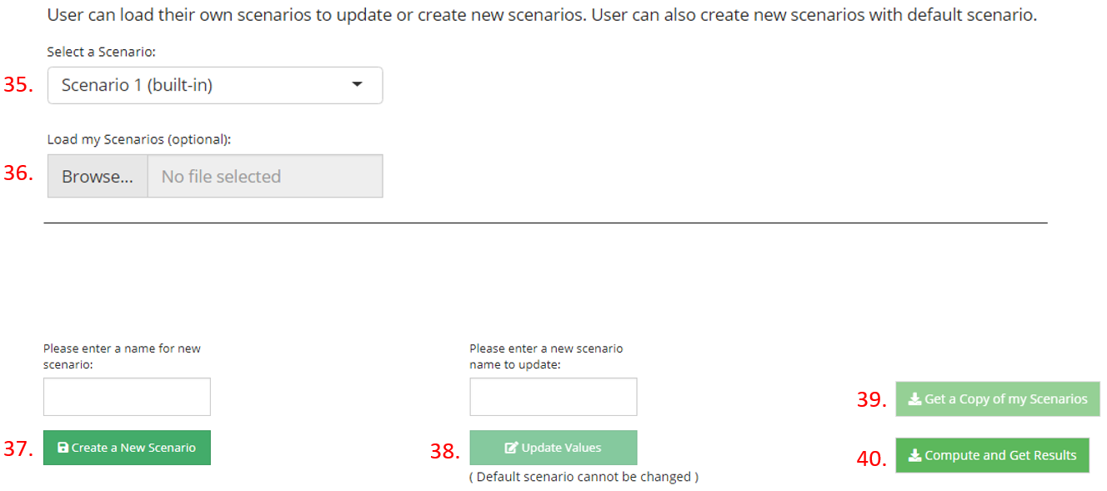

Figure 9: Importing, creating, and downloading input and running analysis.

# Output

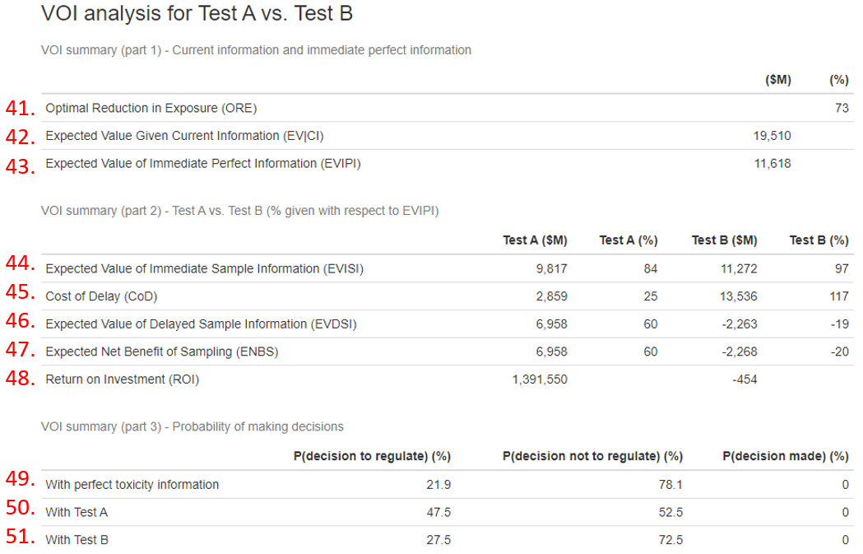

Figure 10: VOI summary tables from output html file.

## VOI Summary Table 1

1. **Optimal Reduction in Exposure (ORE):** *This parameter is used only under BRDM decision rule*. This is the exposure reduction that would minimize the ETSC across the prior uncertainty distribution. The minimized ETSC corresponds to EV|CI given below.
2. **Expected Value Given Current Information (EV|CI):** This is the expected cost (ETSC for BRDM, and ETHC for TRDM) for making the “best” decision based solely on currently available information.
3. **Expected Value of Immediate Perfect Information (EVIPI):** This is the expected reduction in ETSC or ETHC if the decision-maker will have access to perfect information without delay.

## VOI Summary Table 2

1. **Expected Value of Immediate Sample Information (EVISI):** This is the expected reduction in ETSC or ETHC by considering toxicity testing results via Test A or Test B. This value is bounded by EVIPI.
2. **Cost of Delay (CoD):** This is the loss in VOI due to a delay in decision-making from collecting and analyzing toxicity test results.
3. **Expected Value of Delayed Sample Information (EVDSI):** This is the expected reduction in ETSC or ETHC by considering toxicity testing results via Test A or Test B, including the delay in decision-making due to collection and analysis of a toxicity test. EVDSI is obtained by subtracting CoD from EVISI.
4. **Expected Net Benefit of Sampling (ENBS):** This value is calculated by subtracting the cost of obtaining and analyzing toxicity testing result from EVDSI. A positive ENBS implies that performing toxicity testing prior to making a decision is favourable, whereas negative ENBS values mean that the additional information collected does not provide sufficient value to offset the cost of testing.
5. **Return on Investment (ROI):** As the ratio of ENBS over cost of testing, ROI can provide the greatest value per dollar spent.

## VOI Summary Table 3

Under the presence of uncertainty about $R$, the TRDM requires assurance that the risk is above or below the TRL before concluding whether risk mitigation is, or is not, required. VOI summary table 3 provides the probabilities of (1) a decision made to regulate, (2) a decision made not to regulate, and (3) a decision made based on additional information. Similarly for BRDM, these probabilities are computed by checking how often $k>0$.

## Response Surface Analysis

The response surface provides a visual representation of how the amount of uncertainty reduction and the delay in decision-making affect the resulting VOI. This interactive plot allows the user to examine the relationship between delay in decision-making, amount of uncertainty reduced, and resulting EVDSI from various angles. As a reference, EVDSI values based on Test A and Test B are also plotted here. A table with corresponding EVDSI values is also provided.

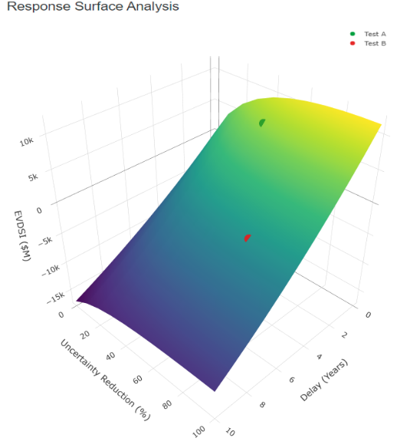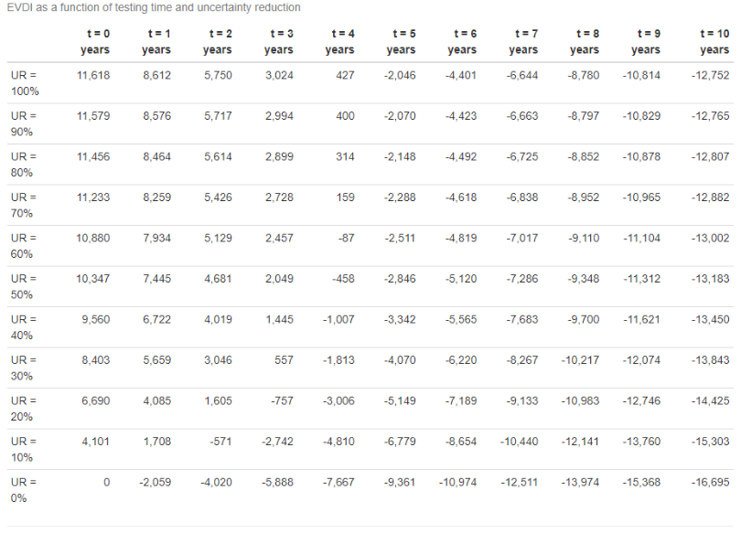

Figure 11: Response surface plot (left) and corresponding EVDSI table (right) from output html file.

## List of input parameters

The list of parameters used for the analysis is provided at the end of the output file as a reference.

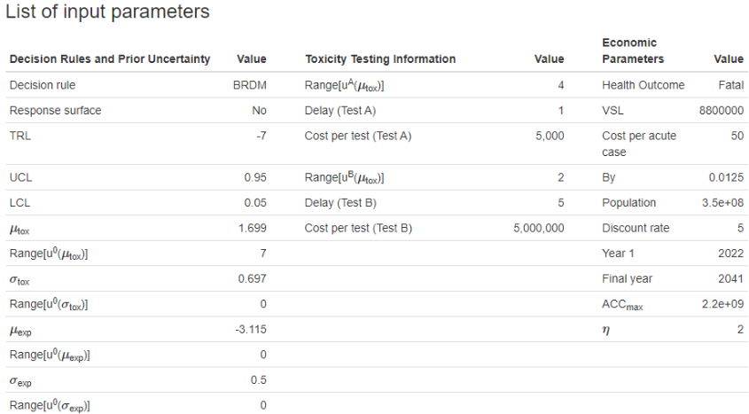

Figure 12: List of parameters used in the VOI analysis