# DSCI 5360 – Data Visualization

# Final Project

**Introduction:** This Report depicts the product and sales information of a Multinational company (name cannot be disclosed because of the confidentiality reasons). There are two tables namely Sales _final.txt and Ratings_final.txt which are joined through left join based on the attribute SKU to provide the “Effects of the Product parameters and performance against Transactions” as shown in the below screenshot.

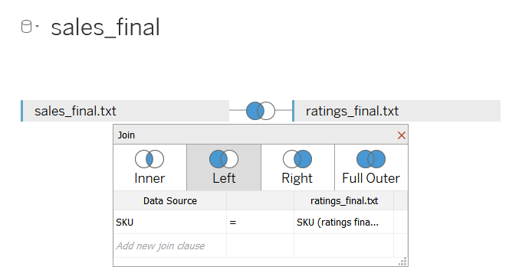

**Dataset:**

 

**Attribute Description:**

Ratings_final.txt consists of the following attributes:

**SKU:** A stock-keeping unit (SKU) is a scannable bar code, most often seen printed on product labels in a retail store.

**AvgRating:** This gives us the product rating which floats from 1 to 5.

**reviewCount:** Number of Reviews for a product.

Sales_final.txt consists of the following attributes:

**SKU:** A stock-keeping unit (SKU) is a scannable bar code, most often seen printed on product labels in a retail store

**Product:** Name of the product.

**Transactions:** it is the number of transactions that are more than one standard deviation above the average dollar value that this sku was involved in. It is a Boolean field where if ‘1’ occurs it is a big transaction and if it is a ‘0’ which means there is no Sale for the product.

**ClassID:** Category of the Product.

**LifeCycle:** It is a categorical field which gives the product information as follows FUT – Future; CUR – Current; RBY - Rebuy

**Color:** Different colors of the products.

**Season:** There are various seasons with the products transactions, respectively.

**Country of Origin**: It is the source country of manufacture/import

**Quartile:** Rankings of success based on sales

**Online:** This is also a Boolean field where if ‘1’ occurs the product is available online and if ‘0’ occurs which means the product is not available online.

**Volume:** The volume of the product.

**Density:** Density of the product.

**Analysis:**

**Story:**

**Effects of the product parameters against Transactions:**

This story is built using two dashboards namely “Quartile and Cluster Analysis” and “Review Analysis” which provides the analysis based on Drill Down Method where we can observe multiple visualizations on Transactional Variations according to the Product Parameters and Ratings.

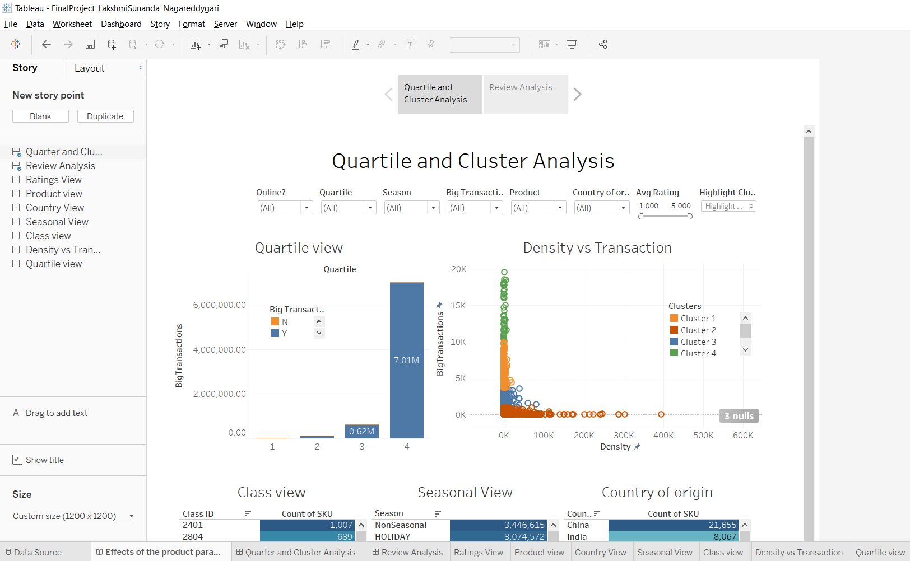

We can observe that if we filter only for the products of the Highest Success (Quartile 4) we can get the information of the number of big transactions which means Sales respective to the density of the product, also provides the Sales according to the Class ID with its respective Count of SKU (Class View), Sales against Seasons (Seasonal View), Country of Origin with its respective Count of SKU (Country View) and the Product View which consists of the details of the Product as screenshot shown below.

Similarly, we can filter for the products according to Quartile wise, Density (Cluster wise).

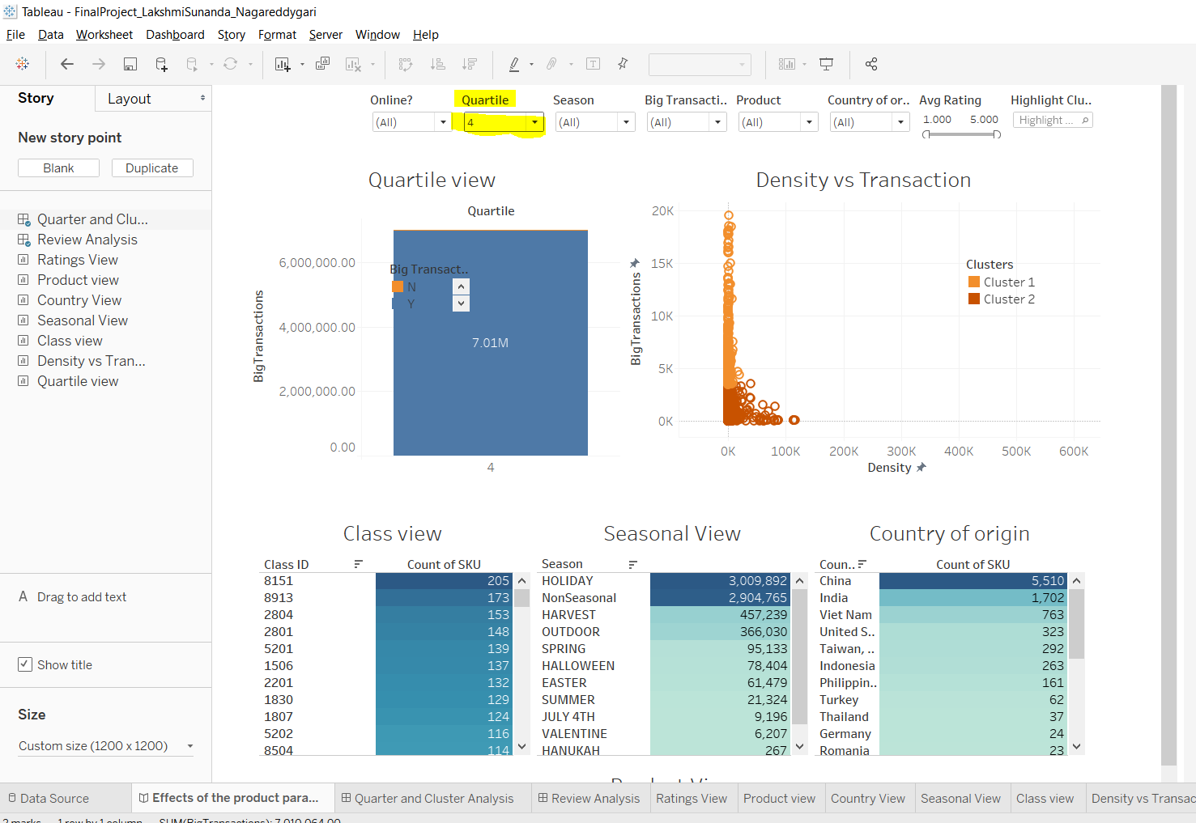

We can also depict the Review analysis for the products according to their Ratings. We can observe with respect to the Quartiles or Seasonal wise or according to the ratings and Country wise.

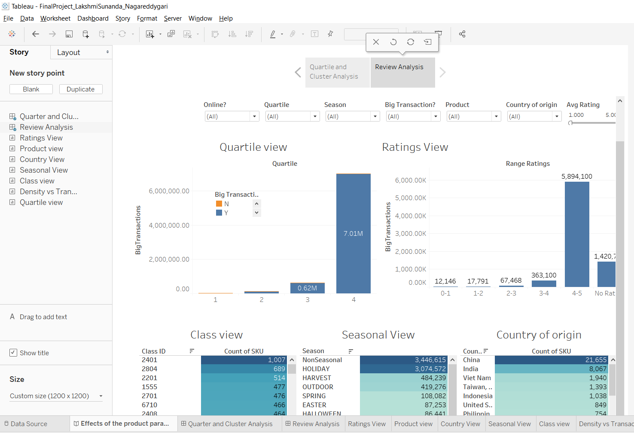

For example, we can filter all the transactions for the ratings 4-5 as shown in the below screenshot.

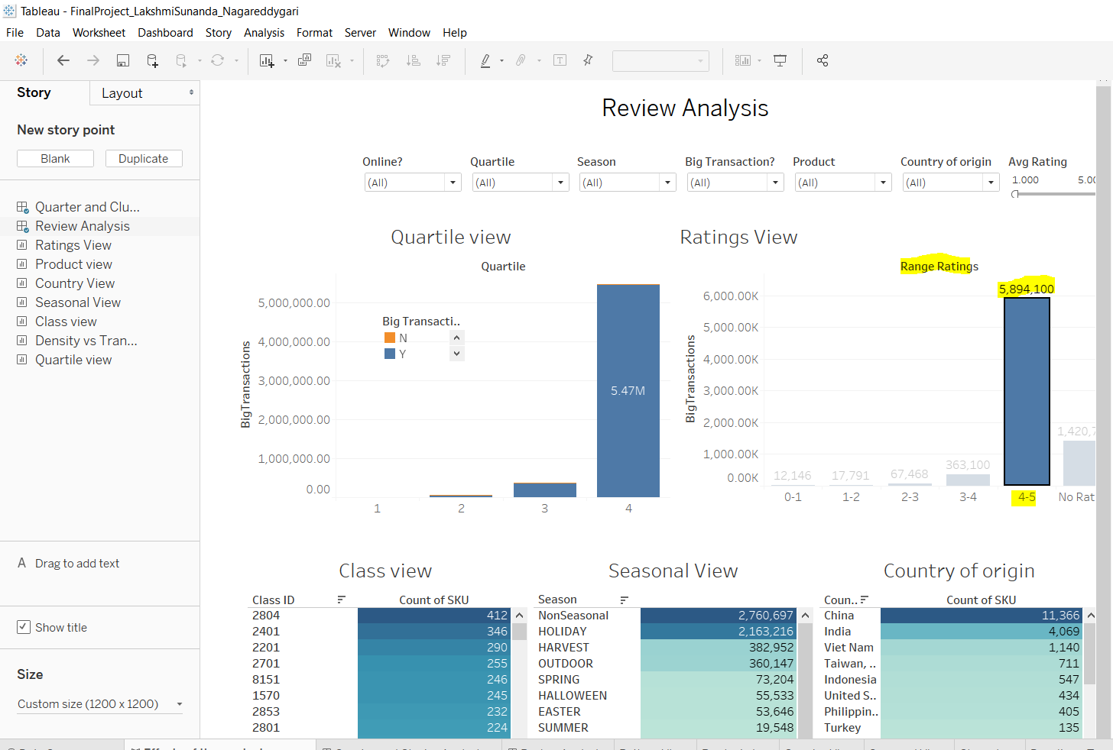

We can find the details of all these dashboards and multiple visualizations below.

**Dashboards:**

**Quartile and Cluster Analysis:**

This Dashboard is built in order to observe how the product attributes are affecting the BigTransactions with respective to all other Attributes of the products.

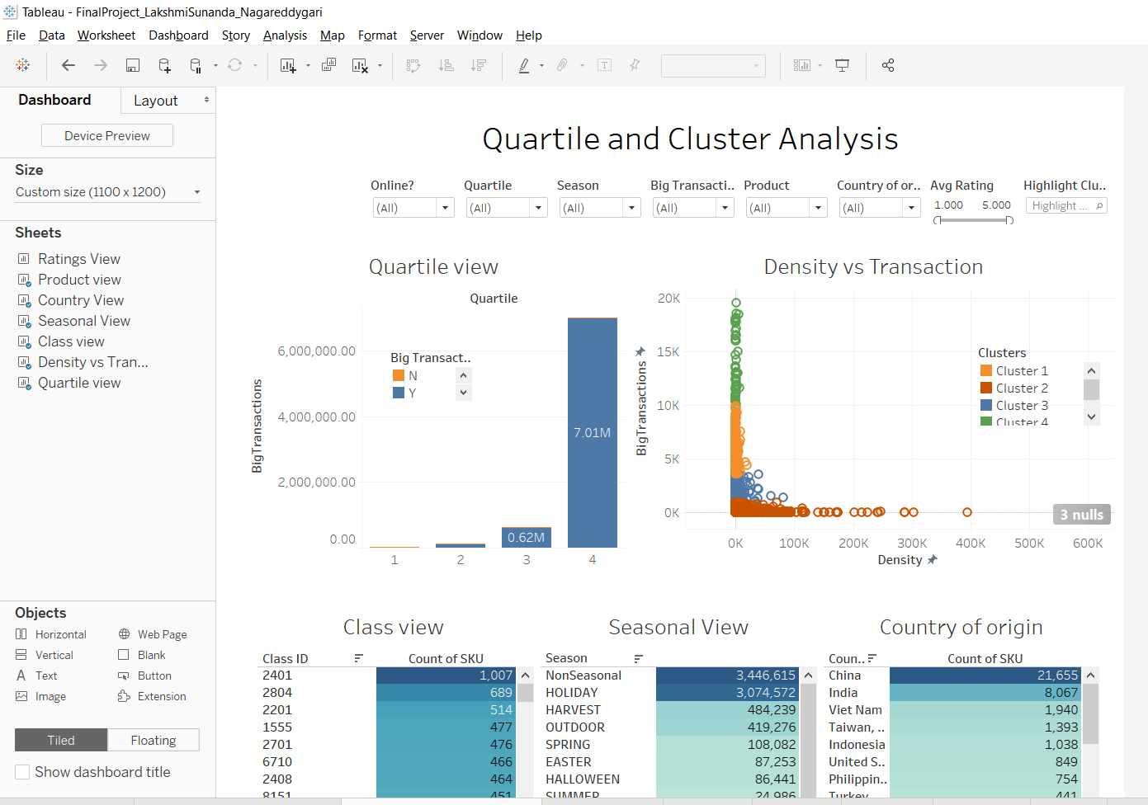

**Review Analysis:**

This Dashboard is built in order to observe how the Ratings are affecting the Big Transactions with respective to all other Attributes of the products

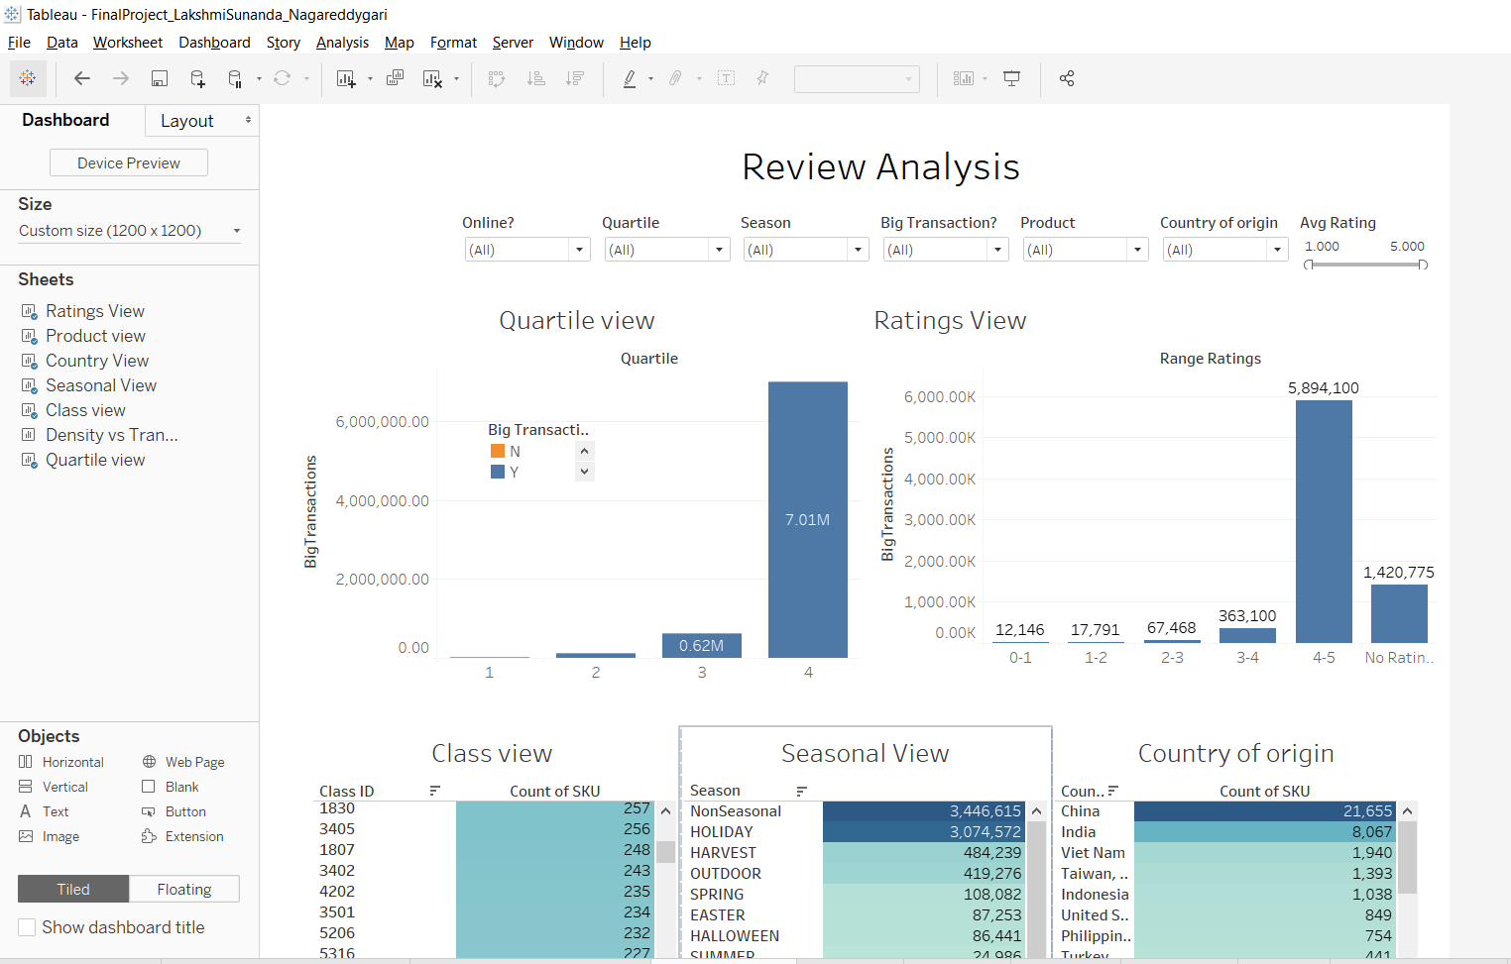

**Multiple Visualizations:**

**Density vs Transaction:**

The visualization below shows clustering based on Density and Big Transactions. The items with greater no. of big transactions, tend to have smaller densities with respect to the colors as shown below.

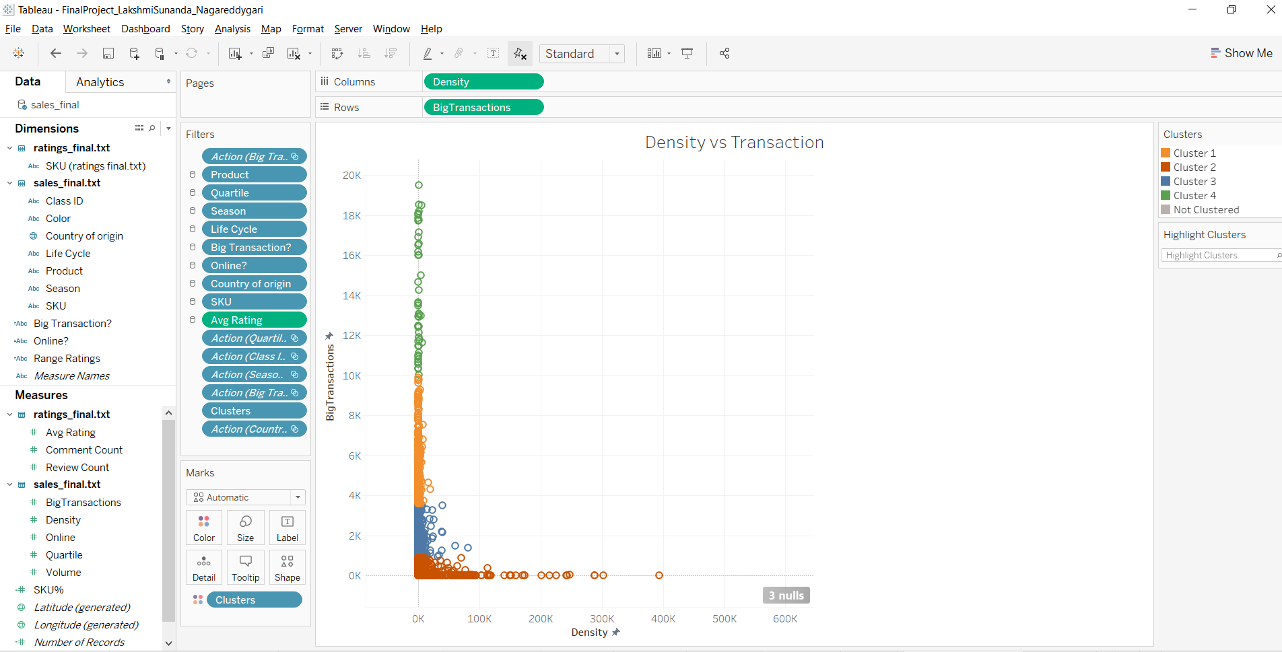

**Ratings View:**

The visualization below shows that products with high rating also have a large number of big transactions.

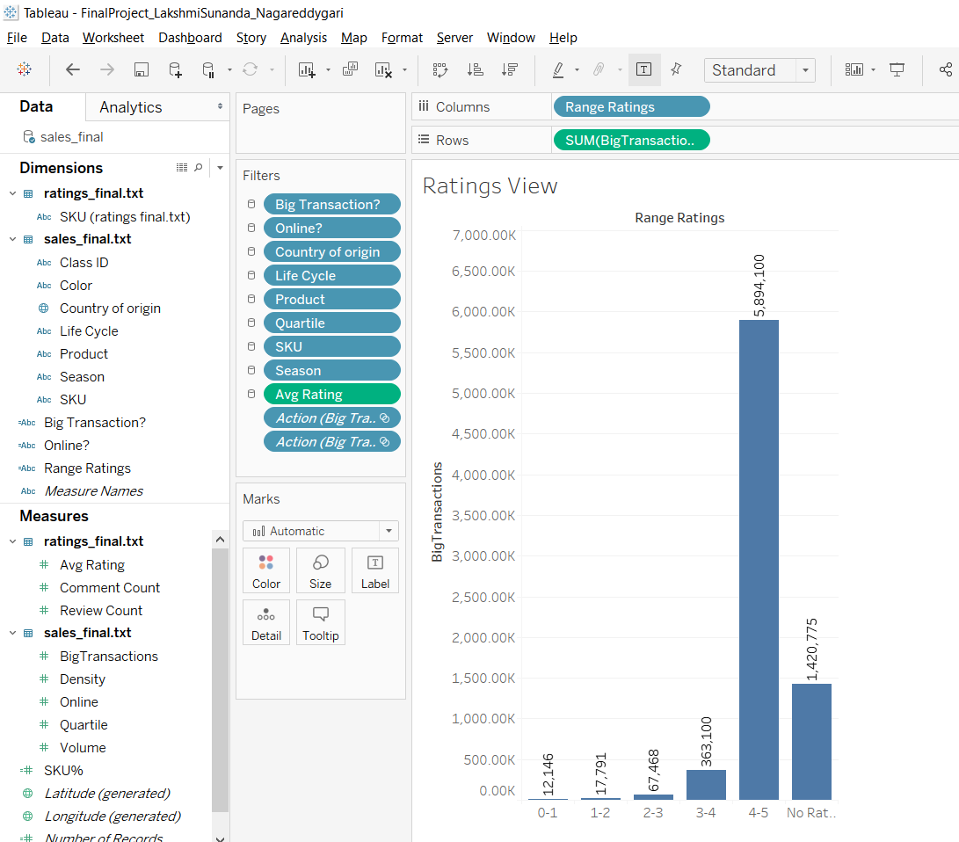

**Quartile View:**

Created this Visualization to identify the Ranking of Success based on Sales.

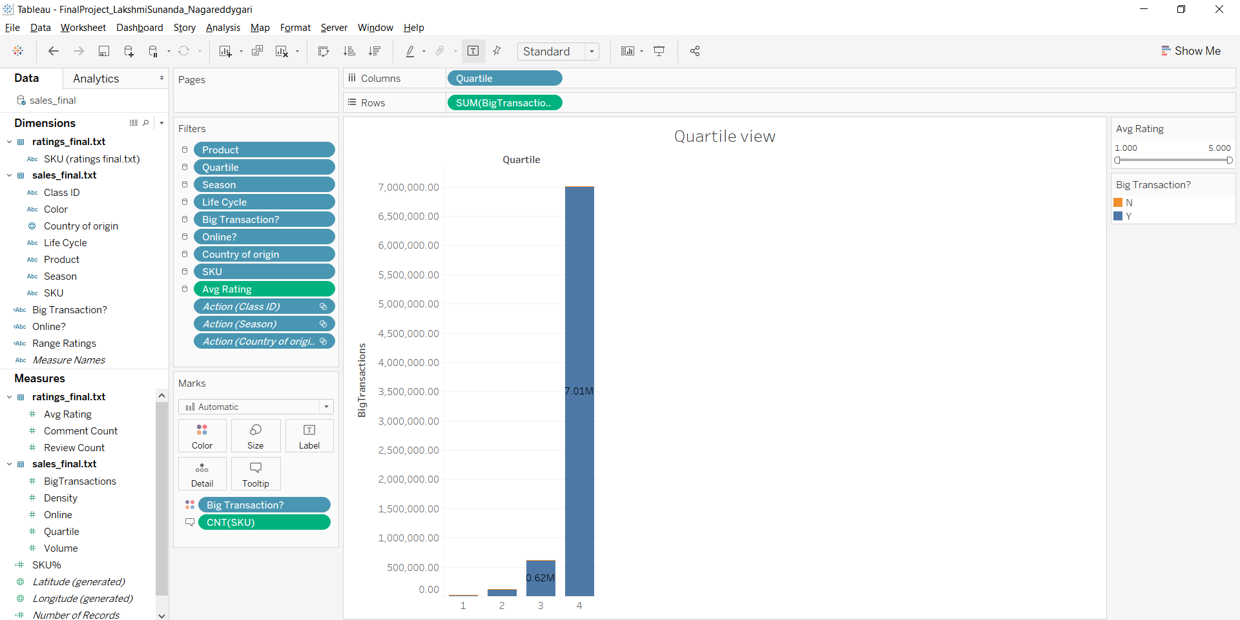

**Product View:**

This visualization is created to provide with the Product Attributes namely Class ID, SKU, Product Name, Avg Rating.

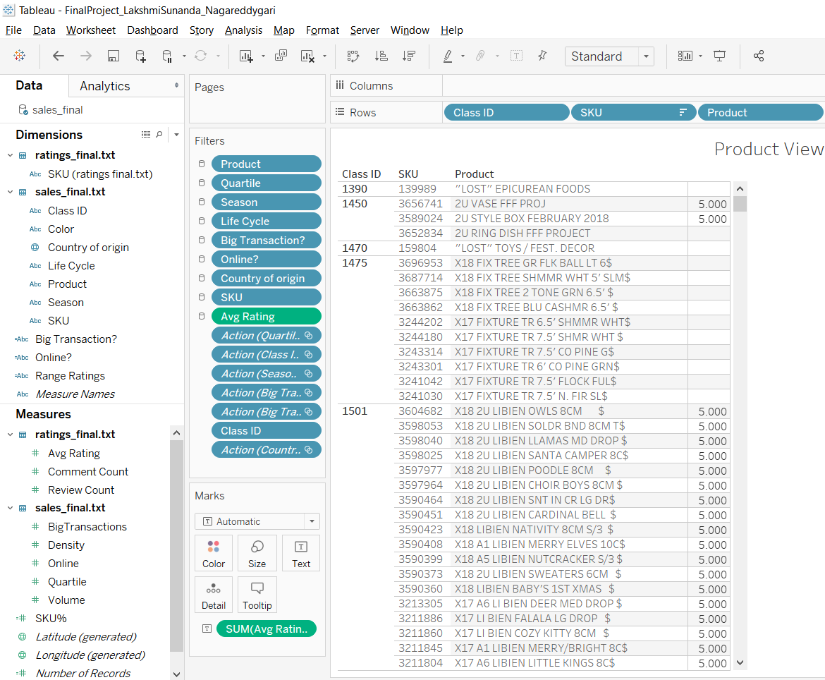

**Country View:**

This visualization is created to provide the Country of origin with the Count of SKU. Country of Origin is the source country of manufacture/import.

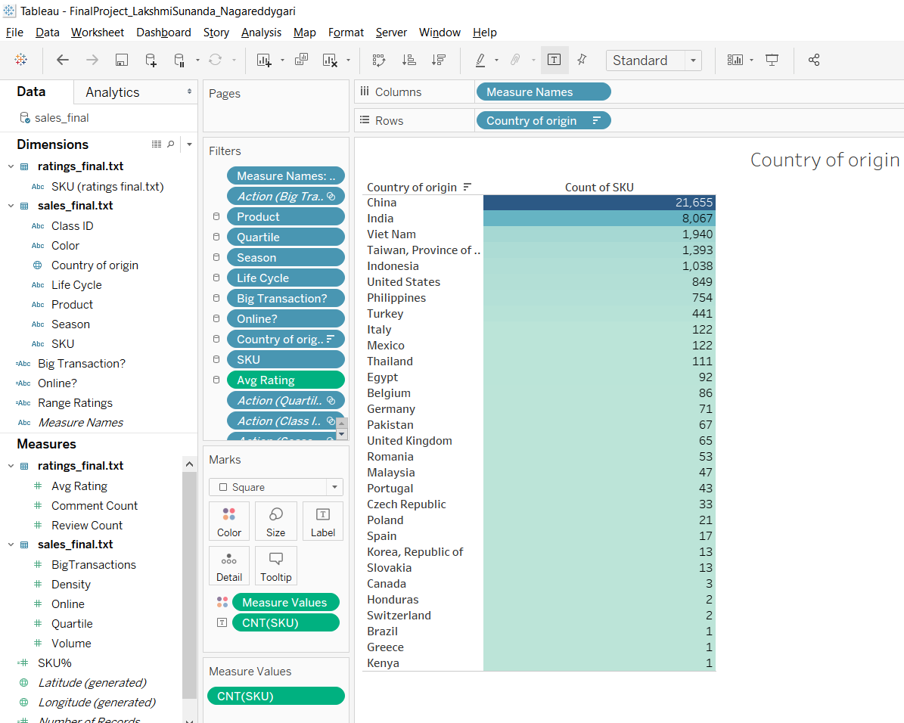

**Seasonal View:**

We can identify the Transactions of the Products according to the Seasons as shown in the below screenshot.

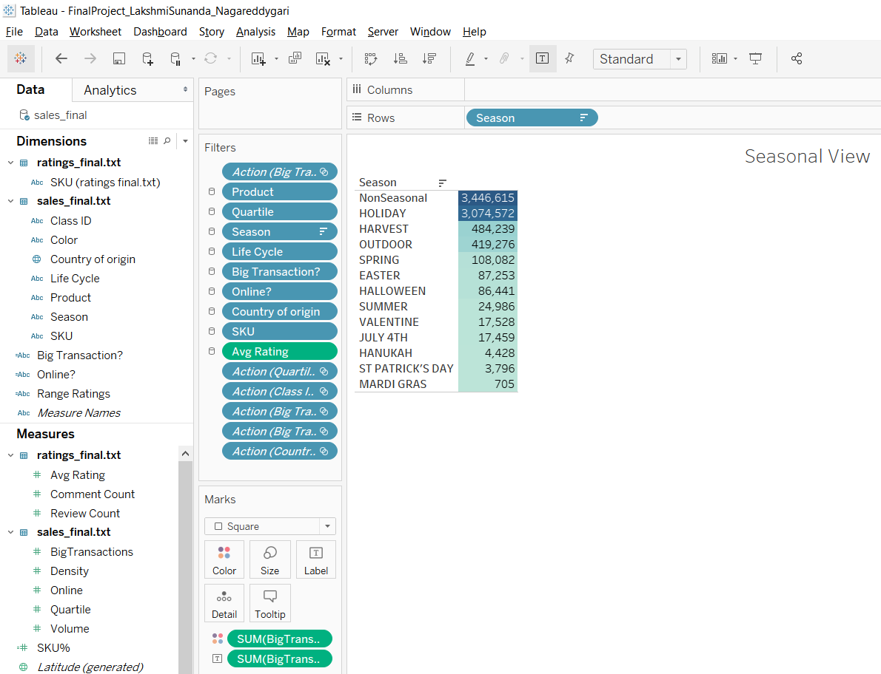

**Class View:**

We can identify which class of products yield the best profit.

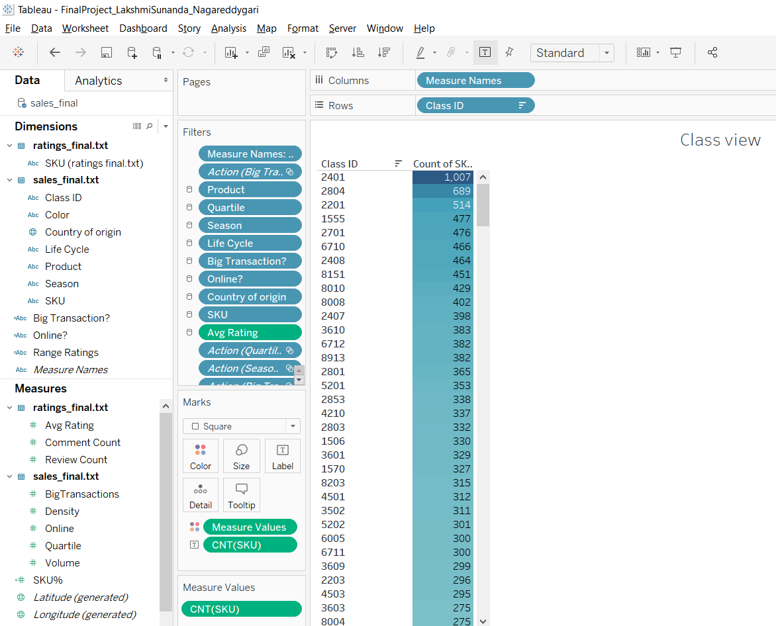

**Business Implications:**

By using this report, we can know all the Sales of each Product with which we can determine how each product is affecting the Company Success.

Created multiple visualizations, added the views into the dashboards to analyze and deep down on the target data and to answer many queries regarding the product.

**Conclusion:**

This Report helps us to easily filter the Success of every product of the Company based on its parameters and performance. We can observe all the categories related to the Success or failure rate of the product. We can find how the online reviews affect the products transactions.