***Assignment1***

***DSCI 5350***

***Lakshmi Sunanda Nagareddygari***

1. **Correctly process and store the files in Hive. All tables created for the solution must have your student_id as a prefix to table name. For example, if I were to store the dictionary table, I would name it dictionary_ks0776**

**SOLUTION:**

create table json_data_ln0197 (dump string);

load data local inpath '/home/training/Desktop/Assignment1/Twitter.json' into table json_data_ln0197;

Below screenshot depicts the twitter data loaded to the table “json_data_ln0197”.

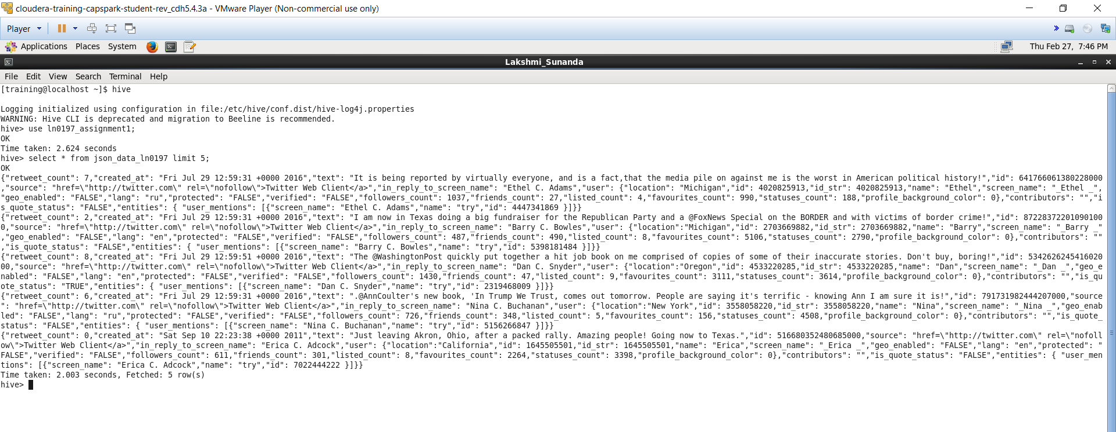

create table json_project_ln0197(

retweet_count int,

create_time_stamp string,

tweets string,

id bigint,

source string,

location string,

user_id bigint,

name string,

screen_name string,

geo_enabled string,

lang string,

protected string,

verified string,

followers_count bigint,

friends_count int,

listed_count int,

favourites_count int,

statuses_count int,

profile_background_color int,

contributors string,

is_quote_status string,

screen_name_re string,

name_re string,

id_re string);

insert into table json_project_ln0197 select

get_json_object(dump,'$.retweet_count') as retweet_count,

get_json_object(dump,'$.created_at') as created_time_stamp,

get_json_object(dump,'$.text') as tweets,

get_json_object(dump,'$.id') as id,

get_json_object(dump,'$.source') as source,

get_json_object(dump,'$.user.location') as location,

get_json_object(dump,'$.user.id') as user_id,

get_json_object(dump,'$.user.name') as name,

get_json_object(dump,'$.user.screen_name') as screen_name,

get_json_object(dump,'$.user.geo_enabled') as geo_enabled,

get_json_object(dump,'$.user.lang') as lang,

get_json_object(dump,'$.user.protected') as protected,

get_json_object(dump,'$.user.verified') as verified,

get_json_object(dump,'$.user.followers_count') as followers_count,

get_json_object(dump,'$.user.friends_count') as friends_count,

get_json_object(dump,'$.user.listed_count') as listed_count,

get_json_object(dump,'$.user.favourites_count') as favourites_count,

get_json_object(dump,'$.user.statuses_count') as statuses_count,

get_json_object(dump,'$.user.profile_background_color') as profile_background_color,

get_json_object(dump,'$.contributors') as contributors,

get_json_object(dump,'$.is_quote_status') as is_quote_status,

get_json_object(dump,'$.entities.user_mentions.screen_name') as screen_name_re,

get_json_object(dump,'$.entities.user_mentions.name') as name_re,

get_json_object(dump,'$.entities.user_mentions.id') as en_id from json_data_ln0197;

Below Screenshot depicts data load to the table I have created with proper columns and data types respectively.

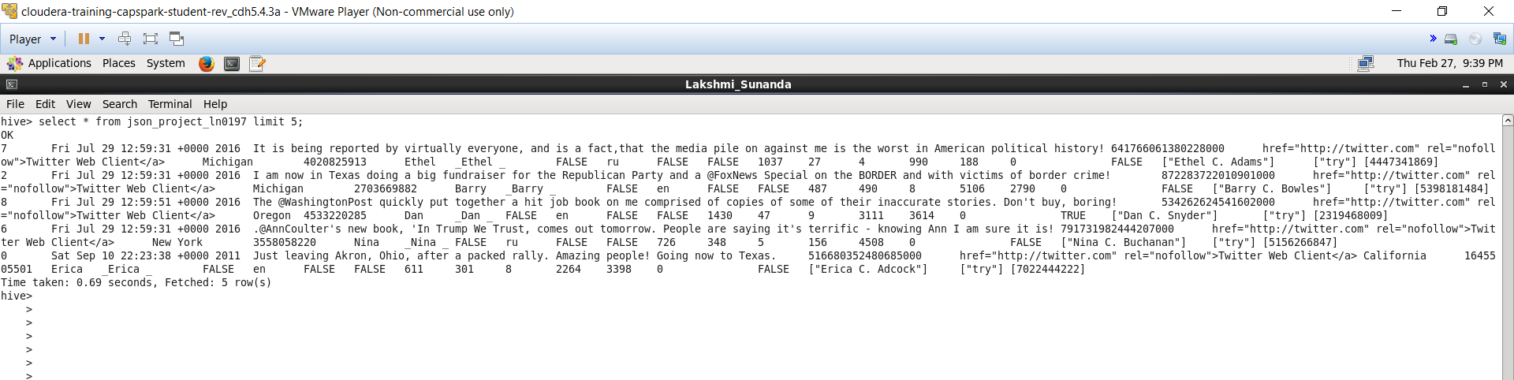

create table hash_dictionary_ln0197(word string,rating int)

row format delimited

fields terminated by ','

lines terminated by '\n';

load data local inpath 'home/training/Desktop/Dictionary.txt' into table hash_dictionary_ln0197;

Below screenshot depicts all the dictionary data loaded to the table “hash_dictionary_ln0197”

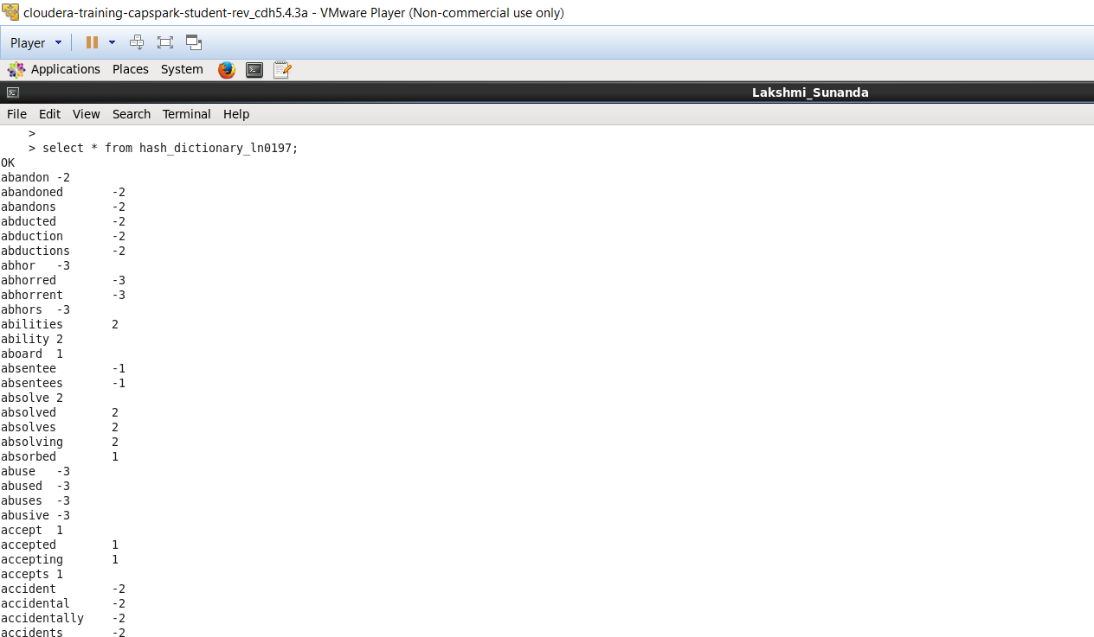

create table split_words_ln0197 as select id as id,split(tweets,' ') as words from json_project_ln0197;

Below screenshot depicts with the data of the tweet words which are split.

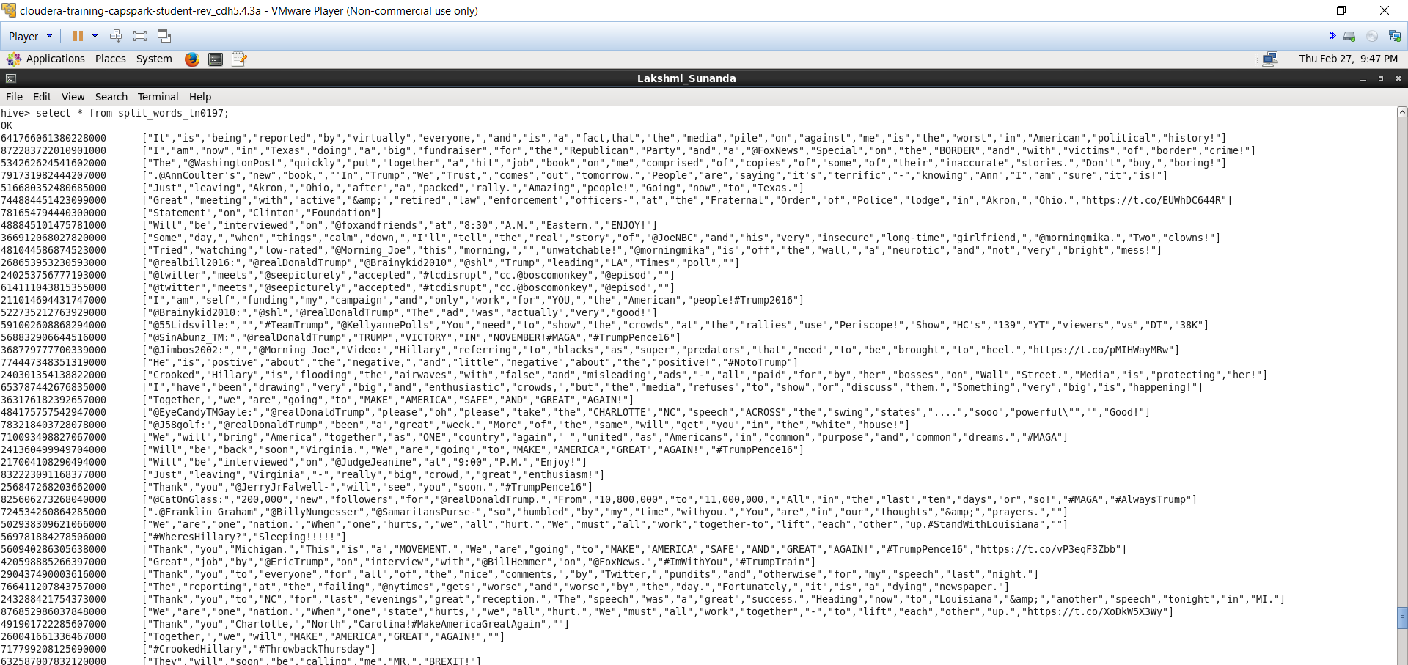

create table tweet_word_ln0197 as select id as id,word from split_words_ln0197_ln0197 LATERAL VIEW explode(words) w as word;

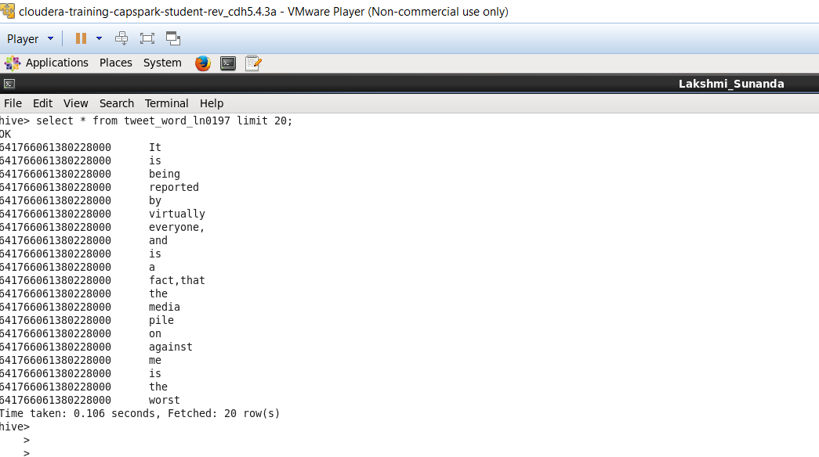

**2. Using the files provided, answer the following:**

**a. What were the hashtags used in the file, and how many times each hashtag was used? (10 points)**

SOLUTION:

create table hash_extract_ln0197 as select id,regexp_extract(word,'^#.+',0) as hash from tweet_word_ln0197 where word=regexp_extract(word,'^#.+',0) and word<>'';

table hash_cleaning1_ln0197 as select id as id,split(hash,'#') as hash_clean from hash_extract_ln0197;

create table hash_cleaning2_ln0197 as select id ,hash from hash_cleaning1_ln0197 LATERAL VIEW explode(hash_clean) h as hash where hash<>'';

create table hash_cleaning3_ln0197 as select id ,regexp_replace(hash,'[,:\\!-:."?]|https//t.co/wnpVlq6oe4|https//t.co/Eph6qy7zyB','') as final_clean from hash_cleaning2_ln0197 where id<>106841024367780000;

create table hash_count_ln0197 as select count(final_clean) as hash_count, final_clean from hash_cleaning3_ln0197 group by final_clean;

Below screenshot depicts with the data of the word and the count the word has been used to tweet.

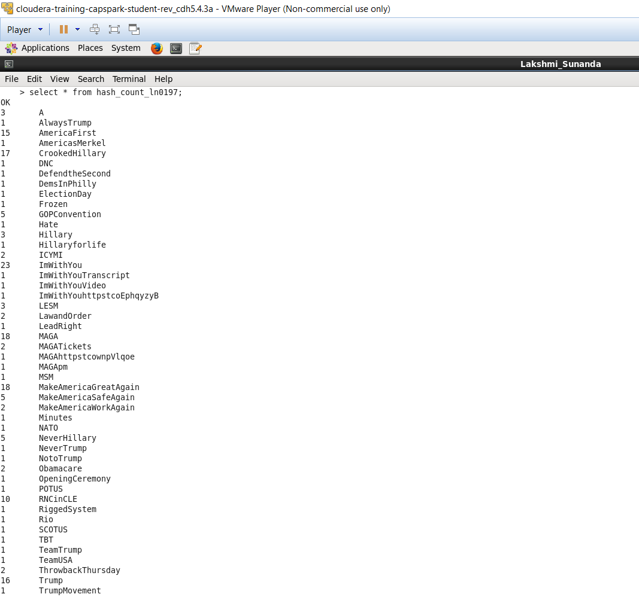

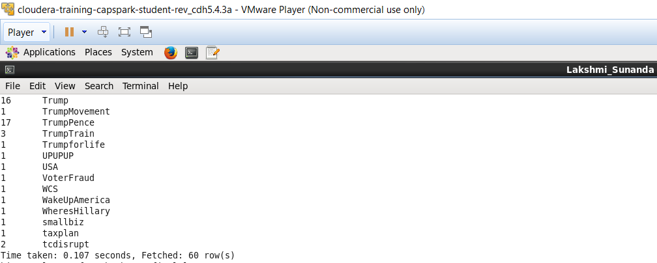

**b. Identify the most trending hashtag by the day. How many times the most trending hashtag was tweeted? (10 points) [Note: day should be in the format ‘yyyy-mm-dd’]**

**SOLUTION:**

create table hash2_ln0197 as select hc.id,hc.final_clean,from_unixtime(unix_timestamp(regexp_replace(js.create_time_stamp,'^\\w{3}\\s|\\s\\d+:\\d+:\\d+\\s|\\+\\d{4}|\\s',''),'MMMddyyyy'),'yyyy-MM-dd') as date from hash_cleaning3_ln0197 hc inner join json_project_ln0197 js on hc.id=js.id;

create table count1_ln0197 as select date,final_clean,count(final_clean) as count from hash2_ln0197 group by date,final_clean;

create table max_count_ln0197 as select date,max(count) as max_count from count1_ln0197 group by date;

create table hash_max_final_ln0197 as select hm.date,hm.max_count,hc.final_clean from max_count_ln0197 hm left outer join count1_ln0197 hc on hm.date=hc.date where hm.max_count=hc.count;

Below screenshot depicts with the data of the count the most trending hashtag was tweeted.

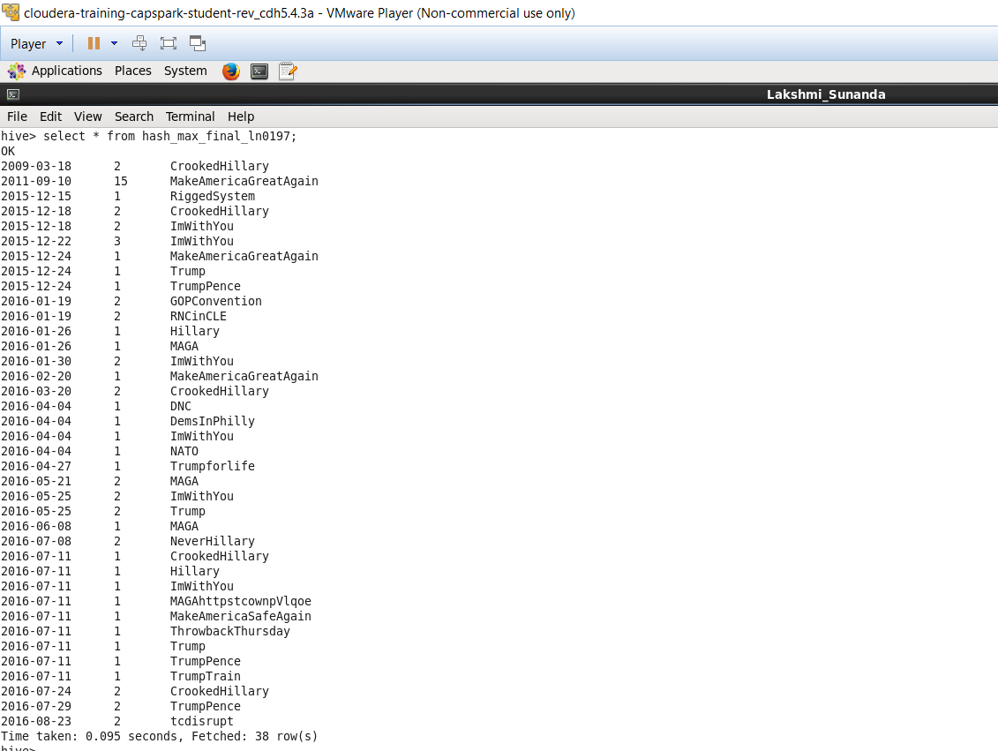

**c. Determine the score for each tweet that was posted? Identify whether the tweet had a positive or negative sentiment? Use the dictionary.txt file for determining the score. Note: Include the date (’yyyy-mm-dd’), tweet_id, user_name, and the score in the resulting query.**

**SOLUTION:**

create table att1_ln0197 as select tw.id,from_unixtime(unix_timestamp(regexp_replace(js.create_time_stamp,'^\\w{3}\\s|\\s\\d+:\\d+:\\d+\\s|\\+\\d{4}|\\s',''),'MMMddyyyy'),'yyyy-MM-dd') as date,regexp_replace(tw.word,'[@#.,\\!-?:"]','') as word from tweet_word_ln0197 tw inner join json_project_ln0197 js on tw.id=js.id;

create table att11_ln0197 as select at.id,at.date,at.word,COALESCE(hd.rating, 0 ) as rating from att1_ln0197 at left outer join hash_dictionary_ln0197 hd on at.word=hd.word;

create table att3_ln0197 as select id,sum(rating) as final_rating from att11_ln0197 group by id;

create table final_ln0197 as select a.id,js.user_id,a.final_rating,from_unixtime(unix_timestamp(regexp_replace(js.create_time_stamp,'^\\w{3}\\s|\\s\\d+:\\d+:\\d+\\s|\\+\\d{4}|\\s',''),'MMMddyyyy'),'yyyy-MM-dd') as create_time_stamp, regexp_replace(regexp_replace(regexp_replace(final_rating,'^0','neutral') ,'^-\\d','negative'),'^\\d','positive') as sentiment from att3_ln0197 a inner join json_project_ln0197 js on a.id=js.id;

Below screenshot depicts the data whether the tweet had a positive or negative sentiment.

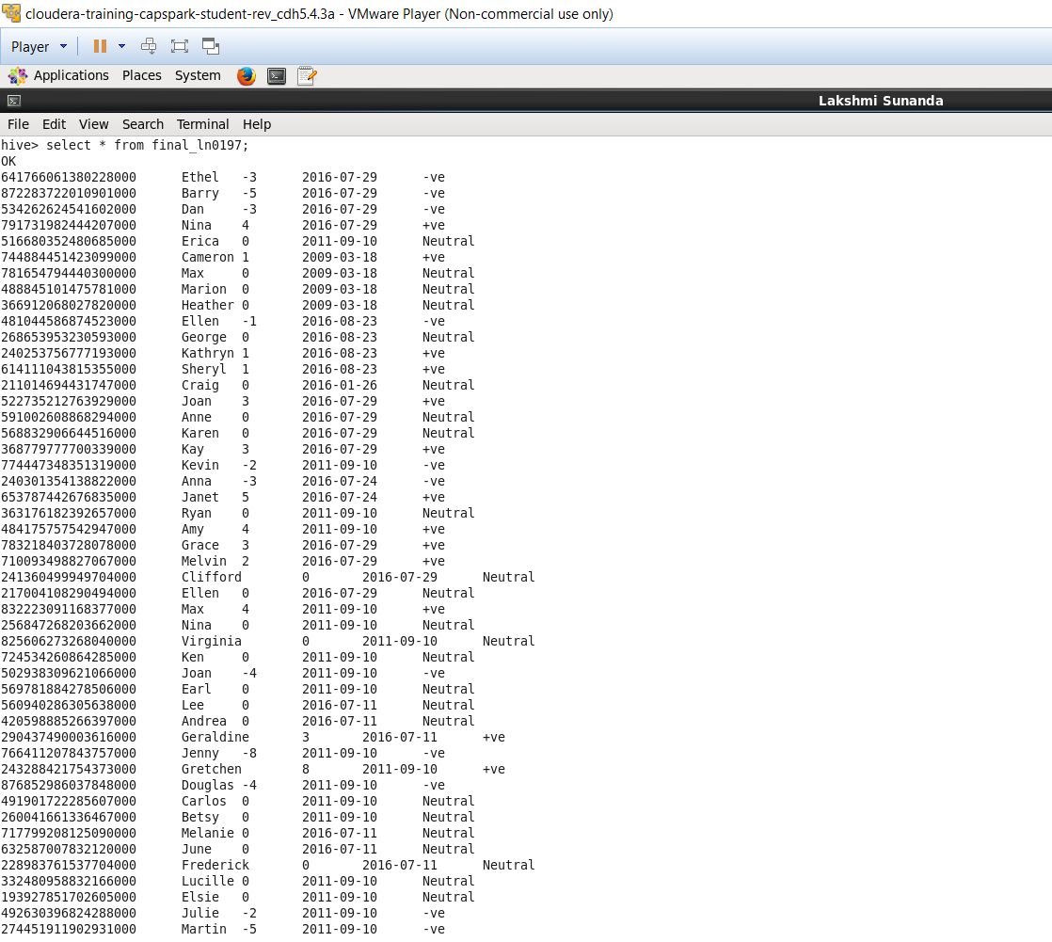

1. **Propose a better solution for the sentiment analysis as compared to 1(c). Cite the source. (5 points) Note: You just need to provide the solution, you are not required to solve the problem using the solution.**

**SOLUTION:**

We can solve sentimental analysis using two approaches Machine Learning and Dictionary Approach. We used Dictionary Approach.

The best ways are through Natural Processing Algorithms. Natural language processing also known as text analytics or data mining, uses software to analyze words and extract their actual meanings. It takes emotion and context into consideration and adheres to a set of rules developed as a result of identified patterns and themes in language.

This analysis can also be possible by implementing Machine Learning Methodologies so as it can learn itself on premise of what words were utilized, how often they were utilized and attempts to comprehend the situation in which they were utilized.

Below is the link which tells a way to use Natural Processing Algorithms for Sentiment Analysis.

<https://casmodeling.springeropen.com/articles/10.1186/s40294-016-0016-9>