Nishanth Lam

10/9/2022

CS 4395

Assignment 6 : Report

I created my knowledge base by cleaning the scraped documents and printing out the 40 most common tokens. I then went through the 40 most common tokens and picked the ones that I felt are relevant or would be useful when designing a chatbot that gives appropriate responses. I then created a python dictionary where the key is the topic, and the value is a list of tokens that may be used in an appropriate answer when talking about that topic. This dictionary will serve as my knowledge base. The tokens I choose are: director, film, original, hollywood, awards, films, academy, inception, batman, tenet, knight, screenplay, foreign, coen, and critics. Picture of the full knowledge base below.

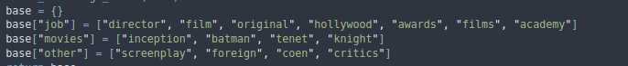

Sample Dialog:

User: What does Christopher Nolan do?

Bot: He is a film director working in hollywood.

User: What are soome movies directed by christopher nolan?

Bot: Christoper Nolan has directed inception, tenet, and the dark knight batman films.

User: What else has Christopher Nolan done?

Bot: Christopher Nolan has written various screenplays, worked in foreign film, and worked on movies with the coen brothers.