21 Day Alpha Breathwork Challenge Guide for Men Over 40



21 Days To Stress Management, Improved Mental Focus, Less Anxiety, Better Sleep and Overall Health

Brought To You By Funk Roberts & Over 40 Alpha



This manual is copyrighted by Marc “Funk” Roberts. All Rights Reserved. No part of this manual may be reproduced or transmitted in any form or by any means, electronic or mechanical, including photocopying, recording, or by any information storage and retrieval system. Images, text, graphics, and other intellectual property are protected by United States and International Copyright Laws, and may not be copied, reprinted, published, reengineered, translated, hosted, reproduced, or otherwise distributed by any means without explicit permission. You may not copy, modify, create derivative works of, publicly display or perform, republish, store, transmit, or distribute any of the material in this video without the prior written consent of Marc “Funk” Roberts. Fines start at $150,000 and include a possible prison sentence upon conviction.
Copyright 2024

Medical Disclaimer
Please Note: The recommendations in this and any other document are not medical guidelines but are for educational purposes only. You must consult your physician prior to starting this or any other program or if you have any medical condition or injury that can possibly worsen with physical activity. This program is designed for healthy individuals 18 years and older only. The information in this document is meant to supplement, not replace, proper exercise training.
All forms of exercise pose some inherent risks. Marc “Funk” Roberts, or anyone associated with Funk Roberts Fitness Ltd advises readers to take full responsibility for their safety and know their limits. Before partaking in the exercises in this or any other program, be sure that your equipment is well maintained, and do not take risks beyond your level of experience, aptitude, training and fitness. The exercises and dietary programs in this book are not intended as a substitute for any exercise routine or treatment or dietary regimen that may have been prescribed by your physician. Don’t lift heavy weights if you are alone, inexperienced, injured, or fatigued. Don’t perform any exercise unless you have been shown the proper technique by a certified fitness trainer or certified strength and conditioning specialist. Always ask for instruction and assistance when lifting. Don’t perform any exercise without proper instruction.
Always do a warm-up prior to any exercise including but not limited to interval training. See your physician before starting any exercise or nutrition program. If you are taking any medications, you must talk to your physician before starting any exercise program, including but not limited to Funk Roberts Fitness. If you experience any light-headedness, dizziness, or shortness of breath while exercising, stop the movement and consult a physician immediately. You must have a complete physical examination if you are sedentary, if you have high cholesterol, high blood pressure, or diabetes, if you are overweight, or if you are over 30 years old. Please discuss all nutritional changes with your physician or a registered dietician. If your physician recommends that you don’t use this or any other program, please follow your doctor’s orders.

Waiver & release of liability
(READ CAREFULLY BEFORE PERFORMING ANY EXERCISES IN THIS MANUAL)
I UNDERSTAND AND ACKNOWLEDGE THAT THERE ARE RISKS INVOLVED
IN PARTICIPATING IN ANY EXERCISE PROGRAM AND / OR ANY EXERCISES CONTAINED WITHIN THIS MANUAL IN CONSIDERATION FOR BEING ALLOWED TO UTILIZE THE INFORMATION IN THIS MANUAL, I AGREE THAT I WILL ASSUME THE RISK AND FULL RESPONSIBILITY FOR DETERMINING THE NEED FOR MEDICAL CLEARANCE FROM MY PHYSICIAN AND OBTAINING SUCH CLEARANCE, THE SAFETY AND/OR EFFICACY OF ANY EXERCISE PROGRAM RECOMMENDED TO ME, AND ANY AND ALL INJURIES, LOSSES, OR DAMAGES, WHICH MIGHT OCCUR TO ME AND / OR TO MY FAMILY WHILE UTILIZING THE INFORMATION IN THIS MANUAL AND TO THE MAXIMUM EXTENT ALLOWED BY LAW I AGREE TO WAIVE AND RELEASE ANY AND ALL CLAIMS, SUITS, OR RELATED CAUSES OF ACTION AGAINST FUNK ROBERTS FITNESS, INC FUNK ROBERTS, AND ,THEIR EMPLOYEES, FOR INJURY, LOSS, DEATH, COSTS OR OTHER DAMAGES TO ME, MY HEIRS OR ASSIGNS, WHILE UTILIZING ALL THE INFORMATION OR PARTAKING IN THE EXERCISES CONTAINED WITHIN THIS MANUAL OR VIDEO LIBRARY. I FURTHER AGREE TO RELEASE, INDEMNIFY AND HOLD FUNK ROBERTS FITNESS, OR FUNK ROBERTS FROM ANY LIABILITY WHATSOEVER FOR FUTURE CLAIMS PRESENTED BY MY CHILDREN FOR ANY INJURIES, LOSSES OR DAMAGES

Introduction

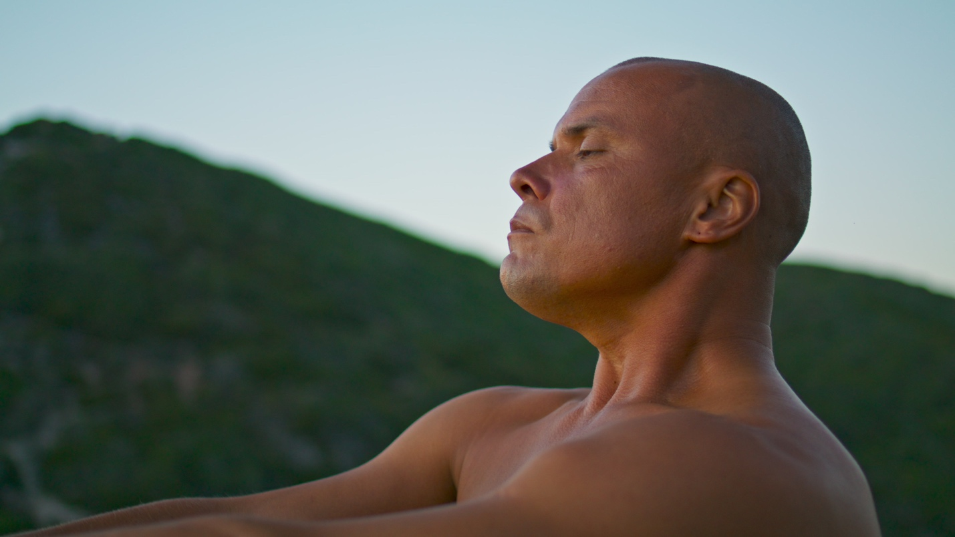

Welcome to the 21-Day Alpha Breathwork Challenge! I'm Funk Roberts, and I'm excited to guide you through this transformative journey.

Over the next 21 days, you'll embark on a step-by-step breathwork program designed specifically for men over 40, 50, 60 and 70.

This challenge will help you harness the power of your breath to reduce anxiety, stress, and cortisol levels, while simultaneously improving relaxation, focus, concentration, and even potentially increasing your testosterone levels.

Each day, we'll engage in a guided breathwork routine that will not only enhance your physical and mental well-being but also empower you to take control of your health in a way that is simple, yet profoundly effective.

By the end of this challenge, you'll have mastered seven powerful breathwork techniques and developed a daily practice that can support you for a lifetime.

The Importance of Breathwork for Men Over 40



As we age, maintaining our health and well-being becomes increasingly important. Stress, anxiety, and hormonal changes can take a toll on our bodies and minds.

Breathwork offers a natural and effective way to combat these challenges, providing numerous benefits that are particularly relevant for men over 40.

- Reduce Anxiety and Stress: Breathwork activates the parasympathetic nervous system, helping to calm your mind and reduce the impact of stress on your body.

- Improve Relaxation: Regular practice of breathwork promotes relaxation, allowing you to unwind and recover from the pressures of daily life.

- Decrease Cortisol Levels: High cortisol levels, often a result of chronic stress, can negatively impact your health. Breathwork helps to lower cortisol, balancing your hormones.

- Increase Testosterone: Some breathwork techniques may support natural testosterone production, crucial for maintaining muscle mass, energy levels, and overall vitality.

- Enhance Focus and Concentration: By improving oxygen flow to the brain and promoting a state of calm, breathwork enhances mental clarity and focus.

- Support Overall Health: Breathwork improves respiratory function, cardiovascular health, and boosts your immune system.

Throughout this journey, you’ll learn how to use your breath as a tool to optimize your health, enhance your performance, and feel more grounded and centered in your everyday life. Together, we’ll unlock the potential of breathwork to transform your well-being.

Let's get started, and remember, you're not alone on this journey. I'm here with you every step of the way. Let's breathe our way to a healthier, more focused, and powerful version of ourselves.

Get It Done!

Your Friend and Coach,

Funk Roberts

How to Use The 21-Day Alpha Breathwork Challenge and Guide



This guide is your companion, designed to ease you into the practice of breathwork with both structure and flexibility. Here’s how to make the most of it:

Daily Practice
Set aside a consistent time each day for your breathwork practice. Whether you prefer mornings to start your day with energy or evenings to unwind, find a time that works for you and commit to it. Consistency is key to reaping the full benefits of this challenge.

Daily Emails
In order to ensure that you io not procrastinate with the 21-Day Challenge, you will need to activate the daily emails. These emails will guide you through your journey with valuable information, tips and strategies to learn and optimize your breathwork practice. Each email will also provide you with a link to the guided breathwork session of the day, ensuring you have everything you need at your fingertips

Guided Video Sessions
Speaking of guided sessions, you will use the provided video tracks to lead your breathwork exercises. These sessions have been carefully crafted to build upon each other, gradually enhancing your skill and depth of experience. Follow along with me as I guide you through each breathwork technique step-by-step.

Reflective Journaling and Worksheet
After each week of breathwork practice, take a moment to journal any thoughts, feelings, or insights that arise. This reflection is a crucial part of the process, helping you to internalize your experiences and track your progress.

Engage with the Over 40 Alpha Brotherhood Facebook Group
If you have questions, need support, or wish to share your experience, use our Over 40 Alpha Brotherhood Facebook Group to connect with others on the same path. This community is here to support you, offer advice, and celebrate your progress. Engaging with others can enhance your experience and provide additional motivation.

Be Patient with Yourself
Some days will be easier than others. Breathwork is a skill, and like any skill, it requires practice and patience to develop. If you find certain techniques challenging at first, that's perfectly normal. Keep practicing, stay committed, and you will improve over time.

Remember, this journey is about progress, not perfection. Embrace each session with an open mind and a willingness to learn. By the end of this 21-day challenge, you will have developed a powerful toolset to enhance your health, reduce stress, and improve your overall well-being.

Benefits of Breathwork
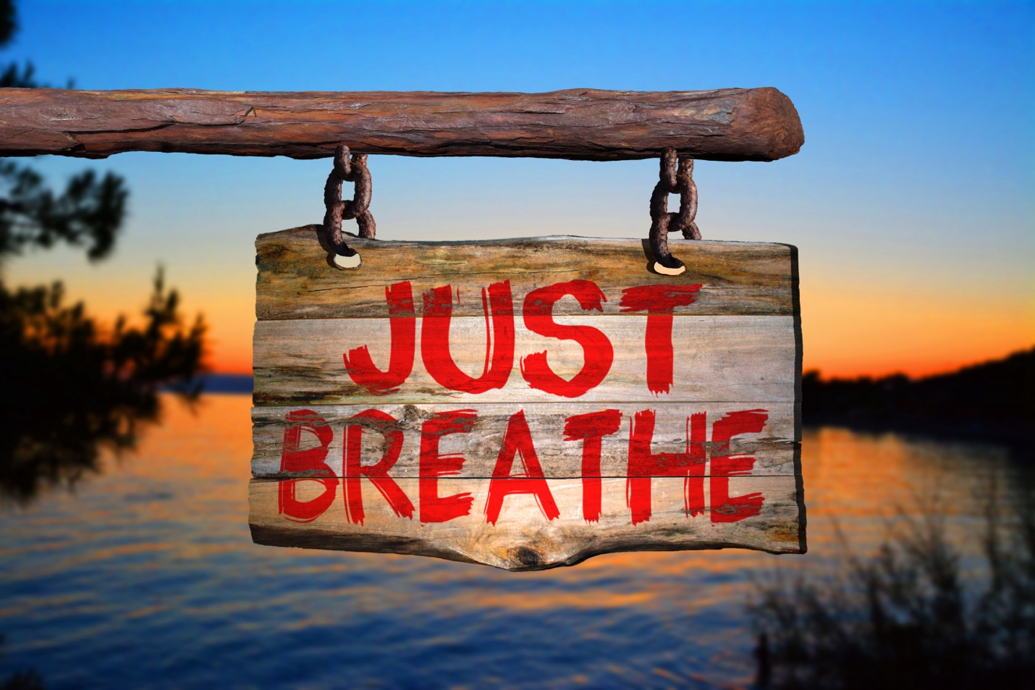
Breathwork offers a myriad of benefits that can enhance your physical, mental, and emotional well-being. By incorporating regular breathwork into your daily routine, you can experience profound changes that support a healthier, more balanced life.

- Reduced Anxiety: Breathwork activates the parasympathetic nervous system, which helps to calm the mind and reduce the physical symptoms of anxiety. This can lead to a greater sense of peace and emotional stability.

- Improved Relaxation: Engaging in breathwork promotes relaxation by encouraging a state of calm and tranquility. This can help you unwind after a stressful day and improve your overall sense of well-being.

- Decreased Cortisol Levels: High levels of cortisol, the stress hormone, can negatively impact your health. Breathwork helps to lower cortisol levels, reducing stress and its harmful effects on your body.

- Increased Focus and Concentration: By improving oxygen flow to the brain and promoting a state of mental clarity, breathwork can enhance your ability to focus and concentrate. This is particularly beneficial in both your professional and personal life.

- Enhanced Hormonal Balance: For men over 40, maintaining healthy testosterone levels is crucial. Certain breathwork techniques can support natural hormone production, contributing to better energy levels, muscle mass, and overall vitality.

- Improved Cardiovascular Health: Breathwork strengthens the respiratory system and improves oxygenation throughout the body. This can enhance cardiovascular health, reducing the risk of heart-related issues common in older men.

- Better Stress Management: Life can be stressful, especially as responsibilities increase with age. Breathwork provides a powerful tool for managing stress, helping you stay calm and composed in challenging situations.

- Increased Energy and Vitality: Regular practice of breathwork can boost your energy levels by improving oxygen utilization and reducing fatigue. This can help you stay active and engaged in your favorite activities.

- Enhanced Mental Clarity and Cognitive Function: Breathwork improves blood flow to the brain, which can enhance cognitive function and protect against age-related cognitive decline. This means better memory, sharper thinking, and a more agile mind.

- Support for Respiratory Health: As we age, maintaining healthy lung function becomes increasingly important. Breathwork exercises strengthen the lungs and improve respiratory efficiency, supporting overall respiratory health.

- Improved Sleep Quality: Many men over 40 struggle with sleep issues. Breathwork can promote better sleep by calming the mind and relaxing the body, making it easier to fall asleep and stay asleep.

By committing to the 21-Day Alpha Breathwork Challenge, you are taking a proactive step towards improving your health and well-being. The techniques you will learn and practice are designed to support you in living a vibrant, energetic, and balanced life, no matter your age. Embrace the journey, and experience the transformative power of breathwork.

21-Day Alpha Breathwork Challenge



Introduction:
Welcome to the path of rejuvenation and inner peace. This 21-Day Alpha Breath-work Challenge is crafted to guide you, a man over 40, 50, 60, and beyond, through the transformative power of breathwork.

Description:
Each day, you will be gently led into a practice that will not only soothe your mind but also fortify your body's natural rhythms, including your hormonal balance. This journey is about integrating mindfulness seamlessly into your life, harnessing the serene strength that comes from within.

Pre-Challenge Session

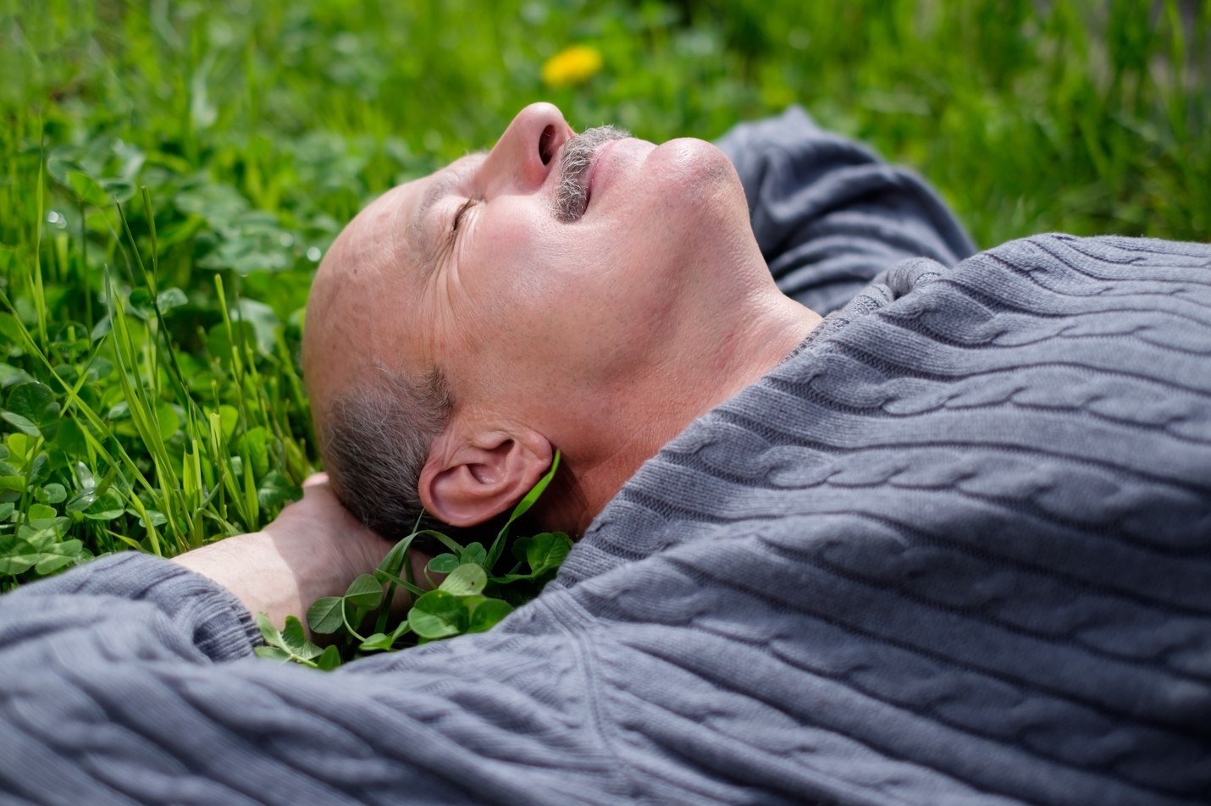

Introduction to Diaphragmatic Breathing

Before we dive into the practice, let's take a moment to understand what we are aiming to achieve with diaphragmatic breathing and why it's so beneficial.

Diaphragmatic breathing, also known as belly breathing, involves breathing deeply into your abdomen rather than shallowly into your chest.

When you breathe this way, your diaphragm—the large muscle located just below your lungs—contracts and moves downward, allowing your lungs to expand and fill with air more efficiently.

Now, why do we want to use diaphragmatic breathing instead of chest breathing?

Firstly, chest breathing, which involves shallow breaths into the upper chest, can trigger the body's stress response.

When you breathe through your chest, you tend to take quicker, shallower breaths, which can lead to feelings of anxiety and stress.

This type of breathing also doesn't fully engage the diaphragm, meaning your lungs aren't getting as much oxygen as they could be.

Over time, this can contribute to fatigue, decreased energy levels, and even higher blood pressure.

On the other hand, diaphragmatic breathing helps to activate the parasympathetic nervous system, which promotes relaxation and a sense of calm.

By taking deep, slow breaths into your belly, you're allowing more oxygen to enter your bloodstream, which can enhance mental clarity, improve energy levels, and support overall cardiovascular health.

It also helps to reduce the tension in your chest and shoulders, which is often associated with stress and poor posture.

In this session, our goal is to shift your breathing pattern from the chest to the diaphragm.

This will help you tap into a more relaxed state of being, improve your oxygen intake, and ultimately, support better overall health and well-being.

Let's get started with our diaphragmatic breathing practice, and experience the difference it can make!

Using Guided Audio for Diaphragmatic Breathing:

To get the most out of this challenge, it's crucial to use the guided audio provided for each breathwork session. For the diaphragmatic breathing session, the guided audio will help you stay on track, maintain the correct rhythm, and ensure you're using the proper technique.

Why Use Guided Audio?

- Consistency: The audio provides a consistent pace and timing for each breath, making it easier to follow the diaphragmatic breathing routine accurately.
- Focus: By listening to the audio, you can focus solely on your breathing without having to count seconds or watch a timer.
- Technique: The guided instructions will remind you of key points, such as relaxing your shoulders, breathing through your diaphragm, and maintaining a smooth and comfortable breath.

How to Use the Guided Audio:

- Find a quiet, comfortable place to sit or lie down.
- Play the guided audio track for diaphragmatic breathing.
- Follow along with the instructions, focusing on the rhythm and technique.
- Allow the audio to guide you through each inhale, pause, exhale, and pause, ensuring you stay relaxed and mindful throughout the session.

Conclusion:
Incorporate the guided audio into your daily practice to experience the full benefits of diaphragmatic breathing. Using the audio will help you master the technique, reduce stress, and promote a deeper sense of relaxation and well-being.

Step-by-Step Guide

Step 1: Find a Comfortable Position
First, find a comfortable position. You can sit in a chair with your feet flat on the ground or lie down on your back. Place one hand on your chest and the other on your belly.

Step 2: Relax Your Shoulders and Jaw
Take a moment to relax your shoulders and your jaw. Let go of any tension you may be holding in these areas. Close your eyes if that feels comfortable for you.

Step 3: Inhale Through Your Nose
Now, take a slow, deep breath in through your nose. As you inhale, focus on sending the air down into your belly. Feel your belly rise as it fills with air. Your chest should remain relatively still. Count to four as you inhale.

Step 4: Hold the Breath
Hold your breath for a brief moment, just a count of one or two. This is just enough time to feel the fullness of the breath without any strain.

Step 5: Exhale Through Your Mouth
Exhale slowly and completely through your mouth. As you exhale, feel your belly fall. Again, your chest should stay mostly still. Count to four as you exhale.

Step 6: Repeat the Cycle
Continue this cycle of breathing: Inhale for four counts, hold for a brief moment, and exhale for four counts. With each breath, focus on the movement of your belly. Feel it rise as you inhale and fall as you exhale.

Conclusion:

Now that you've practiced diaphragmatic breathing, take a moment to notice how you feel. This simple yet powerful technique can be used anytime you need to relax and center yourself. Thank you for joining me in this session. Remember to practice diaphragmatic breathing regularly to enjoy its full benefits.

Introduction to the 7 Guided Breathwork Sessions


Introduction:
Welcome to the 21-Day Alpha Breath-work Challenge! In this program, we have prepared 7 guided breathwork sessions designed to help you master various breathing techniques and enhance your overall well-being.

Description:
Each guided session is carefully crafted to guide you through specific breathwork techniques that promote relaxation, improve oxygenation, and help balance your body’s natural rhythms. Even though we provide guided audio sessions for each breathwork exercise, we have also included detailed written instructions to ensure you fully understand and can practice each technique effectively.

The 7 Guided Breathwork Sessions:

Day 1: Navy SEAL Box Breathing (4-4-4-4)
Adopt this powerful method used by Navy SEALs to stay calm and focused in high-pressure situations.

Day 2: Conscious Breathing Exercise for Anxiety (4-4-6-2)
Use this technique to manage anxiety and enhance mental clarity through controlled breathwork.

Day 3: Breathing Relaxation Exercise (4-2-6-2)
Practice extended exhalations to activate the parasympathetic nervous system and reduce stress.

Day 4: Slow Deep Breathing Meditation (6-2-6-2)
Engage in a rhythmic breathing exercise to promote mindfulness and relaxation.

Day 5: Heart Coherence Breathing Exercise (6-6)
Focus on balanced inhalations and exhalations to enhance heart rate variability and achieve a state of calm.

Day 6: Box Breathing Exercise (5-5-5-5)
Follow this structured breathing pattern to promote relaxation and mental clarity.

Day 7: Balanced Breathing Exercise (5-5)
Practice even breathing to bring balance to your nervous system, reducing stress and promoting calm.

How to Use This Guide:

- Guided Audio Sessions: Start each session by listening to the guided audio track. The audio will help you maintain the correct rhythm and technique.
- Written Instructions: Use the written instructions to deepen your understanding of each technique. Refer to them whenever you need a quick refresher or want to practice without the audio.
- Daily Practice: Commit to practicing one breathwork session each day. Rotate through the different techniques to experience their unique benefits.

Embrace this opportunity to explore the transformative power of breathwork. By following the guided sessions and using the detailed written instructions, you will develop a solid foundation in various breathing techniques, helping you achieve greater relaxation, focus, and overall well-being.

Navy SEAL Breathing Technique - 4-4-4-4 Pattern
Introduction: Welcome to the 21 Day Alpha Breath-work Challenge! Today, we're focusing on the Navy SEAL breathing technique, also known as the 4-4-4-4 technique or box breathing. This method is designed to promote relaxation, reduce stress, and help you stay calm in high-pressure situations.
Description: In this session, we'll guide you through the 4-4-4-4 breathing technique. This method involves a specific pattern of breathing: inhaling for 4 seconds, holding the breath for 4 seconds, exhaling for 4 seconds, and holding again for 4 seconds. This cycle helps regulate your body's stress response and restore a sense of calm.
Breathing Breakdown:
- Inhale (4 seconds): Begin by taking a slow and deep breath in through your nose for a count of four seconds. Focus on filling your lungs completely with air, allowing your diaphragm to expand as you breathe in. Keep your breathing steady and controlled.
- Hold (4 seconds): Once you've inhaled for four seconds, gently pause and hold your breath for another four seconds. This pause helps your body absorb the oxygen and allows it to circulate more effectively.
- Exhale (4 seconds): Slowly exhale through your mouth for a count of four seconds. As you exhale, release any tension and stress. Ensure that you're expelling air fully from your lungs.
- Hold (4 seconds): After you've exhaled for four seconds, pause again for another four seconds before starting the cycle over with the next inhale. This brief pause helps create a smooth and rhythmic breathing pattern.
Why This Works: The Navy SEAL breathing technique leverages controlled and deliberate breathing to engage your parasympathetic nervous system. By practicing this technique:
- Stress Reduction: The focus on your breath and the even rhythm help activate the parasympathetic nervous system, counteracting the "fight or flight" response and promoting relaxation.
- Improved Oxygenation: Deep and slow breaths allow for better oxygen exchange in the lungs, leading to improved oxygenation of the blood and a sense of clarity.
- Mindfulness: This technique encourages mindfulness as you concentrate on the sensation of your breath, helping to redirect your attention away from stressors and into the present moment.
- Anxiety Management: Regular practice enhances your ability to manage anxiety by providing a simple and effective tool to calm your nerves.
Benefits:
- Reduces stress and anxiety.
- Promotes relaxation and mental clarity.
- Enhances mindfulness and present-moment awareness.
- Improves oxygenation and respiratory function.
- Provides a reliable method to regain composure in challenging situations.
Conclusion: To make the most of the Navy SEAL breathing technique, find a quiet and comfortable place to sit or lie down. Practice this technique for a few minutes whenever you feel stressed, anxious, or overwhelmed. With consistent practice, you'll develop the ability to call upon this technique to regain composure and a sense of calm in various challenging situations.

Conscious Breathing Exercise for Anxiety - 4-4-6-2 Pattern
Introduction: Welcome to the 21 Day Alpha Breath-work Challenge! Today, we're focusing on a conscious breathing exercise specifically designed to help reduce anxiety using the 4-4-6-2 pattern. This technique involves mindful and controlled breathing to promote relaxation and mental clarity.
Description: In this session, we'll guide you through the 4-4-6-2 conscious breathing technique. This method involves breathing in for 4 seconds, holding the breath for 4 seconds, exhaling for 6 seconds, and holding again for 2 seconds. This pattern is designed to help you manage stress and anxiety effectively.
Breathing Breakdown:
- Breathe in for 4 seconds.
- Hold the breath for 4 seconds.
- Breathe out for 6 seconds.
- Hold the breath for 2 seconds.
- You can breathe in and out through your nose, or you may find it easier to breathe out through your mouth as if you are blowing out a candle.
- Focus on making each breath smooth and comfortable.
Why This Works: Conscious breathing exercises, also known as mindful or deep breathing, involve intentionally paying attention to your breath and controlling its rhythm. By practicing this technique:
- The structured pattern helps to regulate your breath, which can significantly reduce stress levels.
- The extended exhalation activates the parasympathetic nervous system, promoting relaxation and reducing the body's stress response.
- Holding the breath after inhalation and exhalation enhances breath control and awareness, helping to reset and refresh the mind.
Benefits:
- Reduces anxiety and stress.
- Promotes mental clarity and focus.
- Enhances relaxation and mindfulness.
- Improves respiratory function and breath control.
- Provides a simple, effective way to achieve a calm state.
Conclusion: Incorporate this 4-4-6-2 conscious breathing exercise into your daily routine to experience its full benefits. Regular practice will help you manage anxiety, improve your overall health, and foster a more relaxed, focused mindset.

Breathing Relaxation Exercise - 4-2-6-2 Pattern
Introduction: Welcome to the 21 Day Alpha Breath-work Challenge! Today, we're focusing on a breathing relaxation exercise using the 4-2-6-2 pattern. This technique is designed to promote deep relaxation and mindfulness through a controlled, rhythmic breathing pattern.
Description: In this session, we'll guide you through the 4-2-6-2 breathing technique. You'll take slow, measured breaths: inhaling for 4 seconds, pausing for 2 seconds, exhaling for 6 seconds, and pausing again for 2 seconds. This pattern helps to create a calming and relaxing effect on your body and mind.
Breathing Breakdown:
- Breathe in for 4 seconds.
- Pause for 2 seconds.
- Breathe out for 6 seconds.
- Pause for 2 seconds.
- Focus on breathing in easily and comfortably, rather than deeply.
- You can breathe in and out through your nose, or you may find it easier to breathe out through your mouth as if you are blowing out a candle.
- Relax your shoulders as you breathe out.
- This exercise results in approximately 4.25 breaths per minute.
Why This Works: The 4-2-6-2 breathing relaxation exercise utilizes an extended exhalation to promote relaxation. By practicing this technique:
- The longer exhalation of 6 seconds activates the parasympathetic nervous system, inducing a state of relaxation and reducing the body's stress response.
- The deliberate pauses enhance breath awareness, fostering a mindful connection between the body and mind.
- Scientific studies suggest that regulated breathing can positively influence heart rate variability, enhance oxygenation, and optimize the balance between sympathetic and parasympathetic nervous system activity.
Benefits:
- Reduces stress and anxiety.
- Promotes deep relaxation and mindfulness.
- Improves oxygen exchange and respiratory function.
- Enhances heart rate variability and cardiovascular health.
- Provides a structured method for achieving a balanced, calm state.
Conclusion: Incorporate this 4-2-6-2 breathing relaxation exercise into your daily routine to experience its full benefits. Regular practice will help you manage stress, improve your overall health, and foster a more relaxed, mindful mindset.

Slow Deep - Paced Breathing Meditation - 6-2-6-2 Pattern
Introduction: Welcome to the 21 Day Alpha Breath-work Challenge! Today, we're focusing on a slow deep breathing meditation using the 6-2-6-2 pattern. This technique is designed to promote deep relaxation and mindfulness through controlled, rhythmic breathing.
Description: In this session, we'll guide you through slow deep breathing. You'll take slow, deep breaths: inhaling for 6 seconds, pausing for 2 seconds, exhaling for 6 seconds, and pausing again for 2 seconds. This pattern helps to create a calming effect on your body and mind.
Breathing Breakdown:
- Breathe in for 6 seconds.
- Pause for 2 seconds.
- Breathe out for 6 seconds.
- Pause for 2 seconds.
- You can breathe in and out through your nose, or you may find it easier to breathe out through your mouth as if you are blowing out a candle.
Why This Works: The slow deep breathing meditation leverages the power of controlled breath and pauses to enhance relaxation and mindfulness. By practicing this technique:
- You extend the duration of each breath, which helps to slow down your heart rate and promote a state of calm.
- The pauses between breaths allow your body to fully process the inhalation and exhalation, optimizing oxygen exchange.
- This rhythmic breathing pattern helps to activate the parasympathetic nervous system, which reduces stress and promotes relaxation.
Benefits:
- Reduces stress and anxiety.
- Promotes deep relaxation and mindfulness.
- Improves oxygen exchange and respiratory function.
- Stabilizes heart rate and enhances cardiovascular health.
- Provides a simple, effective way to achieve a balanced, calm state.
Conclusion: Incorporate this slow deep breathing meditation into your daily routine to experience its full benefits. Regular practice will help you manage stress, improve your overall health, and foster a more mindful, relaxed mindset.

Heart Coherence Breathing Exercise - 6-6 Pattern
Introduction: Welcome to the 21 Day Alpha Breath-work Challenge! Today, we're focusing on heart coherence breathing, specifically the 6-6 pattern. This technique is designed to improve heart rate variability and overall well-being through controlled, rhythmic breathing.
Description: In this session, we'll guide you through heart coherence breathing. You'll take slow, even breaths: inhaling for 6 seconds and exhaling for 6 seconds. This pattern is meant to create a balanced and calming effect on your body and mind.
Breathing Breakdown:
- Breathe in for 6 seconds.
- Breathe out for 6 seconds.
- Aim to take 5 breaths per minute using this technique.
- Breathe in and out through your nose or exhale through your mouth as if blowing out a candle.
- As you breathe out, focus on relaxing your body.
Why This Works: Heart coherence breathing, also known as coherent or resonance frequency breathing, involves controlled breathing patterns to improve heart rate variability (HRV) and overall well-being. By practicing this technique:
- You maintain a consistent breathing rhythm, around 5-6 breaths per minute, which is slower than normal resting breathing.
- The balanced inhalation and exhalation help stabilize your heart rate and promote a state of relaxation.
- Imagining your breath coming from the area around your heart can help establish a deeper connection between your heart's rhythms and your breath.
- The practice aims to increase HRV, shifting the autonomic nervous system towards relaxation and stress reduction.
Benefits:
- Reduces stress and anxiety.
- Promotes a sense of calm and emotional balance.
- Improves focus, concentration, and mental clarity.
- Enhances heart health and overall well-being.
- Provides a structured method for achieving a balanced, calm state.
Conclusion: You can customize the breathing pattern, listen while using other apps, set sleep timers, and more with our app. Make heart coherence breathing a part of your daily routine to experience its full benefits.

Box Breathing Exercise - 5-5-5-5 Pattern
Introduction: Welcome to the 21 Day Alpha Breath-work Challenge! Today, we're focusing on the box breathing exercise, specifically the 5-5-5-5 pattern. This technique is a powerful tool for managing stress and enhancing focus.
Description: In this session, we'll guide you through the 5-5-5-5 box breathing technique. This method involves four equal parts: inhaling for 5 seconds, holding the breath for 5 seconds, exhaling for 5 seconds, and holding the breath again for 5 seconds. This rhythmic breathing pattern is designed to create a sense of balance and calm.
Breathing Breakdown:
- Breathe in for 5 seconds.
- Hold the breath for 5 seconds.
- Breathe out for 5 seconds.
- Hold the breath for 5 seconds.
- Repeat the cycle.
- You can breathe in and out through your nose, or try exhaling through your mouth as if you're blowing out a candle.
Why This Works: The 5-5-5-5 box breathing exercise is highly effective in regulating the nervous system. By maintaining this structured breathing pattern:
- You help reset your breath, which can reduce feelings of anxiety and stress.
- It enhances your ability to focus by bringing mindfulness to your breathing.
- The pattern stabilizes your heart rate and promotes a state of relaxation.
- It helps improve your lung capacity and respiratory function.
Benefits:
- Reduces stress and anxiety.
- Promotes relaxation and mental clarity.
- Improves focus and concentration.
- Stabilizes heart rate and enhances respiratory function.
- Provides a structured method for achieving a balanced, calm state.
Conclusion: If the 5-5-5-5 pattern feels too slow or too fast, feel free to explore other box breathing versions on my channel or try my app, which allows you to customize your breathing pattern. Make this practice a part of your daily routine to experience its full benefits.

Balanced Breathing Exercise - 5-5 Technique
Introduction: Welcome to the 21 Day Alpha Breath-work Challenge! Today, we're focusing on the 5-5 balanced breathing exercise. This simple yet powerful technique helps to bring balance to your nervous system, reduce stress, and promote a sense of calm.
Description: In this session, we'll guide you through the 5-5 breathing technique. You'll take even breaths, inhaling for 5 seconds, pausing briefly, and exhaling for 5 seconds, followed by another brief pause. This rhythmic breathing pattern is designed to optimize your oxygen intake, improve circulation, and enhance mental clarity.
Breathing Breakdown:
- Breathe in for 5 seconds.
- Pause for half a second.
- Breathe out for 5 seconds.
- Pause for half a second.
- Breathe in and out through your nose. Alternatively, try exhaling through your mouth as if you're blowing out a candle.
Why This Works: The 5-5 breathing exercise leverages the science of diaphragmatic breathing and its profound impact on the nervous system. By maintaining this rhythm:
- You activate the vagus nerve, which triggers the body's relaxation response and helps reduce stress hormones.
- The pattern optimizes the balance between oxygen and carbon dioxide in your body, enhancing respiratory function.
- It promotes better blood circulation and influences brain oscillations, leading to improved focus and cognitive function.
Benefits:
- Reduces stress and promotes relaxation.
- Improves oxygen flow and respiratory function.
- Enhances circulation and cardiovascular health.
- Boosts mental clarity and cognitive function.
- Provides a simple, effective way to achieve a balanced, calm state.
Conclusion: Make this 5-5 breathing technique a part of your daily routine to experience its full benefits. Regular practice will help you manage stress, improve your overall health, and foster a brighter, more focused mindset.

Main 21-Day Breathwork Schedule

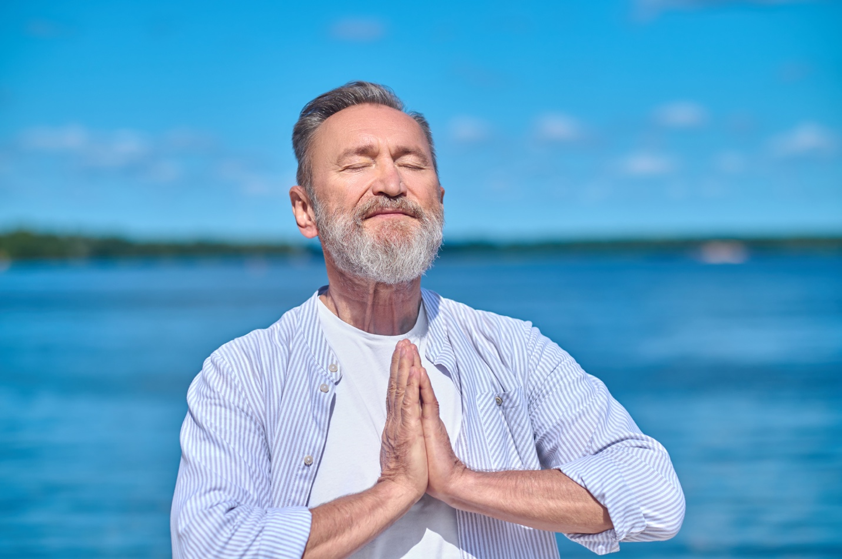
The challenge will rotate the seven main routines, ensuring a balanced and comprehensive approach to breathwork.

Week 1: Foundation and Relaxation

Day 1: Navy Seal Box Breathing 4-4-4-4
Day 2: Conscious Breathing Exercise for Anxiety 4-4-6-2
Day 3: Breathing Relaxation Exercise 4-2-6-2
Day 4: Slow Deep Breathing Meditation 6-2-6-2
Day 5: Heart Coherence Breathing Exercise 6-6
Day 6: Box Breathing Exercise 5-5-5-5
Day 7: Balanced Breathing Exercise 5-5

Week 2: Building Resilience

Day 8: Navy Seal Box Breathing 4-4-4-4
Day 9: Conscious Breathing Exercise for Anxiety 4-4-6-2
Day 10: Breathing Relaxation Exercise 4-2-6-2
Day 11: Slow Deep Breathing Meditation 6-2-6-2
Day 12: Heart Coherence Breathing Exercise 6-6
Day 13: Box Breathing Exercise 5-5-5-5
Day 14: Balanced Breathing Exercise 5-5

Week 3: Advanced Integration

Day 15: Navy Seal Box Breathing 4-4-4-4
Day 16: Conscious Breathing Exercise for Anxiety 4-4-6-2
Day 17: Breathing Relaxation Exercise 4-2-6-2
Day 18: Slow Deep Breathing Meditation 6-2-6-2
Day 19: Heart Coherence Breathing Exercise 6-6
Day 20: Box Breathing Exercise 5-5-5-5
Day 21: Balanced Breathing Exercise 5-5

NAMASTE!

Funk Roberts

