Over 40 Alpha Supplements
https://www.rocktomic.com/2-0

Templates
https://rocktomicplatform.blob.core.windows.net/client-resources/templates.html?t=1753719689391

Distributed for Over 40 Alpha Supplements
1615 Lakes Pkwy, Suite C,
Lawrenceville, GA 30043
www.over40supplements.com

https://drive.google.com/drive/folders/1qAEbmA-w1ERqaEWVu6QMhGImKjTi2Evd
Before uploading, please make sure your label files meet the following requirements:
Supplement Labels
- File Format: JPEG (.jpg),
- Resolution: 300 DPI (high-quality print standard),
- File Size: Maximum 10MB per file,
- File Naming: Use the product SKU as the filename (e.g., ROC123.jpg)

Label Templates
https://rocktomicplatform.blob.core.windows.net/client-resources/templates.html?t=1753719689391#

https://www.amazon.ca/stores/page/D1DC730C-714E-4FBB-99B1-BDCB1173618A?ingress=2&lp_context_asin=B0B7GTNXTD&visitId=62bc92b5-d1e2-413d-875c-f7dd943db841&store_ref=bl_ast_dp_brandLogo_sto&ref_=ast_bln

Supplement 1 - Sleep Well Gummies

ROC920 - Sleep Well Gummies

ROC920 - Sleep Well Gummies
SLEEP WELL GUMMIES
Natural Passion Fruit Flavor
30 Servings
- Supports Deeper, Restorative Sleep
- Regulate Sleep Cycles
- Non-Habit Forming

60 Gummies
Dietary Supplement

Label 2 – ELECTROLYTE POWDER FORMULA
ROC617 - ION + Select Electrolyte Formula
ROC617 - ION + Select Electrolyte Formula

ELECTROLYTE POWDER FORMULA
Blue Raspberry
30 Servings

Favicons
- Optimal Hydration
- Support Energy & Endurance
- Promote Recovery & Reduce Fatigue
NET WEIGHT: 225 G (7.94 OZ)
DIETARY SUPPLEMENT

Label 3 – Creatine Gummies
ROC943 - Super Creatine Gummies 1000mg

SUPER CREATINE GUMMIES
Pure Creatine Monohydrate
1000mg
Lemon Flavour
- muscle recovery
- exercise performance
- Enhanced Muscle Function

60 Gummies
Dietary Supplement

Label 3a) Alpha Creatine
ROC609 - Creatine Powder 300g
Colour – Navy - https://www.yeti.ca/shop-by-colour/navy

ROC609 - Creatine Powder 300g
Alpha Creatine Monohydrate
- muscle recovery
- exercise performance
- Enhanced Muscle Function

60 SERVINGS
Net WT. 300 G (10.58 OZ)
DIETARY SUPPLEMENT

Label 4 – Alpha Vitality Boost - Testosterone
ROC745 - Premium Testosterone w/ Testofen®

ALPHA VITALITY BOOST
Premium Testosterone
with Testofen® & LJ100®
30 Servings
- Supports healthy testosterone levels
- Promotes stamina and energy
- Aids performance and muscle strength

Dietary Supplement
90 capsules

Label 5 – Omega Armor 3X

ROC814 - Omega 3 Fish Oil

Title:
Omega Armor 3X
Fish Oil
Fish Oil – 1200MG Omega 720MG

- Supports brain and nerves
- Visual Support
- Helps Join Flexibility

60 SOFTGELS - 30 Day Supply

LEMON FLAVOR
DIETARY SUPPLEMENT

Label 6 -Probiotic – 40 Billion CFU
ROC816 - Probiotic - 40 Billion CFU

Alpha Gut Restore
Probiotic-40 Billion CFU
MAKTREK® Bi-Pass Technology

- Boost Digestive Health
- Help Strengthen The Bodies Defenses
- Help Replenish Healthy Bacteria

60 Capsules
DIETARY SUPPLEMENT

Label 7 – Alpha Sleep Formula
ROC817 - Sleep Formula
Alpha Sleep Formula
With Melatonin and Valerian

- Natural Sleep Aid
- Assist in Body Regeneration
- Relaxing and Calming Blend
60 Capsules

Dietary Supplement

Label 8 - Alpha Shield D3+K2

ROC831 - Vitamin K2 + D3

ROC831 - Vitamin K2 + D3

Alpha Shield 5000 D3+K2
Vitamin

- Support Bone Health
- Promote Immune System
- Helps with Healthy Muscles

60 Capsules
Dietary Supplement

Label 9 - ROC824 - Magnesium Glycinate
ROC824 - Magnesium Glycinate

Magnesium Glycinate

- Natural Sleep Aid
- Calming Effect
- Supports Bones & Joints

60 Capsules - 30 Day Supply
DIETARY SUPPLEMENT

Label 10 – Alpha Armor - Men’s Multivitamin

ROC507 - Ultra Multivitamin For Men
ROC507 - Ultra Multivitamin For Men

Alpha Armor
Advanced Men’s Multivitamin

- Potent Vitamin, Mineral & Antioxidant Formula
- Energizers & B-Vitamin Complex
- Immune and Prostate Support

60 Capsules – 30 Day Supply
DIETARY SUPPLEMENT

Label 11 – Alpha Prime Natural Testosterone Support
ROC506 - Ultra Test Natural Testosterone Support

ROC506 - Ultra Test Natural Testosterone Support

Alpha Prime
Natural Hormone Support

- Muscle Growth
- Testosterone Production Support
- Increase Bodybuilding Results

90 Capsules – 30 Day Supply
DIETARY SUPPLEMENT

Label 12 – Alpha Mojo Boost

ROC502 - Male Enhancement Or Boost
ROC502 - Male Enhancement Or Boost

Alpha Mojo Boost
Mood Enhancement
Help Increase Drive
Endurance

60 Capsules – 30 Day Supply
Dietary Supplement

Label 13 ROC2241N - 2lb Whey Armor Natural Protein Vanilla w/Stevia & Natural Flavor Non-GMO
ROC2241N - 2lb Whey Armor Natural Protein Vanilla w/Stevia & Natural Flavor Non-GMO

Alpha Whey Armor
Vanilla Ice Fuel
24g Natural Protein
- Natural Protein
- Sweetened with Stevia
- Digestive Enzymes of Absorption
- Non- GMO Whey

Vanilla
w/Stevia & Natural Flavor
NET WT. 2 LB (5 OZ) | DIETARY SUPPLEMENT

Label 14 - Whey Armor - Choco Power Blend

ROC2201N - 2lb Whey Armor Natural Protein Chocolate w/Stevia & Natural Flavor Non-GMO
ROC2201N - 2lb Whey Armor Natural Protein Chocolate w/Stevia & Natural Flavor Non-GMO

Alpha Whey Armor
Choco Power Blend
24g Natural Protein

- Natural Protein
- Sweetened with Stevia
- Digestive Enzymes of Absorption
- Non- GMO Whey

Chocolate
w/Stevia & Natural Flavor
NET WT. 2 LB (5 OZ) | DIETARY SUPPLEMENT

Label 15 – Alpha Shred

ROC105 - Best Sellers Blend
ROC105 - Best Sellers Blend

ALPHA SHRED
Natural Energy & Thermogenesis

- Assists Metabolism
- Supports Energy Levels
- Helps Reduce Inflammation

Dietary Supplement – 60 Capsules

Distributed for Over 40 Alpha Supplements
1615 Lakes Pkwy, Suite C,
Lawrenceville, GA 30043
www.over40supplements.com

Collagen Type 1 & 3 Grass Fed 350g – 35 serv. ROC450 - https://rocktomic.store/samples/supplements/collagen-type-1-3-grass-fed-350g-35-serv/

Alpha Collagen Peptides – ROC450

Alpha Collagen Peptides
Hydrolyzed Type 1 & 3 Grass Fed
- Supports Joint Health
- Helps Build Muscle & Burn Fat
- Promoted Skin Elasticity

Dietary Supplement – 350 Grams
35 Servings

Distributed for Over 40 Alpha Supplements
1615 Lakes Pkwy, Suite C,
Lawrenceville, GA 30043
www.over40supplements.com

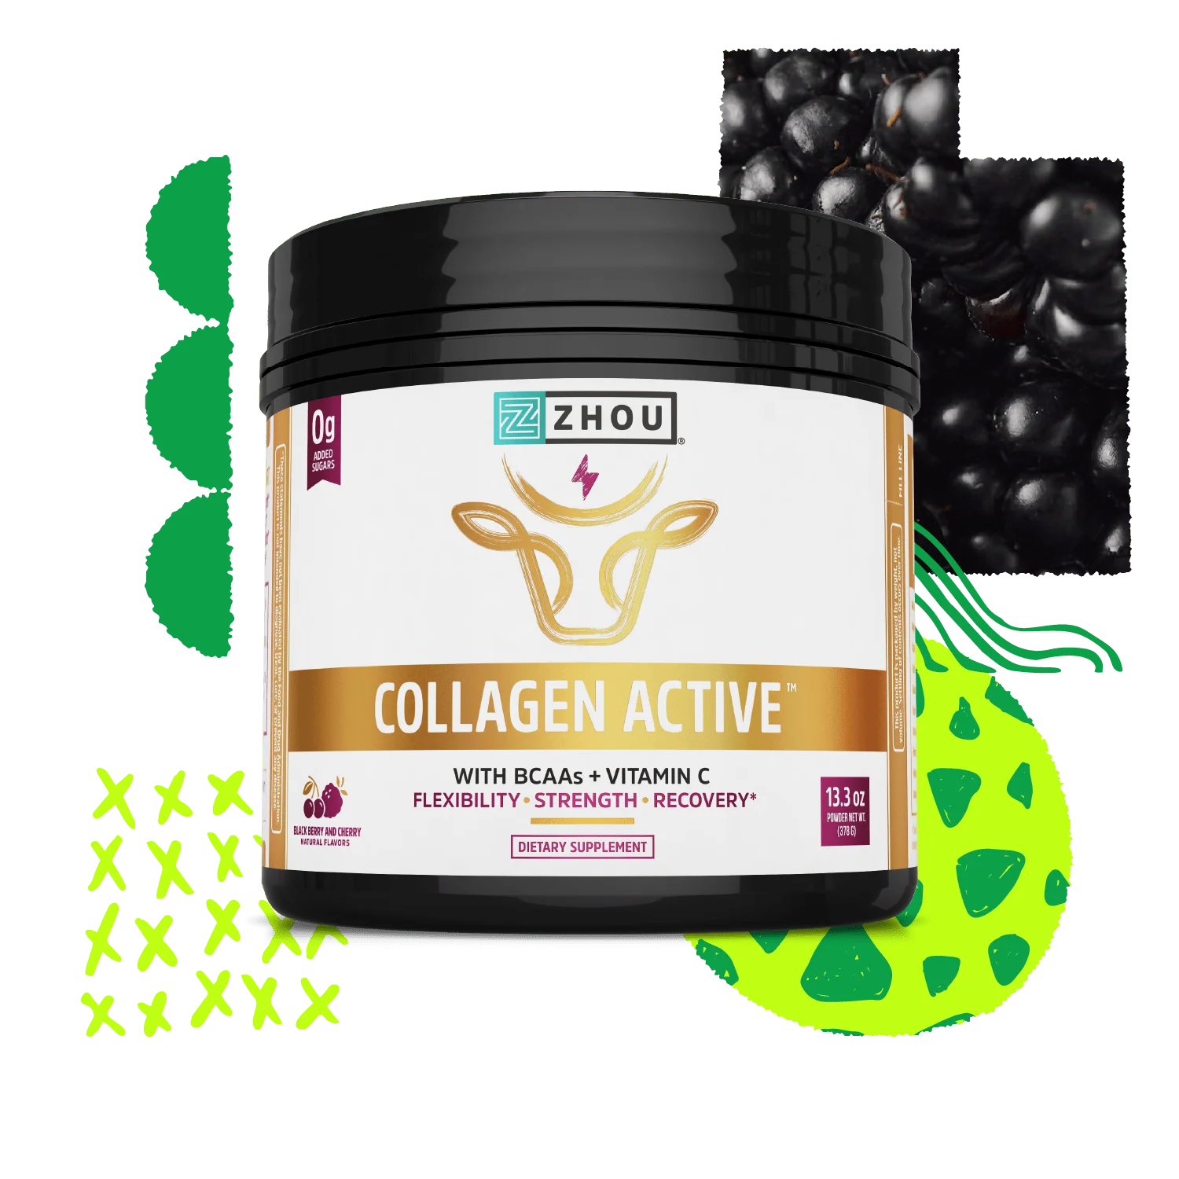

Oxy Burn | ROC123
- Black label with red writing and RED
- https://www.amazon.ca/Berberine-Supplement-Supports-Efficient-Metabolism/dp/B0CQMH8WC9?th=1

Metabolic Burn – ROC123

Metabolic Burn
Advanced Fat-Loss Formula
Energy Booster
Fat Metabolism
Appetite Control

Dietary Supplement – 60 Capsules

Distributed for Over 40 Alpha Supplements
1615 Lakes Pkwy, Suite C,
Lawrenceville, GA 30043
www.over40supplements.com

Metabolic Blast Off Pre-Workout | Pre -Workout Blast Off 312g w/ Watermelon | ROC606
White and Purple writing
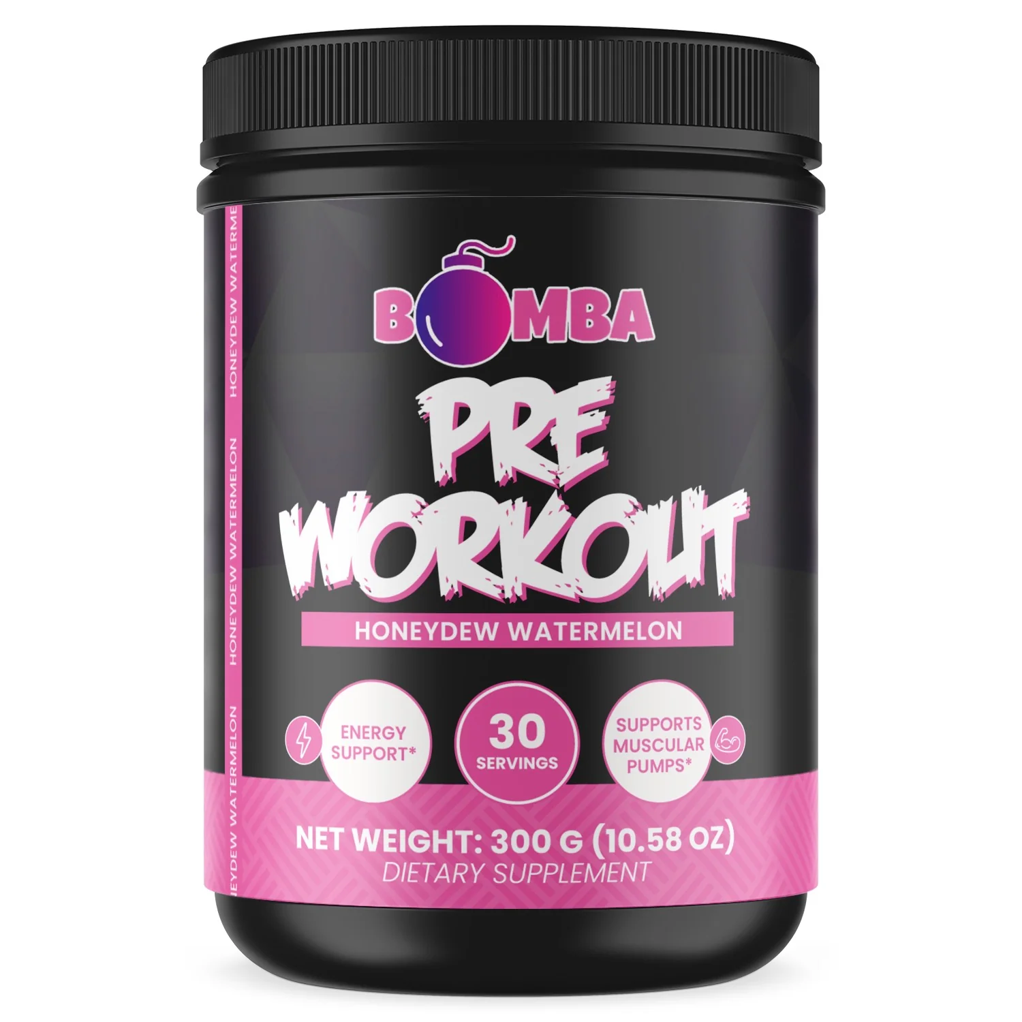

Metabolic Blast Off Pre-Workout
Honeydew Watermelon

- Energy Support
- Promotes Endurance
- Assists in Gains and Strength

Dietary Supplement – 30 Servings
Distributed for Over 40 Alpha Supplements
1615 Lakes Pkwy, Suite C,
Lawrenceville, GA 30043
www.over40supplements.com

Metabolic Blast Off Pre-Workout | Pre -Workout Blast Off 312g w/ Natural Flavor | ROC605
https://www.amazon.ca/Herba-Montmorency-Tart-Cherry-Concentrated/dp/B089FP9YSL/ref=ast_sto_dp_puis?rdc=1

White with Red Writing
Metabolic Blast Off Pre-Workout
Fruit Punch

- Energy Support
- Promotes Endurance
- Assists in Gains and Strength

Dietary Supplement – 30 Servings

Distributed for Over 40 Alpha Supplements
1615 Lakes Pkwy, Suite C,
Lawrenceville, GA 30043
www.over40supplements.com

Alpha BCAA+EAA | BCAA + EAA Strawberry Candy 300g  w/Natural Flavor | ROC014

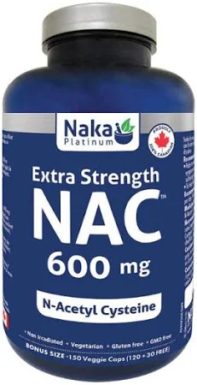

Alpha BCAA+EAA ROC014
Strawberry Candy

- Essential Amino Acids
- Electrolyte Hydration
- Intra and Post Workout Fuel

Dietary Supplement – 340 Grams
30 Servings

Distributed for Over 40 Alpha Supplements
1615 Lakes Pkwy, Suite C,
Lawrenceville, GA 30043
www.over40supplements.com

Super Alpha Greens | Green Superfood – Apple Cinnamon Turnover | ROC938

https://rocktomic.store/samples/supplements/green-superfood-apple-cinnamon-turnover/

Super Alpha Greens-ROC938

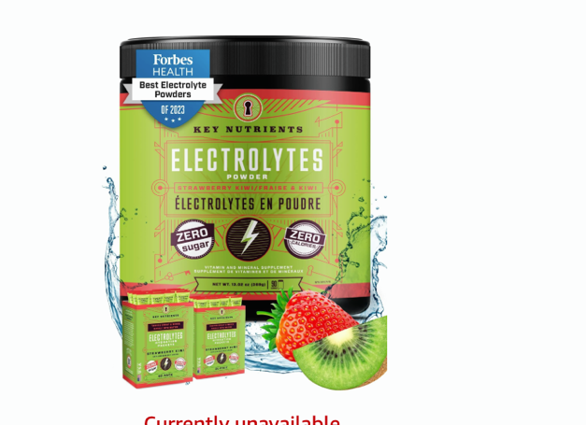

Super Alpha Greens
Apple Cinnamon Turnover

- Daily Greens
- Immune Boost
- Gut Health & Digestive Support

Dietary Supplement – 30 Servings

Distributed for Over 40 Alpha Supplements
1615 Lakes Pkwy, Suite C,
Lawrenceville, GA 30043
www.over40supplements.com

ACV Gummies | Apple Cider Vinegar Gummies | ROC930

https://rocktomic.store/samples/supplements/apple-cider-vinegar-gummies/
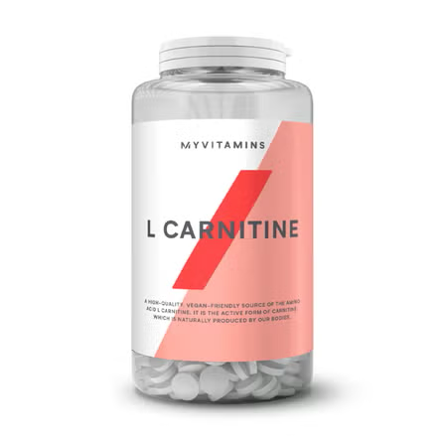

ACV Gummies- ROC930

ACV Gummies
Apple Cedar Vinegar

- Supports Weight Health
- Promotes Digestive Health
- Supports Detoxification

Dietary Supplement – 30 Servings

Distributed for Over 40 Alpha Supplements
1615 Lakes Pkwy, Suite C,
Lawrenceville, GA 30043
www.over40supplements.com

Alpha Collagen Gummies | Collagen Gummies | ROC924

https://rocktomic.store/samples/supplements/collagen-gummies/

Alpha Collagen Gummies ROC924 White with RED

Alpha Collagen Gummies
Strawberry Flavour

- Support Skin Health
- Promotes Healthy Joint
- Hydrolyzed Collagen

Dietary Supplement – 30 Servings

Distributed for Over 40 Alpha Supplements
1615 Lakes Pkwy, Suite C,
Lawrenceville, GA 30043
www.over40supplements.com

Alpha Joint Support Plus | Platinum Turmeric Joint Support Plus | ROC830

https://rocktomic.store/samples/supplements/platinum-turmeric-joint-support-plus/

Alpha Joint Support Plus-ROC830
Turmeric Platinum

- Supports Joint Health
- Helps Reduce Discomfort
- Balances Response to Metabolic Stress

Dietary Supplement – 60 Capsules
30 Servings

 | Berberine Plus - Glucose Metabolism | Berberine Plus | ROC2251
https://rocktomic.store/samples/supplements/berberine-plus/

Berberine Plus - Glucose Metabolism - ROC2251
- Blood Sugar Balance
- Promote Metabolic Health
- Cardiovascular Function

Dietary Supplement – 60 Capsules
30 Day Supply

Digestive Enzyme | Digestive Enzyme | ROC303

https://rocktomic.store/samples/supplements/digestive-enzyme/

Digestive Enzyme – Probiotic Blend - ROC303

- Improve Digestive Health
- Enhance Nutrition Absorption
- Support Healthy Digestion

Dietary Supplement – 60 Capsules

