|  |  |  |  |  |
| --- | --- | --- | --- | --- |
| Employer – 3NF | | | | |
| employer_ID | name | address | phone | email |
| 1 | Alpha Computing | 515 Alpha Way | 555-515-5245 | alphacomputing@alpha.org |
| 2 | Darryl Electronics | 654 Simba Way | 555-515-6216 | darrylelectro@darrylelectro.com |
| 3 | Jimba Microprocessors | 721 Jimba Ave | 555-425-5215 | jimbamicropro@jimba.net |
| 4 | Kettle Coffee | 421 Kettle Boulevard | 555-745-2910 | kettle@kettlecoffeeisgood.ca |
| 5 | Stan\'s Bagels | 425 Bagel Road | 521-542-4919 | stanley@stansbagels.com |
| 6 | Tony Pizzeria | 234 Tony Street | 512-492-1928 | tony@tonypizzanow.org |
| 7 | Denton Photography | 555 Alpha Way | 555-234-8239 | denton@dentonphoto.ca |
| 8 | Fine Refinishing | 7820 Wood Way | 514-849-2938 | refinish@finewood.now |
| 9 | James Richardson Brandy | 514 Avenue Decadent | 512-481-2381 | jrichardson@bestbrandies.org |
| 10 | Smoke Show | 290 Smoker Boulevard | 555-512-1932 | smokeshow@smokeshowsmokeables.org |

Primary Key

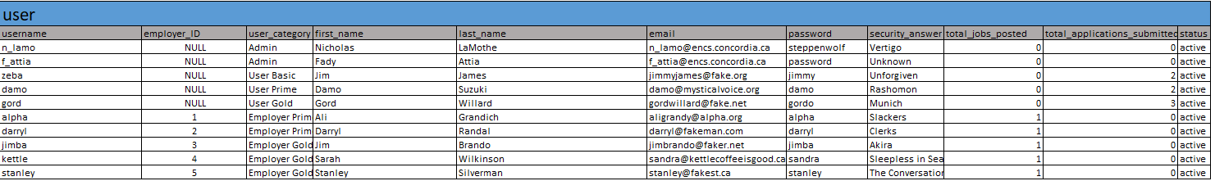

Primary Key

Foreign Key

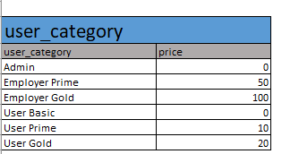

This relationship is Many to one as 2 unique user can choose the same category eg User Basic

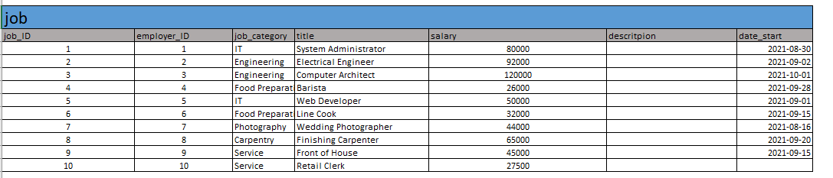

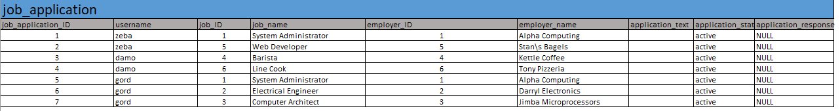

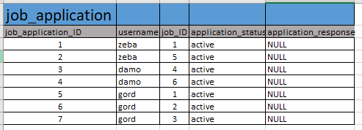

Foreign Key