 | WELDING INSPECTION CHECKLIST  แบบฟอร์มใบตรวจเช็คงานเชื่อม

Project Title: {{ project_title }} | Joint No: {{ joint_no }}
Welder Name: {{ welder_name }} | Process: {{ process }}
Welder ID: {{ welder_id }} | Date: {{ date }}

SECTION 1: BEFORE WELDING CHECK (ก่อนการเชื่อม)
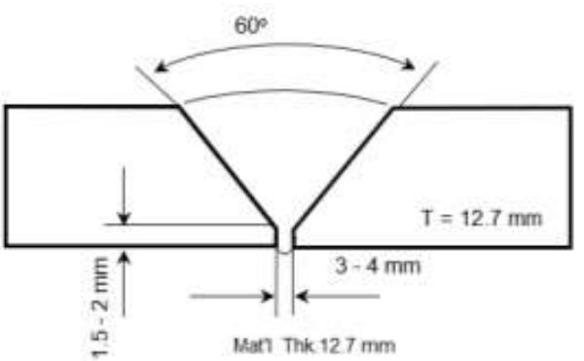 | Checklist | Result | Remarks
 | Groove Angle (60°) | {{ c_ga_na }} N/A {{ c_ga_pass }} Pass {{ c_ga_fail }} Fail | {{ r_ga }}
 | Root Opening | {{ c_ro_na }} N/A {{ c_ro_pass }} Pass {{ c_ro_fail }} Fail | {{ r_ro }}
 | Root Face | {{ c_rf_na }} N/A {{ c_rf_pass }} Pass {{ c_rf_fail }} Fail | {{ r_rf }}
 | Cleaning | {{ c_cl_na }} N/A {{ c_cl_pass }} Pass {{ c_cl_fail }} Fail | {{ r_cl }}
 | Preheat Min 21 °C | {{ c_ph_na }} N/A {{ c_ph_pass }} Pass {{ c_ph_fail }} Fail

Re-drying SMAW: 300–400 °C for 1 hr; keeping at 120–135 °C.
{{ c_rd_na }} N/A {{ c_rd_pass }} Pass {{ c_rd_fail }} Fail

SECTION 2: DURING WELDING CHECK (ขณะทำการเชื่อม)
Weld Pass(es) | Current Type  & Polarity | Current  (Amps) | Voltage  (Volts) | Travel Speed  (mm/min) | Interpass Temp (°C)  MAX 260 °C
Root Run | {{ p1_type }} | {{ p1_amp }} | {{ p1_volt }} | {{ p1_spd }} | {{ c_p1_pass }} Pass {{ c_p1_fail }} Fail
Hot Pass (Second Layer) | {{ p2_type }} | {{ p2_amp }} | {{ p2_volt }} | {{ p2_spd }} | {{ c_p2_pass }} Pass {{ c_p2_fail }} Fail
Fill layers | {{ p3_type }} | {{ p3_amp }} | {{ p3_volt }} | {{ p3_spd }} | {{ c_p3_pass }} Pass {{ c_p3_fail }} Fail
Fill layers | {{ p4_type }} | {{ p4_amp }} | {{ p4_volt }} | {{ p4_spd }} | {{ c_p4_pass }} Pass {{ c_p4_fail }} Fail
Cap Layer | {{ p5_type }} | {{ p5_amp }} | {{ p5_volt }} | {{ p5_spd }} | {{ c_p5_pass }} Pass {{ c_p5_fail }} Fail

SECTION 3: AFTER WELDING CHECK (หลังการเชื่อม)
Inspection Item | Result | Remarks
Visual Inspection | {{ c_vi_na }} N/A {{ c_vi_pass }} Pass {{ c_vi_fail }} Fail | {{ r_vi }}
Post-Weld Dimensions | {{ c_dim_na }} N/A {{ c_dim_pass }} Pass {{ c_dim_fail }} Fail | {{ r_dim }}
Surface Defect Check | {{ c_suf_na }} N/A {{ c_suf_pass }} Pass {{ c_suf_fail }} Fail | {{ r_suf }}
NDT PT | {{ c_pt_na }} N/A {{ c_pt_pass }} Pass {{ c_pt_fail }} Fail | {{ r_pt }}

Inspector Sign-Off | Verifier Stamp
________________________  (........................................)  Sign & Date | INTERNATIONAL WELDING ENGINEER  ________________________  (........................................)  Sign & Date

Welding inspection photographs
ภาพถ่ายประกอบการตรวจสอบ Joint No: {{ joint_no }}

SECTION 1: BEFORE WELDING CHECK
{{ img_1_1 }}  1.1 {{ cap_1_1 }} | {{ img_1_2 }}  1.2 {{ cap_1_2 }}

SECTION 2: DURING WELDING CHECK
{{ img_2_1 }}  2.1 {{ cap_2_1 }} | {{ img_2_2 }}  2.2 {{ cap_2_2 }}

SECTION 3: AFTER WELDING CHECK
{{ img_3_1 }}  3.1 {{ cap_3_1 }} | {{ img_3_2 }}  3.2 {{ cap_3_2 }}

Inspector Sign-Off | Verifier Stamp
________________________  (........................................)  Sign & Date | INTERNATIONAL WELDING ENGINEER  ________________________  (........................................)  Sign & Date

