Computational Techniques Laboratory Term 2

02.02.2017
Natalie Lauf
PIC code Simulations in 1D – Part 1

Lab 1 Tasks (copied from VLE):

Define a measure of noise amplitude level, below which the results become swamped by noise
- How does this noise level vary with number of cells and number of particles? Can you propose an equation to relate number of cells and particles to noise level?
- How does the computation time vary with number of cells and particles? Does it agree with what you would expect?
- Tips: separate simulation from analysis (optimise progress)
- NB: Include calculation and discussion of Errors

Introduction to Landau Damping: *copied from VLE

Landau damping
Landau damping is a resonance process, in which energy in a wave can be transferred to particles.
Consider an electrostatic wave in a plasma. Particles which are moving slowly relative to the wave are accelerated and decelerated as the wave goes past, but return to their previous velocity afterwards. Similarly, a fast moving particle also sees the wave go past, is accelerated and decelerated equally by the oscillating electric field. Particles which are moving at a similar velocity to the wave can remain in phase with it, and see the wave as nearly stationary. These "resonant" particles experience an almost constant electric field, and so can be accelerated or decelerated by the wave.
This is analogous to surfing on water waves: objects moving slowly relative to the wave just bob up and down, but if a surfer can swim so that they are moving at a similar velocity to the wave then they can be accelerated by it. A surfer then experiences a constant "phase" of the wave (i.e. the rising edge) so is always being accelerated by it.
Particles moving slower than the wave are accelerated, whilst those moving faster are decelerated. If there are more particles moving slower than the wave than moving faster, then energy will be taken from the wave and it will be damped. This is Landau damping, and is a kinetic phenomenon in plasmas (i.e. does not appear in fluid models like MHD).

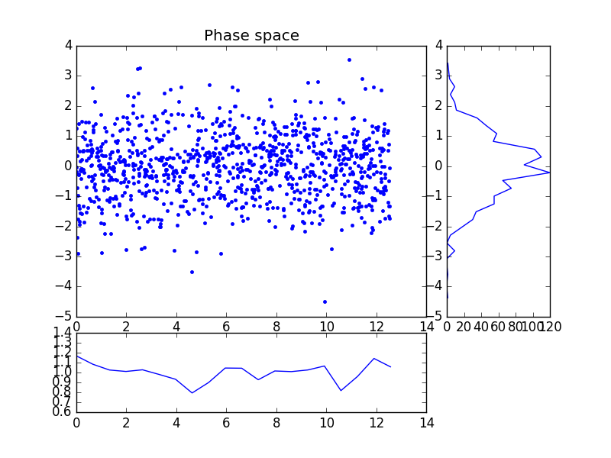

First pass output from provided ecp1d.py Figure 1 phase space, charge density, and velocity distribution

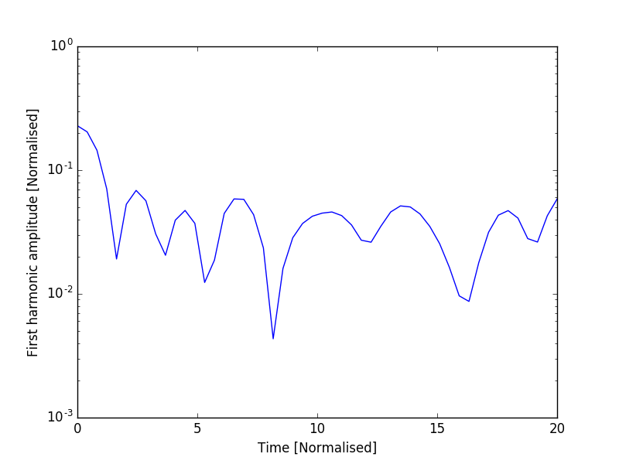

First pass output from provided ecp1d.py Figure 2

Interactive script used to vary particle count and cell size via python towards achieving steady amplitude with minimal noise.

from epc1d import *
from numpy import linspace, pi
L = 4*pi
pos,vel = landau(10000000,L)
s=Summary()
run(pos,vel,L,8,[s],linspace(0.,20,50))
import matplotlib.pyplot as plt
plt.plot(s.t,s.firstharmonic)
plt.yscale('log')
plt.show()

Table below summarises results.

L (i.e. length of domain) [m] | Npart (i.e. particle count | Time | First Harmonic | Cell count
4*pi | 1000 | 20.0  Runtime in landau function including subfunctions 951 µs | 0.0152644008202 | 8
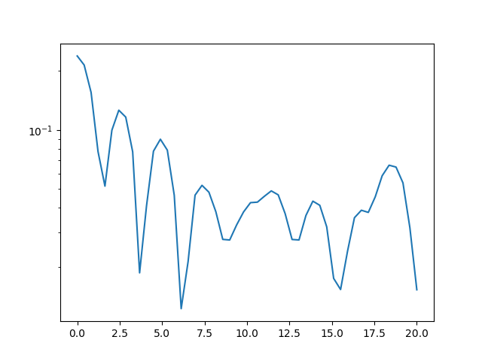
4*pi | 1000 | 20.0 | 0.0276569872459 | 4
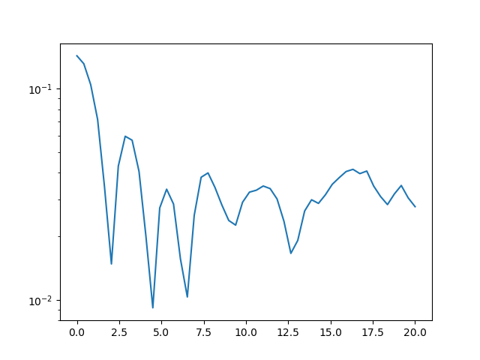
4*pi | 10000 | 20.0 | 0.00668444866315 | 8
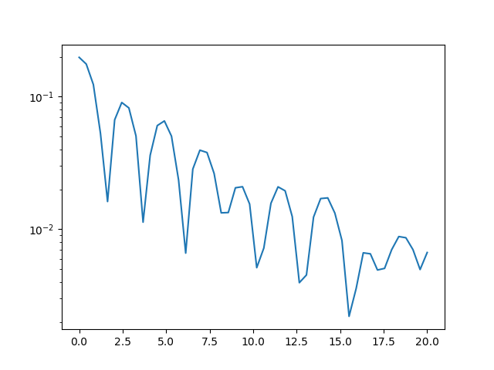
4*pi | 10000 | 20.0 | 0.00778283621367 | 4
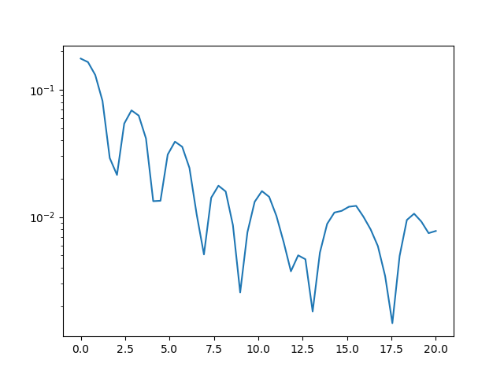
4*pi | 100000 | 20.0  Runtime in landau function (inclusive of subfunctions: 963 µs) | 0.00721222852728 | 8
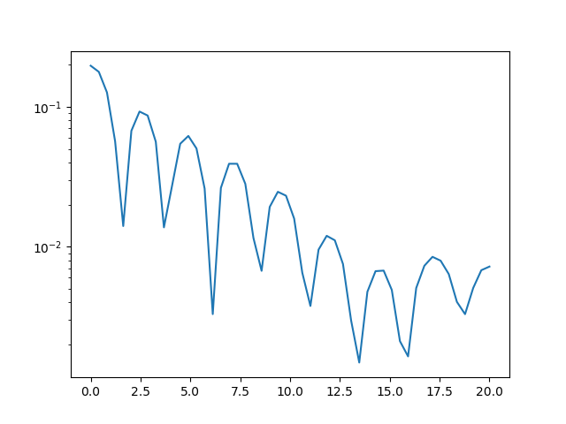
4*pi | 1000000 | 20.0  489.37 [ms] in run function and subfunctions  951 µs in landau functions and subfunctions | 0.00490489802085 | 8
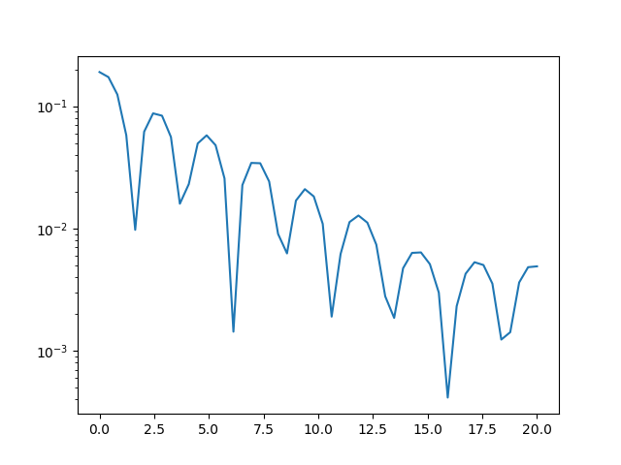
4*pi | 1000000 | 20.0  12h13 start  12h32 finish  21 minute runtime | 0.00439645431034 | 12
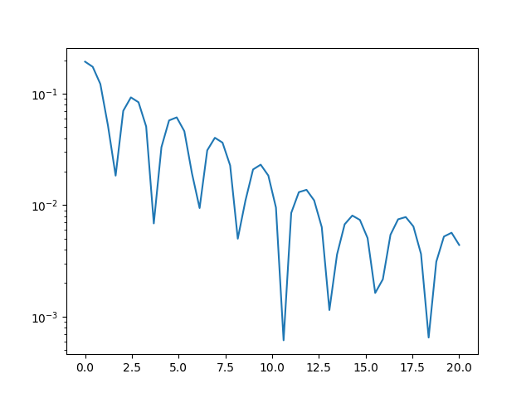
4*pi | 1000000 | 20.0  12h37 start  13h00 finish  23 minute runtime | 0.00555569513776 | 16
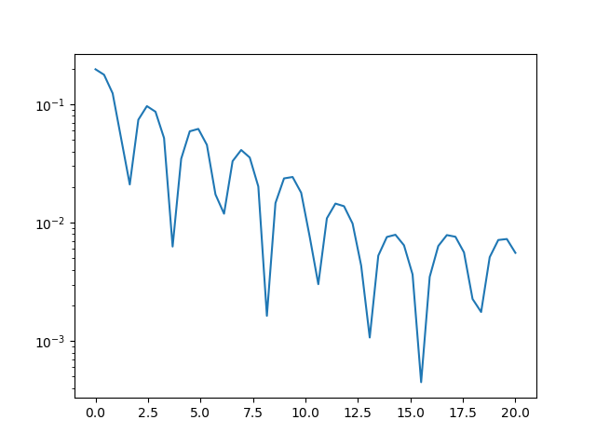
4*pi | 10000000 | 20.0  13h10 start  15h03 end  117 minute runtime | 0.00406686240263 | 8
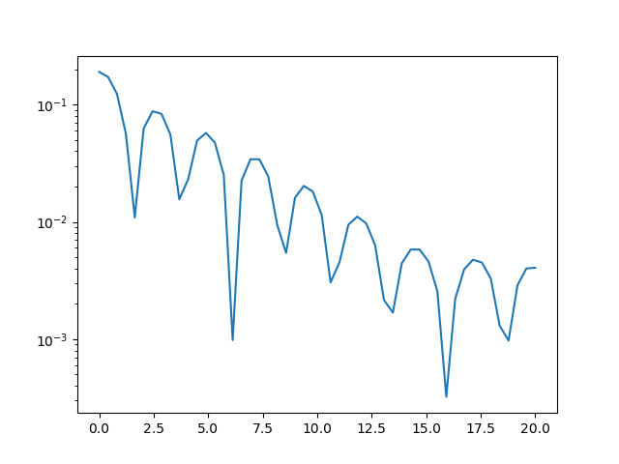

If the Electric field is only calculated at the vertices and the particle Coulomb fields cancel each other out in the short range which is important when we consider the PIC code where a large number of particles are considered in each cell, then it follows that collisions between the charged particles are not modelled very well via this technique. Source of error → can we account for this some way?

Additionally we can consider minimising the noise in the system via the ‘quiet start’ initial conditions to optimise ‘uniformity’ of the distribution.
Suggested method 1: Sobol’s quasirandom sequence →
Risk-neutral (ref. Martingale probability theory i.e. prior knowledge does not inform or impact on prediction of future successes i.e. only the current events ‘matter’)
Monte Carlo v. quasi-Monte Carlo → Finder Software?
Also Random number generator – high-discrepancy, low-discrepancy
→ Involve Number Theory? Orrr unnecessary rabbit hole
Van der Corput sequence Base → consider but move on to Hammersley’s sequence for now
and select → optimise code → generate some results in terms of the physics that is
happening ref. To Sanderson and Boyd

Include in the code a write out to text of velocities, densities, leave domain length fixed as it does not have a huge impact, particle number, cell count, than iterate through to acquire data → move on to statistical analysis, graphs etc, also note that fftw3 is installed on this machine and likely will assist in speeding up the runtime and accuracy of the fft; use svn repository? Also be sure to always include a write out of the initial code/results for comparison to validate that results are reasonable i.e. not horribly wrong

fft function ifft function pwelch function to remove noise ref to part 2 of the lab. Periodogram funcion, bandpower function

Parallel Computing Toolbox AND MATLAB Coder required (GPU option faster than C or Fortran ..?)

Suggested method 2: Hammersley’s sequence →

Also not the consistant VisibleDeprecationError which I have hereto ignored.

Computational Laboratory Lab 2 (Continuation of Landau Damping)
Measure oscillation frequency and damping rate – Part 2
Natalie Lauf
Date:

Task (Copied from VLE):
To compare results against theory, or make predictions, we need to extract the key information from our results.
- Write a code (in a language of your choice; I recommend Python) to find the peaks in the amplitude result. A good way to do this is to notice that the peak occurs where the sign of the derivative changes sign. You can't test where the derivative is exactly equal to zero, because the data points probably won't hit the peak exactly. Instead, to find these points in a signal 'f', first take the derivative and then multiply every point with the point next to it:
If the derivatives at two neighbouring points are both positive, or both negative, then the result will be positive. Only where the sign of dfdt changes will the result be negative. You therefore just need to find where the variable 'sign' is negative.
- From the spacing between the peaks, find the frequency and an estimate of the error
- Fit a curve (line on a log-linear plot, exponential on linear) through the peaks in the region before the noise becomes important to get the damping rate and error
- How do these vary with the length of the box? Compare against the analytic result
- How do your results vary with number of cells and number of particles? Does your result converge?

Typical result for testing
To check that your analysis code is producing roughly the right numbers use a case where the length of the box is 4 pi.
- Analytic result: angular frequency omega = 1.41566, damping rate gamma = 0.153359
- Typical result with 20 cells and 2e5 particles: omega = 1.33 +/- 0.16, gamma = 0.168 +/- 0.002

