# Project Accessibility

**Date:** Friday, September 13, 2019

**To:** Dr. David Chesney, Judy Pao

**From:** Norin Lavaee, nlavaee

**Class:** EECS 495-001

**Subject:** Intelligent Accessibility Options

### Overview

**Purpose:**

The purpose of this project is to provide users who may have disabilities in the categories of vision, hearing, cognitive/neural, mobility, and speech with a combination of accessibility settings enabled on their iphones to meet their respective needs.

**Summary:**

Today, the iphone supports a myriad of accessibility features that are available for various groups of users. However, it is difficult for a user to know all the options available to them, and how to best combine these various features to serve their needs. In addition, there are many additional features that the iphone supports that are not categorized as ‘Accessibility’ features, that can still be very useful to groups of people in the various categories outlined above.

Through research, it is evident that there are many blogs, YouTube channels, and other content (i.e. MacfortheBlind, A Quadriplegic’s Guide to the Galaxy, etc.) that write posts about how these various features work together and what each person has found useful for their personal journey. However, there is currently no system or application that, without directly prompting the user, recognizes or attempts to recommend what features may be helpful to them. There is a need for a way to help organize this information and provide users with the best combination of settings that will enhance their day to day life.

### Introduction

In today’s iphone there are many settings that are available, but the Apple documentation can be tedious to look through. In addition, there are no specific instructions on what settings aggregated together would best serve the needs of different sub-groups of the diversely abled population. The vision for this project is that we are able to create a system that will be able to recommend the best accessibility features for each person, depending on what they have already selected and what recommendations those with similar needs as them have identified as helpful.

There is not much progress in this area as to date, as much of the various applications available focus on providing additional functionality catered towards one sub-group. We want to harness and make use of the settings that are already available within the iphone. There is a great need for this project as more than 2/3rds of the diversely abled population have some sort of smartphone device. The mission is to make it that they are able to gain all benefits available from their devices’ built in settings.

### Stakeholders

The main stakeholders for this project beyond the team are direct members of the diversely and typical abled community. Members of the diversely abled community will be able to have a way to easily toggle settings on and off, while quickly understanding the change they will experience on their device without having to read through and search documentation. In addition, those who are typical abled often time toggle many of these various settings on and off as well in order to enhance their experience.

Looking much further ahead, Apple is a stakeholder as well. If Apple were to add a small ‘screening’ process as a part of their on-boarding, they would also be able to perhaps aggregate accessibility settings in such a way that can cater better to users. It is beneficial for Apple as well because the features they have created will be more broadly used, and great for the user since they may gain exposure to a feature that they love and would not have interacted with otherwise.

### Goals

The user goal is to have an iOS application that can access the users’ settings and identify based on their pre-selected accessibility settings what other settings should be recommended to the user. In addition, a reach goal is to create a guide within the application that showcases various accessibility features under the various disabled sub-groups visually as well as contextually so that users do not need to toggle settings on and off multiple times in order to understand the change they are selecting.

### Scope

**Priorities & Application Experience [See Fig 2 & 3]:**

Below is the full scope of the project, broken down into priorities, and how the application will function.

* Request access to the user’s settings
* P0: Begin on-boarding process with requesting that the user select from the distinct categories to set up:
  + Visual
  + Hearing
  + Mobility
  + Cognitive/Neuro
  + Speech
    - Select the top three most popular* settings and ask in each screen if the user would like to turn those on
      * *popular will be determined based on gathering further research into the above categories and seeing which categories current users find most useful to enable on their iphones
* P0: After the user finishes this process, ask if they would like to enable notifications to see if they would want a new features recommended to them
* P0: Keep track of the users’ settings & begin making recommendations (~1 or 2 weeks) after they have either enabled new settings or recommend based on what they self selected when on-boarding
  + Recommendations will be generated based on continued research of what YouTubers, different sub-groups, and online forums are suggesting has helped them be successful (Very research heavy into understanding these different sub-groups). The goal is to also conduct in person interviews as well.

The reach portion of the project is very relevant because the Apple documentation is tedious to browse, and many of the options do not come with exact descriptions of what they do or how they alter iphone settings visually. Also, options are often hidden under many layers of settings control pages that can be tedious to set and toggle on (i.e. answering phone calls automatically on the iphone).

* P1 - Small guide listing a few features that are additional iphone settings as well not just accessibility settings that users have found helpful to incorporate into their daily lives
* P2 - A large comprehensive guide that displays the settings as images that users can toggle on & off from within the app then applied to their settings as they explore their different options

**Data:**

The goal is to crowdsource the majority of the data that will be used to make recommendations. This will be done by interviewing real people, and looking at the recommendations that users are making online. Admittedly this means that starting out the application will most likely address up to two specific disabilities. However, this will help us stay in scope and grow.

**Implementation:**

The baseline is that we hard code the different categories [see Fig 1] and then we employ Collaborative Filtering in order to match whatever settings are enabled to the closest category. Moving along further we could try to learn based on what recommended settings the user continues to turn on and as well as if the user decides to turn off settings. In this way the user has settings that they can interact with without being directly asked to identify if they have a specific disability.

The main languages will be Swift and Python. Python mainly for creating the model that we will employ for the recommender system. The model will be imported into the main application, which will be written in Swift. The application will follow the iOS architectural pattern of Model View Controller (MVC). As of now, the intent is to not employ story-boards for the creation of the application, as this gives the developer easier control and helps in designing more complex layouts; however, this may change depending on the needs of the project. For the application, the main development environment will be Xcode.

There are also security concerns with the data that is stored on each user. It needs to remain k-anonymous so that users are not identifiable by which accessibility settings they have enabled.

### Project Roadmap (Broad Overview)

Week 09/16 - Begin research on most commonly used settings for specific disabilities. Connect with outside company contacts (currently know Accessibility drivers at Microsoft), and pursue user interviews, generate hi-fi mock-ups on Figma (only design after gaining a firm understanding of user needs)

Week 09/23 to alpha launch - Begin development work while still aggregating research. Goal is to have basic framework for application set up, and first P0 fully functional.

Beta launch - Development work complete and functional for the two remaining P0s

Omega launch - Functioning P1 and **reach P2

*dates are subject to change, and weekly goals/tasks will be set to stay on target

Work Division: Half of the group will begin the initial search into understanding what exactly is the user problem, user pain points, identifying scenarios, and completing user research. If we cannot meet users in person, another option is to ask for responses on UserTesting.com. The other half will focus on implementation and thinking about what is feasible or not given our time constraints so that it is possible to identify reasonable, timely goals.

As the project moves through phases, all group members will be highly involved in the implementation of various functionalities (breaking down the P0s into separate deliverables that members will be responsible for).

### Conclusion

We believe that aggregating accessibility settings to make smart recommendations will greatly ease and enhance the user experience. The way this is accomplished may change as we speak with more users. However, the main goal to somehow display accessibility information for diverse user groups is a necessity.

### References & Figures:

|  |  |  |
| --- | --- | --- |
| **User #** | **Settings Enabled** | **Settings Enabled** |
| User 1 | ‘Hey, Siri’ | Automatic call answer |
| User 2 | Large Text | Invert Colors |
| User 3 | Large Text | ??? |

**Fig 1:** In this overly simplified example, basic collaborative filtering would recommend User 3 also look at Invert Colors feature.

**High-fi Mock-ups:**

On-boarding:

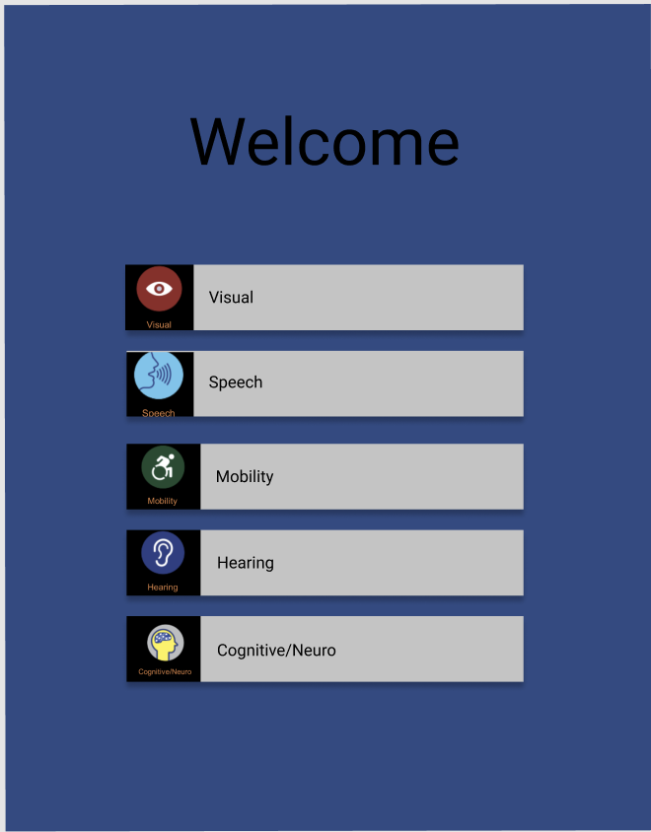

**Fig 2:** A very hi-fi mock-up of what the on-boarding screen with the various options would appear like.

Guide in App Example:

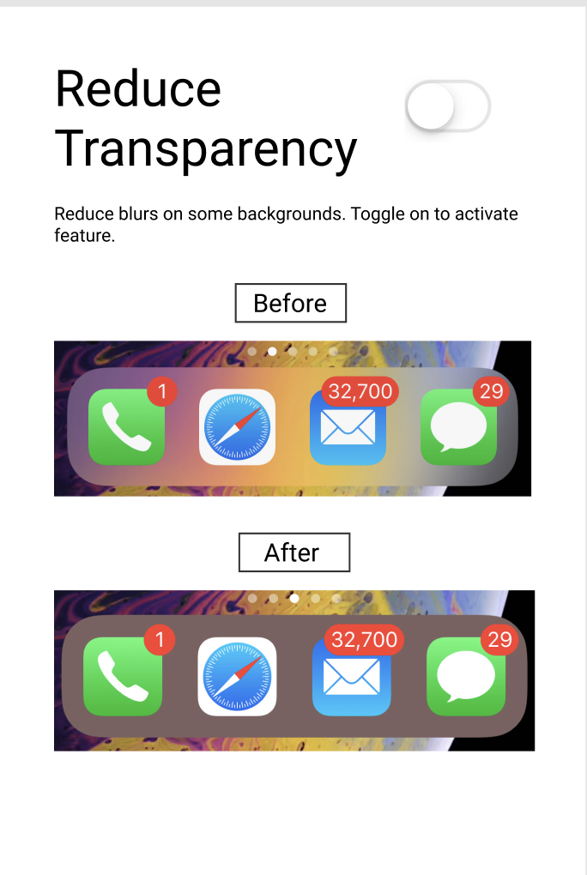

**Fig 3:** An example of what one of the features available under ‘Visual’ section of the guide would appear like. There is the visual representation as well as the textual. There is also the option to toggle on the setting within the app and have that change reflected in the phone settings.

**Sources**

<https://www.youtube.com/watch?v=-PyTxlt3a7Q>

<https://ablethrive.com/life-skills/quadriplegic-demonstrates-accessibility-features-iphone>

<https://support.apple.com/en-us/HT207025>

<https://support.apple.com/en-us/HT202362>

<https://www.jamf.com/resources/webinars/apple-accessibility-features-for-neurodiversity/>

<https://medium.com/ios-os-x-development/modern-mvc-39042a9097ca>

<https://medium.com/ios-os-x-development/ios-start-an-app-without-storyboard-5f57e3251a25>

<http://macfortheblind.com/>

<https://www.apple.com/accessibility/iphone/vision/>

<https://www.apple.com/accessibility/iphone/>

<http://scholarworks.csun.edu/bitstream/handle/10211.3/190202/JTPD-2017-p50-66.pdf?sequence=1>

<https://mashable.com/2018/05/17/iphone-accessibility-features-for-everyone/>

<https://www.imore.com/accessibility-iphone-ipad>