Nate Lawonn
Professor Melichar
Programming Concepts 2
5/31/2026
Debugging Exercise
Upon downloading the project file, I executed the code to see what error would occur. I noticed the code stopped after the first two items in the list, producing a TypeError message that displayed, “Can’t multiply sequence by non-int of type ‘float’.”
I examined the code and discovered, in the third line, the price of the tablet, 500 dollars, was in quotes, indicating a string. To confirm my finding, I set a break point at line 23 and debugged the code. I stepped through each item, price, discount rate, discount amount, and final price until I got the same error when I reached the tablet.
I removed the quotes, ran the code again and had no errors. To polish the code, I set all the prices to two decimal points.
Figure 1Initial error output.
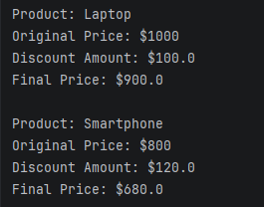
Figure 2 Output of the first two items before the error.
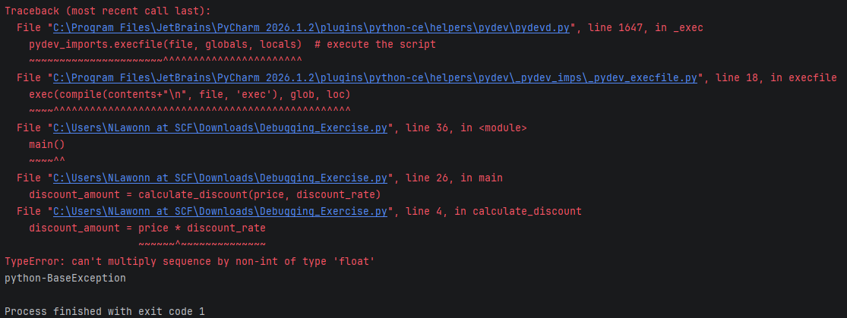
Figure 3 PyCharm error to confirm.
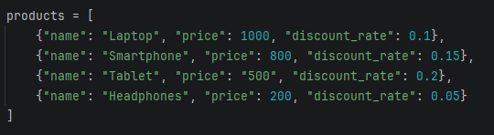
Figure 4 Formatting error in the Tablet price
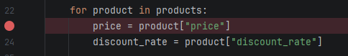
Figure 5 Break point to run through each item.

