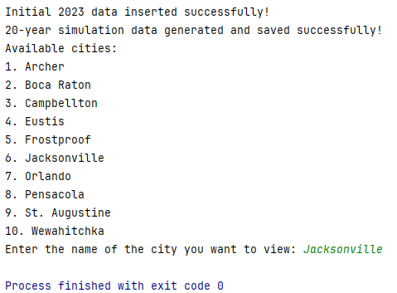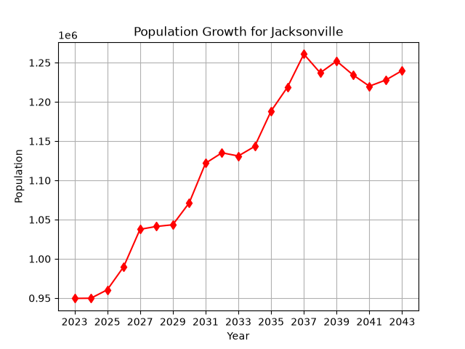
https://github.com/nlawonn/ProgrammingConcepts2/tree/master/ProgrammingExercise13

