

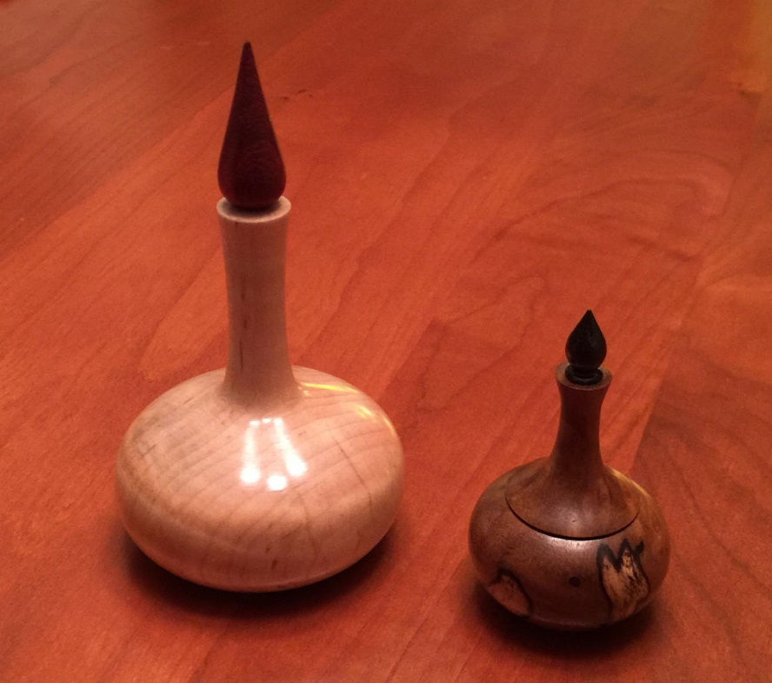

Introduction to Woodturning

By Norm Brewer, Philip Gaudette, Krista Nugent

Contents

Getting Started 3

Safety 4

Lathe Startup Checklist: 5

Stock Preparation and acquiring blanks 5

Wet turning 5

Lathe Terminology 6

Mounting the Workpiece 6

Proper RPM 8

Tools used for turning between centers 8

Planning the project 10

Overview of sharpening lathe tools 10

Spindle turning practice 11

What’s next 13

Turning the Ring Holder 14

Turning the Finial 18

References: 20

# Getting Started

This course is intended to be an introduction to the lathe. You will learn how to mount workpieces on the lathe and use some of the basic turning tools. We will stress safety and safe operations. You won’t become an expert with one course, but I hope you will discover or rediscover that turning is fun and gives you a chance to be creative and make useful and interesting objects.

I use turning as part of my woodworking hobby. I like to make furniture, and many projects contain turned elements such knobs, handles, or even major parts of the project. The Mission style table (below left) is pretty rectilinear, but the drawer pulls are turned. The picture below right shows several practice pieces and the final version of a table base I turned. I am still carving details on the final base.

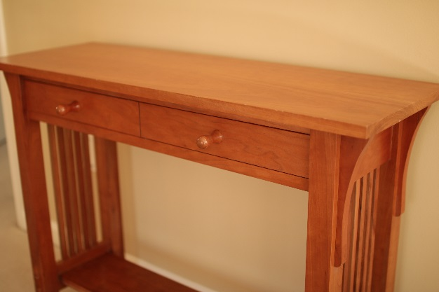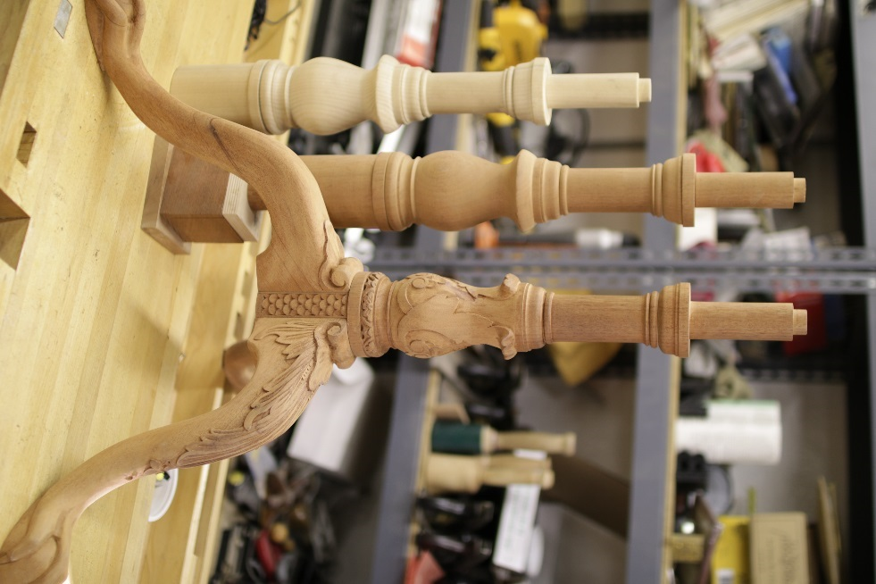

Figure 1 – Minor (knobs) and major (base) turned elements in furniture

**Learning to turn takes time**. I have watched a lot of videos, and spent a lot of hours practicing. I have had a few lessons, read and reread a lot of books and watched the videos again. More than anything else, it just takes practice to develop a feel for the wood and tools. Catches are the bane of turning, and you will undoubtedly experience some at the most inconvenient time. Don’t be discouraged and don’t give up, just keep trying and focus on the tools that work best for you. This class will get you started, but the practicing is up to you, as well as going further by reading books and exploring further. There are many good books and videos on turning available in local libraries, and You-tube, and you may want to further your knowledge if you really get hooked on woodturning. See the references section at the end for more information.

# Safety

Lathes are fun to work with and generally are one of the safer woodshop tools. The amount of planning you need to do is minimal and you can follow the rule “if it looks good, it is good”. However, there are a couple of safety hazards that may not be obvious at first that you should be aware of:

**Workpieces coming loose from the lathe**. There is a lot of momentum stored up in a rotating part, and if it comes loose it may fly in unpredictable directions. Unfortunately, when turning you have to stand right in the area where pieces will fly if this happens (the RED zone). Keep the tailstock tight, and be aware of any looseness or vibration in the work you are turning. **Wear a face shield** **at all times** to prevent getting hit in the face and eyes by big or small objects. Also, make sure the lathe RPM is set correctly for the piece you are turning and stand to the side when first switching on the lathe.

**Getting hair, sleeves, or loose fabric caught in the lathe**. Things can easily get caught in the chuck and pull you into the machine. A less obvious problem is fabric or hair wrapping around the workpiece and being pulled into the machine**. Keep hair tied back and sleeves rolled up or wear a turning jacket**. Also, be careful of badge or ID holders and put them in your pocket while turning. Also be careful of hoodie strings.

**Workpiece breaking apart**. This can happen with pieces that are cracked, glued up, or that contain internal faults. This is most common and dangerous with bowl turning. Again, **wear a face shield** to prevent injury to your eyes, and stand to the side when you switch on the lathe. If you glue up a workpiece make sure you give it a few days to dry completely before turning.

**Chips fly everywhere** when turning. Wear a face shield and clean up the area frequently and when finished turning for the day.

Some other general safety precautions are:

* **Know where the shop fire extinguishers and first aid kits are located** before starting.
* **Never leave the lathe running** **unattended**.
* Before turning on the power to the lathe, **rotate the stock by hand** to be sure that it clears the tool rest.
* **Never adjust the position of the tool rest while the lathe is running**. You can easily ruin your work by crashing the tool rest into the workpiece
* Always **remove the tool rest** from the lathe’s bed when sanding to avoid pinch hazards
* Be careful with the lathe chisels, especially where you set them down. Dropping one on your foot is not a good thing and they always land pointy-end down. Sturdy shoes help prevent problems in this area.
* **Never use your fingers** to check the work for roundness while the lathe is running, especially during roughing operations. Stop the lathe to check the progress, or rest the blade of the tool lightly against the work as it turns.
* Position the tool rest no more than 1/8” from the stock.
* After tightening or loosening the chuck, **remove the chuck wrench** immediately.

# Lathe Startup Checklist:

* No loose sleeves, badge holders, hair, hoodi-cords
* Face shield on
* Rotate work by hand to check for clearance
* Dust mask on if needed
* **Chuck key out of chuck**
* RPM set correctly
* Stand to side when switching on.

# Stock Preparation and acquiring blanks

For this course we will start with some dry softwood for initial practice, and the pieces will be already squared up and ready to use. For your own use you can use any dry hardwood or softwood, but hardwood generally holds fine details best and often has a prettier grain pattern than generic “white wood”. You can find turning blanks at Woodcraft in Springfield or Leesburg, and this includes many exotic hardwoods and colored plywood. For practicing, you might want to use 2x4 lumber cut into 1.5”x1.5”x12” pieces. If you are not certified on the table saw or band saw, you can ask other folks in the woodshop who are certified to help you make some practice blanks. I will supply hardwood blanks for turning the ring holders later in the class.

I normally start with pieces that have a square or rectangular in cross section, but you can also take the additional step of machining the blanks to an octagonal cross section. The roughing gouge makes quick work of knocking off the corners of the square pieces as you will soon see.

# Wet turning

You can also turn green or wet wood, and this is often done for making bowls. Wet wood turning is a good for anyone with a chainsaw and lots of patience. The basic process is to start with a wet blank and turn it to the desired shape leaving 3/4“ of extra wood in all dimensions. You then coat it with a liquid wax/solvent mixture to slow drying and put it away for 6 months to a year to season. Once it is dry you can start to refine the shape and complete the project.

Below is a bowl I made from a piece of green wood. Seasoning took about 9 months between green and finish turning. Unfortunately, I don’t have any pictures of the process.

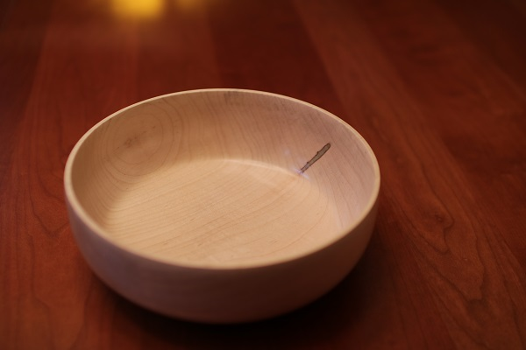

Figure 2 - Bowl turned from green wood

# Lathe Terminology

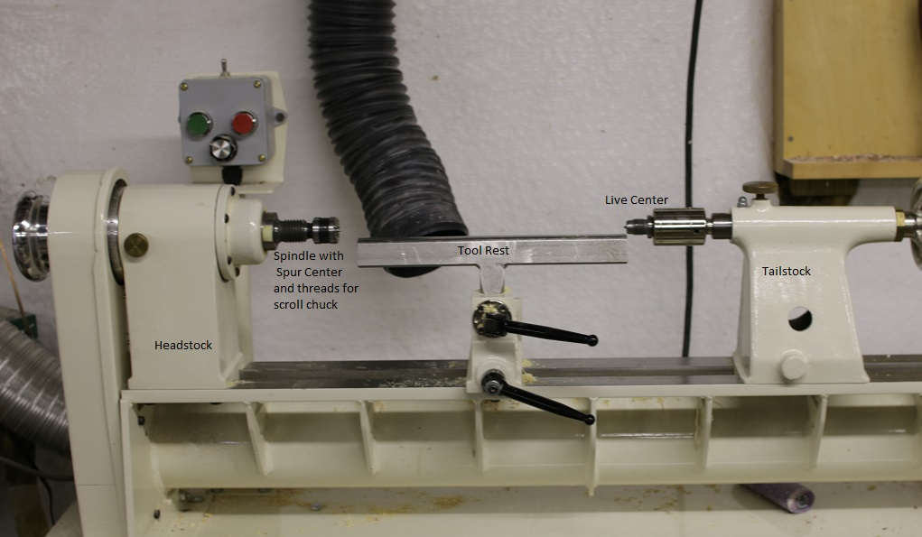

Figure 3 - Parts of a Lathe

* Headstock. Has Morse taper for centers, and threads for chuck. Drives workpiece
* Tailstock. Also has Morse taper for live center and Jacobs drill chuck
* Tool holder supports the lathe chisels
* Spindle – the part that turns

# Mounting the Workpiece

The easiest way to mount things on the lathe is **between centers**. A spur center mounts in the headstock Morse taper and drives the work. A live center is a center with a built in bearing that supports the end of the workpiece opposite the headstock and the bearing rotates as the workpiece rotates. For this course we will start by turning between centers.

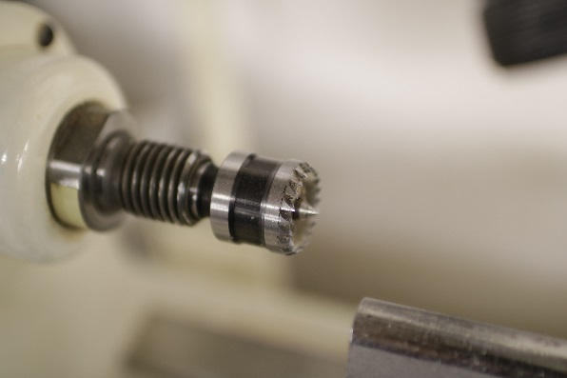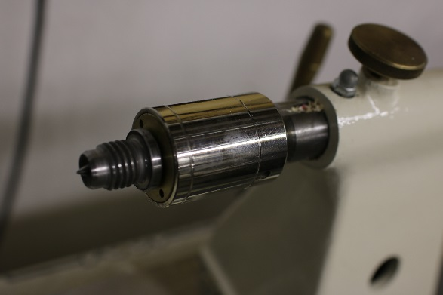

Figure 4 - Spur center in headstock and live center in tailstock

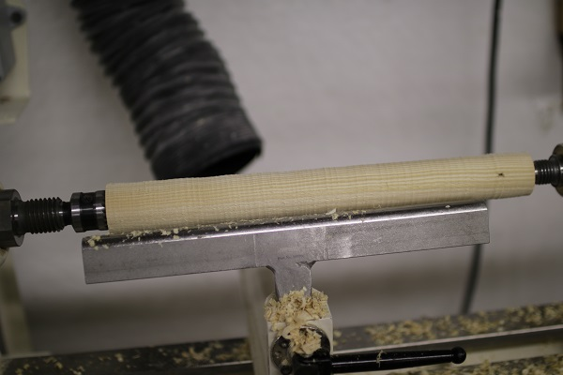

Figure 5 - work mounted between centers

**Scroll chucks** are also used for mounting the workpiece, especially for bowls and boxes where the inside is to be removed. They can be used either with or without a tailstock center. You will use a scroll chuck to finish the ring holders. All the jaws on a scroll chuck move in unison to grip the workpiece.

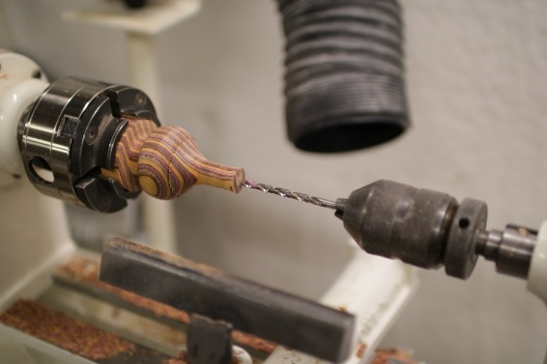

Figure 6 - work mounted in scroll chuck

Removing and remounting pieces works well when using centers, and less well with chucks. It is common for pieces to be a little unbalanced or off center when remounting on a chuck. This isn’t a problem if you can remove a little more stock and true up the workpiece again, but is something to think about before unmounting a piece.

# Proper RPM

Richard Raffan’s book has a table showing optimal RPM for different size workpieces. The RPM depends on the length and diameter of the workpiece. For the short workpieces we will be using, 1250 to 2000 RPM will be about right. Longer workpieces have a tendency to flex or whip, and the RPM must be reduced for them, typically to 700 RPM.

General RPM guideline. When you **multiply the diameter of the piece in inches by the RPM of the lathe, you should get a number between 6,000 and 9,000**. Reduce the RPM for pieces longer than 12”, especially if they have any thin cross sections.

# Tools used for turning between centers

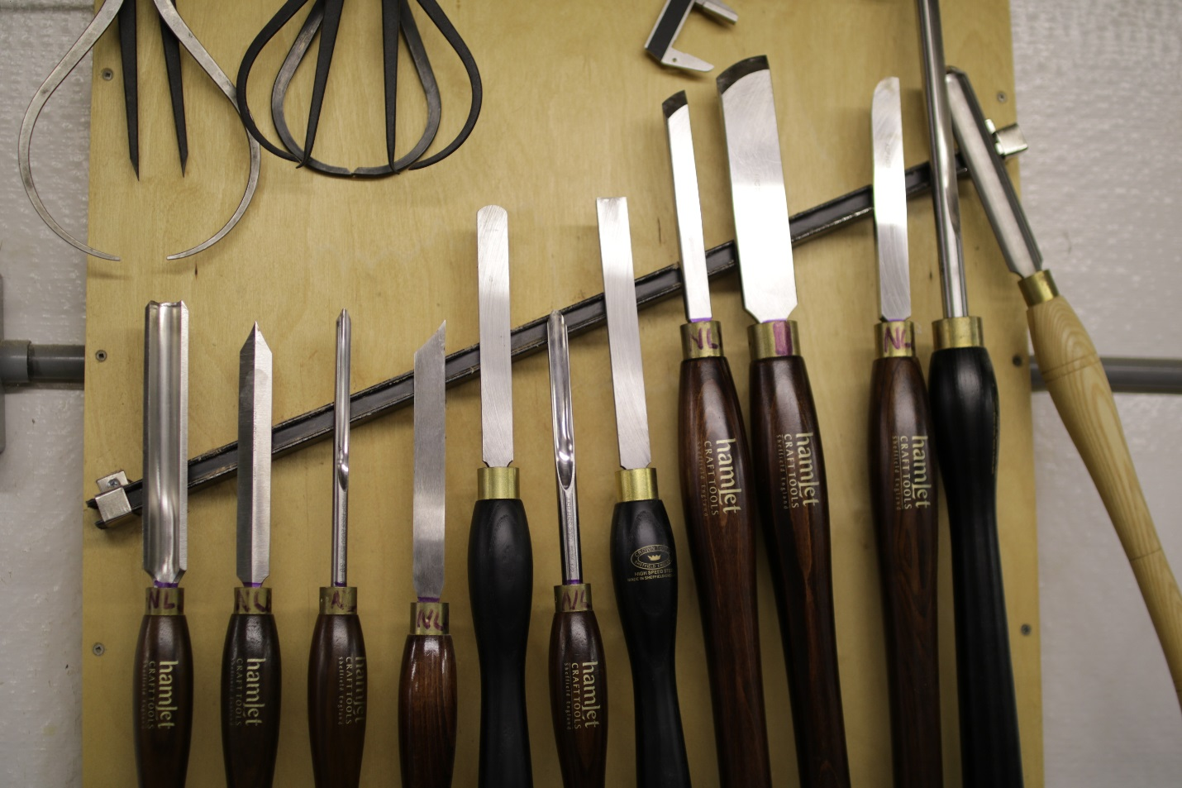

Figure 7 – Various lathe tools: L to R Roughing gouge, diamond parting tool, small spindle gouge, parting tool, round end scraper, 3/8 spindle gouge, flat end scraper, small skew, large skew, round end scraper, bowl gouge, spindlemaster

I will demonstrate the use of all of the tools listed below:

The first tool you will use is the square ground **roughing gouge**. This is used to knock off the corners of the workpiece and get the initial round shape. You use it by making scooping motions starting at the tailstock end of the workpiece and progressing across the workpiece. As you proceed you will soon notice the vibration of the workpiece decreasing and be able to “ride the bevel”. Start with an overhand grip as demonstrated. This [YouTube video](https://www.youtube.com/watch?v=h8YYYYA-6jQ) demonstrates the use of the roughing gouge.

The **spindle gouge** or detail gouge is used for making beads and coves on the workpiece. It takes a bit of practice to become proficient with a spindle gouge, but it is one of the most commonly used lathe tools. **Riding the bevel** is crucial for success with this tool. In this [YouTube video](https://www.youtube.com/watch?v=-0MrdSRq3cQ) Alan Lacer demonstrates how to use a spindle gouge.

The **parting tool** is used for cutting off your project when you have finished it, but is also used with calipers to establish diameters for different parts of the workpiece. You can use the two-handed technique I will demo to quickly size a workpiece.

The **skew chisel** is more difficult to master than the gouges, but it is very versatile and produces a very smooth finish. The key to using the skew chisel is to cut only on a narrow section near the heel of the blade. I recommend practicing a lot on scrap wood with the skew chisel before using it on a project you care about. [Here’s another video](https://www.youtube.com/watch?v=KfeLAHQSbqk) to demonstrate using the skew chisel.

**Scrapers** are the easiest of the lathe tools to use, but produce a rougher finish than the cutting tools. However, when learning you can use scrapers to produce profiles that you might have problems with using the gouges and skew chisel, and are less likely to ruin a workpiece.

**Drilling and boring** can easily be done when you are using a scroll chuck on the headstock so no center is needed in the tailstock. This is done by mounting a Jacobs chuck in the tailstock and placing a drill bit in the Jacobs chuck. You then advance the drill bit into the spinning workpiece. We will use this technique for making the ring holder.

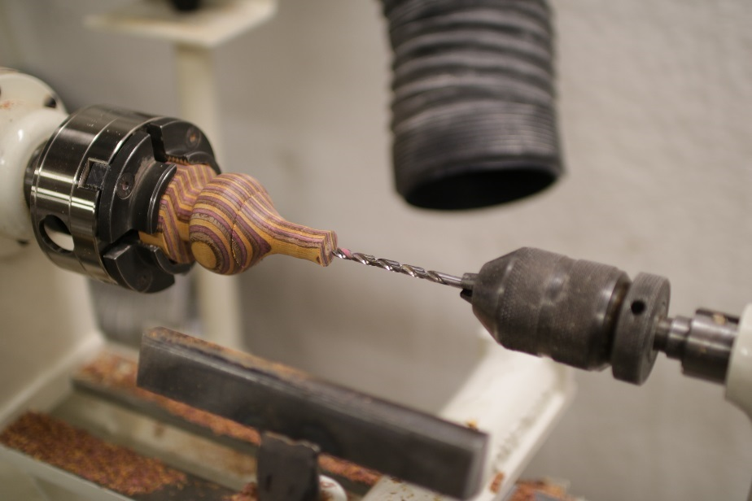

Figure 8 - Drilling a workpiece with Jacobs Chuck in tailstock

**Sanding and Finishing** can be done on the lathe. You remove the tool rest and use sandpaper to smooth the spinning object. I normally start at 80 grit and work up to 500 grit, being careful to inspect after each grit to make sure the sanding marks from the previous grit are removed. Sometimes it helps to reduce the RPM a little to avoid burning. **Be very careful to not let the sandpaper wrap completely around the spindle** or you will be in for a nasty surprise. Also, be sure to use dust collection and a dust mask for this operation.

I often use friction polish on the lathe as a finish, and this dries in a few minutes from the heat of the applicator rubbing on the workpiece. Friction polish is typically shellac with additives.

Another good way to finish small objects is to use the **Beall Buffing System** that uses buffing wheels to polish the wood itself to a high polish. I will demonstrate this if possible.

# Planning the project

You need to think in advance about how you will hold the workpiece, and what order of operations you will use. Some pieces are straight forward. You mount the blank, cut the profile you want, sand, and perhaps finish before removing. Other pieces take some planning to ensure you always have a way to grip the object for all subsequent operations. For example, for the ring holder we will mount the blank between centers and turn it into a cylinder. Then we will grip it with a scroll chuck with the tailstock center holding on the opposite end and cut the profile with the smallest end on the right. We will then remove the tailstock center and drill a 3/16” hole for the flame part and finish the right end of the ring holder. We’ll put the tailstock center back into the hole we drilled and finish turning as much of the ring holder as we can, leaving it attached to the scroll chuck. We’ll sand the ring holder as completely as possible, and finally part off the ring holder from the blank. After parting off, there is no way to hold the ring holder so any further sanding will have to be done by hand.

In general, if you have a blank mounted in a scroll chuck, you work from right to left toward the headstock removing material and finishing as you go so there are no parts with thin cross sections to the left of them.

# Overview of sharpening lathe tools

If you are going to turn, you need to learn to sharpen your tools. However, for the initial course I’ll keep your tools sharp. We will offer a separate sharpening course later.

The tools we will be using are made of tool steel. They can be sharpened using a combination of a grinder and hand stones. Nova Labs has a Wolverine sharpening jig system that makes it possible to repeatedly sharpen tools while removing a minimum of material from the tool.

Most turners keep a grinder near the lathe and sharpen frequently when the turning tool edge seems dull. Nova Labs has a very nice grinder with a CBN 180 grit sharpening wheel. This wheel should be used carefully and only for steel tools. It has a thin coating of CBN and never requires flattening like typical aluminum oxide wheels. **Never sharpen carbide tools using this wheel**. Also, **never try to dress the wheel** using an abrasive or diamond cutter. Also grit and sparks from the grinder can injure your eyes and ruin your glasses so always wear safety glasses or a face shield when grinding.

# Spindle turning practice

1. Mount a practice workpiece between centers by finding the center of each end, punching the center, and then mounting between centers on the lathe.

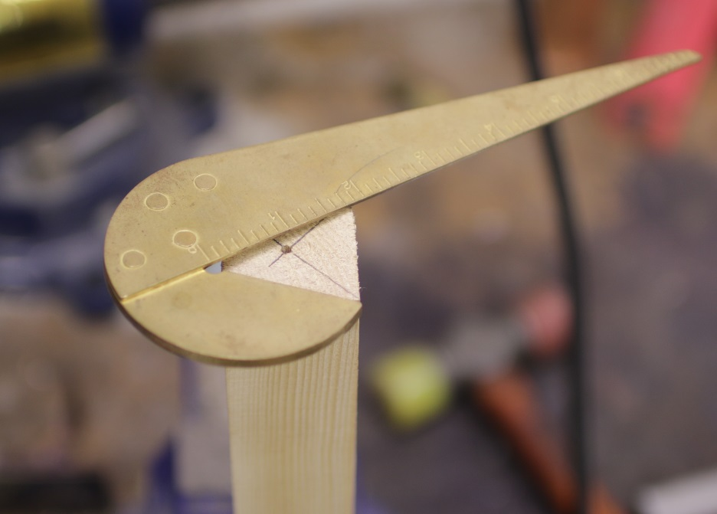

Figure 9 - Marking the center and punching

1. Use the roughing gouge to make a cylinder

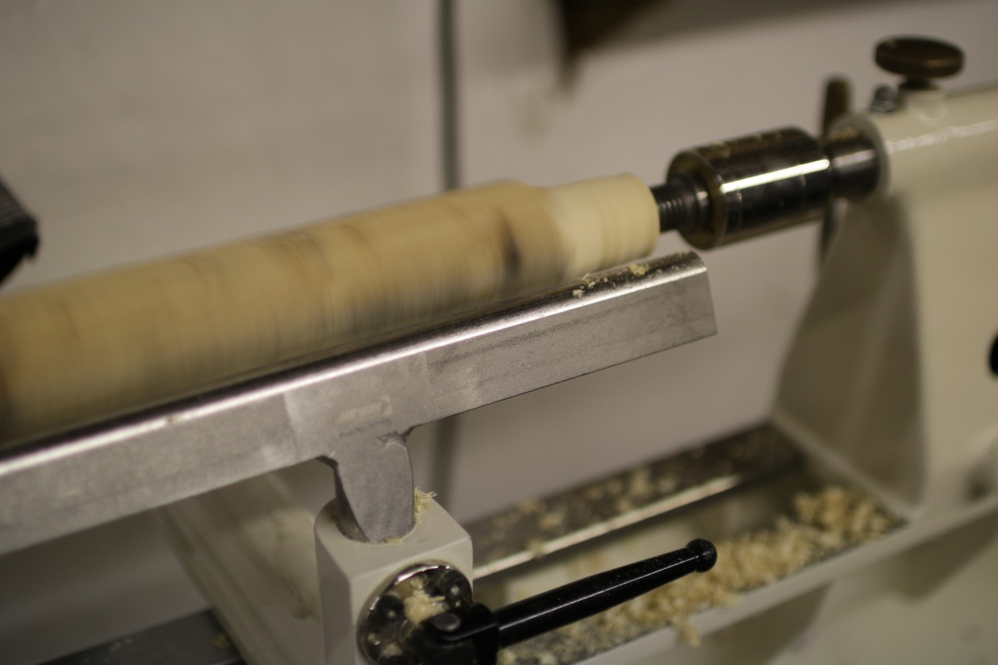

Figure 10 - Use the roughing gouge to make a cylinder using a scooping motion right to left.

1. Mark the cylinder every inch along its length

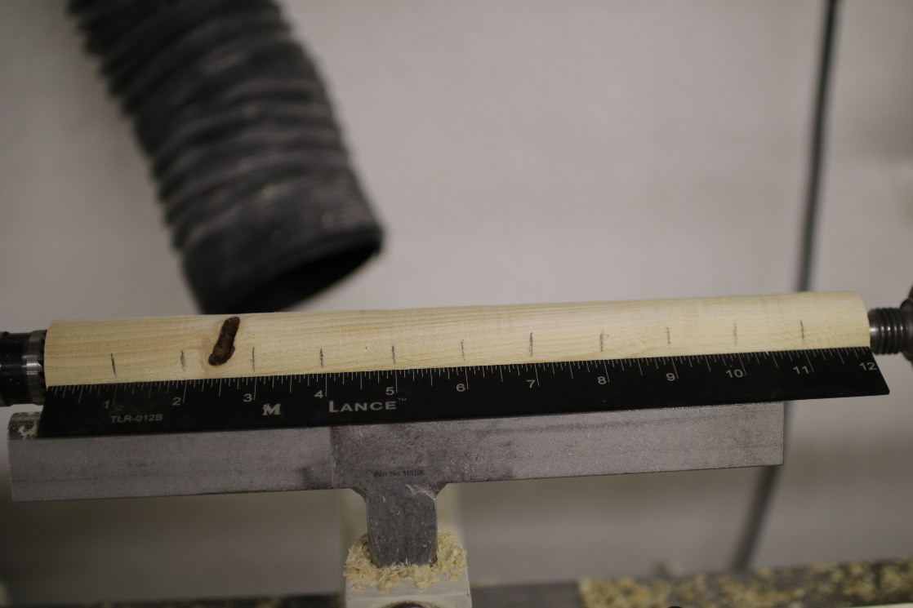

Figure 11 - Mark every inch along cylinder

1. Cut coves at each mark using the spindle gouge

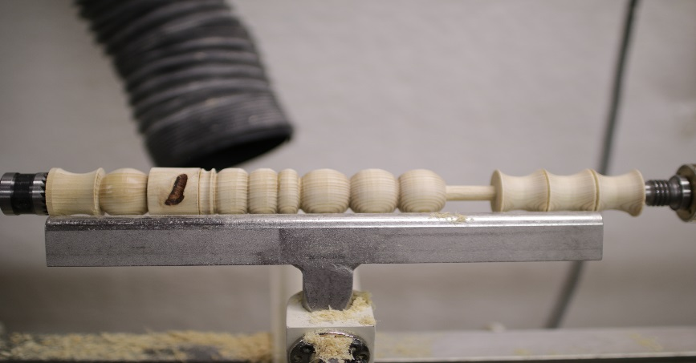

Figure 12 - Sample piece with coves at right, beads, and bead made with skew at left.

1. Mount another practice piece and make it into a cylinder
2. Mark this piece every inch and cut connected beads using the spindle gouge.
3. Make another practice cylinder. Try using the skew chisel to plane the cylinder.
4. Mark this cylinder every inch and try using the skew chisel to roll beads
5. Use the parting tool and calipers to set the diameter of a bead as demonstrated.
6. Part off the piece at the chuck end using the parting tool.

# What’s next

So far we have used a few lathe tools. To get better, you need to practice, read, and watch videos over and over. You can branch out to using different tools and techniques once you feel more comfortable with the equipment and chisels. Hopefully, Nova Labs will offer some additional courses in turning and projects for making different items. Happy turning!

# Turning the Ring Holder

I first saw the wooden ring holders at a craft market in San Francisco a couple of years ago. I bought one from turner Brad Adams and we had a long conversation about turning. I later emailed Brad to ask if he minded if I wrote an article about the ring holders for The Wooden Word, the [Wasington Woodworkers Guild’s](http://www.washingtonwoodworkersguild.org) newsletter. Brad referred me to the article below where he originally got the idea:

<http://www.rrosand.com/articles/15-3.shtml>

We’ll modify the project to fit the materials we have at hand. The overall plan will be:

1. Select and mount the workpiece between centers and make it into a cylinder. Turn one end to fit the scroll chuck for your machine.

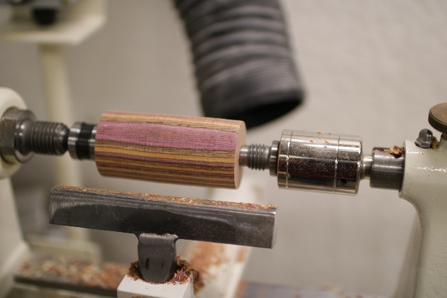

Figure 13 - Mount between centers and make cylinder

1. Put the scroll chuck on the lathe and mount the cylinder from step 1 in the scroll chuck with the live center in the tailstock. Put some pressure on the piece with the tailstock and tighten the scroll chuck. **Remove the chuck key!**

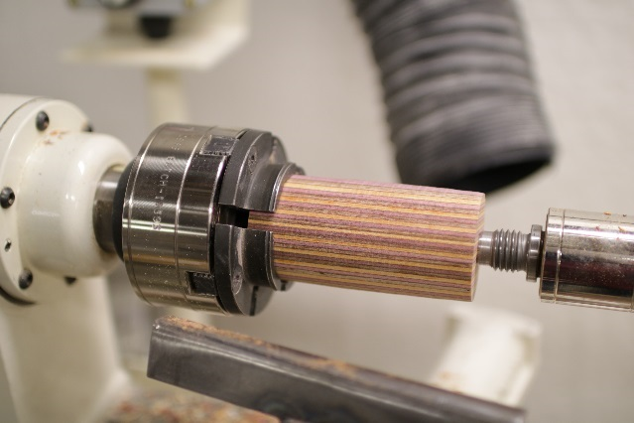

Figure 14 - Mount in scroll chuck with tailstock live center

1. Measure about 1/2 inch to the right of the scroll chuck jaws and make a mark. Then divide the remaining length of the cylinder into thirds. About 1” each with this blank.

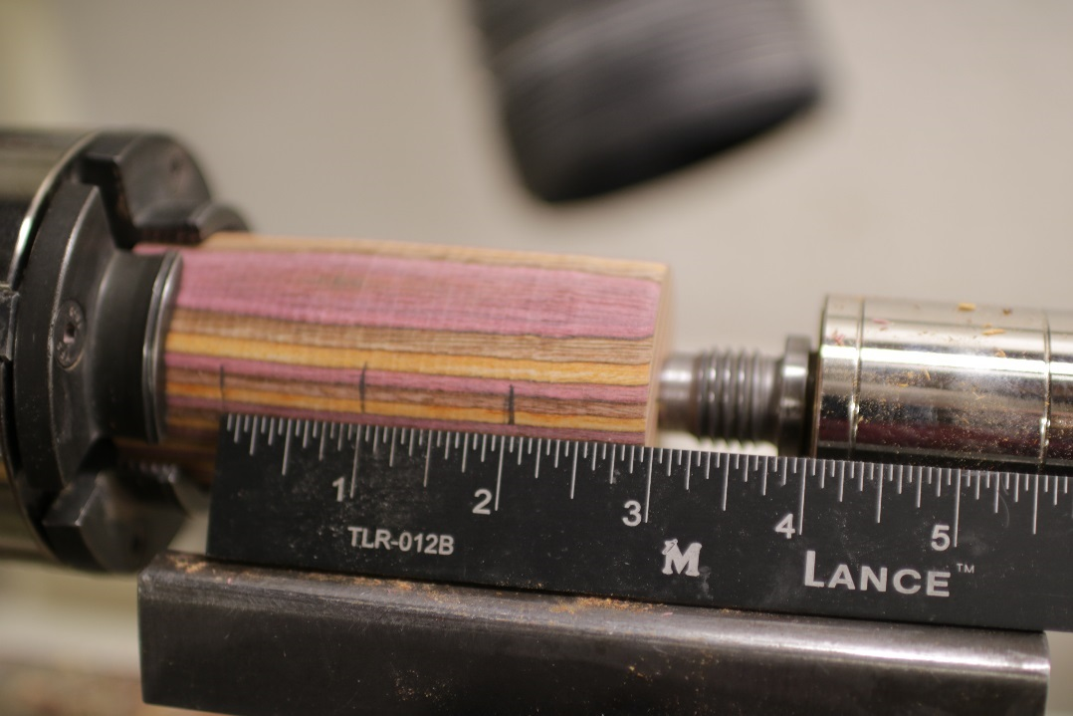

Figure 15 - Mark blank proportions

1. Rough in details with spindle gouge leaving large connection to chuck

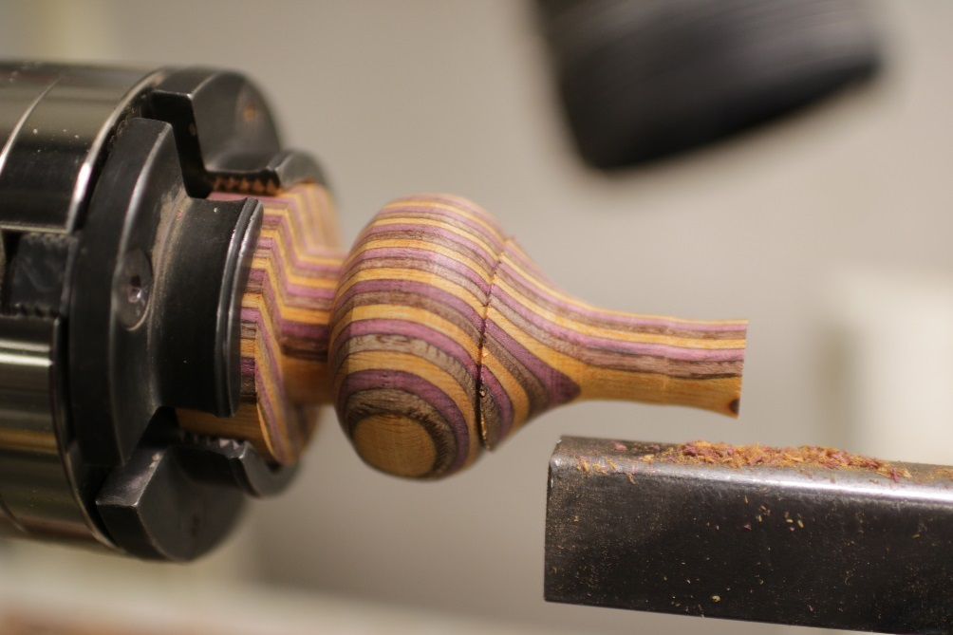

Figure 16 - Rough in details

1. Continue to refine shape, cut to length with parting tool, and drill 3/16” hole in top for flame.



Figure 17 - Drill hole in top

1. Continue to refine the shape, and sand while you still have a thick connection to chuck. Support tailstock end as long as possible.

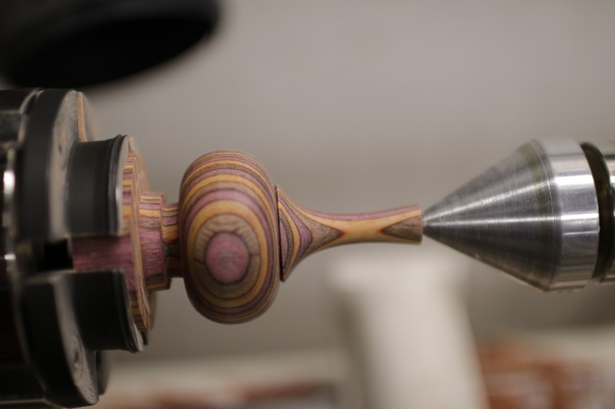

Figure 18 - refine and sand

1. Use the parting tool and reduce diameter of base connection, sand base, and eventually part off the piece.

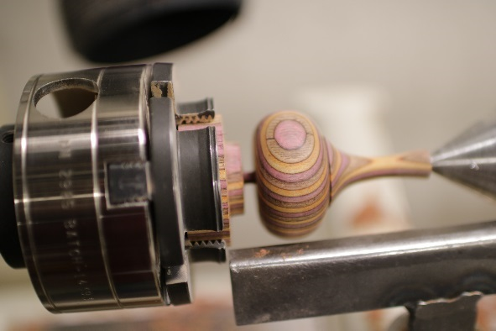

Figure 19 - Sand, reduce base, and eventually part off

1. After some polishing, here’s the result:

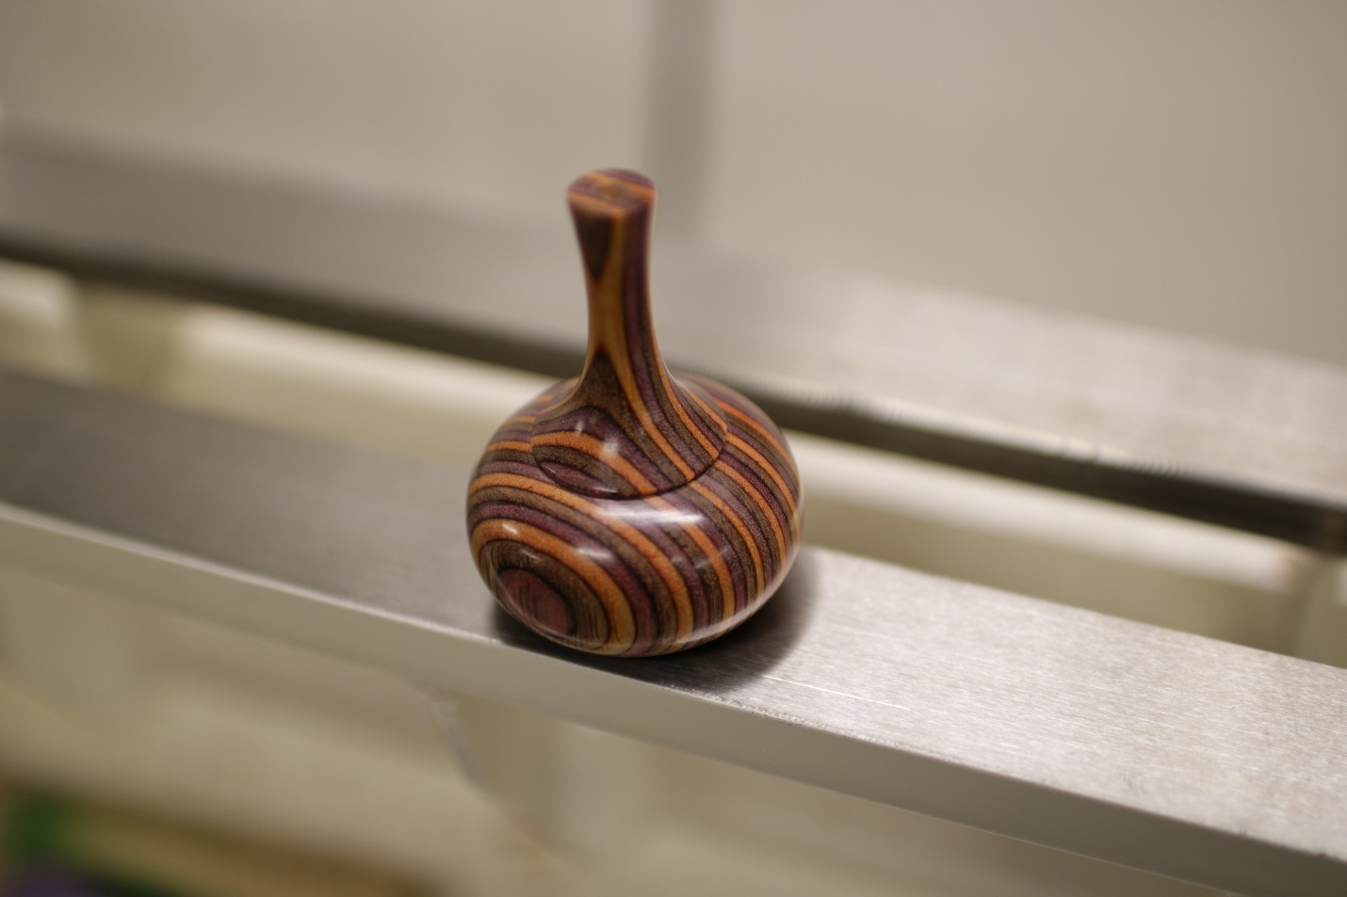

Figure 20 - Polished ringholder

# Turning the Finial

The following pictures show the process of turning the finial or flame. Use a spindle gouge and parting tool, a light touch, and turn the dowel connector on the left end of the finial with a parting tool to 0.186” diameter. Use CA glue to attach it to the body.

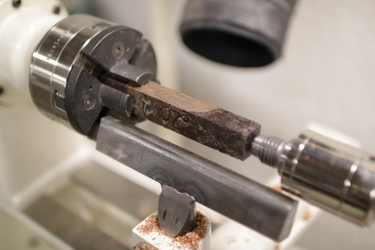

Figure 21 - Mount finial blank in chuck

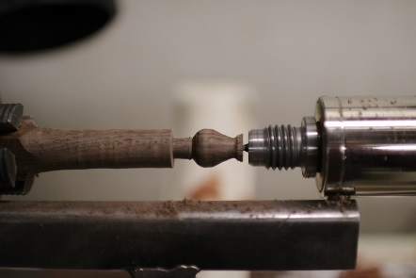

Figure 22 - Rough turn finial

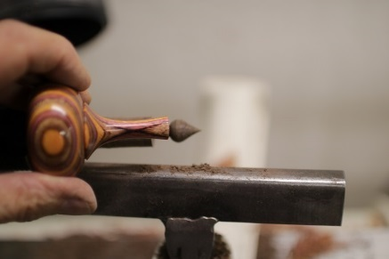

Figure 23 - Check finial size with your base and refine till satisfied

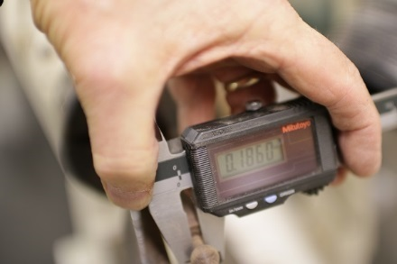

Figure 24 - Turn post to 0.187-0.190

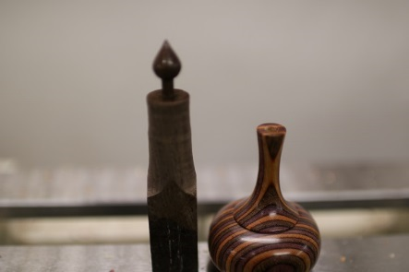

Figure 25 - Polished finial ready to cut off and mount

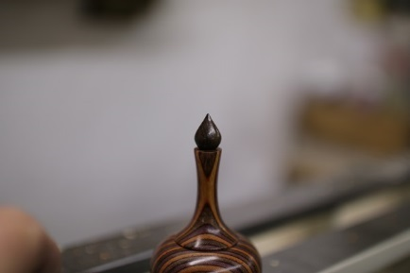

Figure 26 - Finish ring holder

# References:

I found the following books useful:

* [*Turning Wood with Richard Raffan*](https://www.finewoodworking.com/assets/downloads/TurningWood.pdf)
* [*Fundamentals of Woodturning* by Mike Darlow](http://www.amazon.com/Fundamentals-Woodturning-Darlows-Mike-Darlow/dp/1565233557)
* [*Books by Alan Lacer*](http://www.amazon.com/Alan-Lacers-Woodturning-Projects-Techniques/dp/1440340951/ref=sr_1_1?s=books&ie=UTF8&qid=1452804898&sr=1-1&keywords=alan+lacer%27s+woodturning+projects+%26+techniques)

Also, the following web sites have some good information:

[Understanding Woodturning Catches by Richard Raffan](https://www.youtube.com/watch?v=jOvF5f1phhY)

[Woodturning Skew Chisel Techniques and Hand Positioning](https://www.youtube.com/watch?v=lOELuHLk98E). This guy is really good!

<http://www.docgreenwoodturner.com/index.html>

The [Capital Area Wood Turners (CAW)](http://capwoodturners.org/) is a local club that has skill improvement sessions and hands on teaching available, as well as monthly meetings and guest speakers. This is a great resource for improving your turning skills.

# Instructors notes:

I print out this file and supply a copy for each student, even though it is on the Wiki.

I supply two blanks for each student, with some extras available in case of mishaps.  A 3x3x6 poplar blank for practice and a 2 x 2 x 6 blank of attractive wood for the project.  There is a supply of poplar in the lathe area you can cut up for blanks, and I have been getting the nice wood at Woodcraft and submitting the receipt to Jim Sweeney to get repaid.  I like the laminated colored plywood blanks you can get at Woodcraft, but they have packs of 4 2x2x12 exotic wood on sale periodically.   I will be going to Woodcraft before the next course and if you want I’ll get some blanks for your course.  Let me know if you want that.

I bring my own turning tools to the course for students to use.  I bring two roughing gouges, two ½” spindle gouges and two 3/8” spindle gouges, and a parting tool.  I sharpen these tools at home before the class, and they normally don’t need to be touched up in the class.  The tools at Nova Labs are not always sharpened correctly, and they don’t have conventional roughing gouges.  I also bring my own calipers which have rounded ends.  We probably should ask Nova Labs to purchase a few better tools, and I’ll look into that later.

I turn finials for the ring holders at home because there isn’t time to do that in the course.  I have a bunch of different styles for students to choose from.  I make these from pen blank materials or scraps I have laying around.

I put together the notes for the course based on making a small project – a ringholder.  I picked this project because it is just a bead and a cove, but it illustrates a lot of aspects of spindle turning and results in a completed object.  I start the course with a 30 minute lecture where I explain the following:

1. Safety aspects of the lathe and how it can hurt you, what PPE we use etc.  Covered in the writeup
2. Types of lathe chisels we will use, stressing what the bevel of the tool is and how important it is to “ride the bevel”
3. Workholding – centers and chucks

Next we go to the shop, and I show students how to mark the centers of a blank, centerpunch it, and mount it between centers on both lathes.  We normally set the speed at 1200 rpm to start and go to 1800 rpm when the diameter gets lower than 2”.  I have been using 3x3x6 inch poplar blanks, and  One blank per student is usually enough.  I have them use the roughing gouge to make a cylinder, then mark it at 1” intervals and cut coves and beads using a ½” spindle gouge.  I normally give them 1 hour to practice and try to help them get the feel for turning and riding the bevel.  Early on, I found out that I was hovering over the students too much, which made some of them nervous, so my approach now is to leave the students alone to practice and check every few minutes to see if there are questions or problems.  In the meantime, I do something else in the shop.  If we start at 7:00 by 8:30 most students are ready to try making the ring holder.  The steps are as follows:

1. Mount new blank between centers and turn one end to a cylinder with a diameter that will fit in the chuck. Don’t go too small!
2. Remove spur center from headstock, mount chuck, and mount blank in chuck with tailstock in place.
3. Turn blank to a cylinder.
4. Mark the blank for the ringholder – 1.25” base and 1.75” top
5. Turn ringholder leaving at least 1” diameter wood holding it to the chuck
6. Remove tailstock and drill 3/16” hole 1” deep in top of ringholder
7. Make slight concave in drilled end of ringholder
8. Sand using all grits.
9. Part off ringholder
10. Buff using rouge, white diamond, and wax wheels
11. Put in finial

Typically at least one student has a catch on the bead of the ringholder, and they have to back up on the blank and repeat the process.  The 6” blanks are long enough to allow a couple of tries.