Predictive Maintenance Report
Prepared by: Coley Costello
Date: December 2025
For: X team at YZ Corporation

1. Executive Summary
This report evaluates the operational health and anticipated failure timeline of Motor A and Motor B using sensor trend analysis, anomaly scoring, and insights from the attached Failure Modes and Effects Analysis (FMEA) chart. Motor A shows a clear pattern of accelerated degradation with a projected failure in the near term, while Motor B remains stable. Pre-work and post-work actions are incorporated to ensure safe and effective maintenance execution.

2. Assets Assessed
This analysis covers two production motors equipped with vibration monitoring, temperature sensors, current draw measurement, and anomaly scoring. These indicators collectively allow early detection of mechanical wear, inefficiency, and operational risk.

3. Data Summary
Sensor data includes vibration (mm/s), temperature (°C), current draw (A), and anomaly scores collected over a multi-day operational period. The dataset is complete and reliable, supporting accurate trend interpretation and predictive modeling.

4. KPI Trend Analysis
• Vibration: Motor A shows steadily increasing vibration levels, indicating potential bearing wear or mechanical misalignment. Motor B remains within normal limits.
• Temperature: Motor A exhibits a rising temperature trend consistent with increased friction or cooling inefficiency. Motor B remains stable.
• Current Draw: Motor A displays increased electrical load, often associated with mechanical resistance or component degradation.
• Anomaly Score: A machine-learning–based early warning signal reveals an accelerating anomaly pattern for Motor A, preceding physical failure indicators.
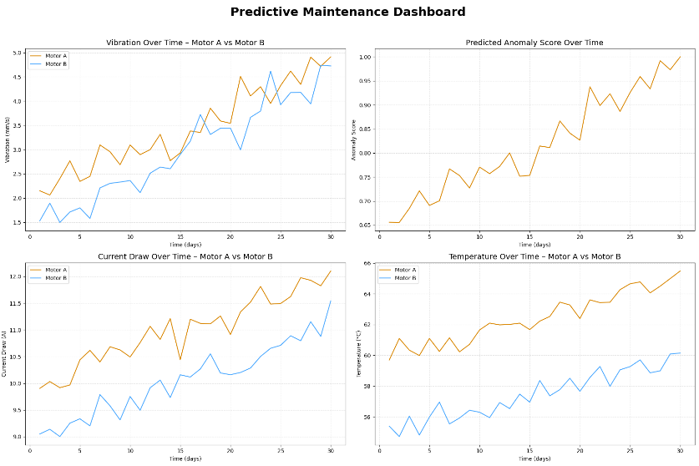
Figure 1 Vibration, Temperature, Current Draw, and Anomaly Score Dashboard (Motor A vs Motor B)

5. Predictive Modeling Results
Using NumPy-based regression analysis, Motor A’s anomaly score is projected to exceed the critical failure threshold (1.0), indicating a high likelihood of failure soon if no intervention occurs. Motor B shows no significant risk within the model’s predictive window.
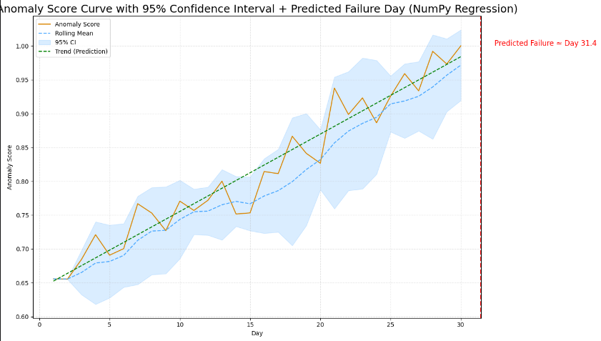
Figure 2 Anomaly Score Curve with 95% Confidence Interval (Motor A)

6. FMEA Risk Alignment
Based on the attached FMEA chart, key failure modes consistent with Motor A’s degradation include bearing failure, shaft misalignment, overheating due to lubrication issues, and electrical overload. These modes typically carry high Severity (S) and moderate-to-high Occurrence (O) ratings, contributing to elevated Risk Priority Numbers (RPNs). Motor A’s behavior aligns with the highest-risk categories identified in the FMEA. Actual FMEA scores can be inserted here once available.
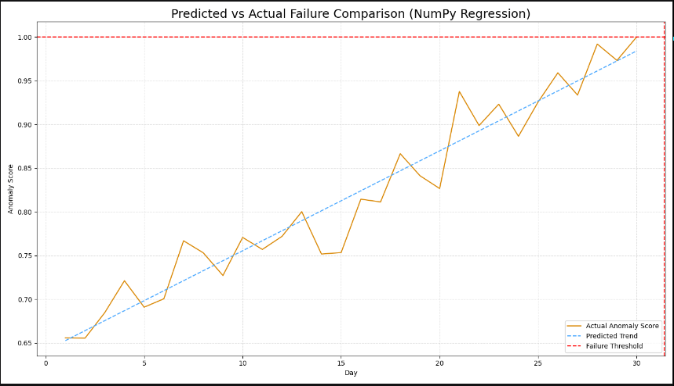
Figure 3 Predicted vs Actual Failure Comparison

7. Pre-Work and Post-Work Actions
Pre-Work Actions:
• Perform Lockout/Tagout (LOTO)
• Notify operations personnel of scheduled maintenance
• Review relevant FMEA findings to understand risk levels
• Verify electrical isolation and motor cooldown
• Inspect surrounding equipment and workspace safety
• Gather required PPE and tools

Post-Work Actions:
• Restore power safely and conduct a controlled restart
• Reassess vibration, temperature, and current readings
• Update anomaly model baselines to reflect repaired state
• Document all work completed per SOP
• Update the FMEA if new failure insights were discovered
• Communicate changes and findings to maintenance and reliability teams

8. Maintenance Recommendations
Immediate (Next 3–7 Days):
• Inspect Motor A bearings and shaft alignment
• Check lubrication quality and replenish as necessary
• Remove debris or airflow restrictions causing thermal rise

Mid-Term (1–2 Weeks):
• Increase monitoring frequency for Motor A
• Re-baseline anomaly score after any maintenance actions
• Evaluate the cost-effectiveness of partial component replacements

Long-Term:
• Implement automated vibration and temperature alert thresholds
• Reassess the FMEA annually or after major maintenance events
• Integrate anomaly scoring into your preventive maintenance strategy

9. Conclusion
Motor A shows multiple converging indicators of near-term failure, supported by both predictive modeling and FMEA risk assessment. Proactive maintenance is strongly recommended to prevent unplanned downtime. Motor B remains stable with no immediate risk. This report presents clear, accessible, and actionable information to support confident decision-making in your maintenance program.

