Game Design Document

YAC

YET ANOTHER COMMANDO

Written by Nicolas Lebedenco

Version: 1.0

August 04, 2016

Conteúdo

Changelog 4

Concept 5

Overview 5

Premise 5

Objective 5

Structure 5

Unique traits 5

Platform 5

Genre 5

Rating 5

Target audience 6

Competitive analysis 6

Financial analysis 6

Technology 6

Team 6

Producers 6

Developers 6

Game Designers 6

Contributors 7

Visual Assets 7

Audio Assets 7

Features 7

General 7

Game play 7

Elements 7

Player movement 7

Player actions 8

Combat 9

Weapons 9

Power-Ups 9

Camera 9

Perspective 9

Control 9

User interface 9

GUI 9

HUD 9

Multiplayer 9

Game world 10

Overview 10

Travel 10

Scale 10

Time 10

Scenarios 10

Static Elements of the Scenario 10

Dynamic Elements of the Scenario 10

Player 10

Enemies 10

NPCs 10

Level design 10

Skills 10

Obstacles 10

Enemies 10

Non-Enemies 10

Level progression 10

Game engine 10

Render 10

Textures 10

Lights 10

Shadows 10

Audio 10

Terrain 11

Water 11

Particles 11

Physics 11

Input controls 11

Music and Sound FX 11

Visual Style 11

References 11

Rambo: First Blood Part II / Ashura (阿修羅) / Secret Command - Sega Master System 11

Assault Commando 11

Assault Commando 2 11

Minigore 2 11

Appendix A: GUI Layout 11

Appendix B: HUD Layout 11

Appendix C: Character Animation 11

Appendix D: Story 11

# Changelog

**Version 1.0**

* Initial concept, design and description of basic game mechanics and reference titles

# Concept

## Overview

Fast paced 3D vertical scroller shoot ‘em up resembling old NES games such as *Commando* and *Ikari Warriors*. With very simple controls suitable for mobile platforms, the game sets a pace for play, and the player must react quickly to the changing environment.

## Premise

A highly trained military asset is the last resort in a large scale conflict. In order to accomplish his mission, he must pass through enemy territory destroying as many opposing units as possible.

## Objective

The main objective of the game is to keep your character alive by destroying as many enemy units as possible until you find the exit point in each scenario. The exit point can be a door, a button/switch, a checkpoint or an element to be destroyed. Some levels may have secondary objectives such as to unlock passages, find secrets, escort prisoners, kill certain foes or free friendly units.

## Structure

Game is divided in chapters with each chapter later subdivided in levels. Each level can be played independently although they are expected to give the player a sense of progressive difficulty. No inventory system or complicated character customizations.

## Unique traits

A rule of thumb is any new game concept should have at least three unique selling points (USPs). These are elements that customers would see on the back of the box to entice them to buy the game (marketing bulletpoints).

## Platform

Mobile Devices: iOS 8+, Android 5.0+ (API21), Windows Phone 8.1

Minimum operating system versions are imposed by the game engine (Unity 5.x)

## Genre

Run and gun shooter: a shoot 'em up in which the protagonist fights on foot, sometimes with the ability to jump. Run and gun games may use side scrolling, vertical scrolling or isometric viewpoints and may feature multidirectional movement.

## Rating

Describe the ESRB rating you are aiming for with your game. Try to include the content descriptors that you expect to receive. Ratings and content descriptors can be found here: http://www.esrb.org/ratings/ratings_guide.jsp

## Target audience

Every game needs to have a target customer in mind. The most basic demographic include age, gender. Ideally, you want to cover psychographics and positioning here.

## Competitive analysis

Describe the games that will likely attract the same target customers as the proposed game. It should include a list of relative strengths for each competitor and a side-by-side comparison across all competitors and the proposed game.

## Financial analysis

What is the argument for making the game? The components of the analysis are budget, projected sales, and return on investment.

## Technology

* Development:
  + Unity 5.x
  + Android SDK
  + iOS SDK
  + Windows Phone SDK
* Distribution:
  + Apple Store
  + Google Play
  + Windows Mobile Store

# Team

## Producers

Nicolas Lebedenco  
Thiago Borda

## Developers

Nicolas Lebedenco  
Thiago Borda

## Game **Designers**

Nicolas Lebedenco  
Thiago Borda

## Contributors

### Visual Assets

Add names of companies/individuals that contributed with assets used in the game

### Audio Assets

Add names of companies/individuals that contributed with assets used in the game

# Features

## General

What the player can do in general terms.

1. Create Profile
2. List Missions
3. Play Mission
4. Automatically save progress [Can a mission be saved in the middle of it or is progress registered only by accomplishing a mission?]
5. View score/stats after a Mission is accomplished
6. Automatically Save best score/stats for each accomplished Mission
7. View best scores/stats for each mission
8. View/Modify Game Settings [while in game?]
   1. Auto Shoot [on|off]
9. Abandon/Restart Mission

## Game play

Describe the basic gameplay mechanic.

### Elements

1. Mission (aka Level): [define]
2. Scenario: [define]
3. Static Structure:
4. Unit:
5. Player: [define]
6. Enemy: [define]
7. Bullet: [define]
8. Power-up: [define]
9. Destructible: any game element that is subject to damage. This includes the Player, Enemies and less obviously some Static Structures.

### Player movement

Player moves in constant speed. There is no distinction between walk and run.

Player can move in all four directions and face a different direction than that of movement.

Because of the scrolling mechanic (detailed in [reference section detailing scrolling]) movement backwards is limited for the player which gets blocked by the bottom of the screen. The same does not apply to enemies which can cross the screen in any direction, most of the times top to bottom. All other constraints such as the maximum turning angle however do apply for both types of units.

|  |  |  |  |  |
| --- | --- | --- | --- | --- |
|  | Up | Down | Left | Right |
| Front | X |  | X | X |
| Move | X | X | X | X |

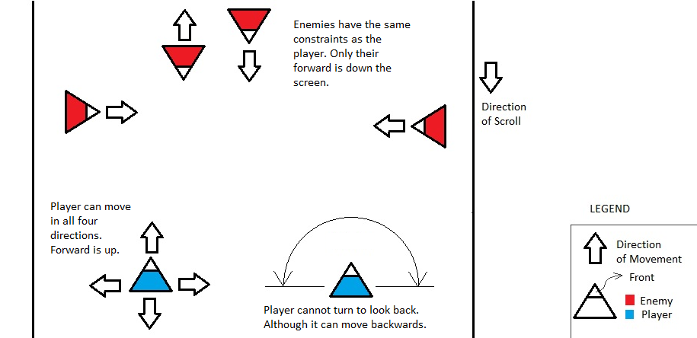

Picture - Basic movement and positioning of units. Player come from the bottom of the screen. Enemies come from the top. Enemies can cross the upper and lower bounds of the screen contrary to the player.

Movement is affected by **Auto Shoot Settings**:

1. **Auto Shoot ON:**

* Player always faces the direction of movement except when moving backwards in which case it faces the opposing direction.
* There is no way to turn without moving.
* In this mode, one of the player’s hands is free to perform other actions not related to movement.

1. **Auto Shoot OFF:**

* Player controls movement and turning independently. It may face a direction and move in another.
* Turning is constrained to the upper 180o arc.
* In this mode, one of the player’s hands is free to perform other actions not related to movement.

### Player actions

Player can perform actions and move at the same time.

1. **Shoot:**
   * Player fires a bullet (in abstract terms unrelated to the actual game implementation which may or may not simulate a real projectile).
   * Because of the movement constraints the player **cannot** shoot backwards
   * Player can shoot with one of two weapons (see [add reference to weapons section]):
     1. Primary
     2. Secondary
   * Shooting is affected by **Auto Shoot Settings**:
     1. Auto Shoot ON: the primary weapon fires automatically when an enemy is in front of the player and in range.
     2. Auto Shoot OFF: player must activate the fire action (i.e. by pressing the fire button) corresponding to his weapon of choice (Primary or Secondary). Weapon will fire regardless of having an enemy in range.
   * The secondary weapon must always be manually activated regardless of the control mode.

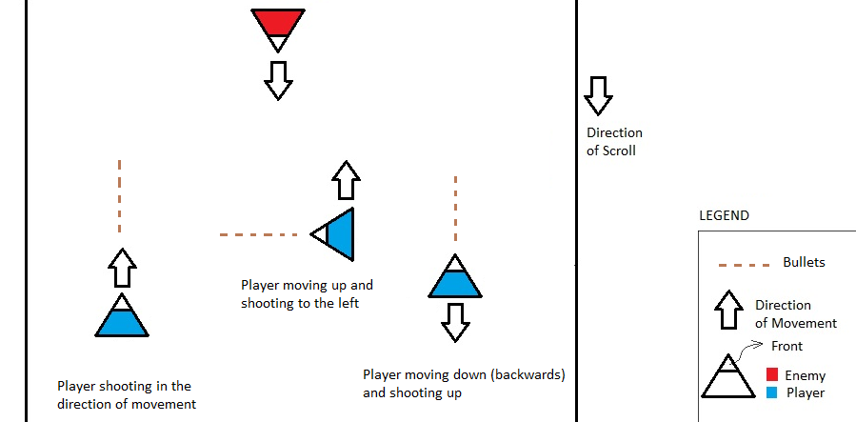

Picture - Player shooting and moving

1. **Collect Power-Ups:** 
   * Player can collect power ups by walking over them.

### Combat

1. **Health**
   * All destructible elements spawn with a certain amount of health points.
   * Damage taken deducts health points.
   * If the value reaches zero or below the game element is destroyed/killed.
   * Health points can be restored by:
     1. Collecting power ups
2. Ammo
3. Damage
   * Bullet hits and explosions cause a certain amount of damage which is a value deducted from the health of affected destructible elements.
   * No friendly fire.
     1. Player **does not** take damage from his own bullets and explosives.
     2. [Should the player take damage from explosive structures?]
     3. Enemy units do not damage each other. As a consequence enemy bullets pass through other enemy units. [is this a good idea?]

### Weapons

1. Primary
2. Secondary

### Power-Ups

1. Health
2. Ammo
3. Buff

## Camera

### Perspective

Top down camera with very small perspective distortion and a small angle relative to the ground normal (something around 20o) to resemble a 2.5D game using a ¾ (oblique) perspective.

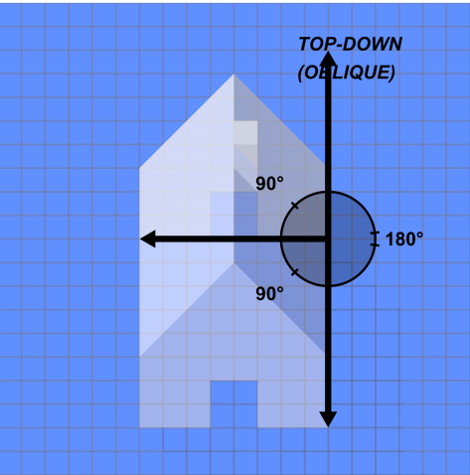

Picture - Camera Perspective

### Control

Camera follows the player. [detail this]

## User interface

### GUI

[Describe elements (types of widgets and there function)]

[Refer to section with layouts]

### HUD

[Describe elements]

[Refer to section with layouts]

## Multiplayer

Not supported.

# Game world

## Overview

## Travel

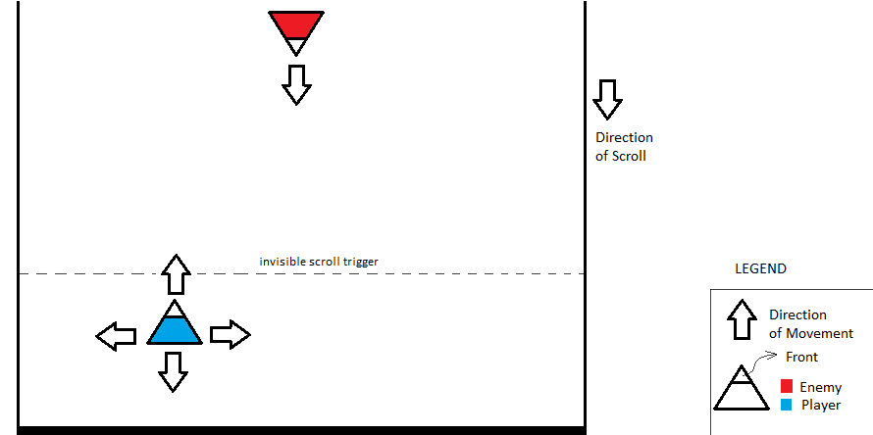

Picture - The invisible scroll trigger in the first third of the screen guarantees that the player field of view is never less than half of the screen height and pushes the player to progress.

## Scale

## Time

## Scenarios

## Static Elements

## Dynamic Elements (Units)

### Player

### Enemies

Some Enemies DO NOT move and shoot the same time

Some Enemies DO NOT move at all. Only face and shoot forward.

Some Enemies DO STOP at all always moving forward in constant speed.

Some Enemies move until they find a spot and stay there DO NOT move aymore and only face and shoot forward

Some Enemies DO NOT move but can shoot forward and sideways.

Enemies NEVER shoot backward.

Some Enemies can move backwards.

Different shooting range.

Some Enemies can throw explosives.

Constraints to reduce AI awkwardness:

1. AI units try to avoid shooting each other (despite that there is no friendly fire damage in the game).
2. AI units try neither to collide nor pass through each other, although there is no collision between units.

### NPCs

# Level design

## Skills

## Obstacles

### Enemies

### Non-Enemies

## Level progression

# Game engine

## Render

## Textures

## Lights

## Shadows

## Audio

## Terrain

## Water

## Particles

## Physics

## Input controls

# Music and Sound FX

# Visual Style

# References

## Rambo: First Blood Part II / Ashura (阿修羅) / Secret Command - Sega Master System

## Assault Commando

## Assault Commando 2

## Minigore 2

# Appendix A: GUI Layout

# Appendix B: HUD Layout

# Appendix C: Character Animation

# Appendix D: Story