Programming Station Development Build
The Development Build is divided into two main processes: (1) Initial Set Up, and (2) Daily Process. The Initial Set Up explains how an operator connects the Programming Station components before beginning to program routers. The Daily Process walks through the repetitive process of how the operator programs routers.

Hardware Setup

Material List:
- 1x Teltonika RUTX08 router
- 1x PPC
- 1x Beckhoff PLC
- 1x Ethernet Switch
- 2x BeagleBone Black
- 1x Schneider Electric HMI
- 1x 24V Power Supply
- 7x Ethernet Cables
- 2x USB A Cable (BeagleBone Black)
- 1x USB A to B Cable (printer)
- 2x Spring-Clamp terminal blocks

Initial Set Up

Build Connections:
- 24V Power Supply connected to Spring-Clamp terminal blocks A and B
- PLC connected to Spring-Clamp terminal block A
- HMI power cord connected to Spring-Clamp terminal block A
- Ethernet Switch connected to Spring-Clamp terminal block B
- Ethernet Switch connected by ethernet cable to Router LAN2 port
- BeagleBone Black A connected by ethernet cable to Router WAN port
- BeagleBone Black B connected by ethernet cable to Router LAN3 port
- PPC connected by ethernet cable to Router LAN1 port
- PLC connected by ethernet cable to Ethernet Switch

Basic Device Set Up:
- HMI: the green dual power plug inserted into the power port.
- Click into the HMI and enter “54” as the password. A new screen should appear.
- PPC: the green triple power plug inserted into the power port and power button pressed.

PPC Instructions:
These instructions demonstrate how to set up the PPC for the Daily Process. They include ensuring the BeagleBone Blacks B is connected and working.
- Click into the PPC and enter “OshkoshAerotech” as the password. The desktop should appear.
- Once the Programming Station is set up and the router is on, in the PPC, press Windows+R and type “cmd” and enter.
- Type “ipconfig” and look for the 192.168.1.xxx subnet.
- Go to your search bar and enter “view network connections” and click.
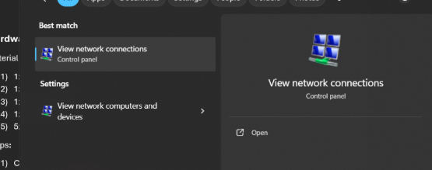
This screen should pop up:
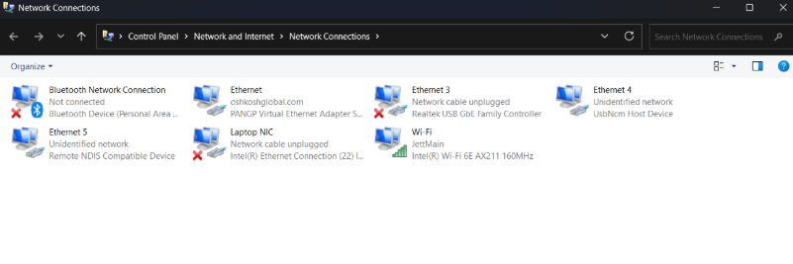
- Find your ethernet connection. This is the BeagleBone Black B. You can find it by unplugging and plugging the Ethernet port back in and see which Ethernet # appears. Right click on it and click on “properties”. Click on “Internet Protocol Version 4 (TCP/IPv4)” and click on “properties”.
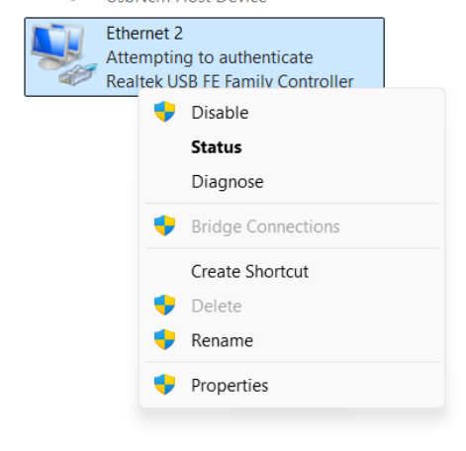 | 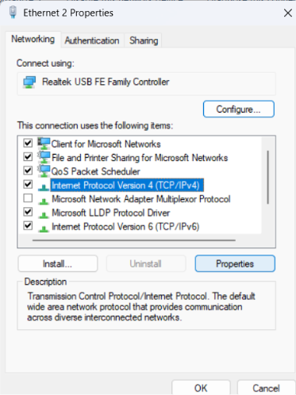
Click on “Use the following IP Address” and enter IP address that ends with 192.168.1.xxx. The subnet mask should auto populate and if it doesn’t then enter “255.255.255.0”.
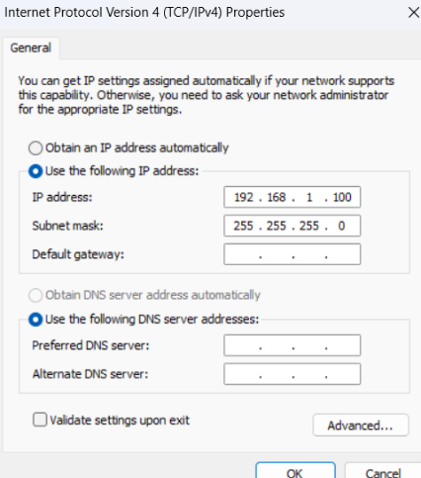

BeagleBone Black Set Up:
These instructions walk through accessing the BeagleBone Black and ensuring it has the correct subnets. For more information, check out the Quick Start Guide.
- In the search bar of the PPC, type “terminal” and hit enter.
- Type ssh raj@192.168.7.2 and hit enter.
- When prompted, enter “Jetway” as your password. You won’t see the word being typed. Type “Jetway” and hit enter.
- Once you’ve entered the BeagleBone Black, type “ip a” to see all interfaces and their subnets.
- Make sure the Beaglebone Black has subnets with 192.168.1.xxx and 192.168.81.xxx.
*** For the BeagleBone Black B, it will be raj@192.168.6.2 since it will have the ip address of 192.168.6.2 instead of …7.2.
NOTE FOR NATE: I will probably have to set up the username and password for ssh to replace the default username and password.

Adding a Username to SSH on BeagleBone Black and Making It Accessible
To securely add a custom username and ensure it can SSH into your BeagleBone Black, follow these steps:
1. Connect and SSH in
- Power on your BeagleBone Black and connect it to your network (Ethernet or USB over Ethernet).
- Find its IP address on your router or by pinging it from your host machine.
- SSH in with the default credentials (e.g., ubuntu@<IP> or debian@<IP>) and password temppwd linuxpropaganda.wordpress.com+1.
2. Create a new user
- Run: sudo adduser <your_username>
Replace <your_username> with your desired name (e.g., madmax).
- Follow the prompts to set a strong password for this user.
3. Add the user to the sudo group
- This grants them root privileges: sudo usermod -aG sudo <your_username>
4. Configure SSH to allow the new user
- Edit the SSH config: sudo nano /etc/ssh/sshd_config
- Ensure these lines are present and correct:
PermitRootLogin yes
PasswordAuthentication yes
5. Restart SSH
- Apply changes: sudo systemctl restart ssh
6. Test SSH access from your host
- From your computer, SSH into the BBB as the new user:
ssh <your_username>@<BBB_IP>
- Enter the password you set in step 2.

