Nathan Leigh
Contact Details
Profile
Manchester

nleigh11@hotmail.com

www.nathanleigh.co.uk

Highly skilled back-end software engineer with proven technical devops
ability in multiple cloud providers such as Azure, GCP and AWS.

Passionate in architecting and maintaining secure, available and scalable infrastructure to process large volumes of real time data. Experienced in developing mission critical software solutions in a variety of programming languages and database technologies.

Work Experience
Work


YELP – Stream Processing – Software EngineerOct 21 – Present

The Stream Processing team is responsible for the entire streaming infrastructure at Yelp. From transporting events reliably between services with Kafka, to processing massive streams of data in real-time using Apache Flink and Beam. Our team offers simple abstractions to bring the full potential of big data to Yelp’s core systems, which power features such as the ~$1B revenue Ads business.

Heavily involved with SysOps and Data Engineering, with expertise in architecting large distributed systems that can scale, store and crunch terabytes of data. A deep understanding of full end to end software development, deployment and monitoring processes, using tools such as Terraform, Jenkins, Docker, Kubernetes, Grafana and Prometheus. Expert in best practices with multiple AWS technologies.

Work remotely within a globally distributed team, utilising my excellent communication and collaboration skills. Joined Yelp initiatives such as Culture Club to champion a more inclusive community and build a fun welcoming environment for new Yelpers. Mentored and supported junior engineers. Participated in recruitment interviews and oncall support.

ARM – Insights Team – Cloud EngineerJuly 19 – Oct 21

Part of an internal start up within ARM looking at generating smart insights from IoT Camera devices running AI software, for applications such as office space utilisation, monitoring COVID mask wearing, supermarket customer & stock insights and street traffic violations.

Played a critical part on the architecture of the back end platform using Golang services for ingesting, processing and data retrieval. Used DB technologies such as InfluxDB for real time data processing and Postgres for managing configuration and data reports. Gained significant devops skills by managing resilient and scalable cloud services with Docker, Helm & Kubernetes.
Created applications for generating analytical graphs and charts using Grafana. Also created Desktop and Android/IOS mobile apps for configuration using React-Admin and Flutter.

BBC – Datalab – Software EngineerApr 18 – Jun 2019

Worked within a newly formed remote team, building recommendation systems for many of the BBC's products and services. Demonstrated leadership qualities by taking initiative on strategically designing many of the systems from initial conception through to production, meeting strict SLA's from clients with millions of weekly users like BBC Sounds.

This role was part of an initiative to build a machine learning platform for the entire BBC organisation. It involved heavily collaborating with data scientist's to provide valuable data engineering and insight, such as data discovery, data cleaning and generating context/relationships for the BBC's multi varied and diverse content. Responsible for designing and hosting Python machine learning services in GCP, using collaborative filtering, offline scoring and data enrichment for training recommendation models.





BBC - Programme Metadata – Software EngineerMay 17 – Apr 18

Part of the team which managed the critical backbone API for all products that require programme information. This API enabled editors to manage and publish programme content data, such as TV schedules and IPlayer programme availability, which involved processing thousands of data changes per minute. Events were processed using a microservices architecture written in Clojure, communicating via Kafka and hosted within AWS.

Acquired great development practices in engineering system infrastructure to an exceptional standard. This was accomplished by strict coding and testing standards; setting up metrics and alerts; writing troubleshoot documentation in runbooks to reduce possible downtime and providing 24/7 support to maintain highly reliable systems. The team heavily enforced TDD & Pair Programming to guarantee the code was of optimal quality, and practised Infrastructure as code.

AO – Software Developer Sep 15 – May 17

Gained significant experience in developing back end software in agile teams for a major online electrical retailer. Implemented new features and maintained existing code for;
- Handling payments for the 3 million annual orders,
- Strategic optimising for peak demand traffic, such as on Black Friday
- Enabling expansion to new countries or product categories.

Was Tech Lead on multiple projects, obtaining a full understanding of the Agile development process. Demonstrated excellent communication and team working skills by working directly with many facets of an e-commerce company by cooperating with a variety of departments such as finance, fraud, warehouse logistics, customer service and sales teams.



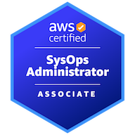
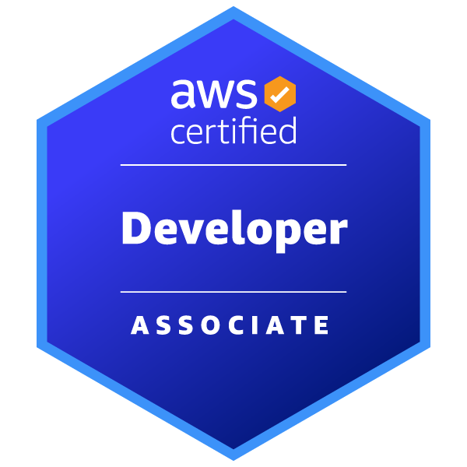

Have a passion for reading and writing (articles on Medium have gathered over 5000+ reads) about new innovations in technology and how it will affect the economy and society in the future.
Live a healthy active lifestyle by visiting the gym regularly and playing 5-a-side football weekly. Hobbies include playing guitar, gaming, history/science podcasts and going on motorbike rides.

The University of Manchester - Bsc. (Hons) Computer Science, 2.12011 – 2014

Final Year project was an Android application for a restaurant system which was awarded a 1st. Was able to gain extensive knowledge in Java programming and attained UI design skills in creating each of the 60+ XML screen layouts for an engaging and accessible user experience.

Also accomplished designing and implementing a complex database using SQLite to store recipe and ingredient relational data.
AWS Certified Developer – Associate
Issued Mar 2018
Credential Link: https://www.credly.com/users/nathan-leigh.eedbb27e
Validates technical expertise in developing and maintaining applications on AWS.
Education
Interests
AWS Certified SysOps Administrator – Associate
Issued: Sep 2022
Credential Link: https://www.credly.com/users/nathan-leigh.eedbb27e
Demonstrates experience deploying, managing and operating workloads on AWS
Interests
Certifications

