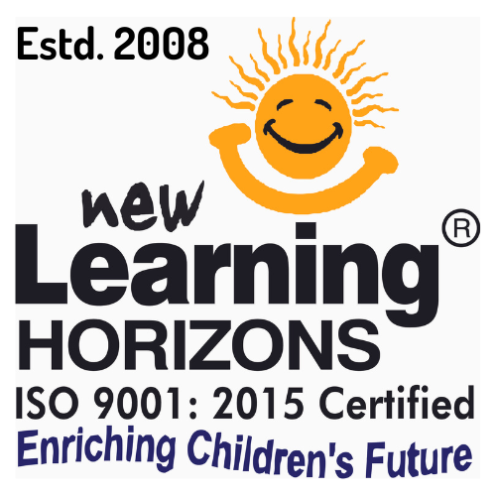
NEW LEARNING HORIZONS
ISO 9001:2015 Certified · Enriching Children’s Future since 2008
Platform Operating Manual
UF Edition — For Unit Franchisees
nlh-platform.vercel.app
Version 1.0

Contents

1. Welcome
Welcome to the New Learning Horizons (NLH) Platform — your workspace for running your franchise as a Unit Franchisee. From one place you can enrol students, track fees, order kits, view the course catalogue and prices, issue certificates.
This manual is written specifically for the Unit Franchisee (UF). It covers every feature available to you.
Tip: Keep this manual handy. When the platform gains new features, an updated version will be shared with you.

2. Your Login & Account

Signing in
- Open nlh-platform.vercel.app in any modern browser (Chrome, Edge, Safari) on a computer or phone.
- Enter your registered email address and password, then click Log In.

First-time login / forgot password
Your account is created with a temporary password sent by email. To set your own:
- On the login page, click “Forgot password?”.
- Enter your registered email and submit.
- Open the reset link from your inbox and choose a new password.
Security: Never share your password. NLH staff will never ask for it. Your login shows only the data for your centre.

3. The Dashboard
The Dashboard is your home screen and summarises your operation at a glance.
- Key numbers — students, orders, fees collected and balance due for your centre.
- Search — find any student, order instantly.
- Follow-ups — one list of students who need attention (see the Follow-ups section). Click an item to jump to the student.
- Quick actions — shortcuts to place an order, add a student and download this manual.

4. Students

The students list
The Students page lists everyone enrolled in your centre, newest joiners first, with course progress, parent contact, fees and status.
- Sessions column — per course: “12/24” for session courses (amber when all sessions are done but not yet marked complete), “monthly” for monthly courses (“📅 renew” near month-end), or “✓ done” when completed.
- Status — paid, partial or pending, calculated automatically from the fee ledger.
- Export — download the list as a spreadsheet.

Enrolling a new student
- Click + Enrol Student.
- Enter name, parent/guardian, gender, date of registration, phone and parent email.
- For a special camp, set Enrolment Channel to “Camp / Event” and type the camp name — it prints on the certificate.
- Choose the centre and the course(s) and level(s); optionally assign a batch and joining date.
- Click Add Student.
Joining date: The batch joining date defaults to the student’s registration date, so attendance counts from when they actually started. You can change it any time.

Courses & batches for a student
- + Batch / Edit Batch — assign or change the student’s batch for that course.
- ⇄ Level — fix a wrongly-selected course/level. Batch, attendance and certificate history are preserved.
- ✓ Complete — mark a course complete and choose the actual end date.
- 🎓 Cert — generate the Certificate of Accomplishment.
- 💬 Review — once complete, send the parent a Google review request on WhatsApp.

Fee tracking & recording payments
Each student has a fee ledger. Fee Total is the agreed fee; Fee Paid is the sum of recorded payments; Balance is the difference.
- Open the student’s Profile tab → Fee Tracking → + Record Payment.
- Enter only the amount received now, the date, the mode and an optional reference (UTR / cheque no).
- Click Record Payment — it is added to the running total and the balance/status update automatically.
Important: You record each instalment; the platform keeps the running total. Every payment is listed in the Payment History.

5. Course Catalogue & Pricing
The Courses page shows every NLH program as a card. Click a program to expand its levels and prices.
On each level you see your kit rate and the Student Fee (what the parent pays).
Use the search box to find any program or level quickly. The catalogue is maintained centrally by NLH — if a price looks wrong, contact the head office.

6. Ordering Kits
Order learning kits through the Orders page (shown to you as “My orders”).

Placing an order
- Go to Orders and click + New Order.
- Select the levels (SKUs) and quantities — you can only order for levels your centre is enabled for.
- Enter the delivery address and submit. You receive an order confirmation by email.

Order lifecycle
Stage | What it means
Pending | Order placed, awaiting invoice from NLH.
Invoiced | NLH generated your invoice — review and pay.
Payment submitted | You entered your payment mode + UTR / reference.
Verified / Closed | NLH confirmed the payment.
Dispatched | Kit shipped with an AWB / tracking number (can happen on credit, independent of payment).

Submitting payment for an order
- Open the invoiced order, choose your payment mode and enter the UTR / reference, then submit.
Bank details: IDFC FIRST Bank, Nagpur – Byramji Town Branch · A/c 10278096847 · IFSC IDFB0042504 · UPI newlearninghorizons@idfcbank

7. Certificates & Parent Communication

Issuing a certificate
- Open the student’s Courses & Batches tab → 🎓 Cert.
- Select the course(s). The certificate shows the student’s name, courses & levels, camp name (if set), centre and date.
- Print / save as PDF, email it, or send it on WhatsApp.

WhatsApp & Google reviews
Certificates and review requests are sent from the official NLH WhatsApp number; you can change the recipient before sending. After a course is complete, use 💬 Review to request a Google review from the parent.

8. Follow-ups & Reminders
The platform flags students who need attention, both inline and on the Dashboard.
- ⚠ Review (sessions done) — all sessions attended but the course is not marked complete. Finish it and issue the certificate, or check why.
- 📅 Renew (month ending) — a monthly course is near month-end. Collect next month’s fee if the student is continuing.
The Dashboard “Follow-ups” card gathers these into one worklist. Clear it weekly to stay on top of completions and collections.

9. Best Practices
- Record every payment the day you receive it — the ledger keeps balances and status accurate.
- Set correct registration and batch joining dates so attendance and session counts are right from day one.
- Mark courses complete promptly and issue certificates — keeps your Follow-ups clean and parents happy.
- Check the Dashboard Follow-ups card at the start of each week.
- Keep parent phone numbers and emails up to date so certificates and reminders reach them.
- Place kit orders ahead of demand so students never wait for materials.

10. Support & Contacts
For help with the platform, your account, pricing or orders, contact the NLH head office:
Contact | Detail
Head Office | 9, Anjuman Shopping Complex, Residency Road, Sadar, Nagpur – 440 001
Phone | 9373111311
Email | admin@nlhnagpur.info
Website | www.nlhnagpur.info

Thank you for being part of the New Learning Horizons family. Together we are enriching children’s futures.

