**Ben’s Pizzeria**

Ben is opening a pizzeria in his town, and he would only take takeout or deliver orders. He needs us to make a tailor-made relational database for his business. He wants to store all important information and data that his business generates. He will then monitor his business progress using dashboards. We will work only at the back end.

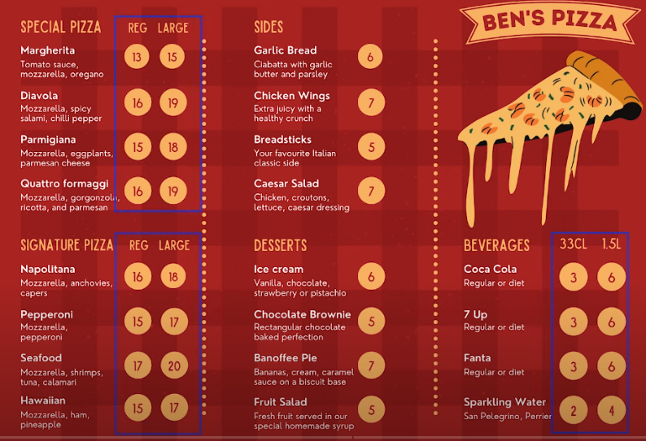

**Main areas to focus on**

* Orders
* Stock Control
* Staff

**Orders Data required**

**Ben’s**

1. Item name
2. Item price
3. Quantity
4. Customer Name
5. Delivery Address

**Ours’**

1. Row ID
2. Order ID
3. Item Name
4. Item Category
5. Item size
6. Item Price
7. Quantity
8. Customer first name
9. Customer last name
10. Delivery address 1
11. Delivery address 2
12. Delivery City
13. Delivery Zip Code

**Dashboard 1 – Order Activity**

For this, we need a dashboard with the following data:

1. Total Orders
2. Total Sales
3. Total Items
4. Average Order Value
5. Sales By Category
6. Top Selling Items
7. Orders by Hour
8. Sales by Hour
9. Orders by Address
10. Orders by Delivery/Pick-up

**Dashboard 2 – Inventory Management**

We must calculate how much inventory we’re using and then identify inventory that needs re-ordering. We also want to calculate how much each pizza costs to make based on the cost of the ingredients so we can keep an eye on pricing and P/L.

For this, we need a dashboard with the following data:

1. Total quantity by ingredient
2. Total cost of ingredient
3. Calculated cost of pizza
4. Percentage stock remaining by ingredient.

**Dashboard 3 – Inventory Management**

We want to be able to monitor who was working on any given day or shift and what our overall staff costs are. For this, we need a dashboard with the following data:

1. Total staff costs
2. Total hours worked.
3. Hours worked by staff members.
4. Cost per staff member

**Pizzeria Table Schema (Redundant)**

**Database Defined for the Pizzeria**

**Resources Used:**

1. Mockaroo.com – For generating dummy data for analysis
2. Microsoft Excel – For Spreadsheet Data
3. QuickDBD.com – For making the Database Diagram
4. Microsoft SQL Workbench – For implementing database and writing custom SQL queries
5. Google Looker Studio – For Dashboard Visualization and Reports

[Access the Dashboard Report](https://lookerstudio.google.com/reporting/90a15bfe-f92b-4fb3-8c63-874b5ca953ca)