# Working conditions for 4-variable BZ model

## Equations and constants

Four variable reaction-diffusion BZ system:



D=1e-5 cm2/s is diffusion coefficient, which is assumed to be the same for all 4 species in both water and oil phase. Pc is partition coefficient for the 4 species (x=[HBrO2], y=[Br-], z=[Fe3+], u=[Br2]), Px=0.1 (estimated), Pu=2.5 (measured), Py=Pz=0.

The constants are:



We normally use h=[H+]=0.16M, A=[BrO3-]=0.3M, m=[Malonic Acid (MA)]=0.02~2M in experiments.

In the code, I allow normal randomness in BZ drop size (lw) and oil gap size (lo) and acidity (h) with tunable mean value and coefficient of variation (standard deviation divided by mean).

Initial condition for each drop (i.e. initial phase) can be randomly picked from 0:10:350 degree from decoupled reference drops (equivalent to single BZ drop). The IPS indices (1-36) correspond to 0:10:350 degree (2=360○=0).

## Drops on a ring (periodic boundary condition)

1. To get a 2pi/3 pattern in a ring of 3 droplets:

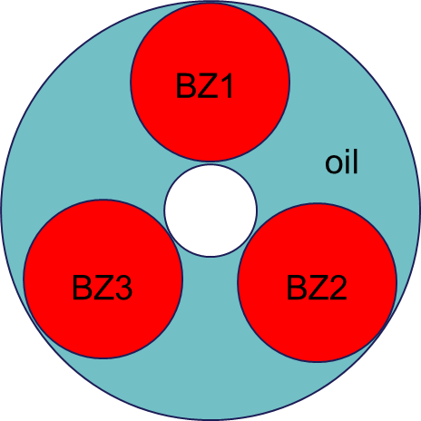

For example:

The conditions same for all drops (if not specified, same for all later cases):

A=0.3; %[BrO3-] (M)

m=0.4; %[malonic acid] (M)

The conditions could be different for each drop (in this case only different initial condition):

bz = 0.0200 0.0200 0.0200 (cm) for drop 1, 2 and 3

oil = 0.0200 0.0200 0.0200 (cm)

h = 0.1600 0.1600 0.1600 (M)

ips = 4 24 18 (Initial phases, 4 means drop 1 start from (4-1)*10 degree out of 360 degrees)

And the spikes of Fe3+ from each drop looks like:

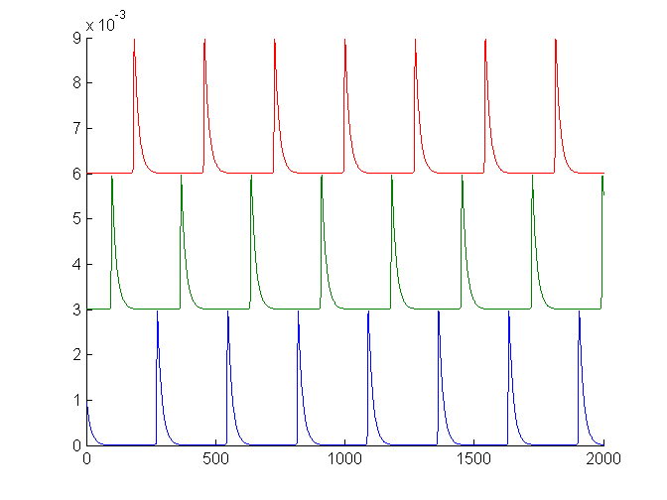

Time (s)

Drop1 Drop2 Drop3

2. Using same conditions in case 1 except for different initial phase we get a-a-b pattern:

ips =22 23 31

And the spikes looks like:

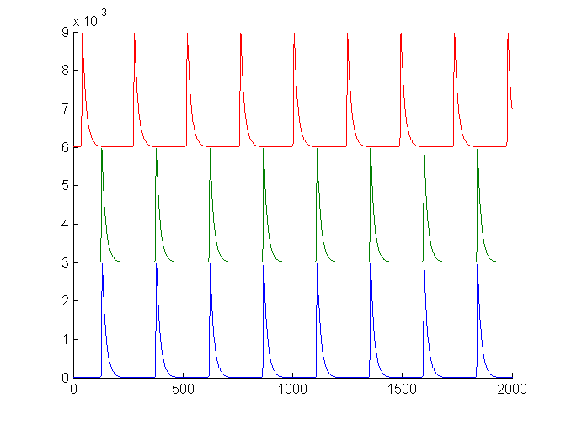

3. If introduce heterogeneity (size of drops or acidity in drops), we get Pi-S pattern:

For example, different drop size (or oil size)

bz = 0.0194 0.0059 0.0201

oil =0.0100 0.0100 0.0100

h = 0.1600 0.1600 0.1600

ips = 18 15 25

And we get (the silent one is the smallest drop):

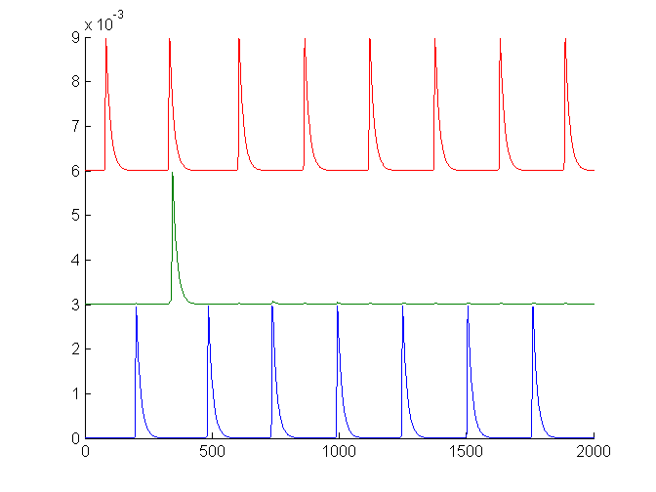

Or we can use different h for each drop to get pi-s:

bz =0.0100 0.0100 0.0100

oil =0.0100 0.0100 0.0100

h =0.1744 0.1645 0.1110

ips = 27 15 25

And we get (the silent one is the lowest acidity, in general low acidity leads to low frequency of oscillation):

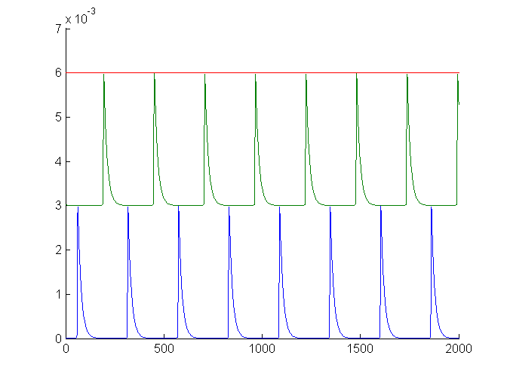

4. Lowering the drop size (or oil size) increase the coupling strength in general. For example, in last case if we change the drop and oil size down to 60 micron then we get 0-S:

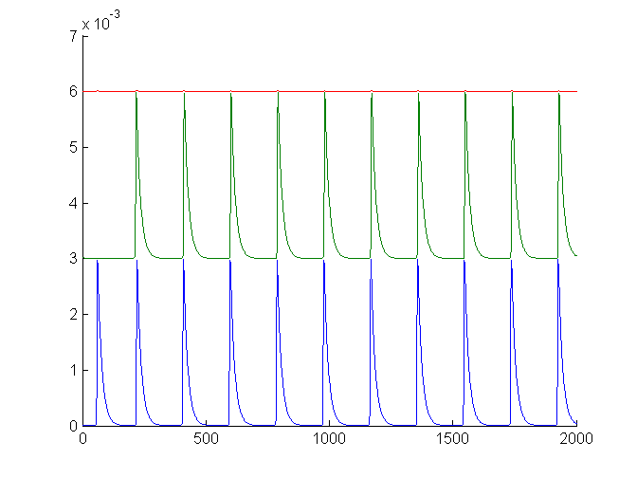

And if we remove the chemistry heterogeneity, then the three drops oscillate in-phase:

bz =0.0060 0.0060 0.0060

oil =0.0060 0.0060 0.0060

h = 0.1600 0.1600 0.1600

ips =16 31 28

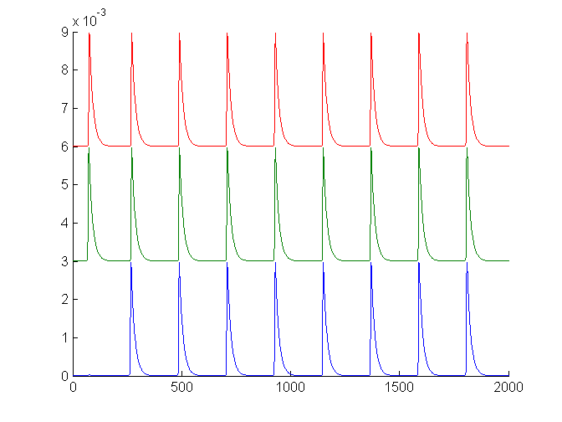

5. Lowering m (malonic acid concentration) has similar effect of increasing coupling strength. Period of oscillation is also elongated for lower m. The extreme case is Turing (stationary) pattern:

bz = 0.0100 0.0100 0.0100

oil =0.0100 0.0100 0.0100

h = 0.1600 0.1600 0.1600

ips =3 31 34

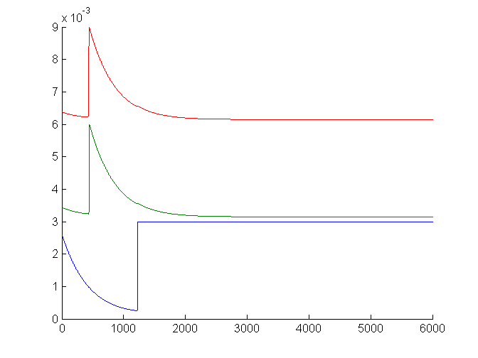

## Chain of drops (no flux boundary condition)

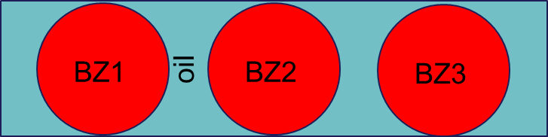

1. Due to symmetry, we have a-b-a pattern (but not a-a-b) with this condition:

bz =0.0100 0.0100 0.0100

oil =0.0100 0.0100 0.0100

h =0.1600 0.1600 0.1600

ips = 4 24 7

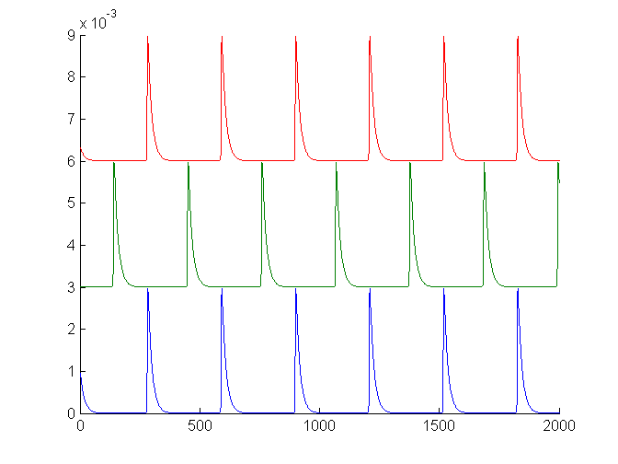

2. We can also get pi-s using a different initial condition, even without heterogeneity (bz, oil, h same as above):

ips = 3 32 23

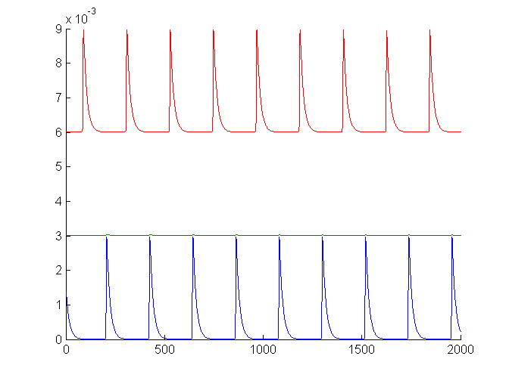

3. Bi-stability for another initial condition:

ips =29 36 2

