13016209: Object-oriented Concepts and Programming
Second Semester, 2017

Project Proposal

- Project developer
Student ID | Name
60090021 | Nipat Liampisan

- Project title
Linux Command Line Prompt

- Project description and requirements
Project description:
This project is a simplified version of the linux bash shell. It will only have some capabilities of the real linux bash shell. This is an attempt to create my own operating system. This linux bash shell will only support some of the linux commands, and it will not support all the options of the commands. It will have a limited supply of memory and you will not be able to freely create files in the shell. The main capabilities that it will have is creating folders, traversing folders, deleting files, creating files, and running files.
Examples:
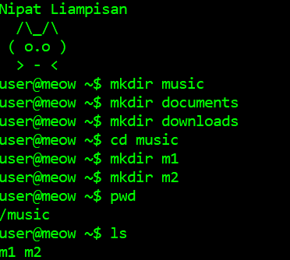

Project requirements:
The data structure that will be used to create a directory is the n-ary tree. Each node can have n number of children and it contains a file pointer. The file pointer can either point to NULL or to an actual file. If it points to NULL, this means that the file is a directory that can be traversed to. If the file pointer is not NULL, it can point to 3 types of files: text file, timer file, or music file.
Commands Supported:
Command | Description
cd | Change the shell working directory  Options:  cd .. (go back to the parent directory)  cd filename (go to the specified directory that is one level down)
ls | List the names of all the files in the current directory
recur_ls | List all the directories in the tree using preorder traversal
mkdir | Create a directory if it doesn’t currently exists
Meow_txt | Create a text file using character ‘|’ as a delimiter when inputting data
Meow_music | Create a music file using the number as musical notes
Meow_time | Create a timer by letting the user enter the amount of seconds to count down from
run | run the process of a file
pwd | Print the current working directory
rm | Recursively remove a directory or delete a file

Tree Structure:
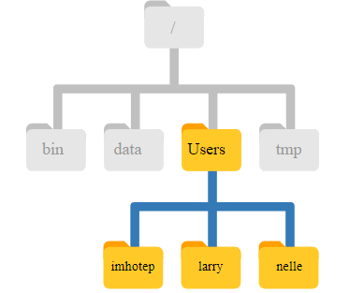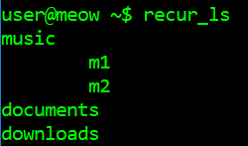

Non-standard C++ functions:
#include <Windows.h>
Beep(int freq, int duration); // duration is in milliseconds
Used in myMusicFile to create sounds
System(“color xx”) //text color and console background changes according to value in xx
Used in myTimerFile to signal end of time
#include <ctime>
Clock()
Used in myTimerFile to keep track of how much time has passed

