NodeSecurity

Business Rules

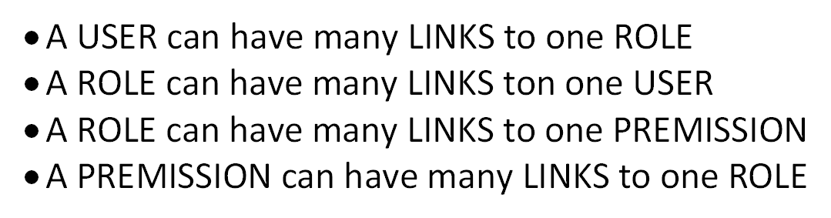

NodeSecurity

NoSQL

