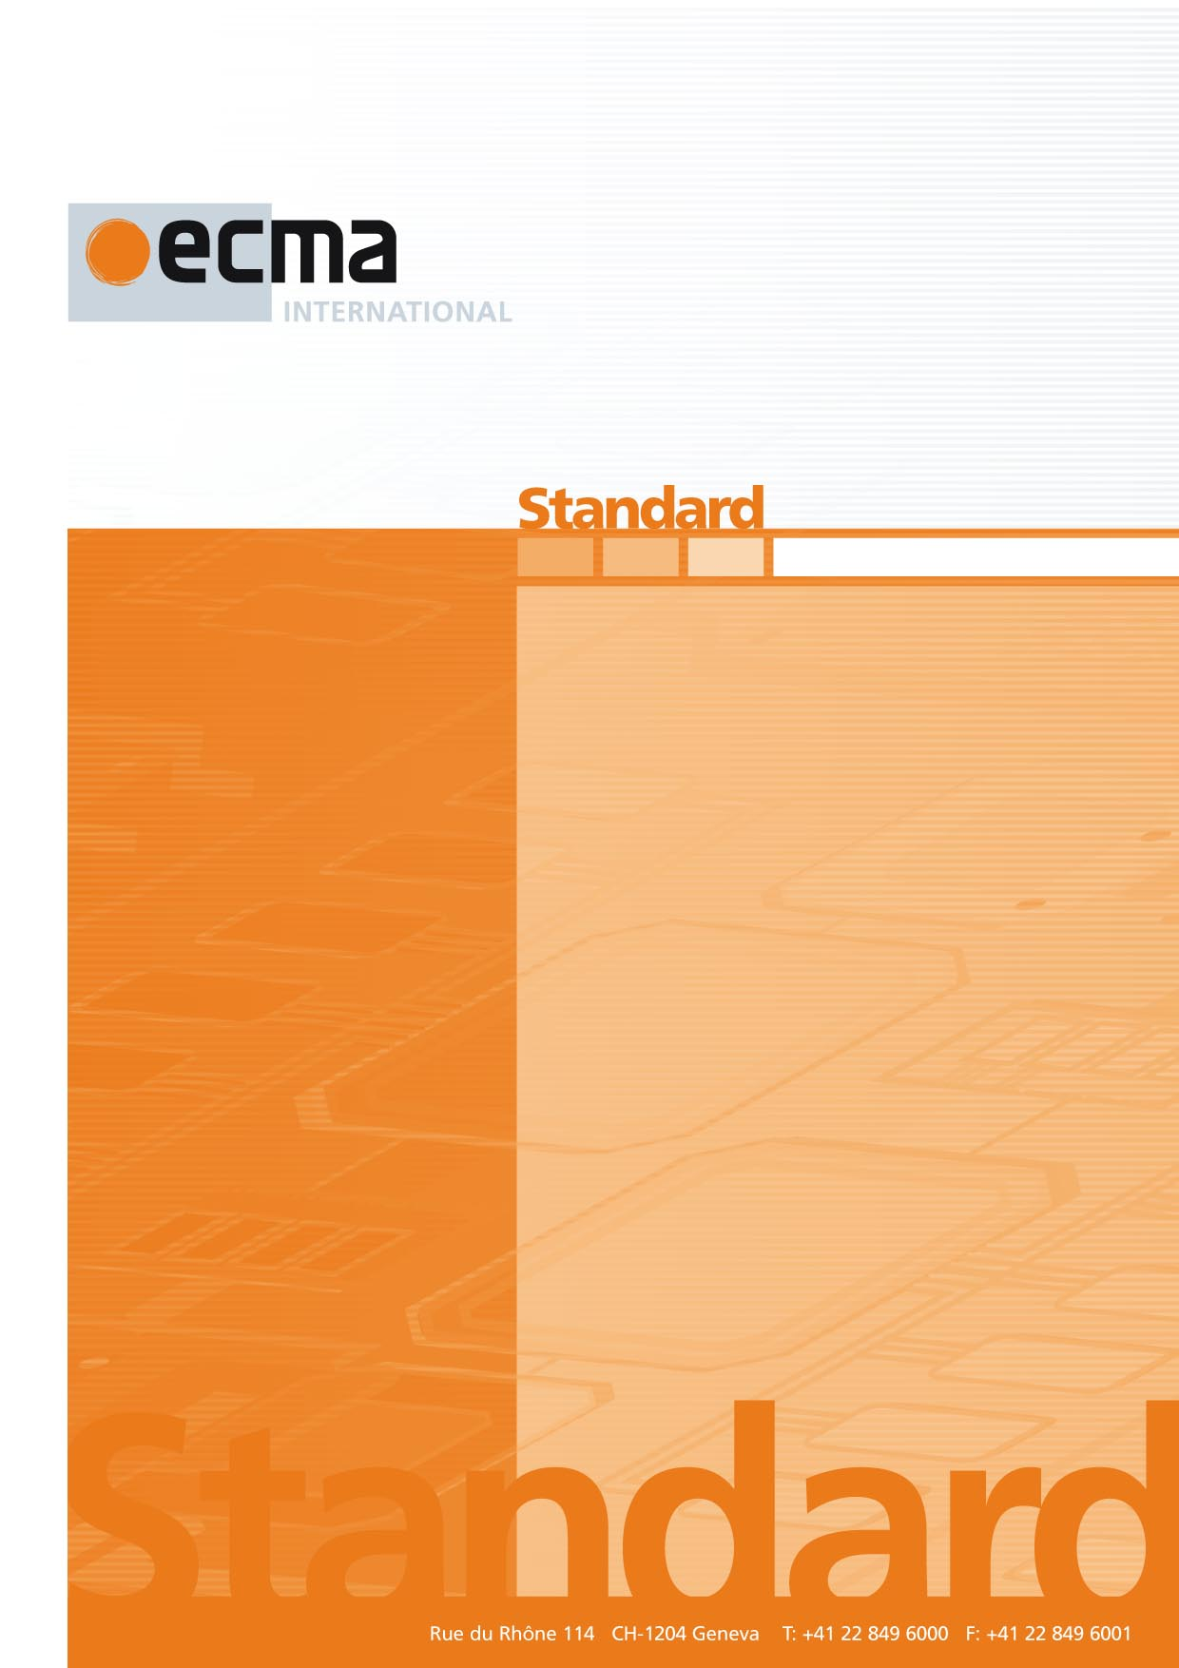

Binding of the Natural Language Interaction Protocol (NLIP) over HTTPS/REST

1st Draft

ECMA-XXX

1st Edition / May 2025

Ecma/TC56/2025/009

Contents Page

1 Scope 1

2 Conformance 1

3 Normative references 1

4 Terms and definitions 1

5 NLIP end point 1

5.1 Optional end points 1

Introduction

The technology of Generative AI (GAI) has the potential to be truly transformative to society. Despite some limitations such as “hallucinations,” the technology is capable of many functions, including but not limited to answering questions, translating, describing and summarizing multi-modal content, generating new content, and summarizing large volumes of information. This enables the creation of intelligent agents that can use AI to analyze data and provide new services.

A much bigger boost to the social benefits of generative AI technology can be obtained by interaction among different in-telligent agents, which may be under the control of different organizations and users. The interaction among intelligent agents can unlock new economic and social value, just like the interactions among various Internet-based services was enabled with the advent of the web browser.

For the intelligent agents to interact with each other, there is a need for a standard common protocol that is used widely among interacting agents. This Standard specifies such a protocol which would ensure interoperability among various services that use AI based technology.

ECMA-XXX defines a Natural Language Interaction Protocol (NLIP).

This Standard describes the binding of NLIP protocol to a base transfer protocol which is using HTTPS with REST.

This Ecma Standard was developed by Technical Committee 56 and was adopted by the General Assembly of <month> <year>.

*COPYRIGHT NOTICE*

*© 2025 Ecma International*

*This document may be copied, published and distributed to others, and certain derivative works of it may be prepared, copied, published, and distributed, in whole or in part, provided that the above copyright notice and this Copyright License and Disclaimer are included on all such copies and derivative works. The only derivative works that are permissible under this Copyright License and Disclaimer are:*

*(i) works which incorporate all or portion of this document for the purpose of providing commentary or explanation (such as an annotated version of the document),*

*(ii) works which incorporate all or portion of this document for the purpose of incorporating features that provide accessibility,*

*(iii) translations of this document into languages other than English and into different formats and*

*(iv) works by making use of this specification in standard conformant products by implementing (e.g. by copy and paste wholly or partly) the functionality therein.*

*However, the content of this document itself may not be modified in any way, including by removing the copyright notice or references to Ecma International, except as required to translate it into languages other than English or into a different format.*

*The official version of an Ecma International document is the English language version on the Ecma International website. In the event of discrepancies between a translated version and the official version, the official version shall govern.*

*The limited permissions granted above are perpetual and will not be revoked by Ecma International or its successors or assigns.*

*This document and the information contained herein is provided on an "AS IS" basis and ECMA INTERNATIONAL DISCLAIMS ALL WARRANTIES, EXPRESS OR IMPLIED, INCLUDING BUT NOT LIMITED TO ANY WARRANTY THAT THE USE OF THE INFORMATION HEREIN WILL NOT INFRINGE ANY OWNERSHIP RIGHTS OR ANY IMPLIED WARRANTIES OF MERCHANTABILITY OR FITNESS FOR A PARTICULAR PURPOSE.*

Binding of the Natural Language Interaction Protocol over HTTPS/REST

# Scope

This Standard defines how the Natural Language Interaction Protocol (NLIP) should be implemented over the base transfer protocol of HTTPS/REST.

# Conformance

A conforming implementation must provide and support all types of messages and submessage along with the semantics defined in the NLIP specification draft, and support them using REST over HTTPS.

# Normative references

The following documents are referred to in the text in such a way that some or all of their content constitutes requirements of this document. For dated references, only the edition cited applies. For undated references, the latest edition of the referenced document (including any amendments) applies.

IETF RFC 7230, *Hypertext Transfer Protocol (HTTP/1.1): Message Syntax and Routing* [https://datatracker.ietf.org/doc/rfc7230/]

IETF RFC 7240, *Prefer Header for HTTP* [https://datatracker.ietf.org/doc/rfc7240/]

# Terms and definitions

For the purposes of this document, the following terms and definitions apply.

4.1

NLIP

NLIP or Natural Language Interaction Protocol is the protocol defined in ECMA-XXX.

4.2

base transfer protocol

a transfer protocol is a communication protocol between two computer systems which supports an encrypted and authenticated transfer of data across those computer systems.

# NLIP end point

A conformant implementation of NLIP over HTTPS/REST will have the Server end-point running on a TCP Server Port. This port would be accessible using a URL defined as https://<server_name>:port/nlip.

## Optional end points

A NLIP end point may also provide an alternate end-point for upload of large binary data. This upload will be provided at any port different than the port used by NLIP end point. The protocol and extension can be provided by an NLIP end point to its peer using a control message with structured format.