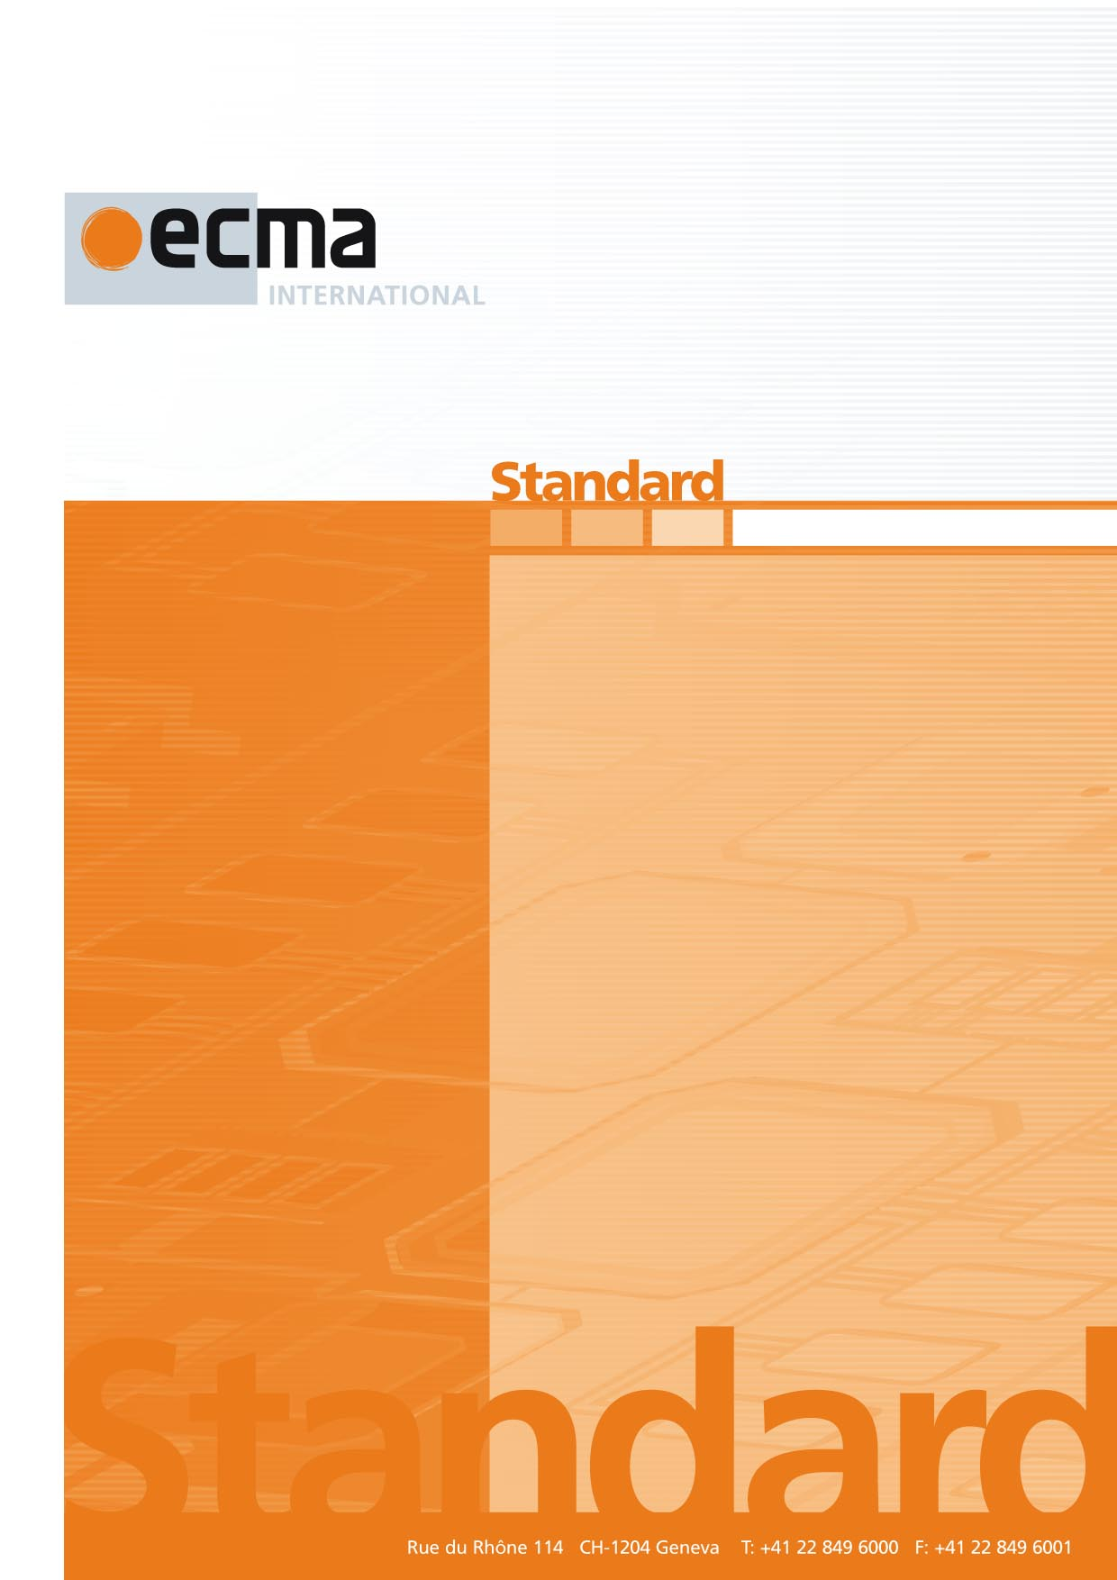

Binding of the Natural Language Interaction Protocol (NLIP) over WebSocket

1st Draft

ECMA-XXX

1st Edition / May 2025

Ecma/TC56/2025/009

Contents Page

1 Scope 1

2 Conformance 1

3 Normative references 1

4 Terms and definitions 2

5 NLIP WebSocket endpoint 2

6 Message Transmission 1

7 Examples 1

8 Message Handling and Framing 1

9 Session Management (Optional) 1

10 Error Handling 1

Introduction

The technology of Generative AI (GAI) has the potential to be truly transformative to society. Despite some limitations such as “hallucinations,” the technology is capable of many functions, including but not limited to answering questions, translating, describing and summarizing multi-modal content, generating new content, and summarizing large volumes of information. This enables the creation of intelligent agents that can use AI to analyze data and provide new services.

A much bigger boost to the social benefits of generative AI technology can be obtained by interaction among different in-telligent agents, which may be under the control of different organizations and users. The interaction among intelligent agents can unlock new economic and social value, just like the interactions among various Internet-based services was enabled with the advent of the web browser.

For the intelligent agents to interact with each other, there is a need for a standard common protocol that is used widely among interacting agents. This Standard specifies such a protocol which would ensure interoperability among various services that use AI based technology.

ECMA-XXX defines a Natural Language Interaction Protocol (NLIP).

This Standard describes the binding of NLIP protocol to a base transfer protocol which is using HTTPS with REST.

This Ecma Standard was developed by Technical Committee 56 and was adopted by the General Assembly of <month> <year>.

*COPYRIGHT NOTICE*

*© 2025 Ecma International*

*This document may be copied, published and distributed to others, and certain derivative works of it may be prepared, copied, published, and distributed, in whole or in part, provided that the above copyright notice and this Copyright License and Disclaimer are included on all such copies and derivative works. The only derivative works that are permissible under this Copyright License and Disclaimer are:*

*(i) works which incorporate all or portion of this document for the purpose of providing commentary or explanation (such as an annotated version of the document),*

*(ii) works which incorporate all or portion of this document for the purpose of incorporating features that provide accessibility,*

*(iii) translations of this document into languages other than English and into different formats and*

*(iv) works by making use of this specification in standard conformant products by implementing (e.g. by copy and paste wholly or partly) the functionality therein.*

*However, the content of this document itself may not be modified in any way, including by removing the copyright notice or references to Ecma International, except as required to translate it into languages other than English or into a different format.*

*The official version of an Ecma International document is the English language version on the Ecma International website. In the event of discrepancies between a translated version and the official version, the official version shall govern.*

*The limited permissions granted above are perpetual and will not be revoked by Ecma International or its successors or assigns.*

*This document and the information contained herein is provided on an "AS IS" basis and ECMA INTERNATIONAL DISCLAIMS ALL WARRANTIES, EXPRESS OR IMPLIED, INCLUDING BUT NOT LIMITED TO ANY WARRANTY THAT THE USE OF THE INFORMATION HEREIN WILL NOT INFRINGE ANY OWNERSHIP RIGHTS OR ANY IMPLIED WARRANTIES OF MERCHANTABILITY OR FITNESS FOR A PARTICULAR PURPOSE.*

Binding of the Natural Language Interaction Protocol over WebSocket

# Scope

This specification defines how the Natural Language Interaction Protocol (NLIP) shall be implemented over the WebSocket protocol using CBOR (Concise Binary Object Representation, RFC 8949) for compact and efficient multimodal communication. It also describes a fallback to UTF-8 encoded JSON text frames for compatibility.

# Conformance

A conformant implementation MUST:

* Support full NLIP message schema as defined in the NLIP JSON Schema.
* Encode/decode messages in CBOR format over binary WebSocket frames.
* Optionally fall back to UTF-8 JSON text frames for non-CBOR-capable peers.
* Support transmission of multimodal submessages, including raw binary content (e.g., audio, image).

# Normative references

The following documents are referred to in the text in such a way that some or all their content constitutes requirements of this document. For dated references, only the edition cited applies. For undated references, the latest edition of the referenced document (including any amendments) applies.

IETF RFC 7230, Hypertext Transfer Protocol (HTTP/1.1): Message Syntax and Routing [https://datatracker.ietf.org/doc/rfc7230/]

IETF RFC 7240, Prefer Header for HTTP [https://datatracker.ietf.org/doc/rfc7240/]

IETF RFC 6455: WebSocket Protocol  
[https://datatracker.ietf.org/doc/html/rfc6455]

IETF RFC 8949: Concise Binary Object Representation (CBOR) [https://datatracker.ietf.org/doc/html/rfc8949]

IETF RFC 7049: CBOR Data Model [https://datatracker.ietf.org/doc/html/rfc7049]

NLIP JSON Schema (ECMA-tc56)

# Terms and definitions

For the purposes of this document, the following terms and definitions apply.

4.1

NLIP

NLIP or Natural Language Interaction Protocol is the protocol defined in ECMA-XXX.

4.2

base transfer protocol

a transfer protocol is a communication protocol between two computer systems which supports an encrypted and authenticated transfer of data across those computer systems.

4.3

CBOR

Binary serialization format for structured data.

# NLIP WebSocket endpoint

The server MUST expose a WebSocket endpoint at:

***wss://<host>:<port>/nlip/ws***

A conformant implementation of NLIP over HTTPS/REST will have the Server end-point running on a TCP Server Port. This port would be accessible using a URL defined as https://<server_name>:port/nlip.

## Optional fallback endpoint

***wss://<host>:<port>/nlip/ws/text***

# 6. Message Transmission

### 6.1 CBOR Format

* Each WebSocket binary frame MUST contain a single NLIP message encoded in CBOR.
* CBOR Content fields MAY include:
  + String
  + Byte string (raw binary)
  + Array, Object (Map)
* Submessages are embedded in CBOR using the same schema.

### 6.2 Text Fallback Format

* If CBOR is not supported:
  + Use UTF-8 encoded JSON in WebSocket text frames.
  + Binary data MUST be base64-encoded.

# 7. Examples

### Example 1: Text + Audio (CBOR)

#### NLIP Message (in Python pseudo-code before CBOR encoding)

{

"MessageType": "Request",

"Format": "structured",

"Subformat": "application/json",

"Content": {"intent": "weather_query"},

"Submessages": [

{

"Label": "transcription",

"Format": "text",

"Subformat": "en-US",

"Content": "What's the weather in Austin tomorrow?"

},

{

"Label": "audio",

"Format": "binary",

"Subformat": "audio/wav",

"Content": b'\x52\x49\x46\x46...' # Raw binary WAV

}

]

}

This is encoded as a **single CBOR binary frame**. The audio submessage uses a byte string directly and no base64 encoding.

### Example 2: Image Processing Request (CBOR)

{

"MessageType": "Request",

"Format": "binary",

"Subformat": "image/jpeg",

"Content": b'\xff\xd8\xff\xe0...', // JPEG binary

"Submessages": [

{

"Label": "description",

"Format": "text",

"Subformat": "en",

"Content": "Process this image for defects"

}

]

}

CBOR encoding allows this entire object to be transmitted compactly.

**Example 3: Text Fallback (JSON over WebSocket text frame)**

{

"MessageType": "Request",

"Format": "binary",

"Subformat": "audio/wav;base64",

"Content": "UklGRngAAABXQVZFZm10IBAAAAABAAEAESsAACJWAAACABAAZGF0YYAA...",

"Submessages": [

{

"Label": "transcription",

"Format": "text",

"Subformat": "en-US",

"Content": "What’s the current stock price of Tesla?"

}

]

}

# 8. Message Handling and Framing

| **Feature** | **CBOR Frame** | **Text Fallback** |
| --- | --- | --- |
| Frame Type | Binary | Text |
| Encoding | CBOR | UTF-8 JSON |
| Binary Data Support | Native (byte string) | Base64 in JSON |
| Compression Support | Optional (via permessage-deflate) | Optional |
| Streaming Support | Chunking via multiple frames | Limited |

## 9. Session Management (Optional)

* Each message MAY include a session ID in "MessageType" or custom field.
* Use WebSocket heartbeat for liveliness checks.
* Session states can be managed using a separate ”Control" message.

## 10. Error Handling

* If CBOR decoding fails, server SHOULD:
  + Send back a JSON error message using the fallback endpoint.
  + Example:

{

"Format": "error",

"Subformat": "decode",

"Content": "CBOR decoding failed. Fallback to text recommended."

}