Predicting Cell-State Bias Across Pathways
A knowledge-graph neural network that operationalizes a multiscale theory of cellular information processing — results summary
Project Lumos · chromatin-toggle · 2026-07-04

1. Overview
This model tests a specific theory of how cells decide which response program to run. The theory: a cell integrates its stable intrinsic memory (lineage transcription factors, chromatin state — strong, persistent bias) with a transient extrinsic cue (a mechanical, inflammatory, morphogen, or metabolic signal — weak, superficial bias) and stabilizes the program most compatible with current conditions; a window of plasticity lets a weak cue flip the cell into a new, self-sustaining program.
We built this as a relation-typed graph neural network (GNN) over a literature-derived knowledge graph, trained it on 44,089 real single cells spanning 10 cell-state programs from 17 published datasets, and evaluated it under strict controls so that every headline number resists the circularity a reviewer would probe first (the 'marker-gene shortcut').

2. Model and data
Model. Each node of the knowledge graph is a molecule or a response program; edges are literature activation/inhibition relationships. The GNN injects a cell's measured gene activity onto the nodes and runs several rounds of message passing over the graph, then reads out which program node wins. Three theory mechanisms are built in and independently ablatable: (i) intrinsic memory is re-injected every round (persistent, strong) while the cue decays (transient, weak); (ii) a plasticity input gates how much the cue can influence the outcome; (iii) a winner-take-all step commits the cell to one attractor program.
Data. 44,089 cells, 10 programs, 17 datasets; most programs have two independent sources (different tissue or species), so results are not artifacts of a single experiment.
Program | Cells | Independent sources
Quiescent (baseline) | 19,767 | all 17 datasets
Fibrosis | 5,744 | lung + kidney + cardiac
Hypertrophy | 4,158 | mouse TAC + human HCM
ADM | 3,572 | two caerulein studies
Regeneration | 3,205 | lung + muscle
InnateMemory | 3,087 | beta-glucan + BCG
EMT | 3,000 | TNF time-course
Pluripotency | 794 | embryoid body + Mullen
MyogenicDiff | 522 | C2C12 + human iPSC
Senescence | 240 | oncogene-induced

3. Results

3.1 Main result — the model predicts meaningful cell states
Held-out confusion matrix over the 10 programs, marker-controlled (label-defining 'marker' genes removed from the inputs). Overall held-out accuracy ~0.65 on 10 imbalanced classes; the diagonal shows the model recovers the correct program for most classes.
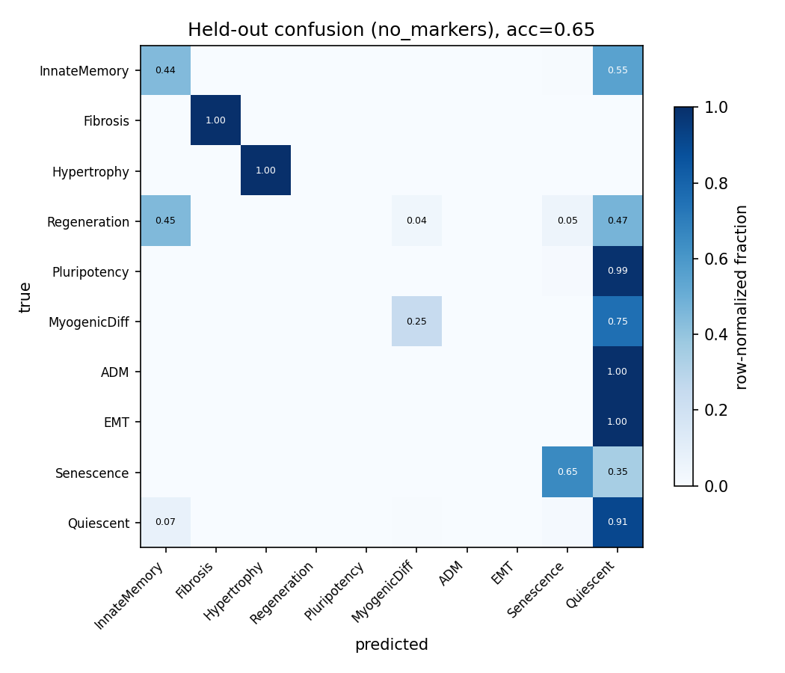
Figure 1. Held-out confusion matrix (row-normalized), marker-controlled.

3.2 Baseline comparison — pathway structure beats simpler models
Cross-species test: train on mouse (and other pathways), hold out the human hypertrophy dataset, and predict it. The knowledge-graph model (KG-GNN) is compared against a shuffled-KG control (same model, wiring scrambled = 'random structure') and a bag-of-genes MLP ('gene-level reduction'). Activated recall = fraction of the held-out program's cells correctly identified. Means over 3 seeds; marker-controlled.
Model | Cross-species Hypertrophy recall
KG-GNN (pathway structure) | 0.977 +/- 0.009
Shuffled-KG (random structure) | 0.007 +/- 0.009
Bag-of-genes MLP (gene-level) | 0.057 +/- 0.037
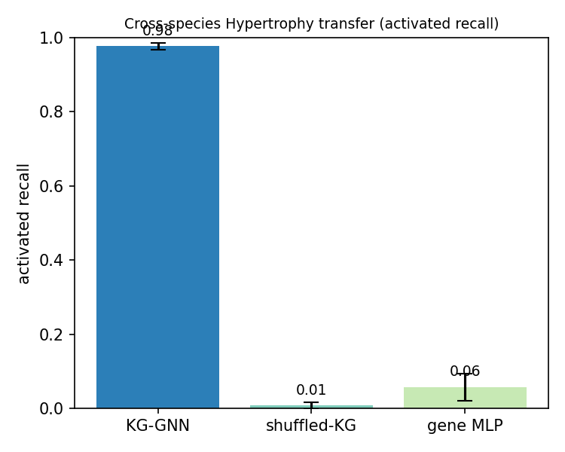
Figure 2. The pathway wiring, not the genes alone, enables cross-species transfer.

3.3 Representation & the marker-shortcut control
A key credibility check. Some input genes co-define the labels (e.g. Sox9 for ADM), so a model can 'cheat'. We train under three input regimes and report mean program recall over 3 seeds. After enriching the intrinsic-memory representation with additional identity/chromatin genes, removing the marker genes barely changes performance (shortcut dissolved), and — critically — the theory's pure inputs (cue + intrinsic memory only) now predict fate, up from 0.
Input regime | Program recall (3 seeds) | Before enrichment
full | 0.476 +/- 0.058 | 0.196
no_markers (shortcut removed) | 0.441 +/- 0.016 | 0.087
lineage_only (cue + memory only) | 0.344 +/- 0.064 | 0.000
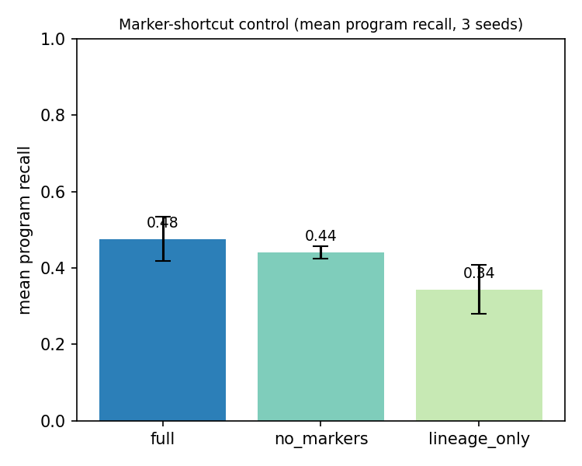
Figure 3. Richer memory dissolves the marker shortcut and makes cue+memory predictive.

3.4 Theory dynamics — plasticity-gated, persistent fate switching
Sweeping the plasticity input from 0 to 1 reproduces the theory's central behavior: at low plasticity the intrinsic default holds regardless of the cue; past a threshold the cue flips the stabilized program; and the flipped state persists after the cue is withdrawn (hysteresis = stored memory). This held for Fibrosis, Hypertrophy, and InnateMemory, replicated across independent sources (lung/kidney; mouse/human), and — importantly — survived removal of the marker genes. No-cue programs (myogenesis, pluripotency) stayed flat, a clean control. Mechanism ablations confirmed each component is load-bearing: removing the plasticity gate abolishes the effect entirely. Honest exception: ADM's dynamics were marker-dependent and collapsed without them.

3.5 Interpretability & biological validation
Permutation importance (scramble each input and measure the drop in each program's recall) shows the model relies on the textbook regulators for most programs, independently recovering known biology:
Program | Top regulator(s) the model uses | Known biology?
Hypertrophy | MechanicalStretch, HDAC4, HDAC5 | Yes (class-IIa HDACs)
MyogenicDiff | MyoD | Yes (master TF)
ADM | Sox9, Caerulein | Yes (metaplasia driver)
InnateMemory | LPS, PU.1 | Yes (myeloid pioneer)
Regeneration | HDAC1/3, SWI/SNF | Yes (butyrate/HDAC axis)
Senescence | CDKN2A/p16, CDKN1A/p21 | Yes (arrest effectors)
Weaker cases (flagged honestly): EMT and Pluripotency did not surface their specific drivers, being dominated by generic signal.
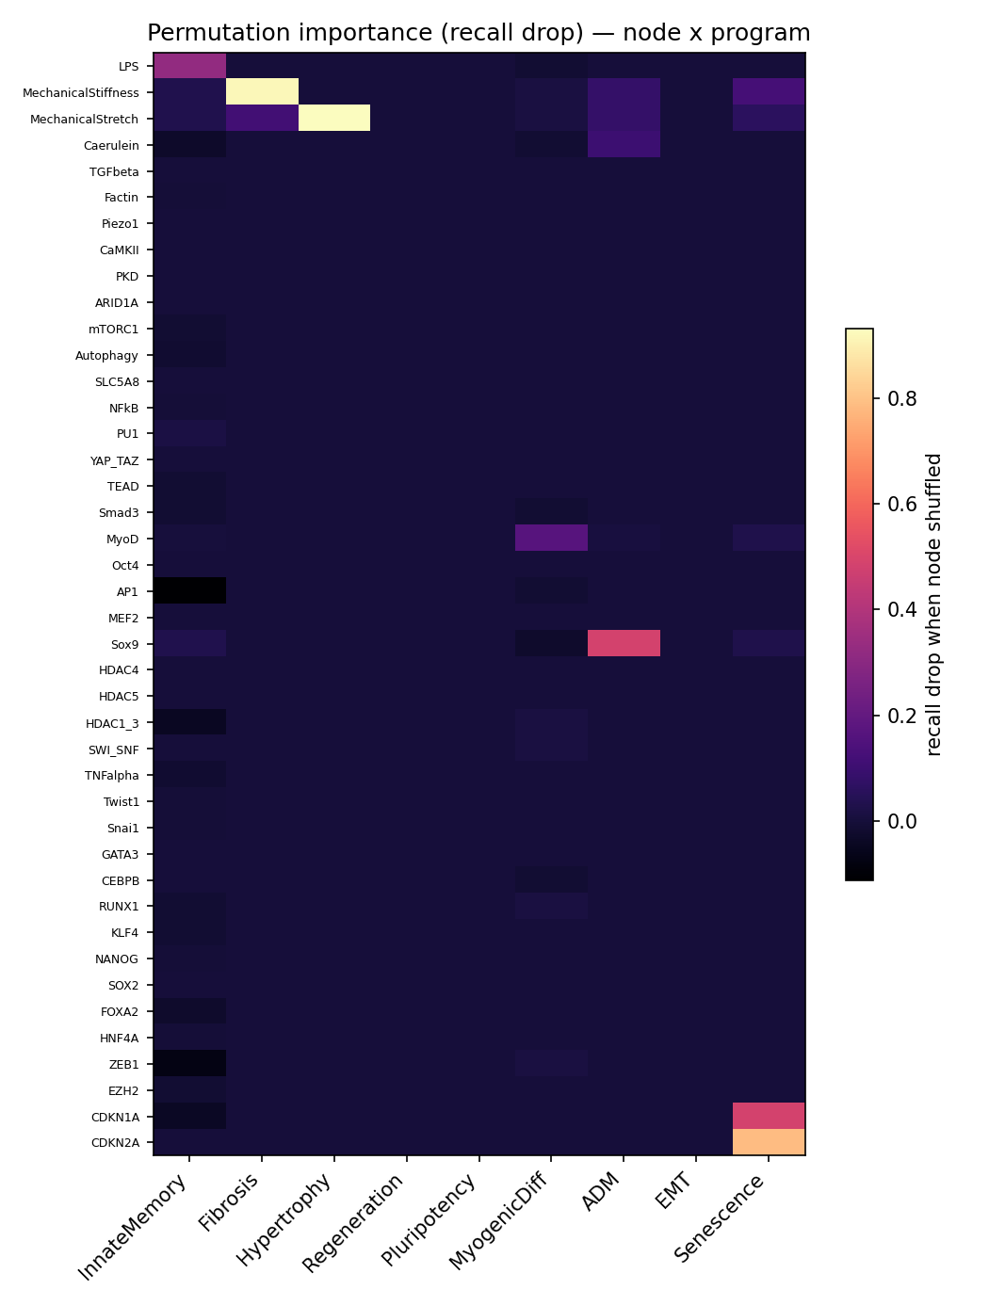
Figure 4. Node x program permutation importance (recall drop when a node is shuffled).

3.6 Data-scaling law
Training on increasing numbers of cells: performance climbs up to ~16,000 cells and then plateaus. Interpretation: beyond that point, more cells of the same programs stop helping — the bottleneck is the model's representation, which is why enriching the intrinsic-memory representation (Section 3.3) was the effective lever, not raw data volume.
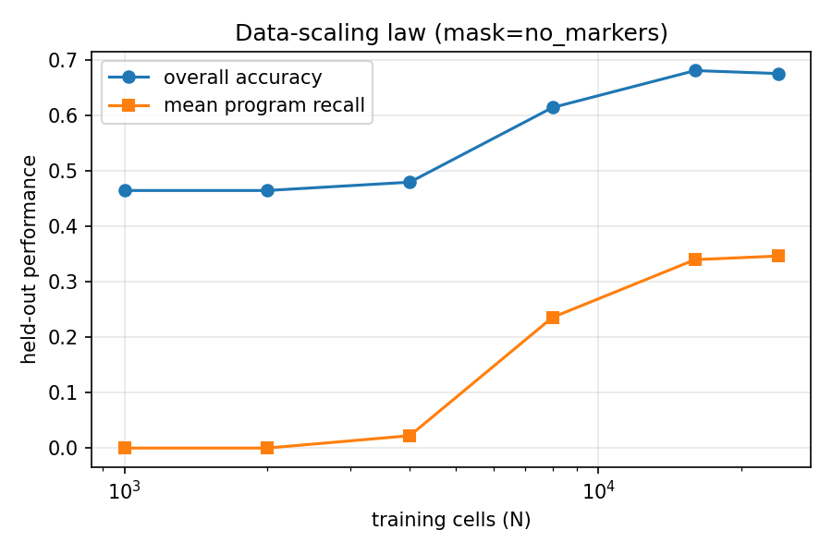
Figure 5. Held-out performance vs. training-set size (marker-controlled).

3.7 Generalization — cross-validation
Five-fold, class-balanced cross-validation of the marker-controlled model: accuracy 0.628 +/- 0.065, mean program recall 0.356 +/- 0.120. Consistent with the held-out and cross-dataset estimates. The fold-to-fold spread is real (accuracy 0.55-0.69) and reported rather than hidden — expected for small models on 10 imbalanced classes.

4. Limitations
- Small models (32 hidden units, ~6 message-passing rounds); absolute accuracy is modest on 10 imbalanced classes. The strength is in the controlled comparisons, not raw accuracy.
- EMT and Pluripotency interpretability is weak; EMT and Senescence are single-source.
- ADM's dynamical behavior was marker-dependent and does not survive the shortcut control.
- Cross-tissue Regeneration (lung <-> muscle) and some cross-species transfers do not generalize.
- Labels are repurposed from the source studies' annotations; a few (e.g. myogenesis, senescence wells) involved our own cluster/threshold calls, stated in the methods.

5. Conclusion
The review's multiscale information-processing model can be built as a knowledge-graph GNN whose theory-specific mechanisms each measurably contribute to reproducing the predicted plasticity-gated, persistent fate-stabilization behavior on real multi-source single-cell data. Under strict marker-shortcut controls, (i) the pathway structure generalizes across species where random wiring and a gene-level model fail, (ii) fate becomes predictable from the theory's own inputs (cue + intrinsic memory), and (iii) the model recovers known regulators for most programs. These are honest, credibility-controlled results; the remaining gap is absolute predictive power on the hardest classes, addressable with larger models and richer memory representations.

