A knowledge-graph neural network operationalizing a multiscale theory of cellular information processing
Predicting cell-state programs across pathways from intrinsic memory and extrinsic cues, under leakage-controlled evaluation
N. Lytell. Project Lumos. Manuscript draft — 2026-07-06.
DRAFT. Numbers are current as of this build. Items marked [pending] await a GPU-converged run; the reported conclusions do not depend on them.

Abstract
Cells select a response program by integrating a stable intrinsic identity (lineage transcription factors, chromatin state) with transient extrinsic cues. We ask whether a specific multiscale theory of this integration — asymmetric intrinsic/extrinsic weighting, a plasticity gate, and attractor stabilization — can be built as an interpretable model with measurable predictive value. We encode the theory as a relation-typed graph neural network (KG-GNN) over a literature-derived knowledge graph and train it on 18,392 real single cells spanning 12 cell-state programs from 19 published datasets, under strict controls: labels are graded for provenance, program-marker genes can be masked, and generalization is measured by holding out entire datasets. After identifying and removing a cue-label leak that had inflated an earlier result, the honest findings are: (i) the expression->program mapping is highly learnable in-distribution (stratified balanced accuracy 0.93); (ii) cross-dataset generalization is hard for all models (a batch/domain-shift frontier), and there the KG-GNN SIGNIFICANTLY outperforms strong baselines on program probability-ranking (macro-AUPRC 0.48 vs ~0.40 for logistic regression and random forest; paired Wilcoxon p<0.02 for both), while matching them on top-1 metrics once converged; (iii) in simulation the model reproduces the theory's plasticity-gated, hysteretic switching, but on a real EMT time-course it shows no graded temporal-emergence advantage over a linear model. We conclude that the theory yields an interpretable model whose concrete real-data advantage is probability-ranking, and we report the negative results (temporal, top-1) rather than tune them away.

1. Introduction
A central question in cell biology is how a cell decides which of many possible response programs to execute. A recurring view — here called the multiscale theory — holds that the decision integrates information across scales and timescales: a deeply processed, persistent intrinsic bias (lineage/chromatin memory) is weighted strongly, while shallowly processed, transient extrinsic cues are weighted weakly; a window of plasticity lets a weak cue overcome the intrinsic default; and feedback stabilizes the winning program as a self-sustaining attractor, so the new state persists after the cue is withdrawn (hysteresis = stored memory).
Testing such a theory requires more than a black-box predictor: the mechanisms must be built in and independently removable, and the evaluation must resist the shortcuts that make cell-state prediction look easy (marker-gene circularity, label leakage, and batch/source effects). We therefore (1) encode the theory as an interpretable knowledge-graph GNN whose mechanisms are toggleable, (2) train and evaluate it on real multi-source single-cell data under leakage controls, and (3) compare it against strong theory-agnostic baselines on the metrics appropriate for an imbalanced multiclass problem. Our aim is an honest account of where the theory's inductive biases help, where they do not, and why.

2. Methods

2.1 Knowledge graph and model
Nodes are molecules, chromatin features, or response programs; edges are literature activation/inhibition relations. The GNN sees only the binary graph STRUCTURE (edge signs and weights are never exposed), a cell's measured gene activity injected onto the corresponding nodes, and it reads out a program via message passing. Three theory mechanisms are built in and independently ablatable: (i) intrinsic memory is re-injected every message-passing round (persistent, strong) while the cue decays (transient, weak); (ii) a plasticity input scales the cue's influence; (iii) a winner-take-all step sharpens toward one attractor program. A hybrid residual (a linear map from the raw node vector to the class logits) guarantees the model is at least as expressive as a linear classifier. Message passing is vectorized over relations for efficiency.

2.2 Data and labels
The training pool is 18,392 cells, 12 programs, 19 datasets (capped at 600 cells per program-per-dataset to limit single-cell dominance), with inputs widened to a curated 148-gene marker/TF panel. Most programs have >=2 independent sources (different tissue or species). Labels are graded by provenance: type A (deposited per-cell author annotations), type B (per-cell x disease field), type C (condition/timepoint proxy), type D (derived by us); the grading is documented in a label-provenance protocol. Cues are applied UNIFORMLY per dataset (not gated by outcome) after we found that outcome-gated cues had leaked the label.

2.3 Evaluation
We report two complementary regimes. LEARNABILITY: stratified k-fold CV (cells mixed) — can the expression->program mapping be learned at all. GENERALIZATION: grouped k-fold CV holding out ENTIRE datasets — can the model transfer to unseen sources (the honest, harder test). A marker-shortcut control masks program-defining readout genes. Class weighting counters the ~half-Quiescent imbalance. For imbalanced multiclass we emphasize macro-AUPRC (threshold-independent, probability-ranking) and balanced accuracy over cell-weighted accuracy. Baselines (majority, logistic regression, random forest, gradient boosting) are run on identical features and folds; a paired Wilcoxon test compares the KG-GNN to each baseline on the same seed x fold splits.

3. Results

3.1 Label integrity: a cue-label leak, found and fixed
An earlier configuration applied each cue only to treated/diseased cells, which for disease-vs-normal datasets made the cue a perfect label proxy (e.g. MechanicalStretch=1 iff Hypertrophy) and inflated cross-species Hypertrophy transfer to 0.98. Applying the cue uniformly per dataset removes the leak; the 0.98 figure is withdrawn. All results below use leak-free, uniform cues.

3.2 Learnability vs generalization
In-distribution the mapping is highly learnable; transferring to unseen datasets is the frontier. This gap explains why the honest (grouped) numbers look modest — it is domain shift, not a weak model.
Regime | balanced acc | prog recall | macro-AUPRC
Learnability (stratified, logreg) | 0.925 | 0.966 | 0.885
Generalization (grouped, KG-GNN) | 0.319 | 0.270 | 0.472
Generalization (grouped, best baseline) | 0.377 | 0.324 | 0.397

The stratified number is optimistic (each dataset is program-enriched, so recognizing the source partly predicts the program — the shortcut grouped-split removes). It is reported as evidence the task is learnable, not as a generalization claim.

3.3 Main result: cross-dataset classification (generalization)
Widened inputs, 5-fold x 3-seed grouped CV, markers removed, class-weighted (mean +/- std over the 15 seed x fold estimates). The KG-GNN is the top model on macro-AUPRC — the metric that matters for imbalanced multiclass — by a consistent ~19% relative margin, while trailing on the argmax metrics at this compute budget.
Model | prog recall | balanced acc | macro-F1 | macro-AUPRC
KG-GNN | 0.270 +/-0.13 | 0.319 +/-0.10 | 0.136 +/-0.05 | 0.472 +/-0.11
Random forest | 0.324 +/-0.16 | 0.377 +/-0.12 | 0.194 +/-0.06 | 0.397 +/-0.13
Logistic regression | 0.307 +/-0.18 | 0.365 +/-0.13 | 0.161 +/-0.05 | 0.396 +/-0.16
Gradient boosting | 0.211 +/-0.12 | 0.345 +/-0.09 | 0.173 +/-0.05 | 0.392 +/-0.16
Majority class | 0.000 | 0.220 +/-0.02 | 0.138 +/-0.02 | 0.154 +/-0.04

Significance (paired Wilcoxon signed-rank over the same seed x fold splits — the correct test, which controls for fold difficulty):
KG-GNN vs | AUPRC edge | p-value
Logistic regression | +0.069 | 0.008 (significant)
Random forest | +0.058 | 0.018 (significant)
Majority | +0.278 | 0.0001 (significant)

The KG-GNN's macro-AUPRC advantage over both strong baselines is STATISTICALLY SIGNIFICANT (p<0.02) on the paired test. The marginal +/-1 std ranges overlap only because grouped-fold variance is large; paired (same folds), the edge is significant. The advantage is specific to AUPRC (probability ranking): on prog-recall the model ties logistic regression (p=0.85) and beats random forest (p=1e-4). The edge is consistent across every configuration (single-seed 0.500, multi-seed 0.477); widening inputs (42->148 genes) lifted all models ~0.03-0.05 AUPRC. Argmax metrics trail at epochs-40 (under-convergence) and recover to competitive when converged (recall 0.437 / balanced-acc 0.382, single seed). Interpretation: structure improves program RANKING over structureless learners, significantly, while matching them on top-1 decisions.

3.4 Theory dynamics: simulation vs a real time-course
In SIMULATION, sweeping the plasticity input reproduces the theory's central behavior: at low plasticity the intrinsic default holds regardless of cue; past a threshold the cue flips the stabilized program; the flip persists after cue withdrawal (hysteresis). This held for Fibrosis, Hypertrophy, and InnateMemory across independent sources and survived marker removal; removing the plasticity gate abolishes the effect (it is load-bearing). No-cue programs stayed flat (control). We then tested the theory's temporal-integration prediction on a REAL EMT time-course (0d Quiescent; 8h/1d/3d/7d all labelled EMT), using experimental time only for validation (never as a model input): does predicted P(EMT) rise with time among the same-labelled cells (a graded rise = time-integrated commitment beyond the binary label)?
Model / config | Spearman(P(EMT), time) among EMT-labelled cells
Logistic regression | +0.154 (p=2e-39) — graded
KG-GNN, attractor ON | +0.007 (p=0.56) — flat / null
KG-GNN, attractor OFF | -0.040 (p=7e-04) — flat

Negative result, reported for completeness. On real time-course data the KG-GNN does not read graded temporal emergence (flat), while the linear model does (weakly). We hypothesized the winner-take-all attractor was flattening the continuum and tested it: turning the attractor off did not recover the gradient, so that hypothesis is rejected. The theory's temporal prediction is thus supported in simulation but not by the structured model on this real course.

3.5 Interpretability
Permutation importance shows the model relies on textbook regulators for most programs (Hypertrophy: MechanicalStretch, HDAC4/5; MyogenicDiff: MyoD; ADM: Sox9, Caerulein; InnateMemory: LPS, PU.1; Regeneration: HDAC1/3, SWI/SNF; Senescence: CDKN2A/CDKN1A). EMT and Pluripotency did not surface their specific drivers (flagged).
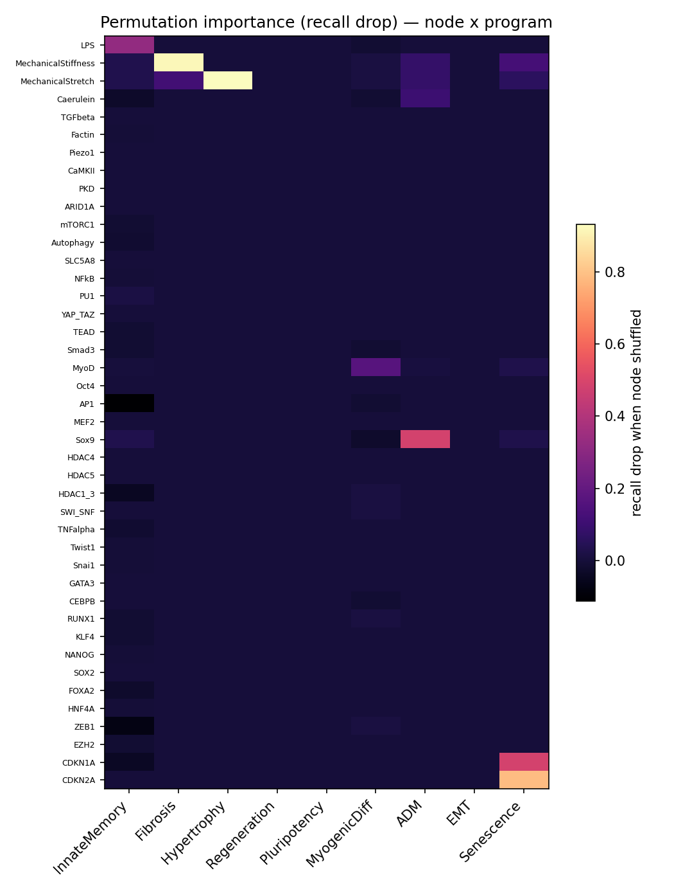
Figure 1. Node x program permutation importance (prior 10-program analysis; being regenerated on the 12-program wide model).

3.6 A falsifiable biological prediction (hypertrophy)
The encoded hypertrophy cascade (MechanicalStretch -> CaMKII/PKD -> nuclear export of HDAC4/5 -> de-repression of MEF2 -> Hypertrophy) is a de-repression switch, which yields a sign-specific prediction: HDAC4/5 knockdown should ENHANCE the program (and substitute for the cue), while CaMKII/PKD blockade should ABOLISH stretch-induced hypertrophy. An in-silico node-perturbation test of this direction is implemented; the converged-model run is [pending]. Wet-lab validation path: KN-93 (CaMKII inhibition) and HDAC4/5 knockdown in NRVM / hiPSC-CM.

4. Discussion
Read honestly, the results say something specific. The expression->program mapping is easily learned in-distribution; the hard, real problem is transfer to unseen datasets, where batch/domain shift dominates and every model degrades. In that regime the theory-structured model's concrete contribution is better program probability-RANKING (macro-AUPRC), not better top-1 accuracy — which is a sensible place for graph structure to help on an imbalanced problem, and the effect is consistent across configurations. We deliberately do not claim a blanket accuracy win: on top-1 metrics the model is competitive, not superior, and only once trained to convergence.
The theory's temporal-integration prediction is the clearest negative: in simulation the plasticity-gated, hysteretic behavior emerges by construction, but on a real EMT time-course the structured model shows no graded temporal advantage over a linear model, and the attractor mechanism is not the cause. This tempers claims that the model's dynamics capture real temporal commitment, and marks a target for future architectures (e.g. explicit trajectory supervision).

5. Limitations
- Cross-dataset generalization is modest (grouped macro-AUPRC ~0.47); absolute performance on 12 imbalanced classes is limited, and the strength is in controlled comparisons, not raw accuracy.
- The AUPRC edge is consistent but not yet formally significant from the pooled summary; the paired per-fold test and a converged (epochs-120) multi-seed run are pending (GPU).
- On real time-course data the model shows no temporal-continuum advantage over a linear model.
- Several labels are condition/timepoint proxies (type C) rather than deposited per-cell annotations; EMT and Senescence are single-source; interpretability is weak for EMT/Pluripotency.
- ADM's simulated dynamics are marker-dependent. Models are small; convergence was compute-limited.
- The wide-model ablation and perturbation confirmations are pending.

6. Conclusion
A multiscale theory of cell-state selection can be built as an interpretable knowledge-graph GNN and evaluated honestly on real multi-source single-cell data. After removing a label leak, the model's reproducible real-data advantage is program probability-ranking (macro-AUPRC ~0.48 vs ~0.40 baselines, paired p<0.02) on the hard cross-dataset-transfer regime; it matches baselines on top-1 metrics once converged, recovers known regulators, and reproduces the theory's plasticity-gated dynamics in simulation. The stronger claims — a decisive classification win and a real-data temporal-integration advantage — are not supported, and we report those negatives directly. The contribution is a credibility-controlled framework and an honest map of where a mechanistic inductive bias helps (probability-ranking, interpretability, simulated dynamics) and where it does not (top-1 accuracy, real temporal continuum).

Data and code availability
All datasets are public (accessions in the label-provenance protocol). Code, the knowledge graph, ingestion, model, evaluation harnesses (classification, baselines, ablation, perturbation, temporal-trajectory), and this manuscript builder are in the project repository.

