
Enecsys Solar Dashboard

Developed by: Jeroen van Marion
Emal:jeroen@vanmarion.nl
Github: https://github.com/nlmaca
Date: December 23, 2016

update 2017, december 12
version 4.0 – Raspbian Stretch

RELEASE NOTES

Version 4.0 – 2017, december 12
- Rebuild of installer scripts for Raspbian Stretch OS
- Rebuild webinstaller for php7
- Rebuild installer and security root settings for MariaDB. Root password is auto-generated and shown in display, just make sure to copy it. It won't be stored
- Updated installation manual
- No upgrade scripts present. Upgrading from Jessie to Stretch could give issues

Version 3.0 – 2016, december 24
- Initial release of 3rd version of the Enecsys Dashboard with the E2PV script from Omoerbeek integrated.
- Complete rebuild of version 2.3
- Possible to download daily mysql backups from dashboard
- Automatic build of history process/data to keep tables clean
- Nightly clean of old data
- Complete with installer scripts and webinstaller
- Build on Raspbian Jessie OS
- php5, mysql, phpmyadmin

version 2.3 > 1.0
- Initial versions of dashboard
- integrated script of https://github.com/omoerbeek/e2pv in installer
- later integrated script settings in database and editable from within dashboard
- created installer scripts

Credits all versions:
– e2pv script to read data from input/output of enecsys gateway: https://github.com/omoerbeek/e2pv
– Dasbhoard theme: https://github.com/puikinsh/gentelella
– Tweakers : https://gathering.tweakers.net/forum/list_messages/1627615/0

INSTALLATION GUIDE

This installation Guide will show you how to completely install a Raspberry Pi (RPI) with Debian Jessie, confgure the RPI and install the Enecsys Solar Dasbhoard with the help of installers. This document is a guide, there will also be a video created of the same process. I don't want to make this document to official ;)

STEP 0

You need some software to make it all happen
SD Formatter 4: To format your Micro(SD) card. scroll down to download the windows version.
https://www.sdcard.org/downloads/formatter_4/

Win32Diskmanager : To burn the image on your SD card
Putty: this is an ssh client we need to connect to the rpi and to install and configure it.

downloads:
SD formatter4: http://www.vanmarion.nl/rpi/SDFormatterv4.zip
Win32Diskmanager: http://www.vanmarion.nl/rpi/Win32DiskImager-0.9.5-install.zip
Putty: http://www.vanmarion.nl/rpi/putty.zip

Download empty ssh file. You will need this to enable SSH. You can do it manually or just download the zip and unpack it.
http://vanmarion.nl/rpi/ssh_file_rpi.zip

install these programs

Download RPI Image (Stretch Lite): https://downloads.raspberrypi.org/raspbian_lite_latest
Unzip the file.

STEP 1

To be able to send your data to pvoutput you have to create an account and setup your system.
NOTE*: IF you already have a pvoutput account you can skip STEP 1

Register an account
http://www.pvoutput.org/register.jsp

After you have logged in go to your account or press settings in the menu

Fill the settings to your needs
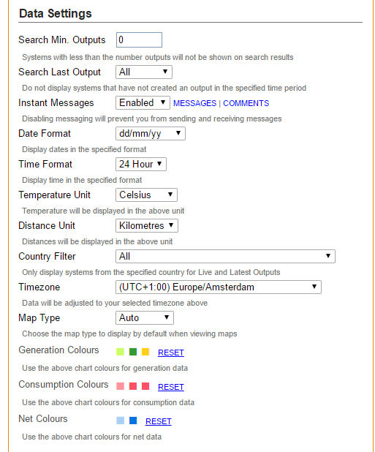

The alert settings you can skip

The next settings are very important. You have to create an apikey which has to be set in the dashboard

select the API to enabled. There should be an api key visable. If not, click on New Key.
After that press save settings first

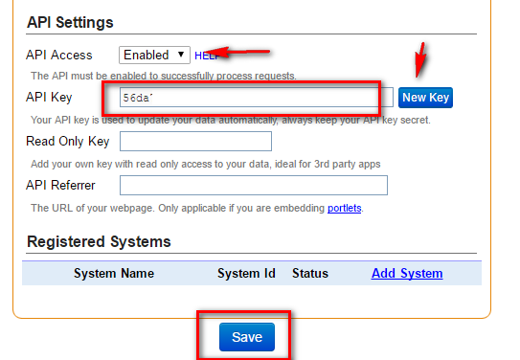

Ok. time to add a system
Fill in the settings to your setup
System settings
System Name | This name will be public to others, so make up a nice one
Status | Active
Number of panels | How many inverters do you have? Set the number
Panel max power | The maximum power of the solar panel
System size | Total power of all panels together
Panel Brand/Model | optional
Orientation | Select your setup
Azimuth | Set a value
Number of inverters | Set the number
Inverter Size | Set same as system size
Country | Set yours
Postal code | Set yours
Array tilt | Set yours
Panel coefficent | Set yours
Shading | Select yours

Example part 1
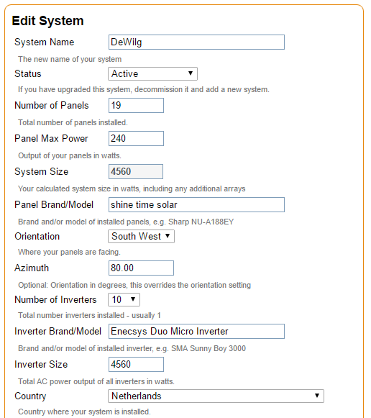
Example part 2
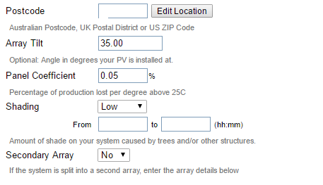

This one is important: Live Settings
Set the status interval to 10 minutes. Don't change this value to anything else!!
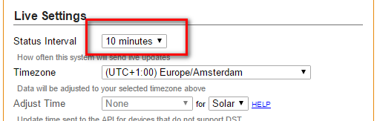

All the rest is optional. Save the settings.
After that you will see your system. You

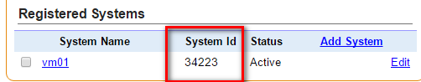
To be able to join the Tweakers Team you have to upload at least 20 inputs.
After that you are able to join a team
We have a large group of Enecsys Users, so i would appreciate if you could join the Team :D.

Join the team: open this url: http://www.pvoutput.org/ladder.jsp?tid=1018
On the right top side you will see a button: Join or Leave Team
Feel free to join

2 values you need in the dashboard:
SystemID: you can retreive that one from the settings page (see screenshot above)
PersonalID : click on Your outputs. In the browser url you will see your personal id

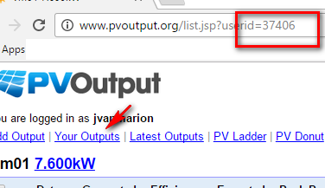

STEP 2

Time to insert your MicroSD. Best to format the SD first with sdformatter4. Start SD formatter 4 and select the drive where your sdcard is plugged into. In my case the K drive
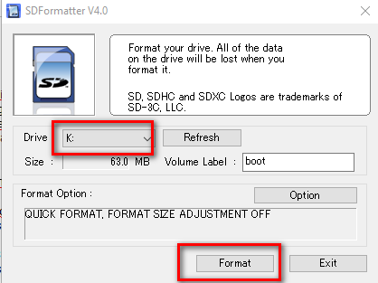
Fig
Click on Format, you will get some warnings, just click OK.

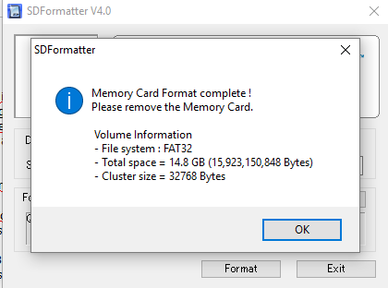
Formatting done. On to the next step.

STEP 3

Time to burn the image on the SD Card. Start Win32diskmanager. You will see this screen. Make sure your sd card drive is selected. Click on the browse icon to select the image file you have downloaded and unzipped in step 1

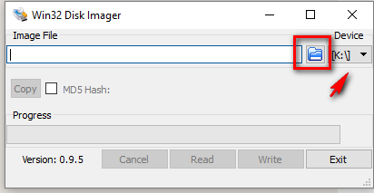
Select the image. If you cant find it on your location, change the Disk Images (*.img *IMG) to *.*
and click on open

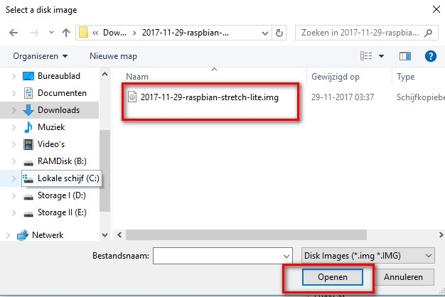

After that the image is selected. Click on Write to burn the image to your SD Card.

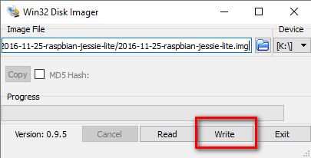

This can take about 5 minutes. Depending on the size of your SD. Get some coffee :D
Sometimes the writing is stuck and nothing happens. Then start over from Step 2. It has happened me quite some times, so don't bother too much about it;)

When you have clicked on Write you will get a warning. Just click OK

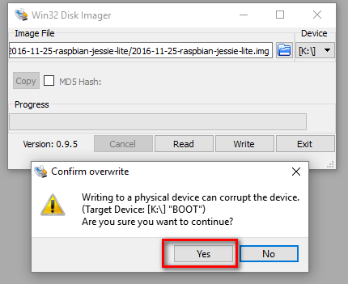
When the writing is done you will get a popup

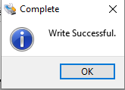

OK. at this point we are not done yet.
Raspberry decided to remove default ssh access to the RPI. And we need SSH.

Download my latest installer zip from my github page
https://github.com/nlmaca/Enecsys_Dashboard/archive/master.zip

In the INSTALL directory you will find a file called ssh
Copy this file to the root of your MicroSD

If you want to do it manually, open Notepad++ (NOT notepad). Make an empty file, save it as ssh (no dot, just ssh) and place it in the root of your SD card.
Or download the file i already created: http://vanmarion.nl/rpi/ssh_file_rpi.zip
unpack the zip file and put it in the root directory

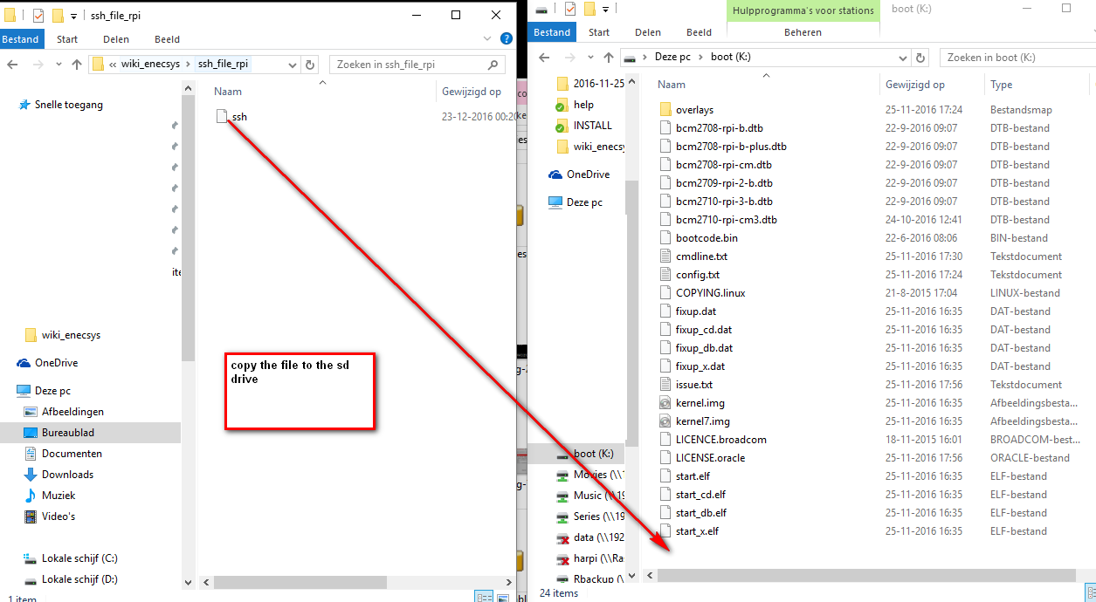

After that you can disconnect the SD Card, stick it in your RPI and power it up and make sure the network cable is connected to your network. It will get an ipaddress automaticly from your router.

STEP 4
OK. How do you find your RPI in your network?
I use a mobile app Fing
Apple: https://itunes.apple.com/nl/app/fing-netwerk-scanner/id430921107?mt=8

Android: https://play.google.com/store/apps/details?id=com.overlook.android.fing&hl=nl

So i can scan my Wifi network. It should show a rpi in there

Using Fing (android) will show my RPI in my network

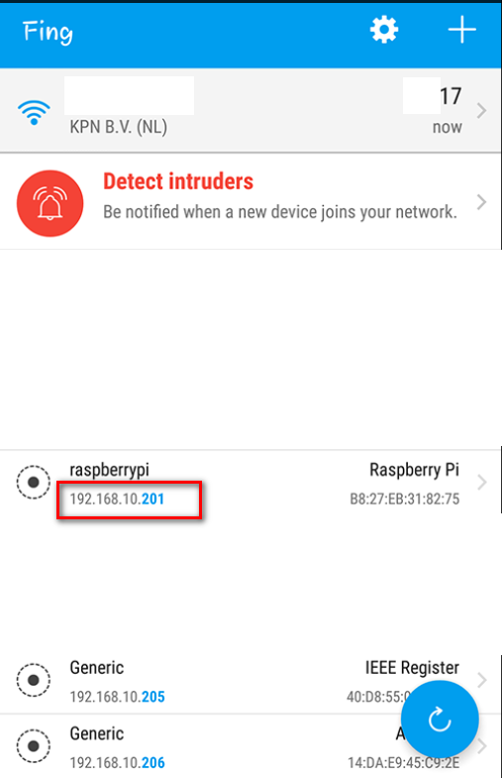
So as soon you have the ipaddress of the RPI we can continue

STEP 5

its time to start Putty.exe to connect to your RPI. You have downloaded this in Step 1. in my case my rpi ipadress is 192.168.10.201

the default ssh port is 22 so we need this when connecting
start putty.exe
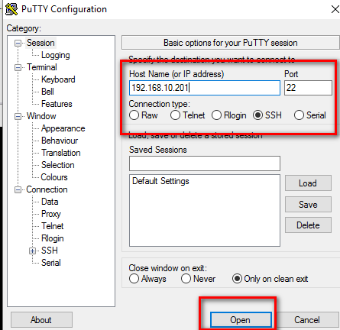

you will get a warning (thats normal). Press Yes/ja

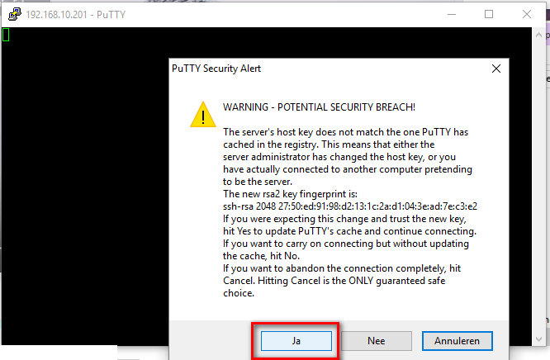
login with the default user and password

login: pi
password: raspberry

done.

STEP 6
First things first. We have to configure the RPI. Follow the screens and you should be ok. To start it type this command: sudo raspi-config

it will show this screen.
When interacting with the screens below use your keyboard:
- selection change: TAB
- confirm: ENTER

There are some steps we have to configure. The first one is to expand the filesystem. Otherwise it will only use a limited space of your SD card.

Go to 7: Advanced Options (use arrow keys): Select A1 (Expand Filesystem) > Enter
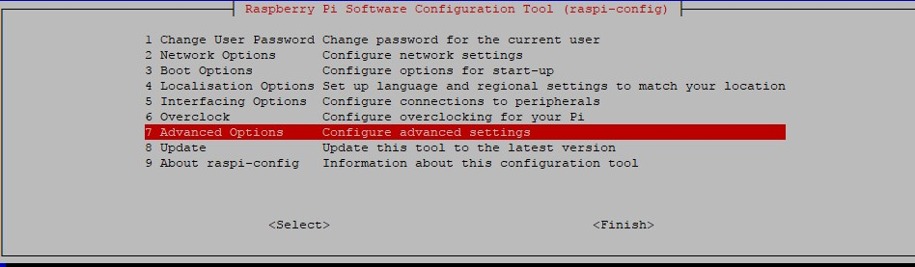
Then select Expand Filesystem

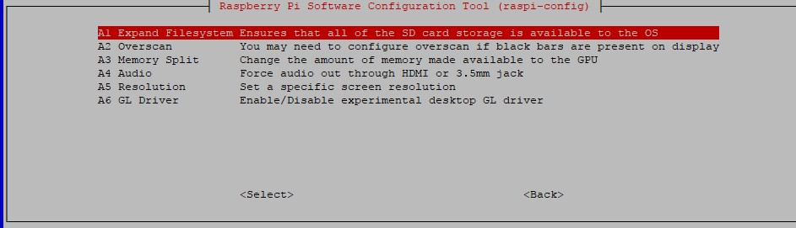

When you pressed enter it will show this screen. Just click OK. We will reboot later
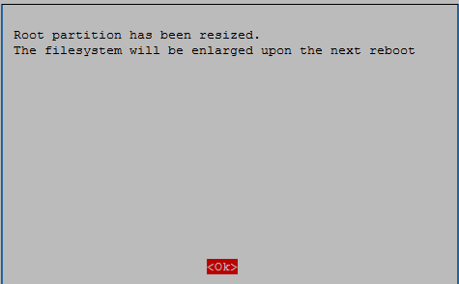

On to changing the password. It is best to set a password of your choice. Make sure to fill it in good (when setting the password it looks like nothing happens, but it will change to what you are typing)

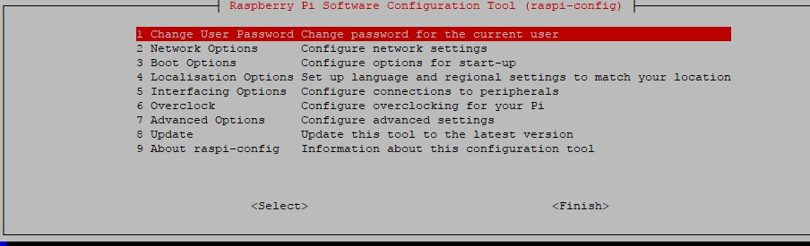

Set the password
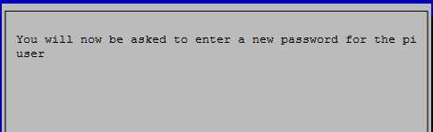
Type the new password twice.
Note: You won't see the characters, so make sure you type it correct!. (copy your password from notepad and paste (right-click mouse) is the best way to avoid wrongly typed characters

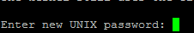
When the password is changed you will get a notice
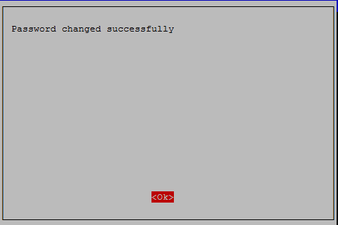
Done.

ok after this select 4 (Localisation options) and press enter
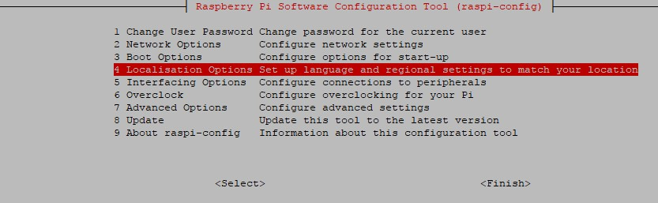
then select change Timezone
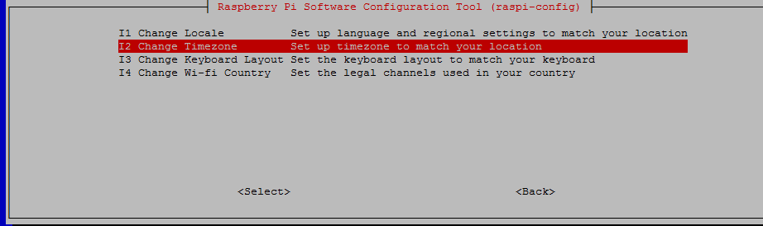
select the next screens to the location where you are

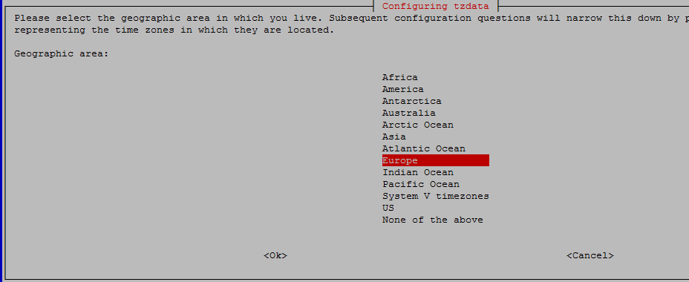

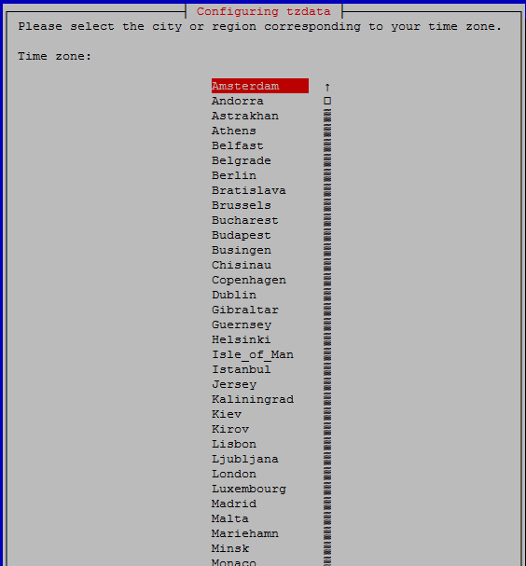
and press enter. It will automaticly send you back to the main screen.

Select 7 Advanced options and press enter
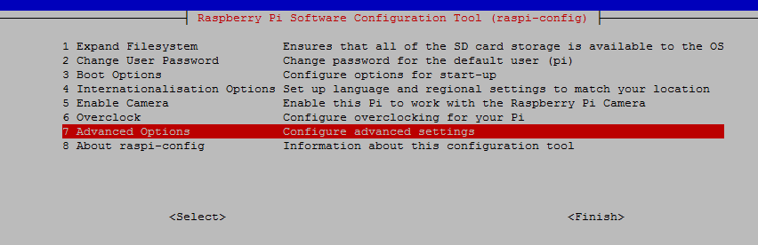
First select A3 Memory Split and press enter
set the value to 16 and select ok
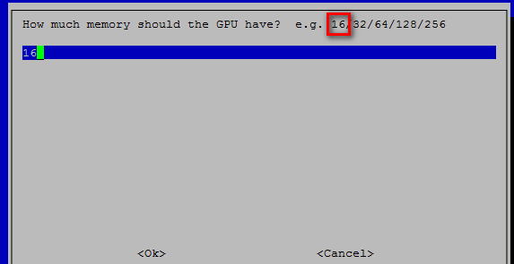
ok all done.
Click finish
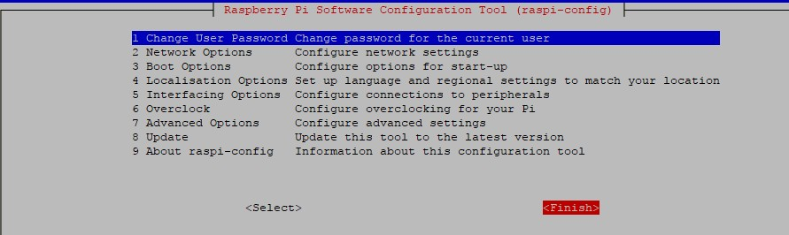
It will ask for a reboot. Press yes.
This will use the complete space of the MicroSD card. The extra space is needed for installation files and data storage.

After the RPI has been rebooted. The rpi is pretty quick in rebooting. So just wait a minute. Again connect to it with Putty (see step 5). However, now connect with the new password you have set.

STEP 7

First make sure the OS is up-to-date
on the command line do the sudo apt-get update and press enter
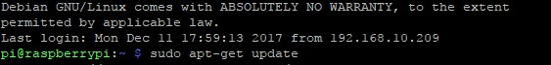
after that to the same for the upgrade process sudo apt-get upgrade and press enter
you will prompted to continue: Press Y and Enter
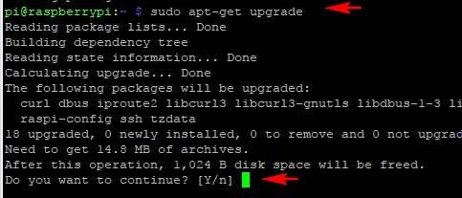
It can take some time to update. Done?. The system is up-to-date now.

Time to start the installer process. Use only the url in this documentation, i had to use another one, because i created the documentation first before i uploaded the code

Download the Installer first
wget https://raw.githubusercontent.com/nlmaca/Enecsys_Dashboard/master/INSTALL_SCRIPTS/installer.sh

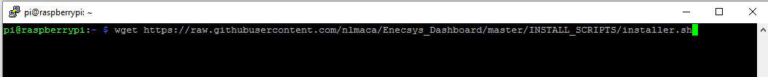
after this you have to set executable rights:
chmod +x installer.sh

Ok. Now we are going to run the installer which will download all the necessary other installer scripts. Run the installer
./installer.sh

You should see these files (type in: ls) to see the files
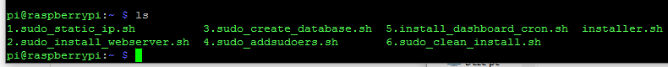
All these files are needed for the dashboard installation. So lets start with the first one

STEP 8
Time to set a static ipadress to your RPI. This script will set the current ipadress to a static one. Just run the script, you don't have to set the ipadress and netmask anymore in this new setup. It will add some comment lines in the /etc/dhcpcd.conf file So if you run it twice it will say that it already is changed.

If you want to set a static ipadress yourself then skip this step (8)

Run the command WITH SUDO!!
sudo ./1.LAN_static_ip_v4.sh

Reboot the RPI so changes take place

command: sudo reboot

and check if you can connect to the ipaddress given in your display.

STEP 9

ok. the next script wil take a bit longer. It will update the rpi and install the mysql server, webserver, php, phpmyadmin
Raspbian stretch now uses MariaDB, which has a slightly new approach on password management. Without adjustment you could login without a password. Time to set some security on that. The script will run the commands, you only have to answer some questions and set a new mysql root password.

Needed:
use this url to generate a random password:
https://www.random.org/passwords/?num=1&len=15&format=html&rnd=new

Run this one WITH SUDO
sudo ./2.sudo_install_webserver.sh

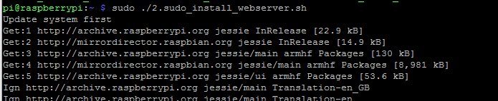
What is this script doing:
- updating your system
- installing php7 and packages, mysql, apache2, phpmyadmin and securing your database with a new root password
- The generated root password will be displayed at the end. Make sure to copy it. It won't be stored and you need it in the next installation, also store it in your password vault

The install process continues. It can take some time. Don;t worry when nothing happens. A lot is happening on the background.
At the end of the script you will see the new mysql password in your screen. Make sure to copy it, because its random generated and not saved

At some point you have to make a selection for which webserver to use. Select Apache2
select apache: SPACEBAR
select finish: TAB
confirm: ENTER

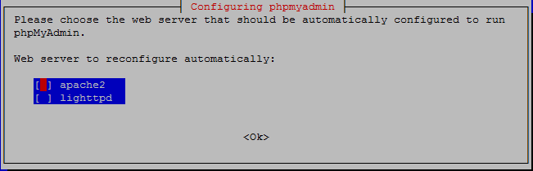

next question is for phpmyadmin. Select no
press Tab, then ENTER to confirm
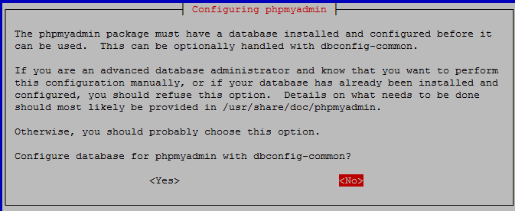
At the end all services will be restarted and you new MySQL root password will be displayed in your screen.
"-------------------------------------------------------------"
"Copy this new Mysql Root password and keep it in a safe place:"
MYSQL_ROOT_PASSWORD
"Installation Done! > Go to script No 3 "

STEP 10
I rebuild this script so a database is created with a prefix and random second part. Username and password are also pre-generated and displayed after installation is done. Al you need is to set the mysql ROOT password you have got in the previous step

Requirements: mysql root password standby

So. start the script again WITH SUDO
sudo ./3.sudo_create_database_v4.sh

question: Enter the mysql root password (right-click for paste)
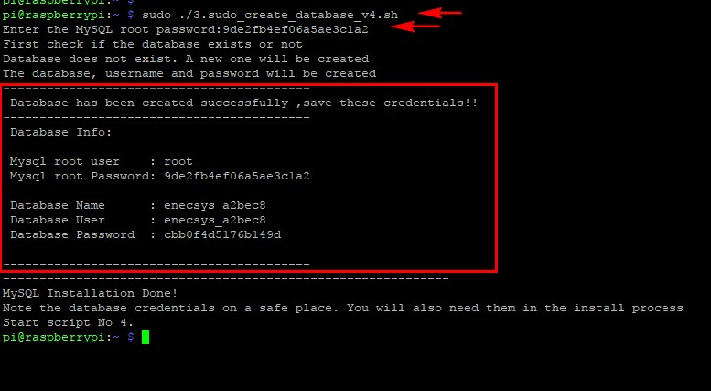
Ok. installation went without problems. The database is created

Again, save the credentials, you will need them later on.

STEP 11
The next script is an easy one, it will add the apache user to the sudo list, so you are able to reboot the RPI from within the dashboard. It will also grant the apache user permissions to run the cronjobs

run the script WITH SUDO
sudo ./4.sudo_addsudoers.sh
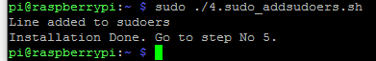

STEP 12
ok. this is an important one to run it right. You have to set a webdirectory as a parameter, so for example if you want to see it in the browser as http://192,168,10,201/enecsys_solar you have to set enecsys_solar as parameter. This wil also install all the cronjobs on the pi user based on the parameter you set. You can use enecsys_solar if you don't know what i mean;).

This command will download all the files from my github page to your RPI and will unpack it into the webdirectory. So the hard part is done for you automaticly :D

You have to run this script WITHOUT SUDO. So don't set sudo in front of it. Because we need everything to run on the pi user, and NOT on the root

./5.install_dashboard_cron.sh enecsys_solar

It will donload the files, unpack them, install them, install the cronjobs. After that you will get this message. In there you will see an url. Copy this one into your browser
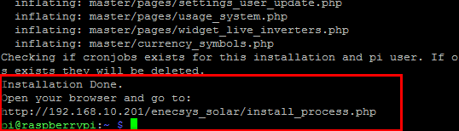

STEP 13
on to the webinstaller. Open the url in your browser to start the dashboard installation, make sure to enter the complete url. In my case: http://192.168.10.201/enecsys_solar/install_process.php

after that agree to the disclaimer and press continue
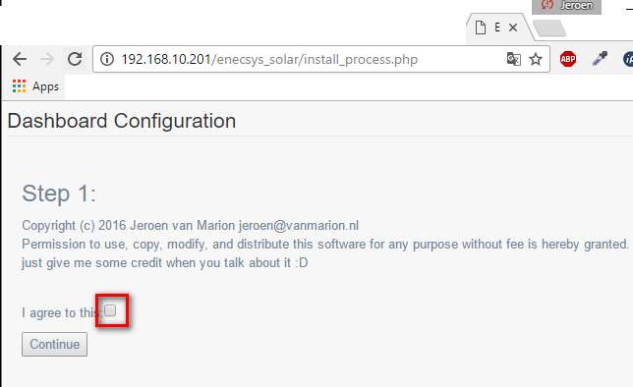
next it will check if the config file is writable. If green press next
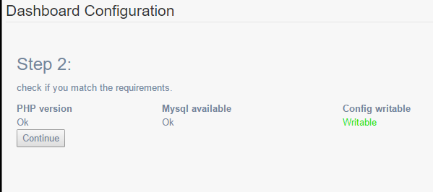

Next screen is where we have to set the database credentials you have set in STEP 10

You only have to set:
- Database Name
- Database UserName
- Database Password

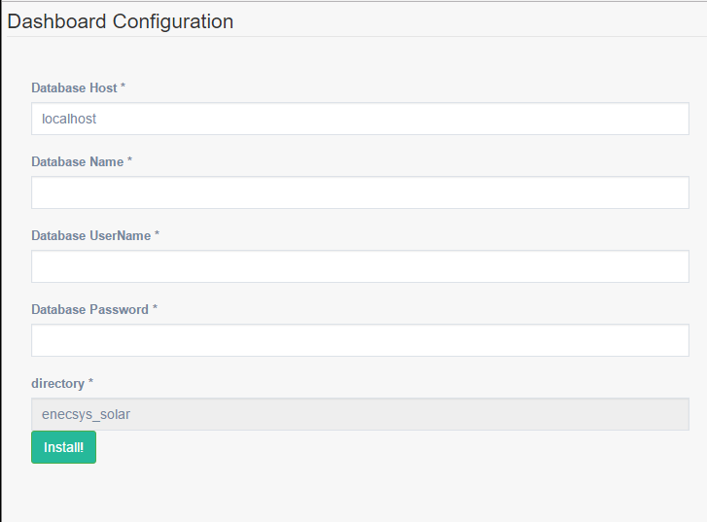
ok. almost done. Below will show a link you can click to go to your dashboard.

The default credentials are:
username: admin
password: dashboard
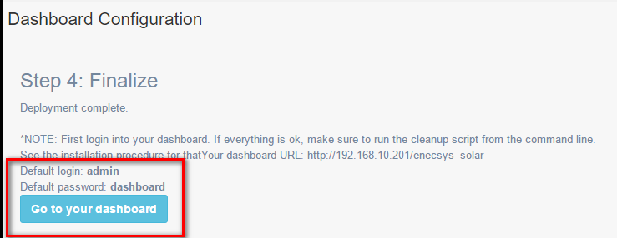
Click on: go to your dashboard and bookmark the page.

NOTE. YOU ARE NOT DONE YET.
Follow this last step

STEP 14

Please go the last step to cleanup the INSTALL files. Run the last script WITH THE WEBDIRECTORY (see step 12)

sudo ./6.sudo_clean_install.sh enecsys_solar

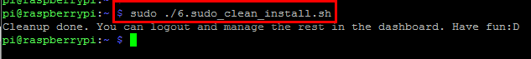
Ok. now you are done. Logout of the RPI by using this command:
exit

STEP 15
The next step is to set your Enecsys Gateway to the new RPI address. You can find the ipaddress of the Enecsys gateway on the gateway itself
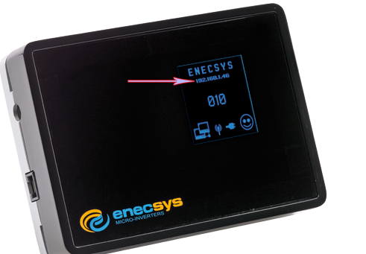

It is best to set the Enecsys Gateway to a static ipaddress. You can do that by deselecting the DHCP
because in my experience the gateway will change ipadresses when you reboot your router.

Go to the ipadress of your enecsys gateway in the browser and login (i don't have the credentials, you should have them). Default credentials are:
username: admin
password: password

Make sure DHCP settings is not selected
In the Remote server address or name enter the ipaddress of the RPI. In my case that would be 192.168.10.201
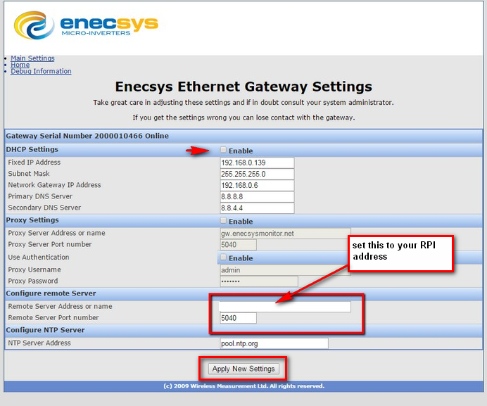
After that Apply New settings.

Ok almost done. Time to go the dashboard to input your inverters, and configure all the settings

STEP 16
Dashboard configuration
Almost done. There are 2 pages you have to edit in the dashboard. Login in your browser with the url you got from step 10

go to settings-> E2PV
make sure these fields are adjusted: common mistake is that users add the personal id in the systemid field. So make sure you set the correct one!!
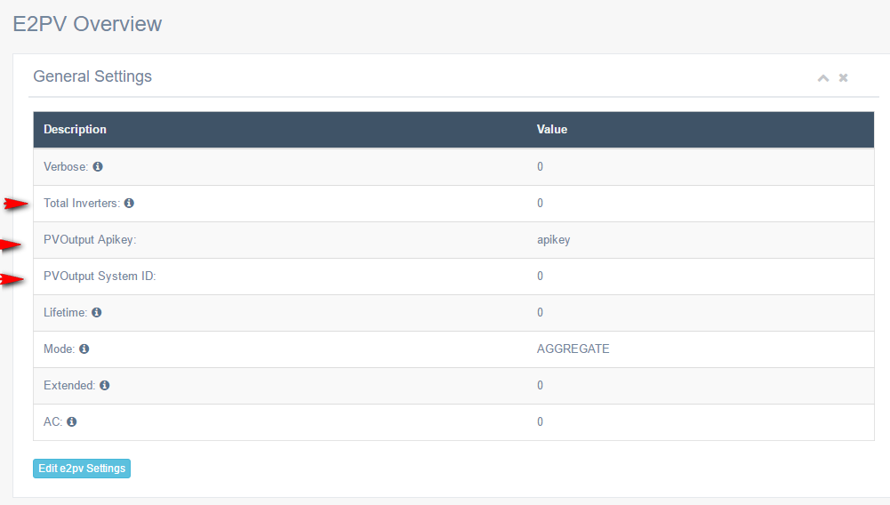
After that set the general settings. The data is not depending on it, but its best to configure the settings first
fill them to your needs

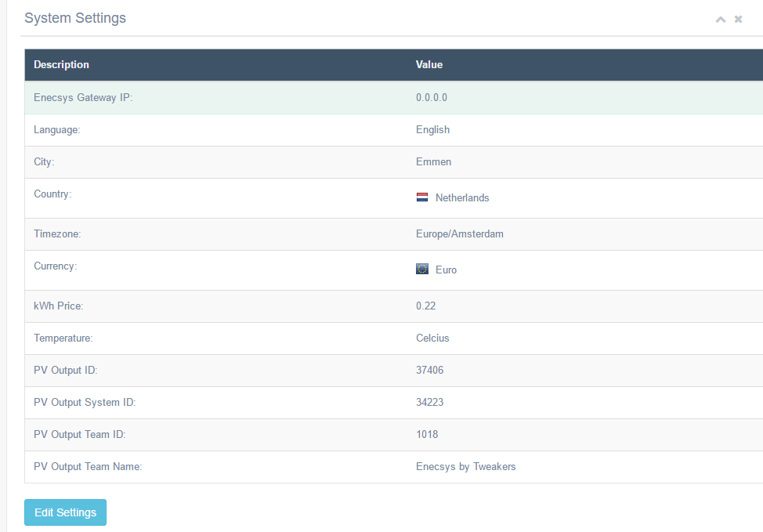

The last setting for now is the Settings → Inverters
you will have to set all the inverter serial numbers you have

Inverter: The inverter serial number.
Inverter type: select the type of your panels
part nr: optional
build date: optional
Duo single: select the inverter type duo/single
Watt panel 1, 2 . Set the watt for each panel
Alias: example: top left panels or bottom roof

After you have set all your inverters and settings its time to reboot the rpi.
YOU NEED TO REBOOT EVERY TIME YOU CHANGE THE E2PV SETTINGS!!

Go to System-> reboot/Shutdown
Click on Reboot RPI to confirm all the changes and to reboot the RPI.
After the reboot you have to wait for data coming in. (so you need daylight)

Ok. now you are done. There is a help page in the dashboard with common issues and a short knowledge base.
Have fun

regards,
NLMaca / Jeroen van Marion

