Model
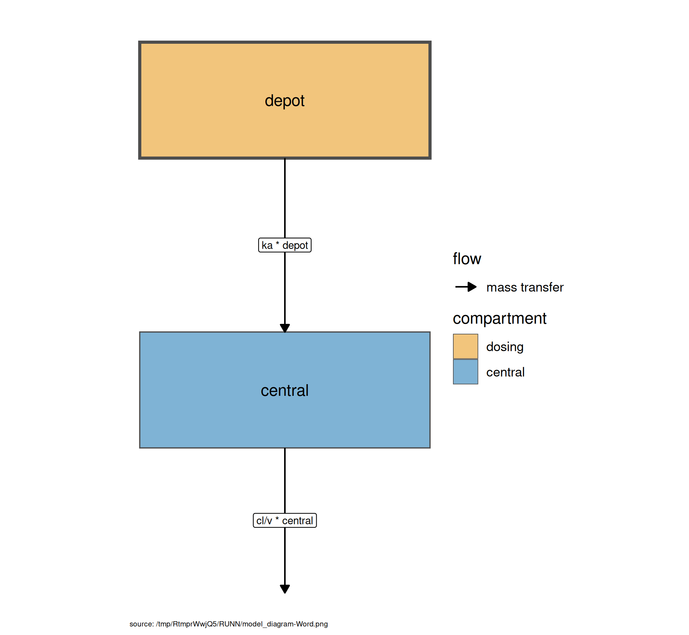
Figure . Model structure

$ka=exp⁡(tka+eta.ka)$
$cl=exp⁡(tcl+eta.cl)$
$v=exp⁡(tv+eta.v)$
$\frac{d depot}{dt}=−ka×depot$
$\frac{d central}{dt}=ka×depot−\frac{cl}{v}×central$
$cp=\frac{central}{v}$
$cp∼add(add.sd)$
Table . Model equations

Tables
Parameter | Est. | SE | %RSE | Back-transformed(95%CI) | BSV(CV%) | Shrink(SD)%
tka | 0.461 | 0.192 | 41.6 | 1.59 (1.09, 2.31) | 71.5 | -0.0769>
tcl | 1.01 | 0.0789 | 7.80 | 2.75 (2.36, 3.21) | 26.2 | 3.89<
tv | 3.45 | 0.0453 | 1.31 | 31.6 (28.9, 34.5) | 14.4 | 11.2<
add.sd | 0.697 | 0.0472 | 6.77 | 0.697 (0.604, 0.789)
Table . Parameter Estimates

Figures

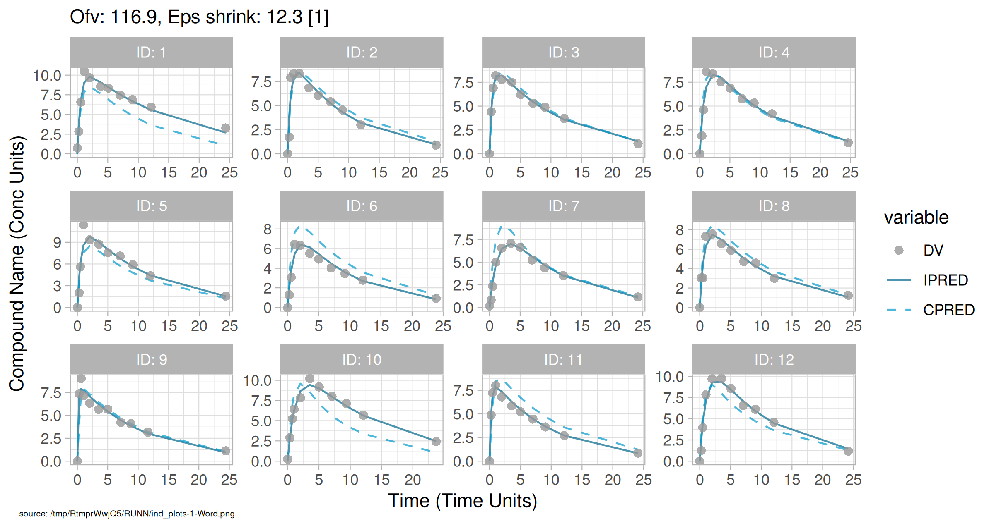
Figure . Individual and population prediction overlay

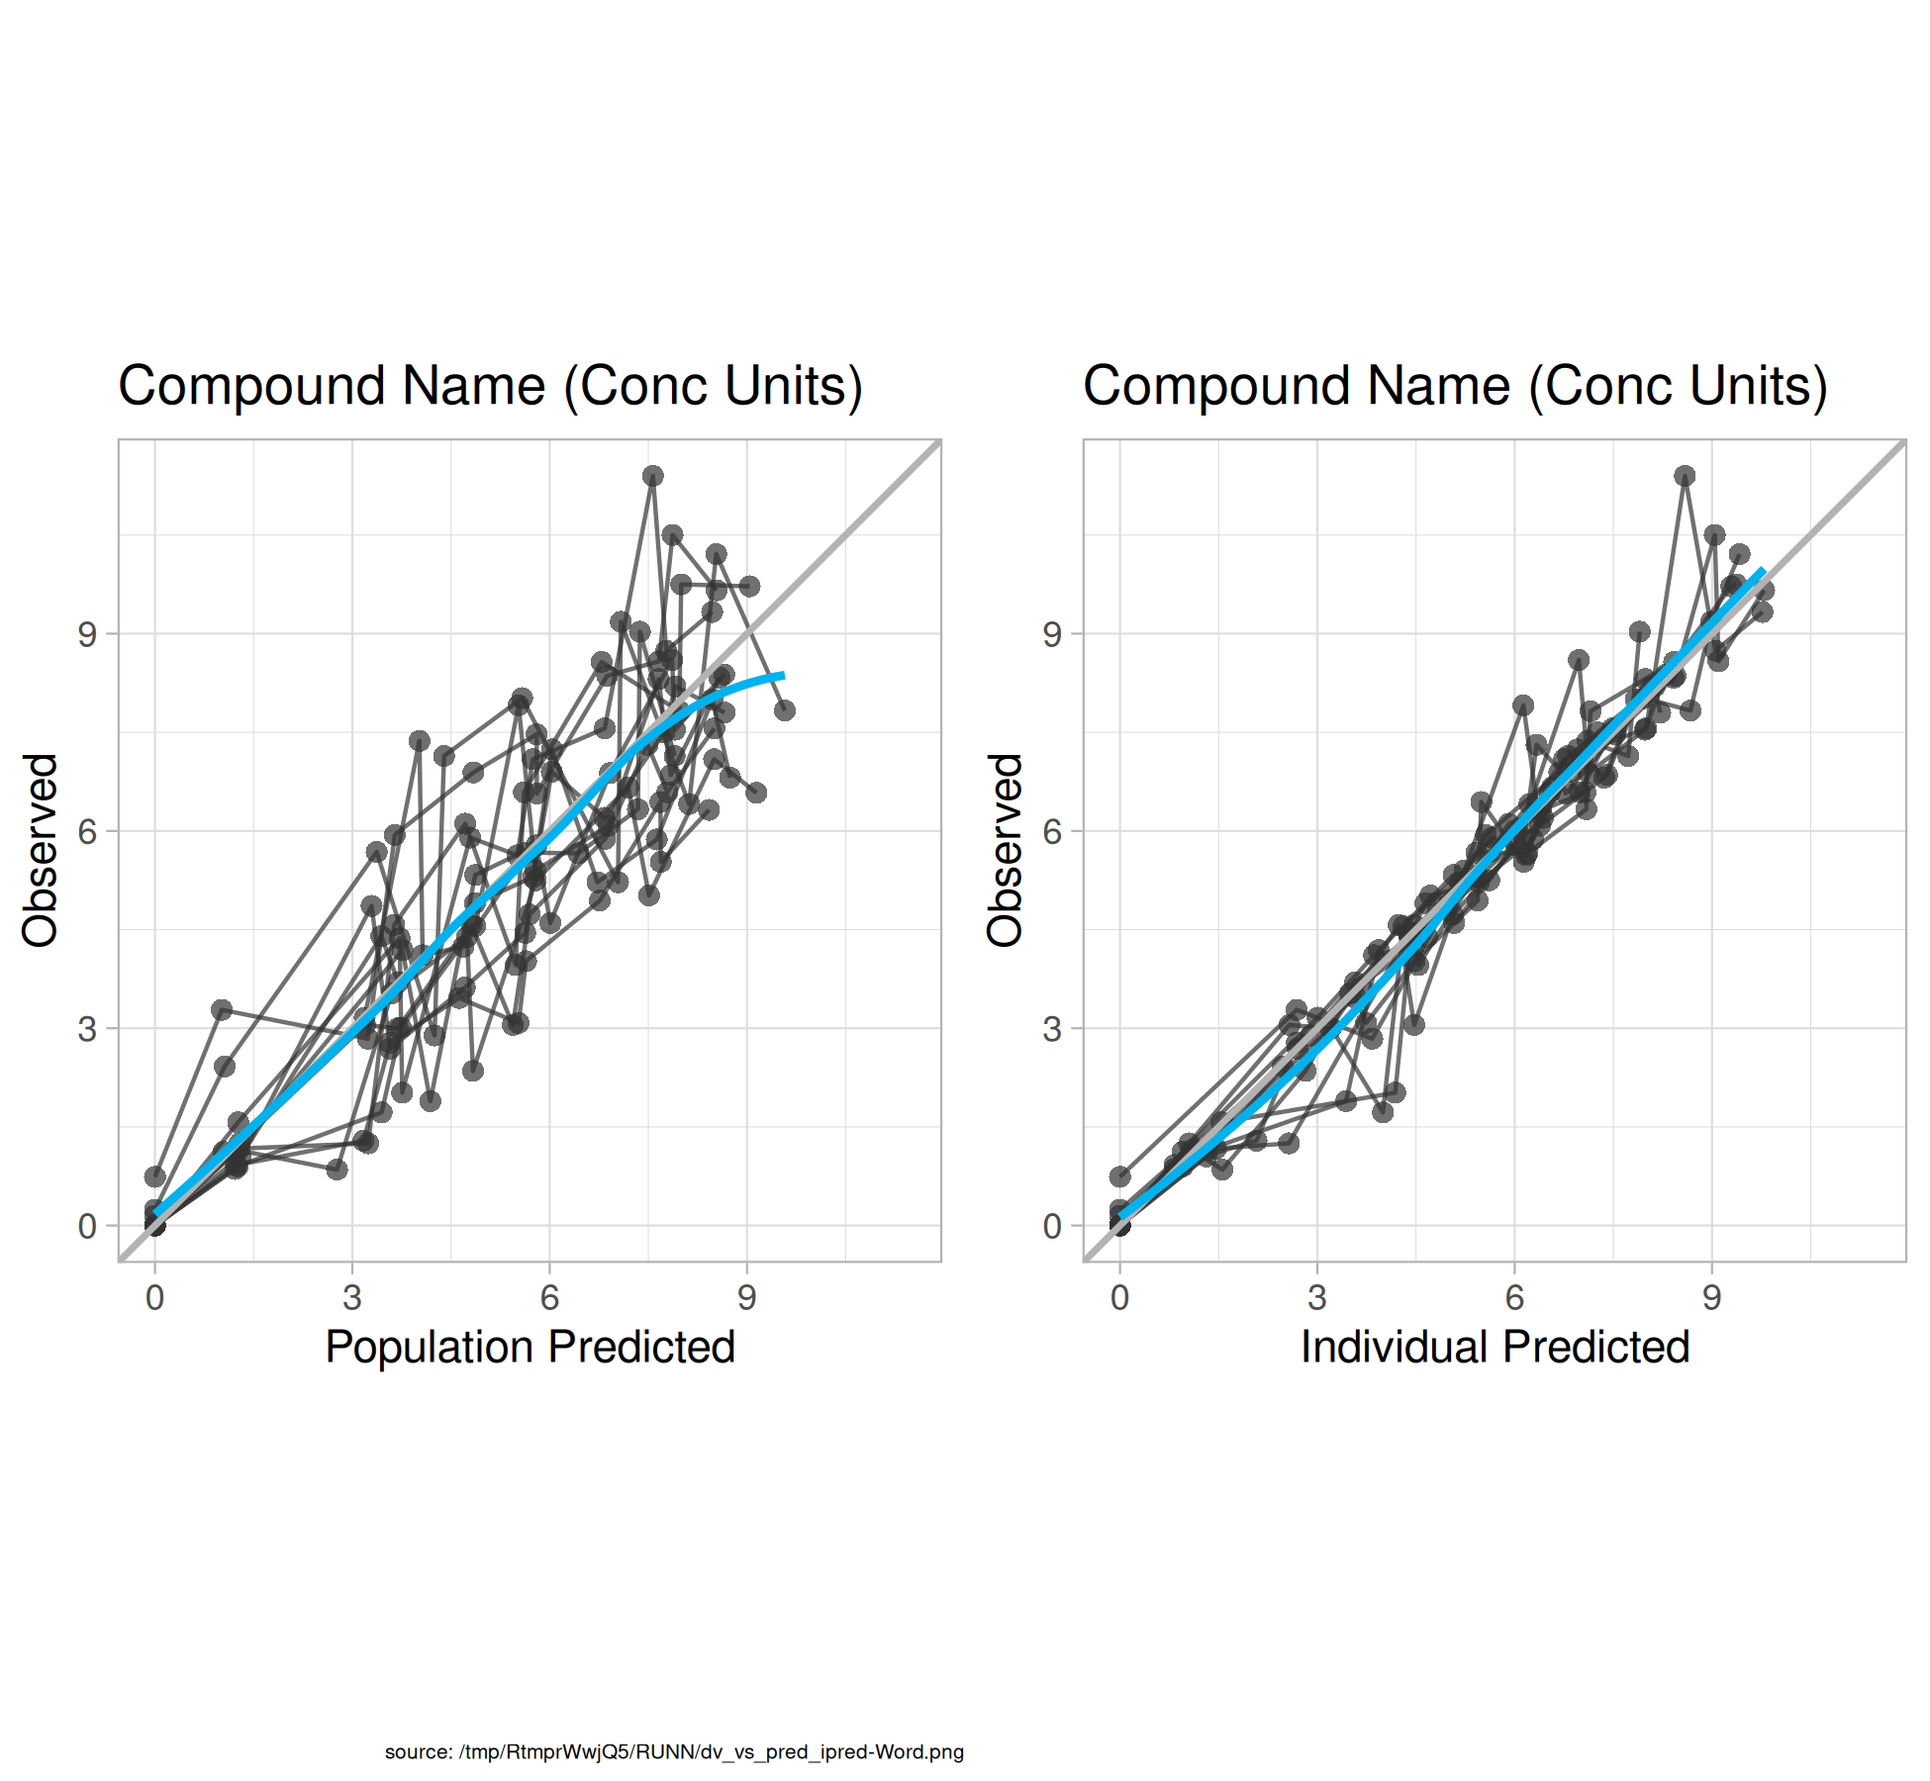
Figure . Observed vs Predicted

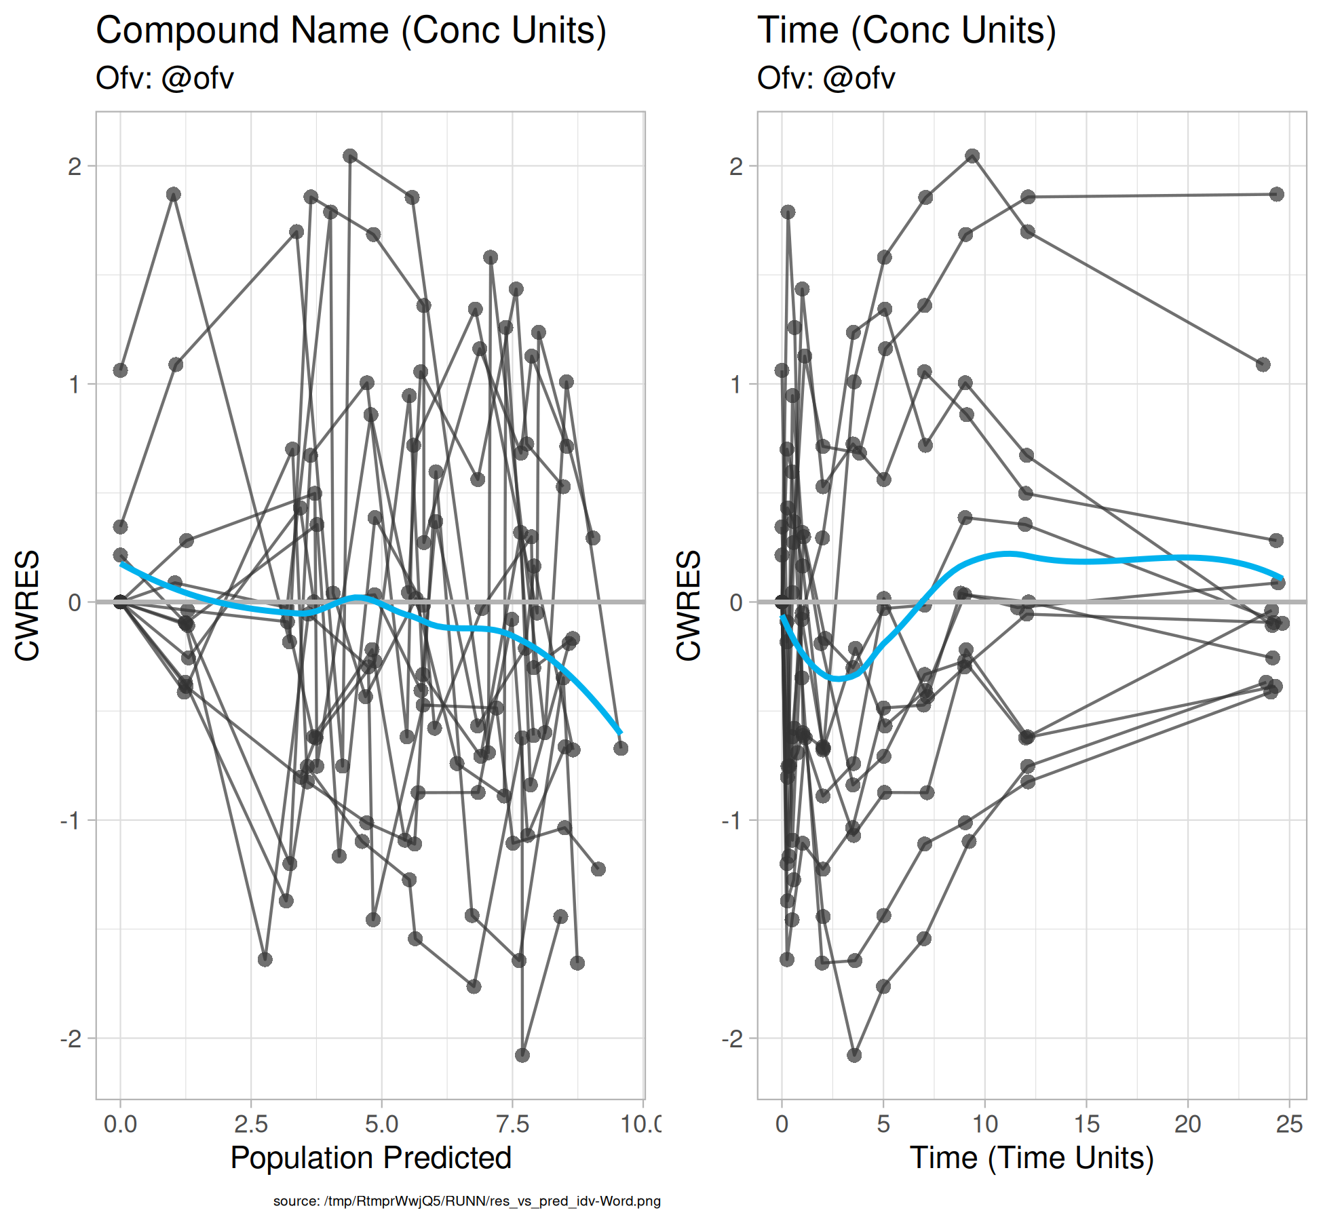
Figure . CWRES vs Pred and Time

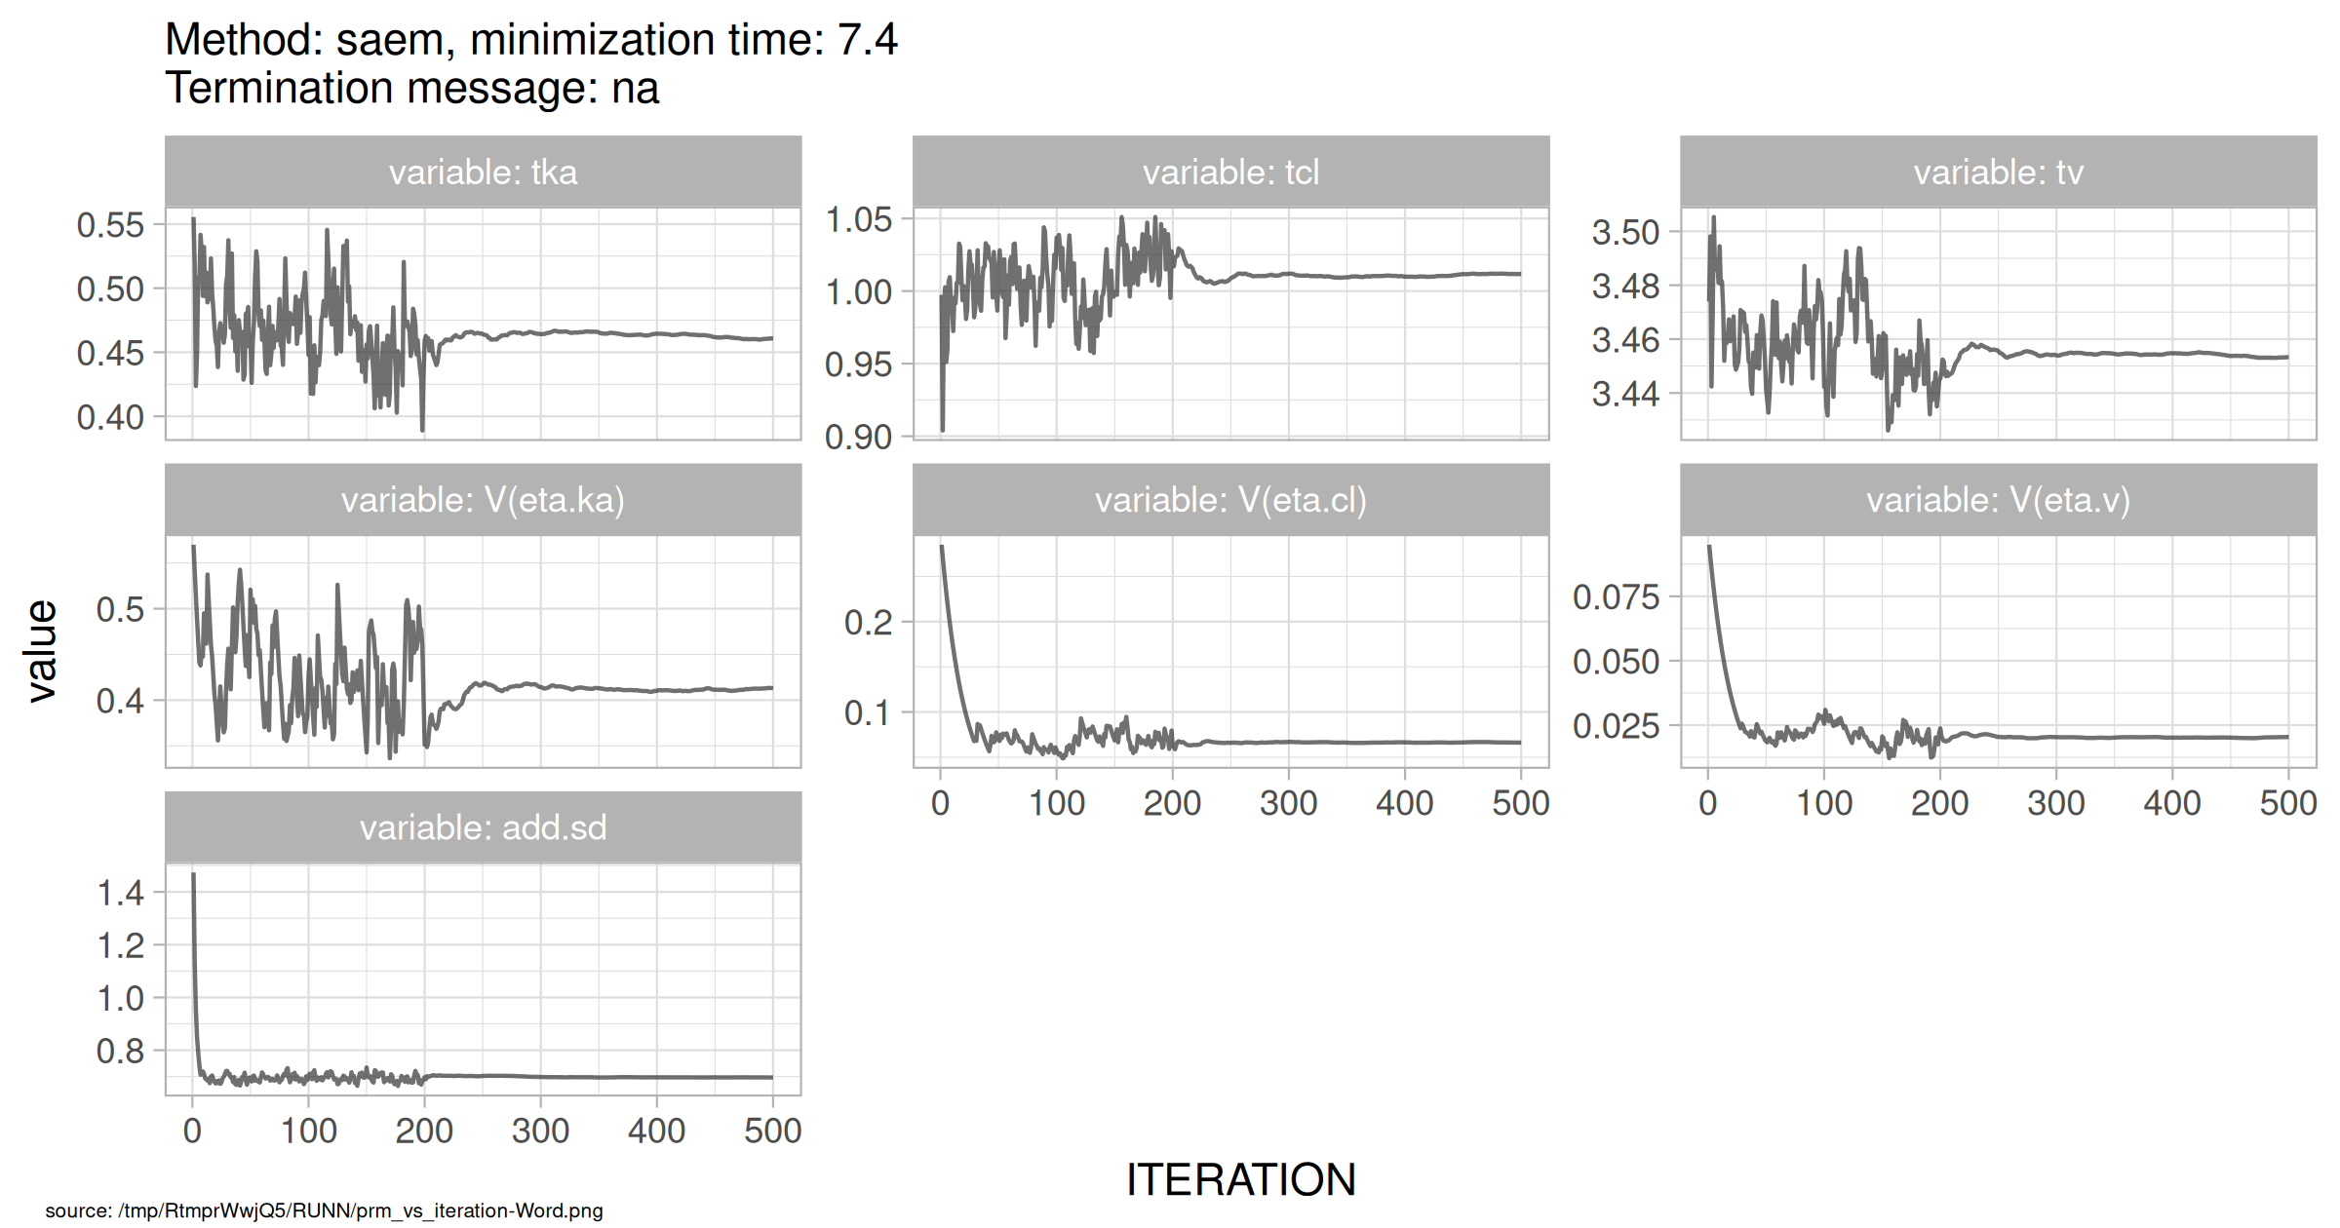
Figure . SAEM Stabilization

