Theophylline population PK model

Methods
Theophylline concentrations from 12 subjects were described by a one-compartment model with first-order absorption (Figure 1), estimated with SAEM in nlmixr2.
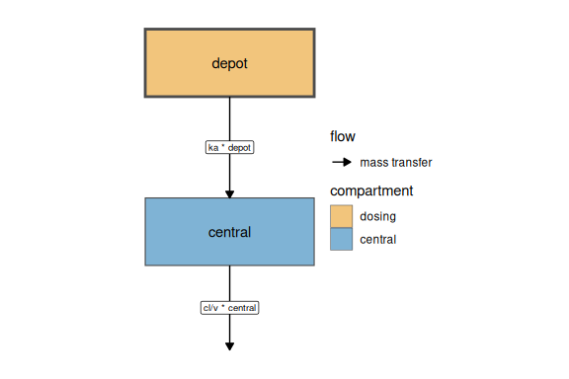
Figure 1: Structure of the final model.
The model is defined by the following equations:
$$\begin{matrix}ka=exp\left(tka+eta.ka\right) \\ cl=exp\left(tcl+eta.cl\right) \\ v=exp\left(tv+eta.v\right) \\ \frac{d depot}{dt}=−ka×depot \\ \frac{d central}{dt}=ka×depot−\frac{cl}{v}×central \\ cp=\frac{central}{v} \\ cp∼add\left(add.sd\right)\end{matrix}$$

Results
The objective function value was 123.05. Table 1 lists the final parameter estimates.
Table 1: Final parameter estimates.
 | Back-transformed | CI Lower | CI Upper | %RSE | BSV(CV%)
tka | 1.586 | 1.089 | 2.308 | 41.554 | 71.516
tcl | 2.750 | 2.356 | 3.210 | 7.803 | 26.159
tv | 31.604 | 28.920 | 34.538 | 1.311 | 14.351
add.sd | 0.697 | 0.604 | 0.789 | 6.772

