# Tables

| Parameter | Est. | SE | %RSE | Back-transformed(95%CI) | BSV(CV%) | Shrink(SD)% |
| --- | --- | --- | --- | --- | --- | --- |
| ka_pop | 0.427 | 0.204 | 47.8 | 1.53 (1.03, 2.29) | 75.4 | 1.05%< |
| V_pop | -0.786 | 0.045 | 5.72 | 0.456 (0.417, 0.497) | 12.7 | 13.3%< |
| Cl_pop | -3.21 | 0.0837 | 2.61 | 0.0402 (0.0341, 0.0473) | 27.6 | 2.65%< |
| a | 0.433 |  |  | 0.433 |  |  |
| b | 0.0543 |  |  | 0.0543 |  |  |

Table . Parameter Estimates

# Figures

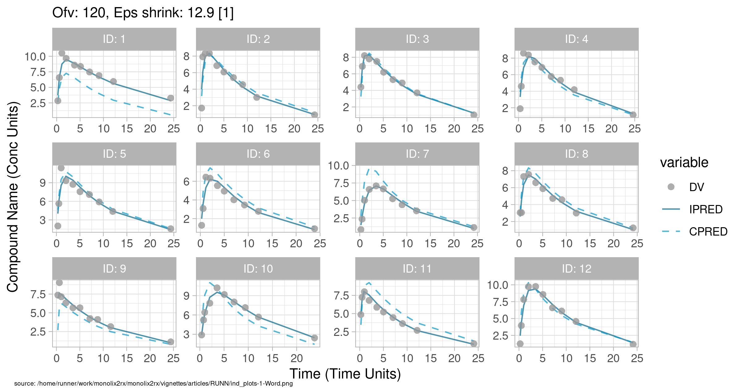

Figure . Individual and population prediction overlay

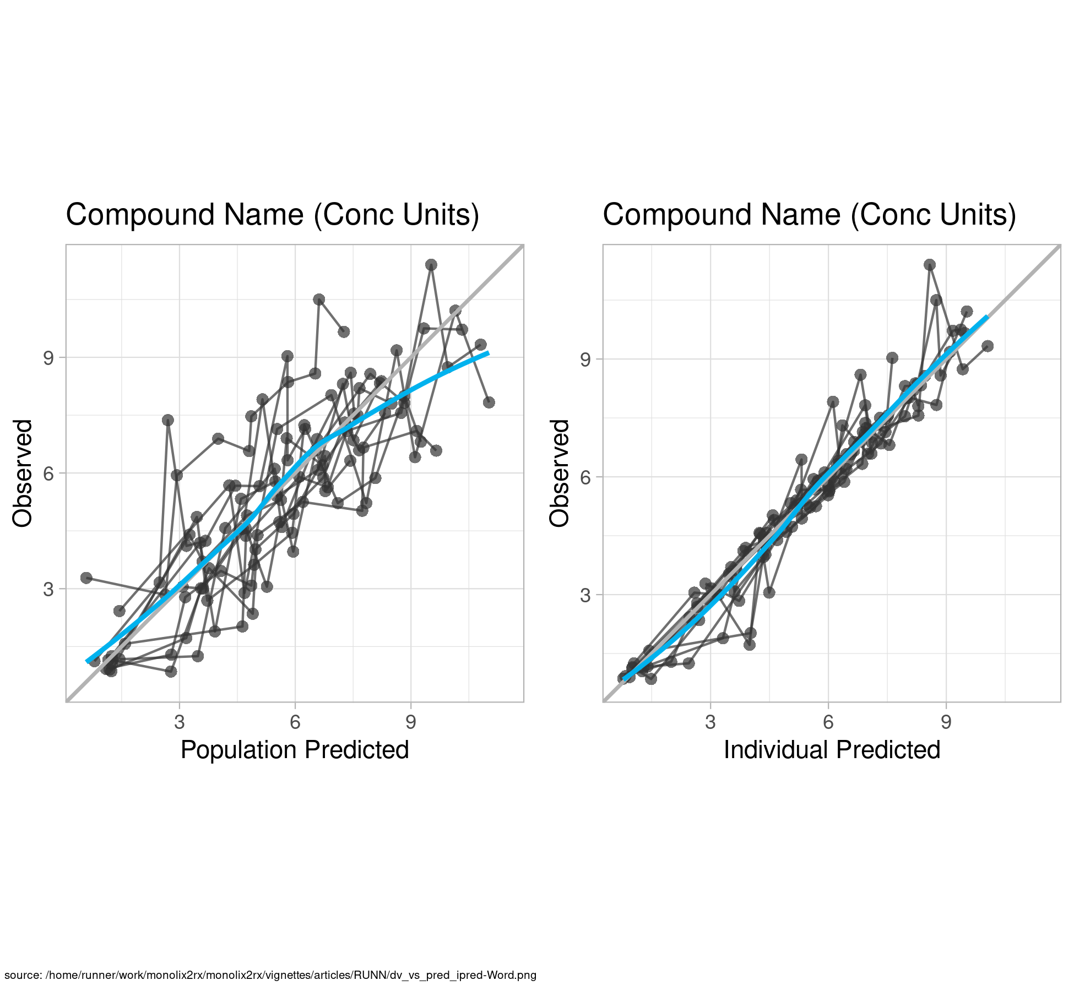

Figure . Observed vs Predicted

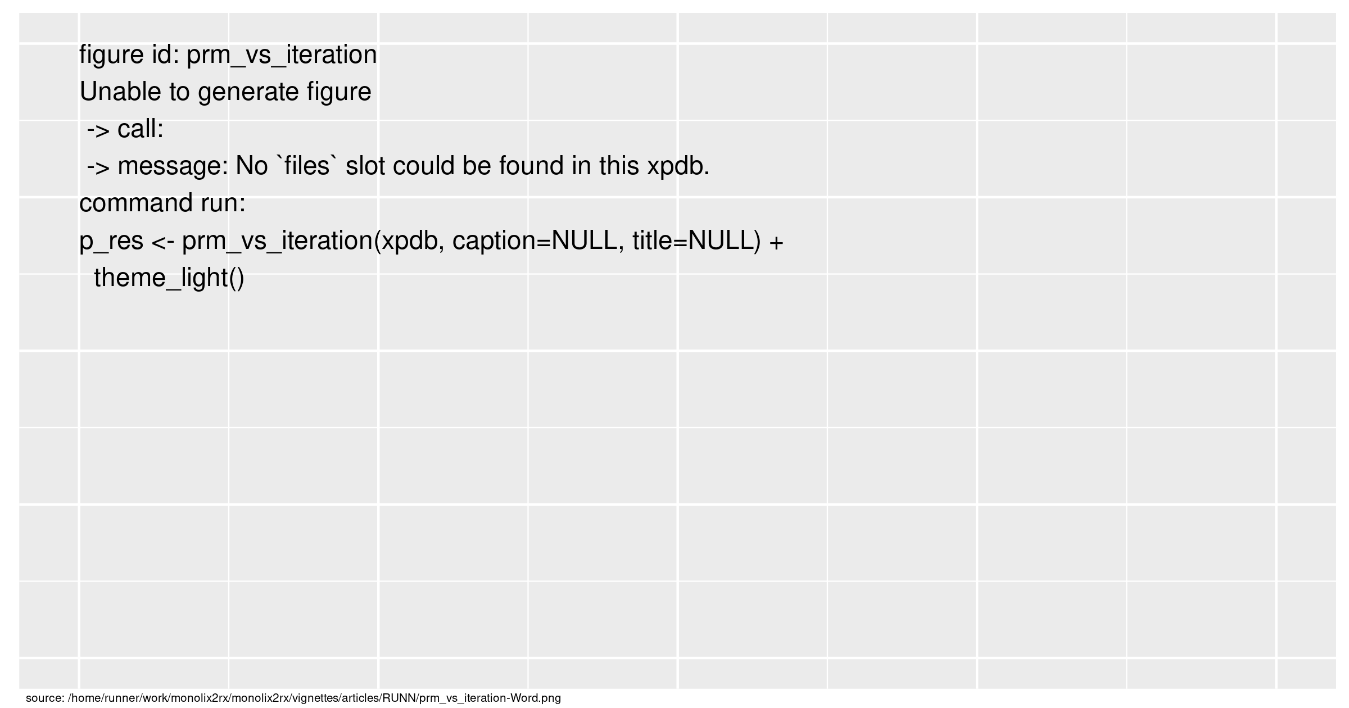

Figure . SAEM Stabilization