Model Structure
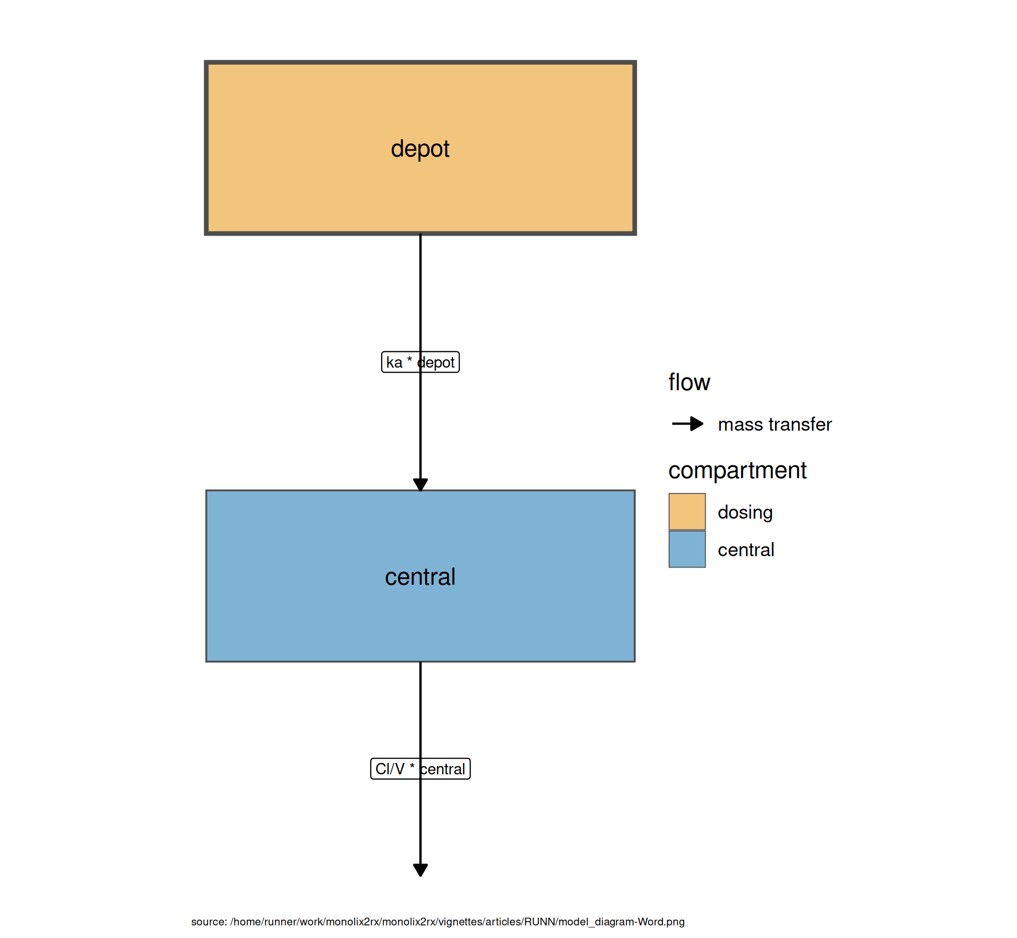
Figure . Model structure

$cmt(depot)$
$cmt(central)$
$ka=exp⁡(ka_pop+omega_ka)$
$V=exp⁡(V_pop+omega_V)$
$Cl=exp⁡(Cl_pop+omega_Cl)$
$\frac{d depot}{dt}=−ka×depot$
$\frac{d central}{dt}=+ka×depot−\frac{Cl}{V}×central$
$Cc=\frac{central}{V}$
$CONC=Cc$
$CONC∼add(a)+prop(b)+combined1()$
Table . Model equations

Tables
Parameter | Est. | SE | %RSE | Back-transformed(95%CI) | BSV(CV%) | Shrink(SD)%
ka_pop | 0.427 | 0.204 | 47.8 | 1.53 (1.03, 2.29) | 75.4 | 1.05<
V_pop | -0.786 | 0.0450 | 5.72 | 0.456 (0.417, 0.497) | 12.7 | 13.3<
Cl_pop | -3.21 | 0.0837 | 2.61 | 0.0402 (0.0341, 0.0473) | 27.6 | 2.65<
a | 0.433 |  |  | 0.433
b | 0.0543 |  |  | 0.0543
Table . Parameter Estimates

Figures

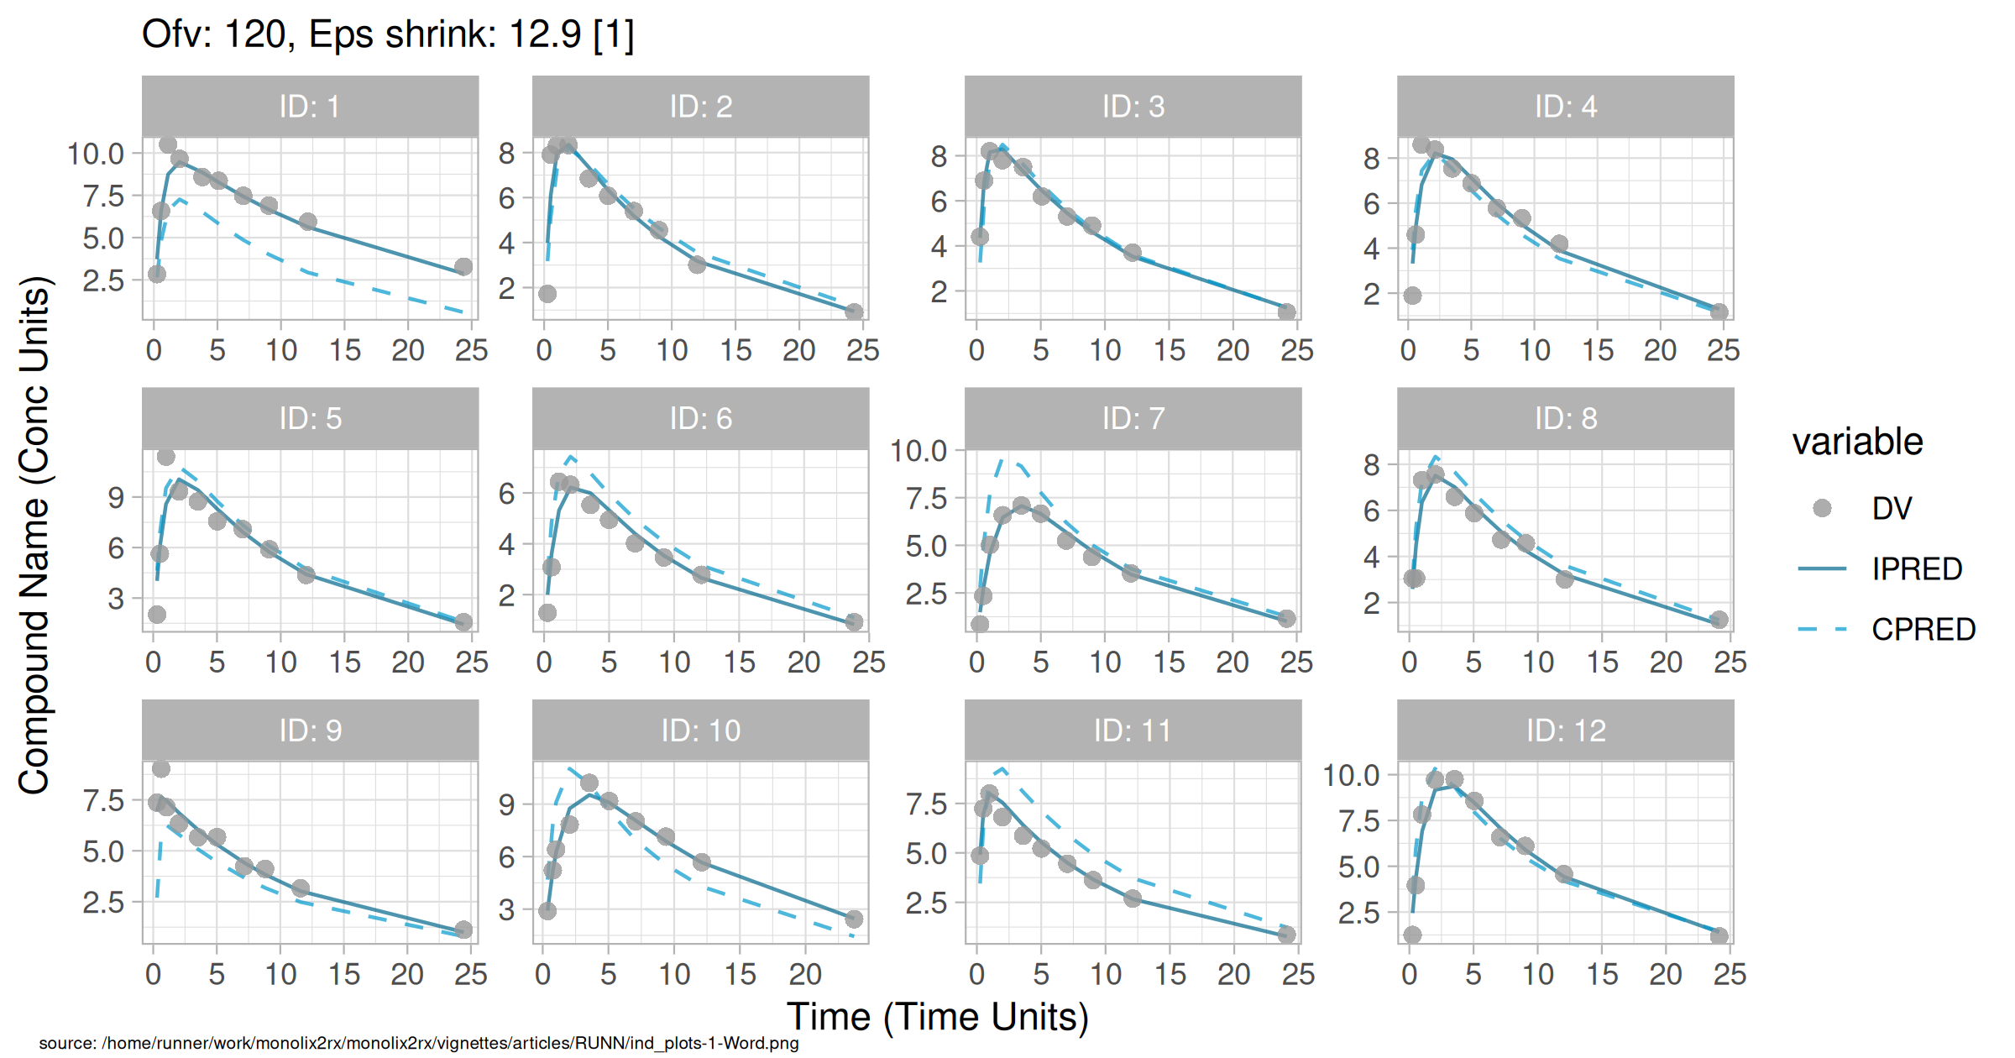
Figure . Individual and population prediction overlay

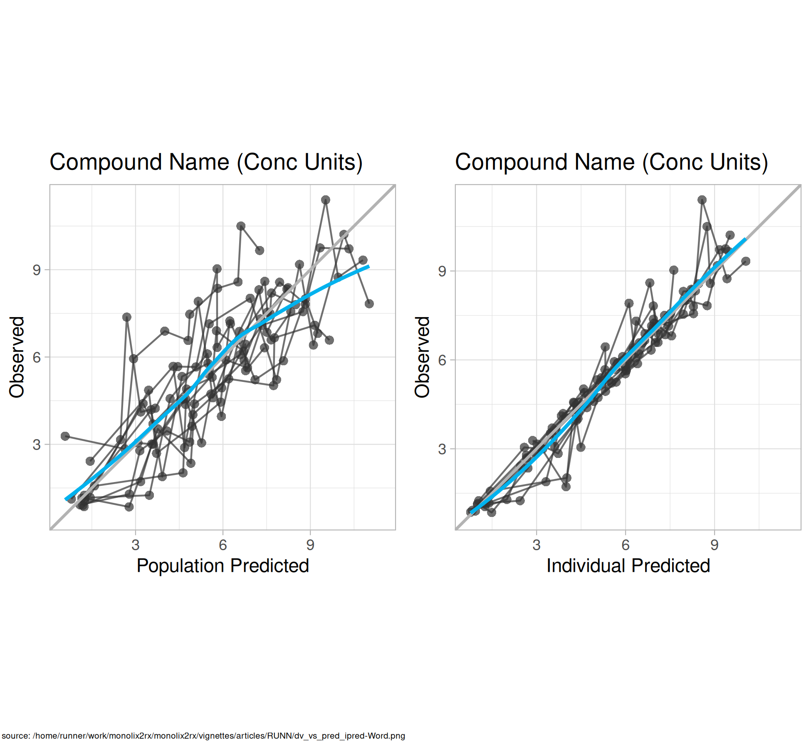
Figure . Observed vs Predicted

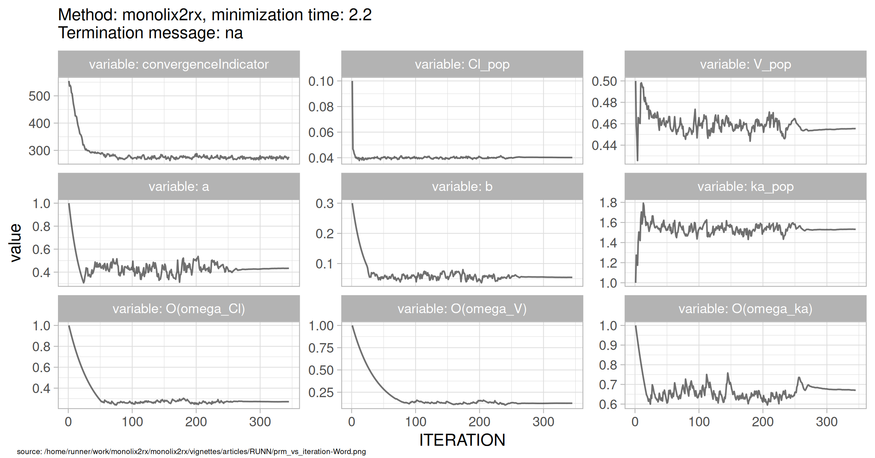
Figure . SAEM Stabilization

