Model Structure
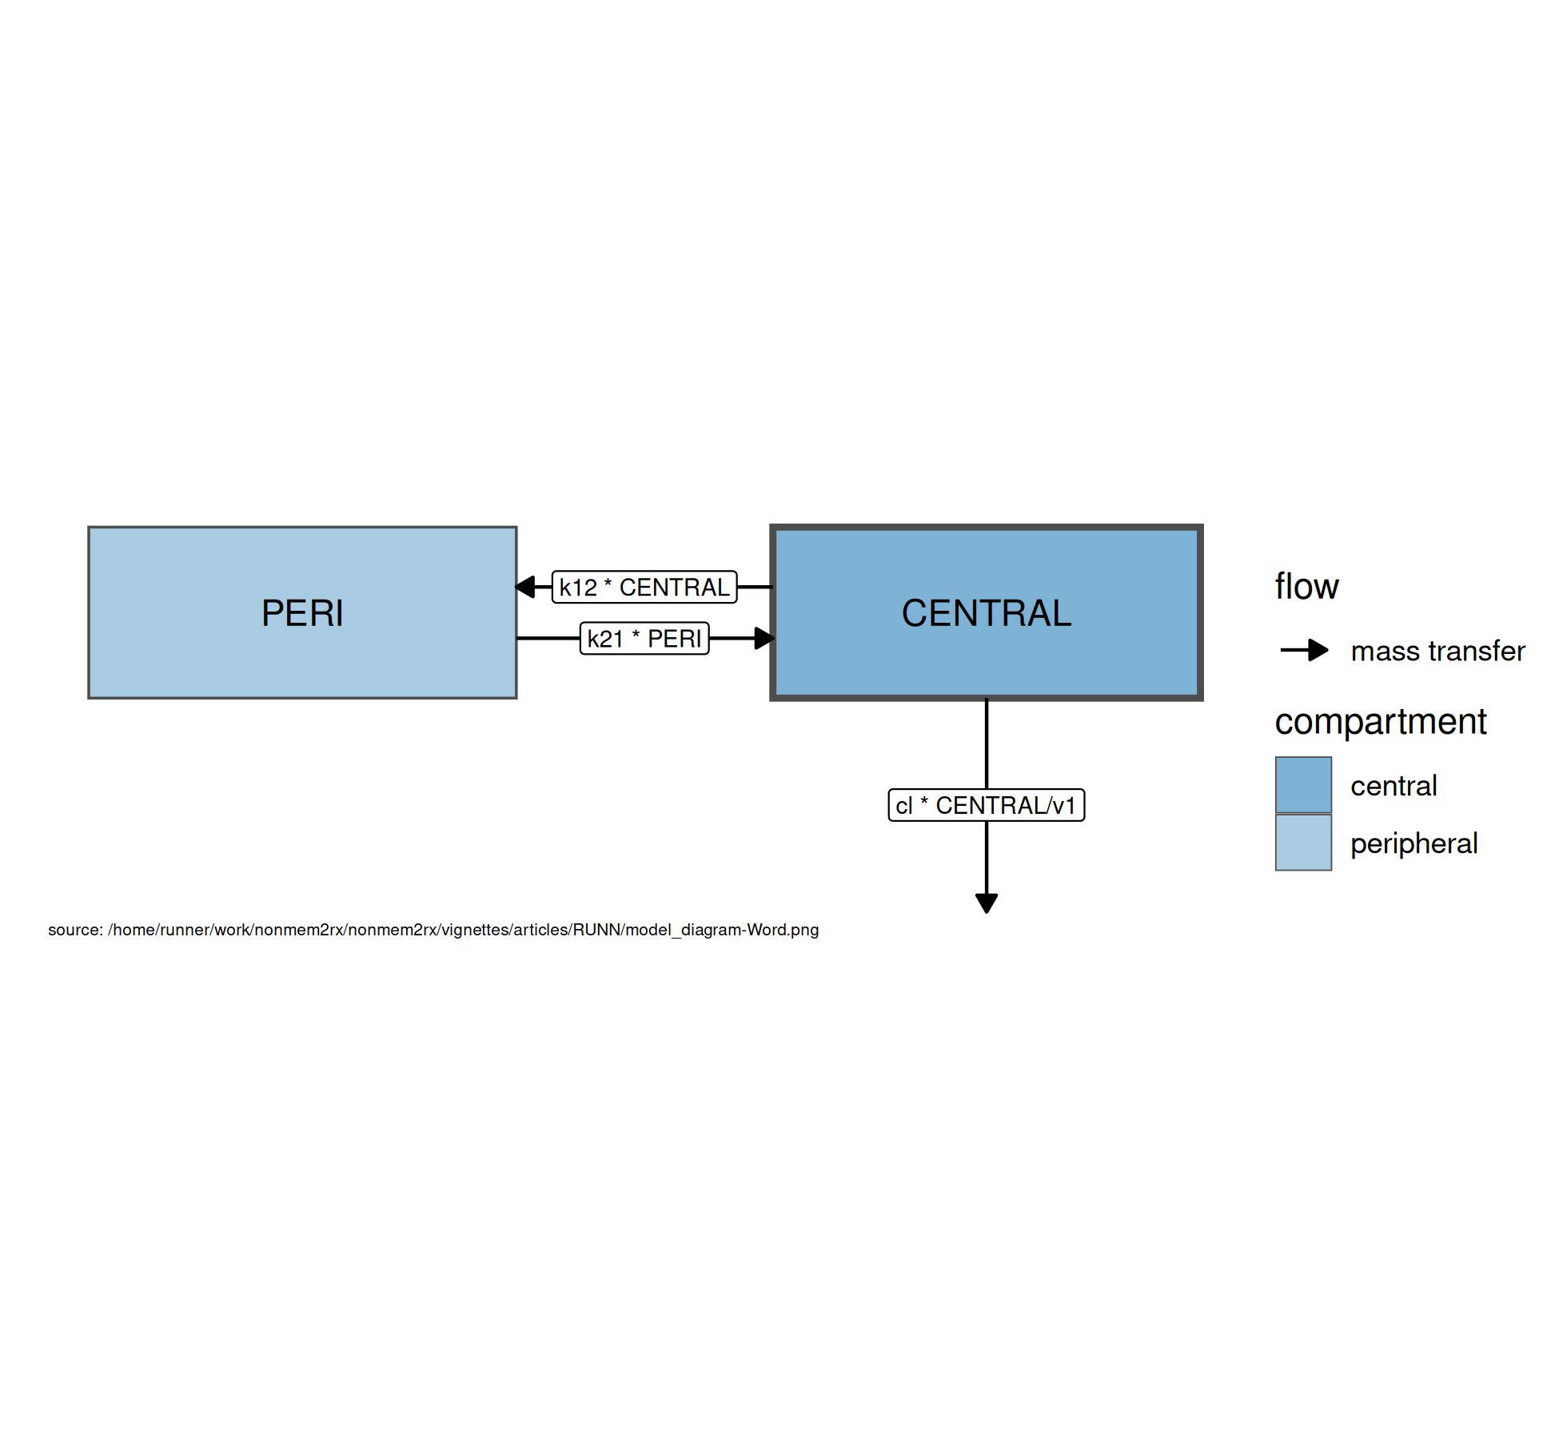
Figure . Model structure

$cmt(CENTRAL)$
$cmt(PERI)$
$cl=exp⁡(theta1+eta1)$
$v=exp⁡(theta2+eta2)$
$q=exp⁡(theta3+eta3)$
$v2=exp⁡(theta4+eta4)$
$v1=v$
$scale1=v$
$k21=\frac{q}{v2}$
$k12=\frac{q}{v}$
$\frac{d CENTRAL}{dt}=k21×PERI−k12×CENTRAL−\frac{cl×CENTRAL}{v1}$
$\frac{d PERI}{dt}=−k21×PERI+k12×CENTRAL$
$f=\frac{CENTRAL}{scale1}$
$ipred=f$
$rescv=RSV$
$ipred∼prop(RSV)$
Table . Model equations

Tables
Parameter | Est. | SE | %RSE | Back-transformed(95%CI) | BSV(CV%) | Shrink(SD)%
log Cl | 1.37 | 0.0298 | 2.17 | 3.94 (3.71, 4.17) | 32.6 | 1.94<
log Vc | 4.20 | 0.0295 | 0.703 | 66.6 (62.8, 70.5) | 32.3 | 2.46<
log Q | 1.38 | 0.0547 | 3.96 | 3.98 (3.57, 4.42) | 32.7 | 40.5>
log Vp | 3.88 | 0.0348 | 0.899 | 48.3 (45.1, 51.7) | 27.5 | 28.4=
RSV | 0.196 | 0.00315 | 1.61 | 0.196 (0.190, 0.203)
Table . Parameter Estimates

Figures

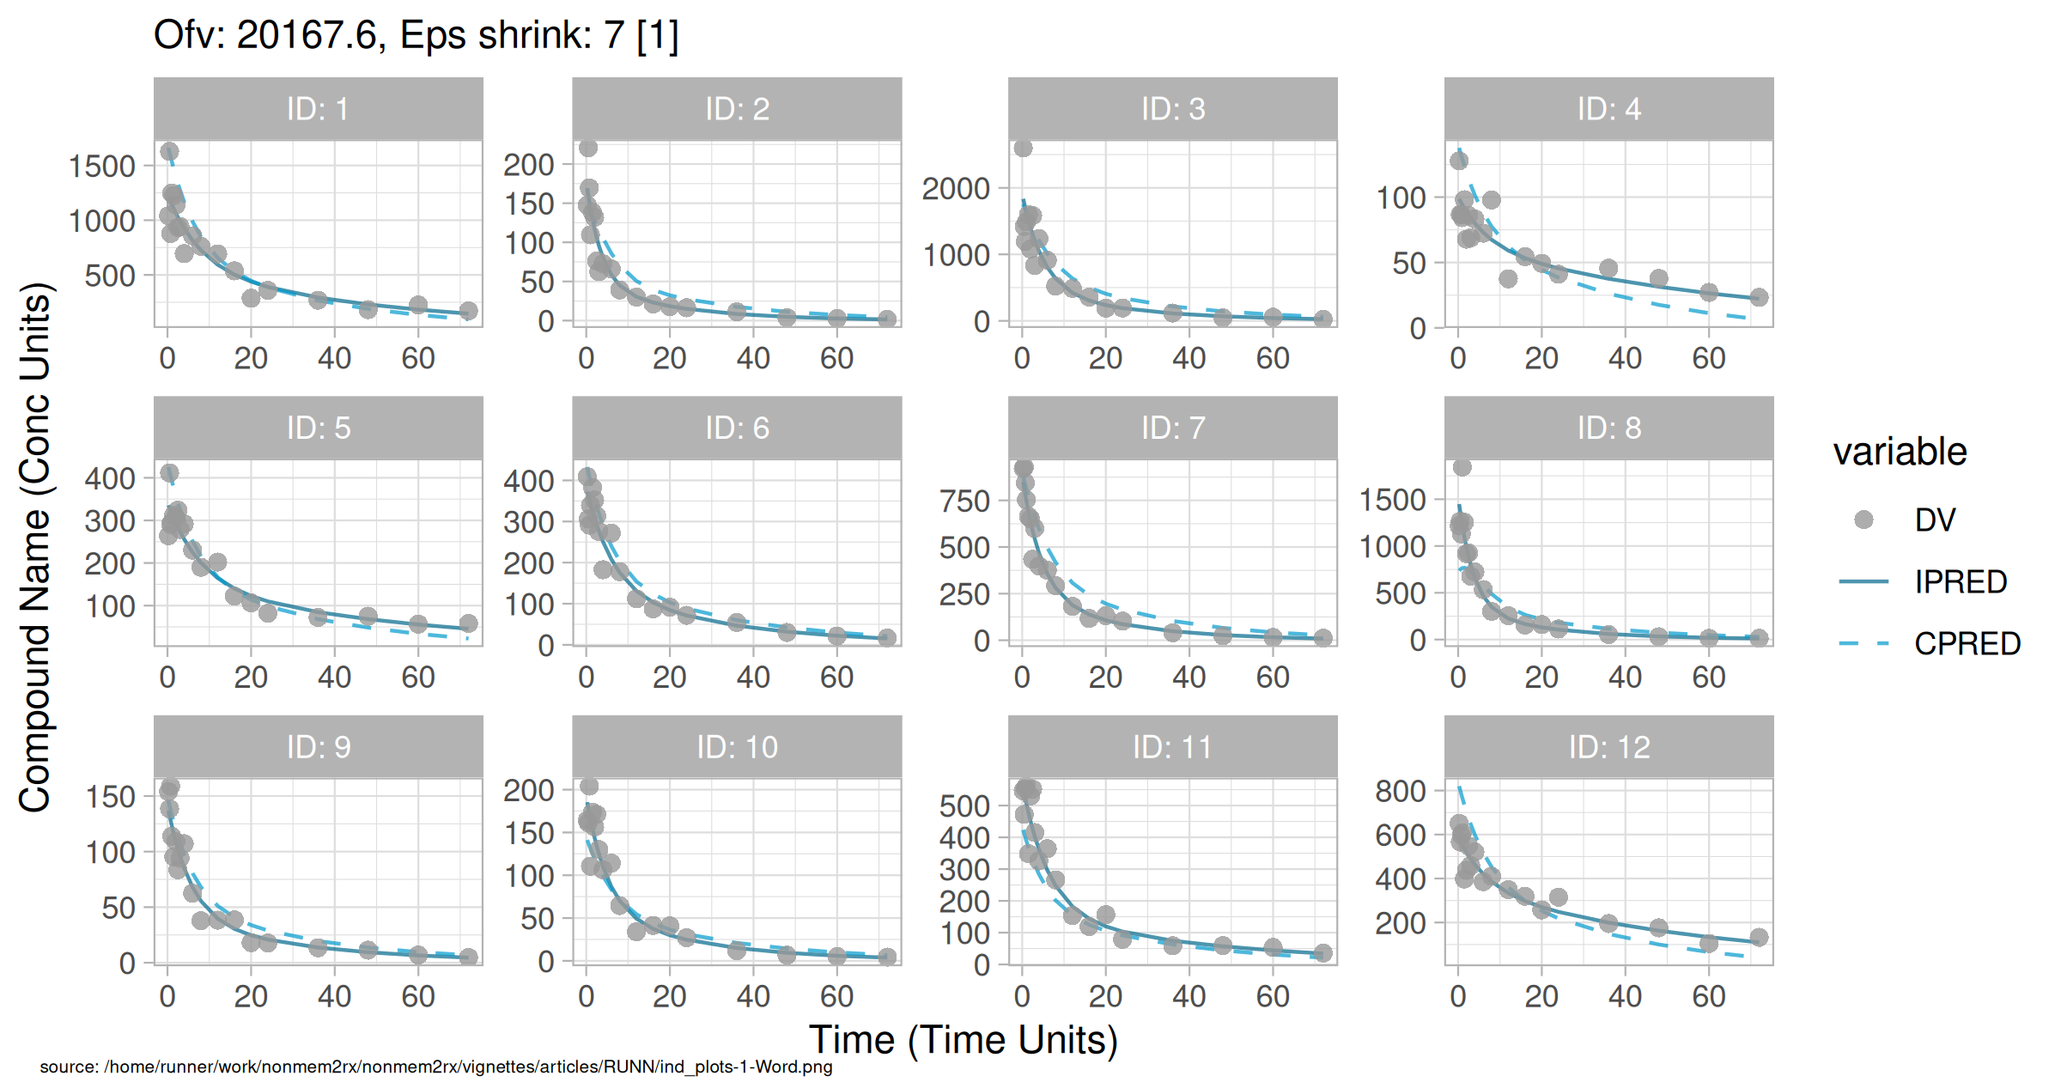
Figure . Individual and population prediction overlay

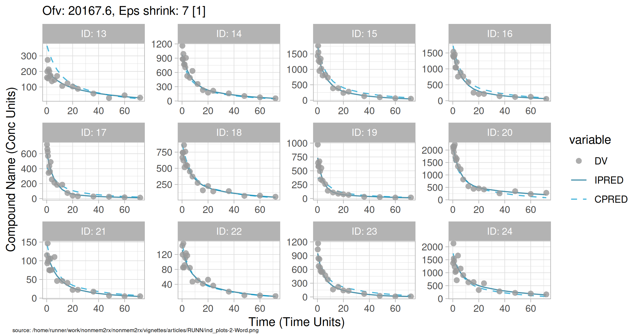
Figure . Individual and population prediction overlay

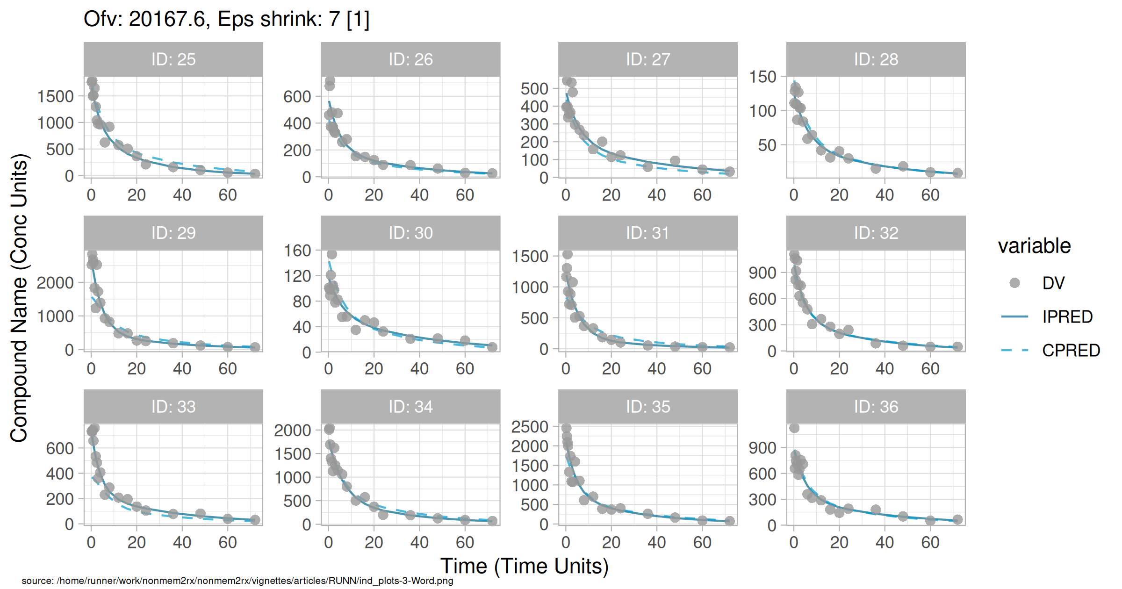
Figure . Individual and population prediction overlay

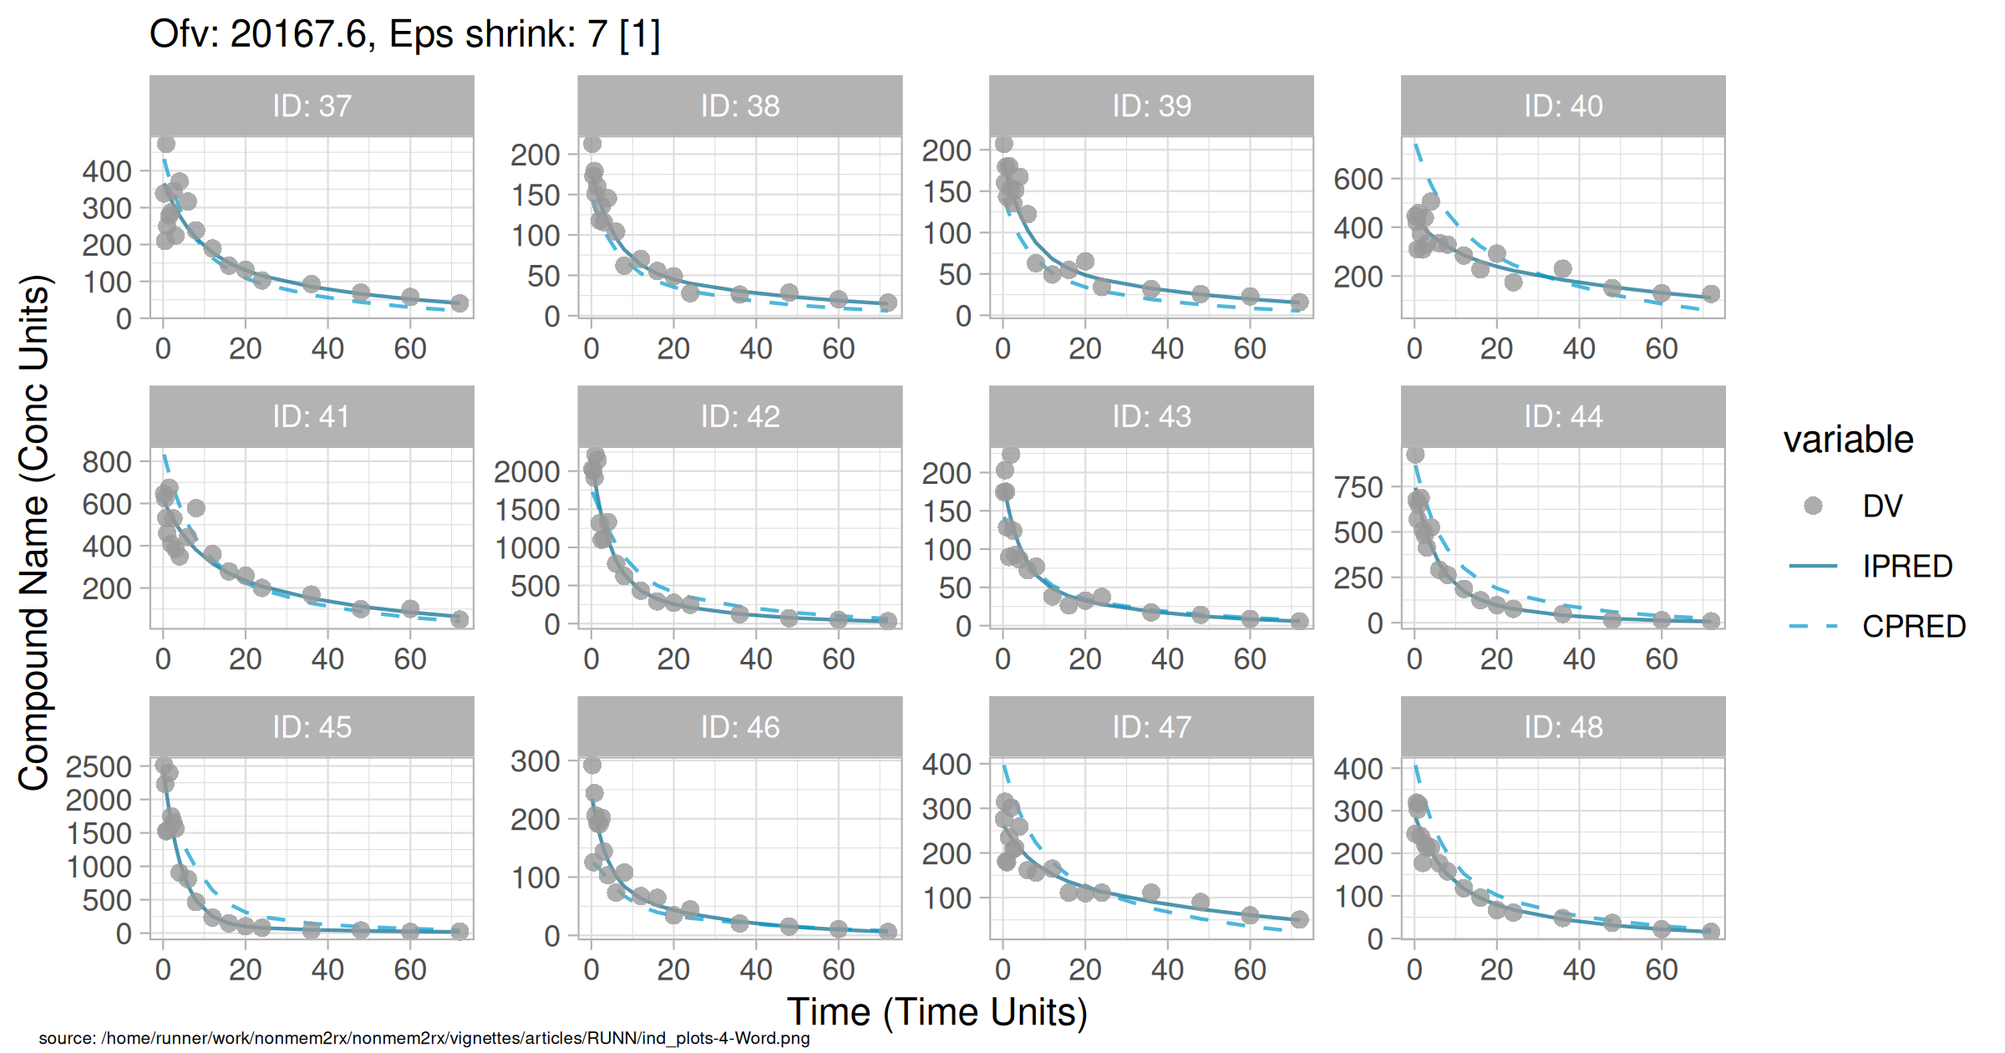
Figure . Individual and population prediction overlay

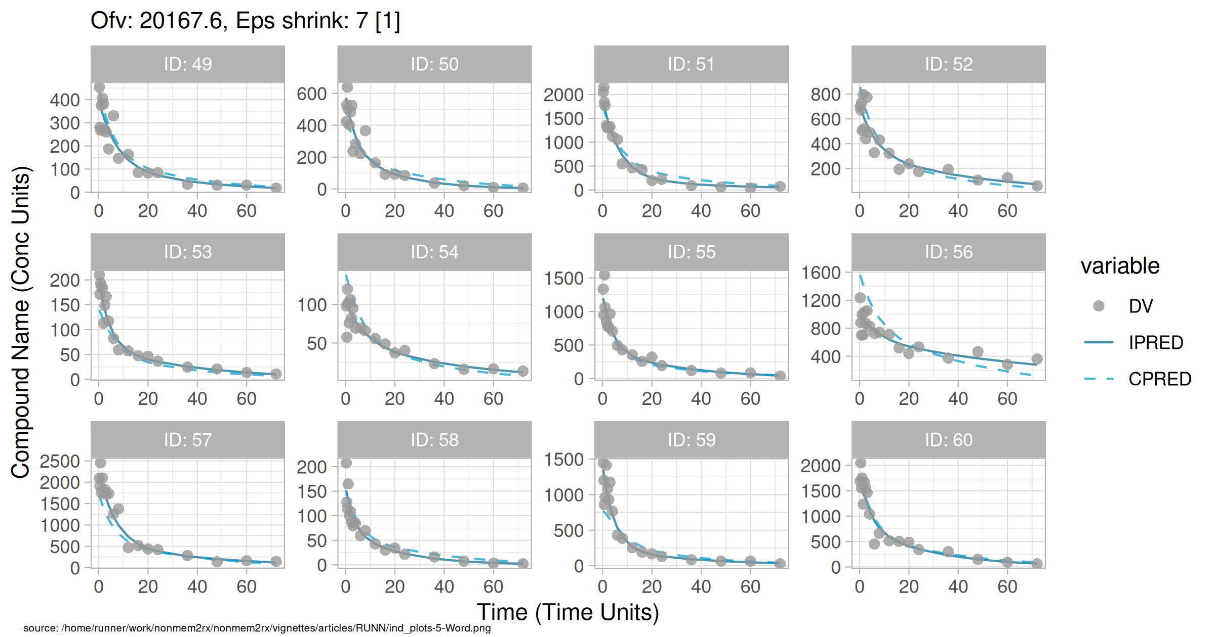
Figure . Individual and population prediction overlay

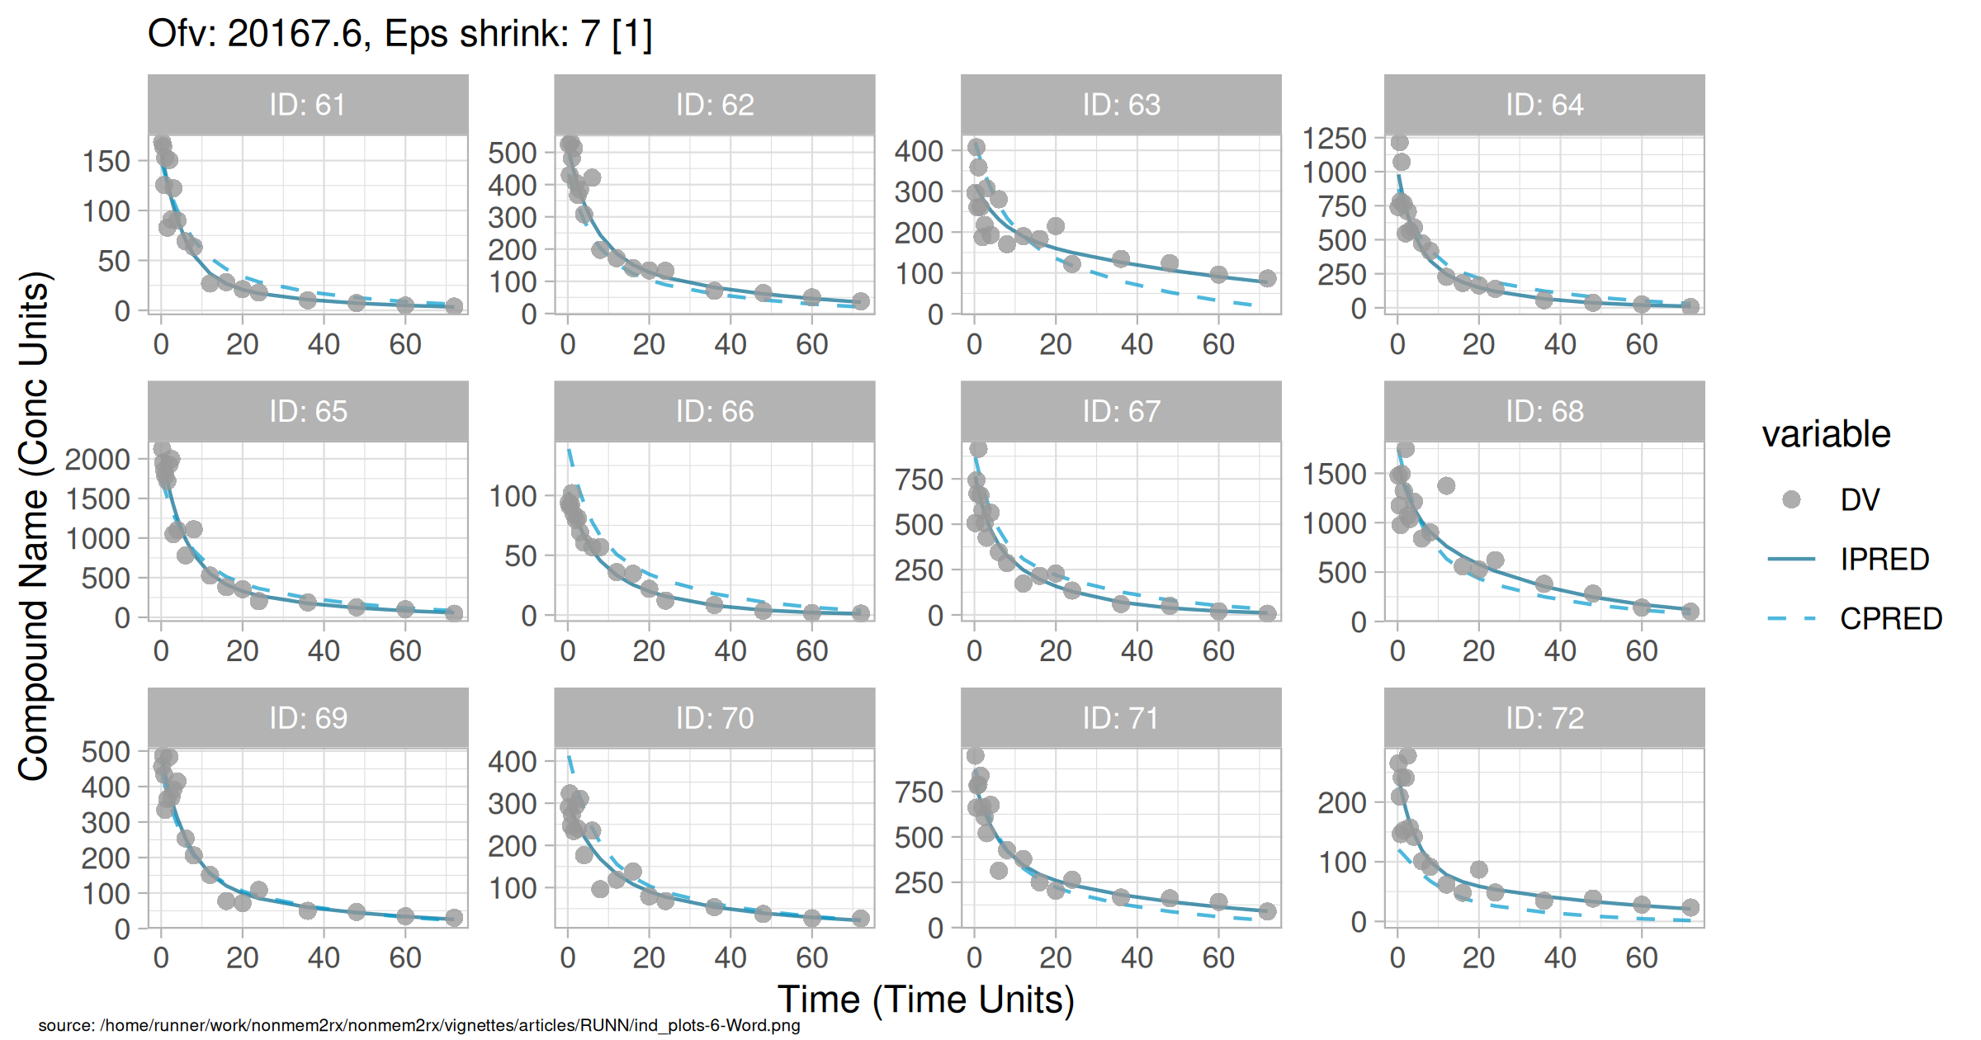
Figure . Individual and population prediction overlay

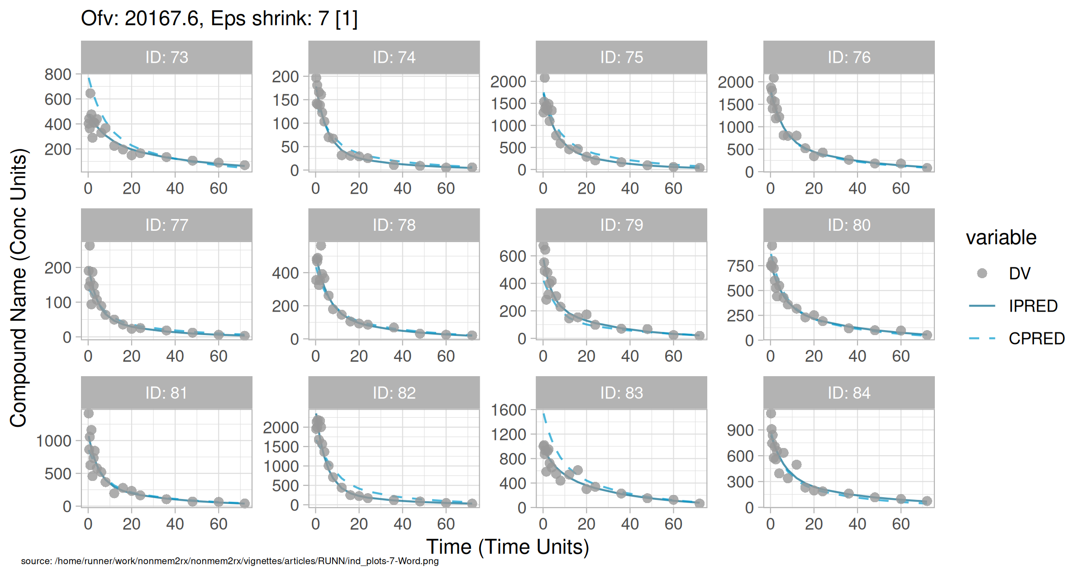
Figure . Individual and population prediction overlay

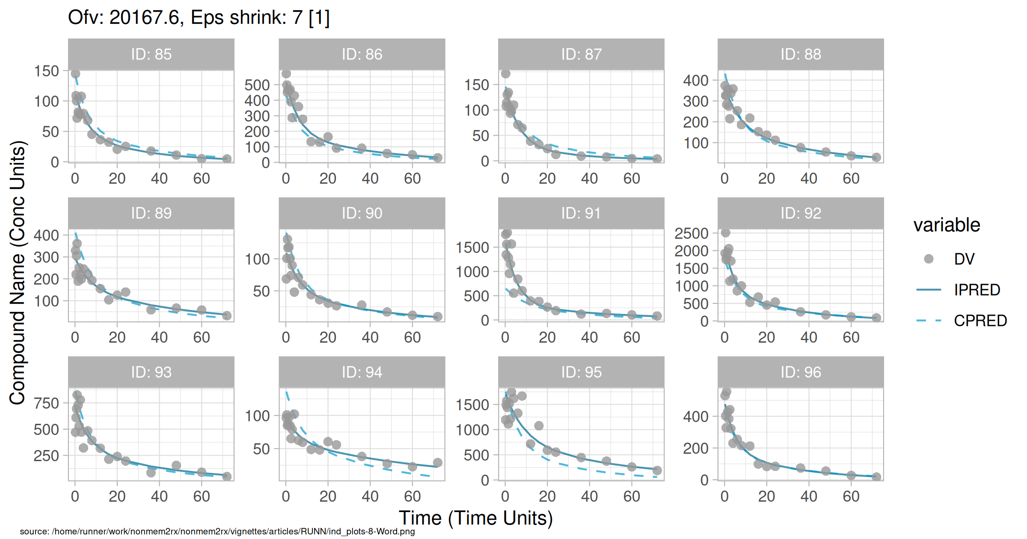
Figure . Individual and population prediction overlay

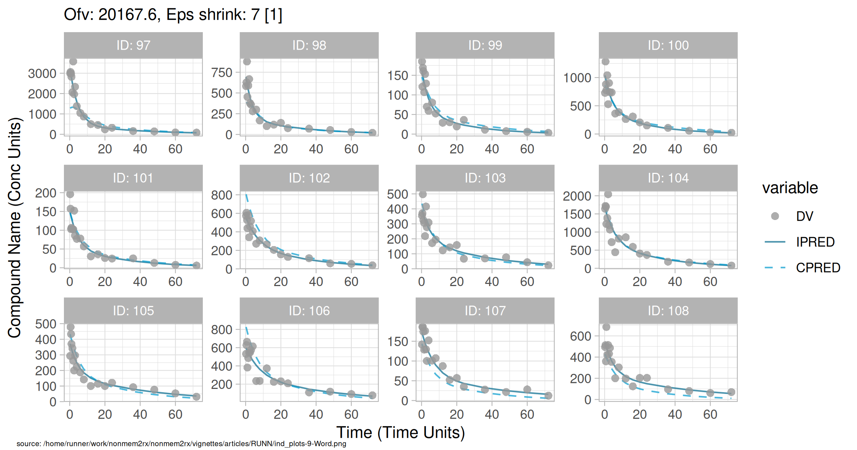
Figure . Individual and population prediction overlay

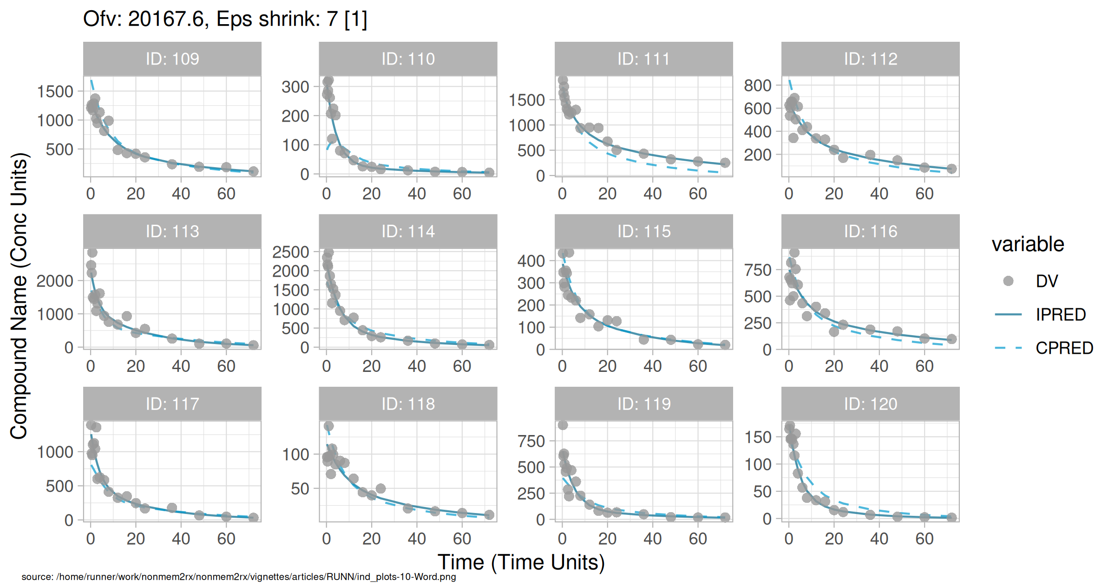
Figure . Individual and population prediction overlay

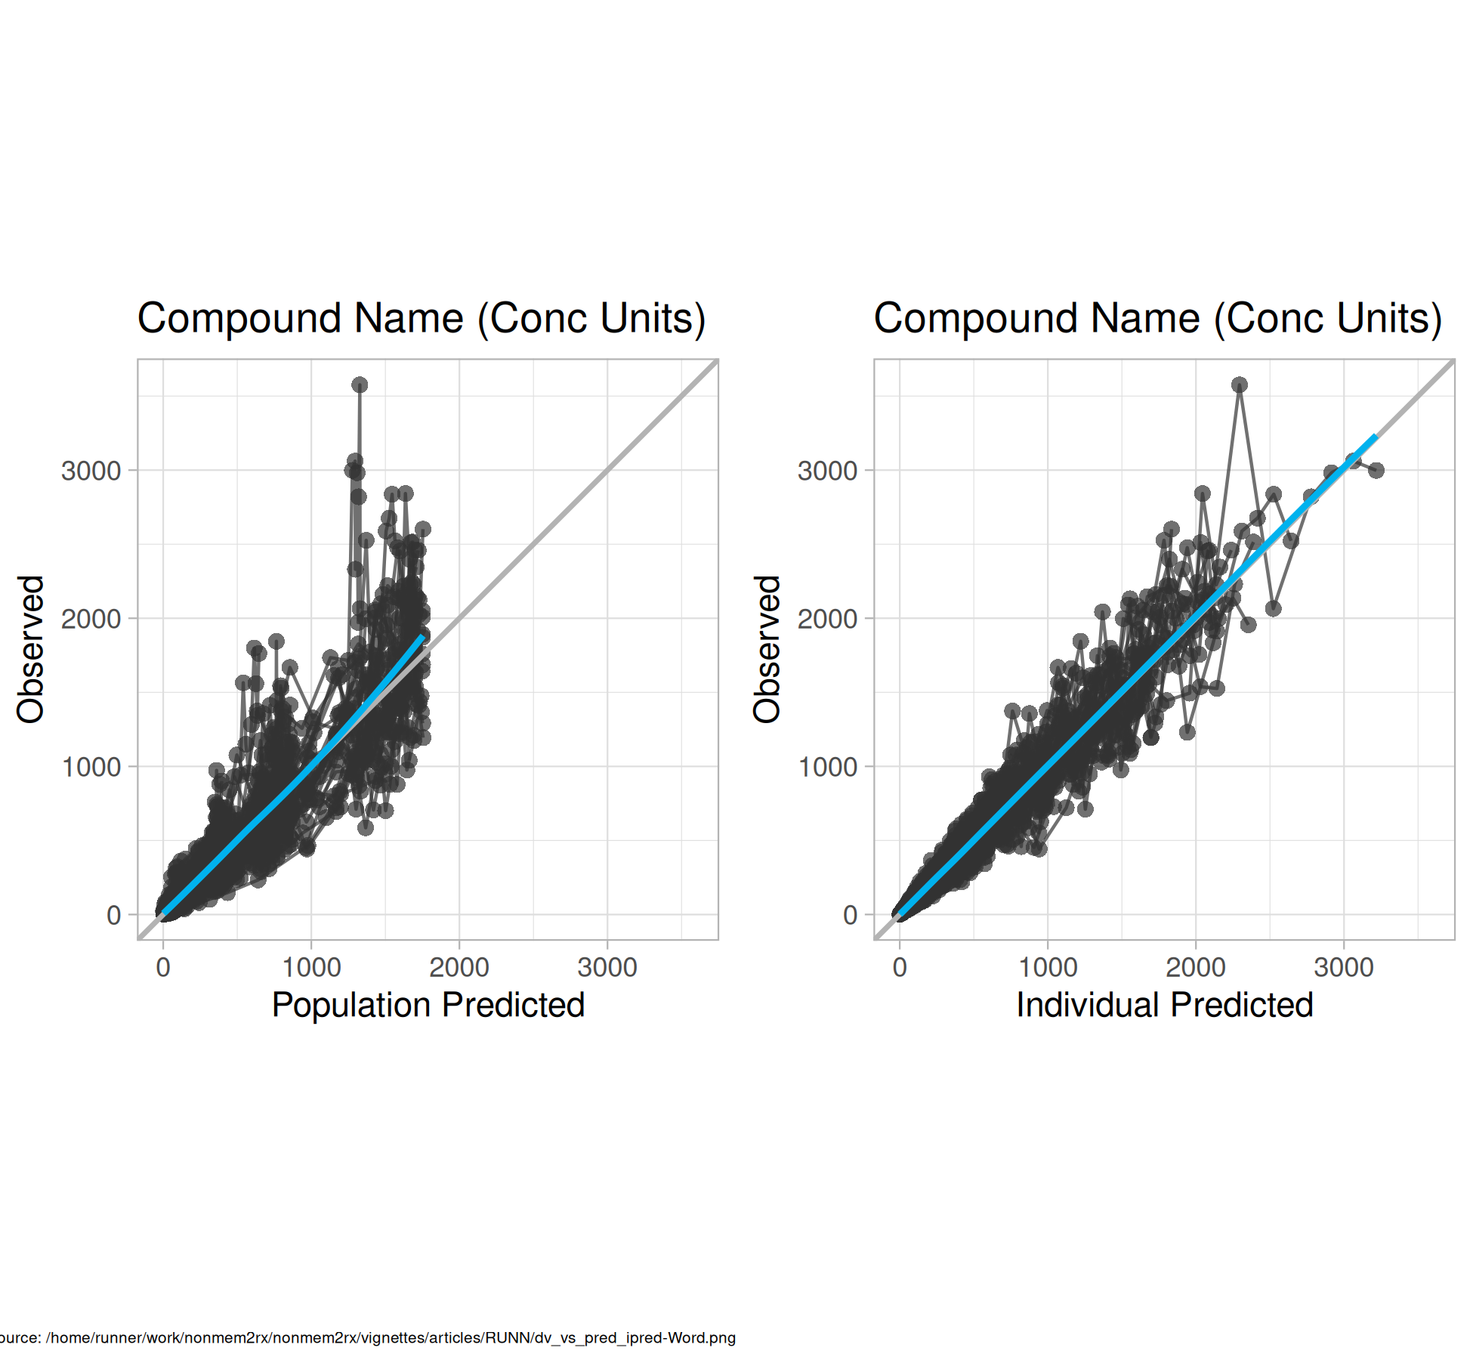
Figure . Observed vs Predicted

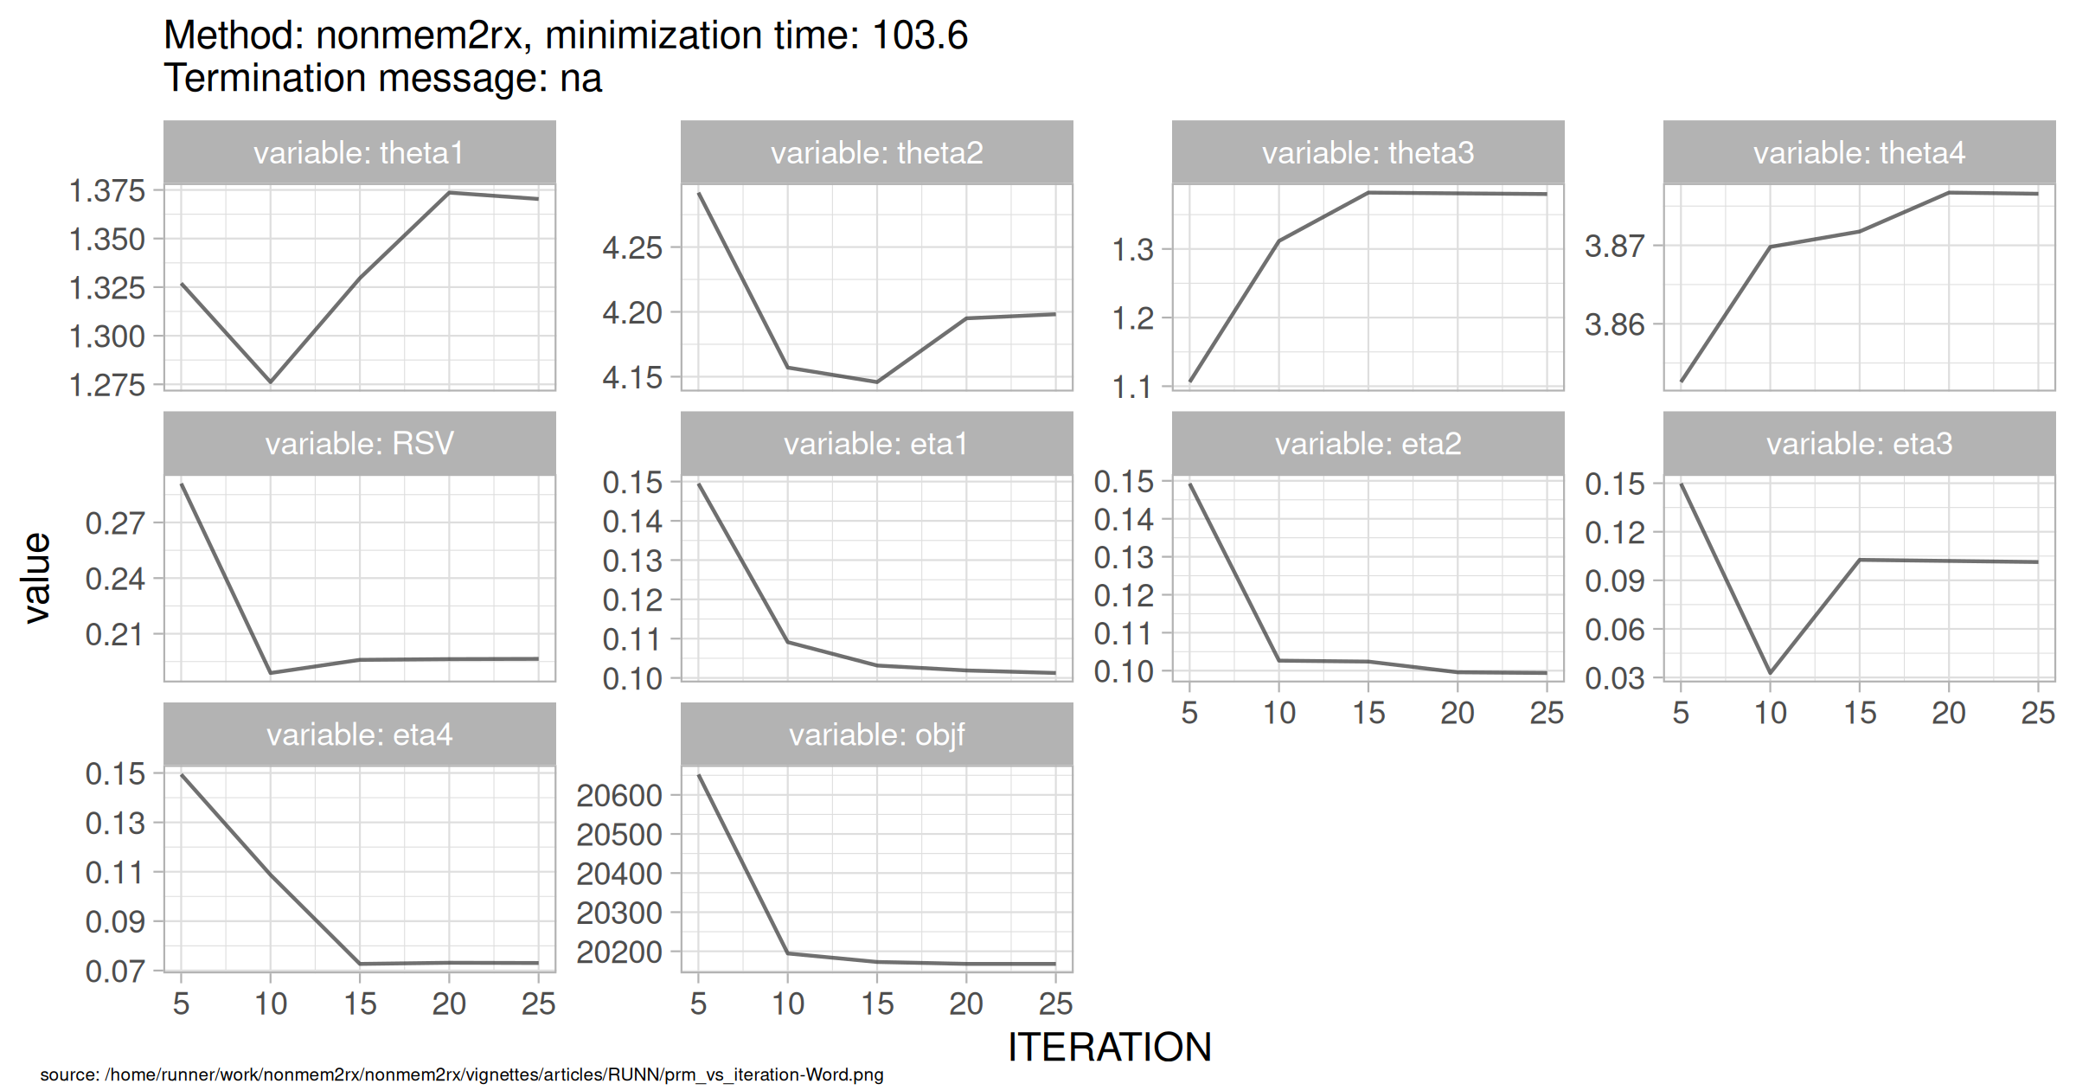
Figure . SAEM Stabilization

