**nlmixr** readme

# Obtaining and installing the **nlmixr** installer

Download the nlmixr installer v1.1.1-3 from <https://github.com/nlmixrdevelopment/nlmixr/releases/download/v1.1.1-3-rc1/nlmixr_1.1.1-3_x86_64_install.exe>

Double-click the file to install. Windows may warn you that it is a suspect file, but it is no such thing:

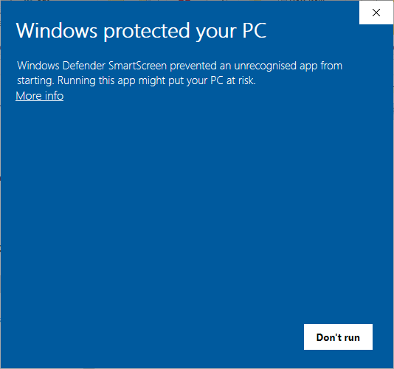

It is not suspect. Click More Info, then click Run anyway.

The installer screen will be shown:

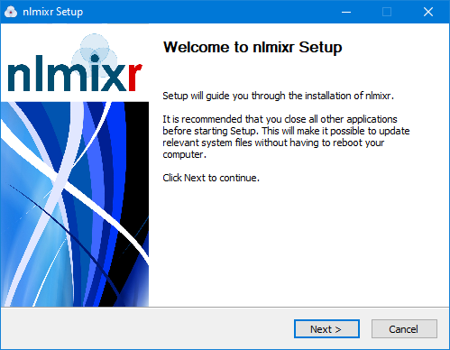

Click next and accept the suggested install location (C:\R\nlmixr_1.1.1-3) and continue. nlmixr will be installed along with all the required extras like Rtools and Python and environment variables will be set automatically. Files will only be placed in C:\R\nlmixr_1.1.1-3.

# Using **nlmixr** with an existing Rstudio installation

To use the installed **nlmixr** with Rstudio, you need to select the appropriate nlmixr R installation. First open Rstudio and then choose “Tools” → “Global Options”; There you can change the “R version”:

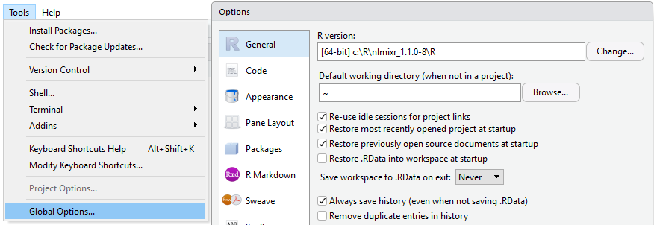

I suggest unchecking “Restore .RData into workspace” and Never saving the workspace on exit for reproducible research.

# **nlmixr** and .libPaths()

Often R has a local library path and a global library path, which can be checked and specified by .libPaths() . This can be problematic for any high-performance R package that links to Rcpp and other libraries. If they are compiled against different binaries they may not work appropriately if at all. Other problems can occur if your library path has international characters. To check if you have more than one .libPaths, you simply enter the .libPaths() command:

> .libPaths()

[1] "c:/Users/matt/R/library"

[2] "c:/R/nlmixr_1.1.0-8/R/library"

One way to fix this is to use the following command:

> .libPaths(.libPaths()[regexpr("nlmixr",.libPaths())!=-1])

> .libPaths()

[1] "c:/R/nlmixr_1.1.0-8/R/library"

There are other ways to more permanently fix the .libPaths() and you can see them by looking at ?Startup in R.

# **nlmixr** and $HOME directories

Based on organizations and your name you may have either a network drive attached to your home directory or have international characters in your name. Either can be problematic for R and for certain R packages nlmixr interacts with. To be safe a $HOME directory should be changed to a user-writable location without any international characters, for example c:/tmp

In windows this can be done by going to the control panel and seraching for “environment variables. The search should bring up “Edit environmental variables for your account”

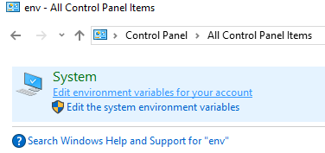

Here you should be able to add a new environmental variable called “HOME” that will point to an appropriate writable directory. This will allow many R packages and other windows libraries to work correctly.