6.894 Problem Set 3
Fang Hui 2004.10.07

1. The Graphic User Interface(GUI)

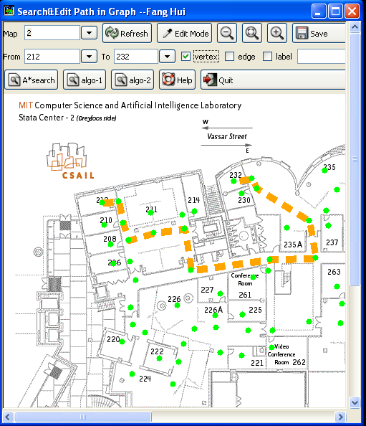

Features:
* Keep a drop-down list of top few most common past search location points
* Scroll bar
* Able to load different floor directly from GUI
* Map is editable by mouse clicking and moving
* Save new configuration into file
* Dynamically undo the image to the previous status (by refresh)
* Zoom in ,out the image size ,or return to actual size in one step
* Display or don not display the vertex ,edges ,or vertex names
* Three searching algorithms included
* Help information provided

1.1 Open
The map image files are located in the ./maps directory ,and the map data files are located in the ./graphs directory. Since each map has one unique number, you can just choose this number as shown in Map drop-down box , or input your favorite map number directly .

1.2 Reload
When finish choosing map number, click the Refresh button to display the new specified image.

1.3 Edit
The default mode for this program is View mode. Please press down the Edit Mode button to enter edit mode. Under the edit mode ,you can:
add vertex: left click somewhere blank
clear vertex: right click on vertex
move vertex: left click on vertex, drag, and release
add edge: middle click first vertex, middle click second vertex (you can use the roll ball on the mouse)
name vertex: left click on vertex, then type name in label box ( on the right side of “label”)

1.4 Save
After finish editing , you can click Save button to save into file. The default file name is the same as shown in map box.

1.5 Search Path
Input from and to points ,then click any one of three algorithm buttons to find path
A* Search: The heuristic algorithm
Algo-1 : The recursive algorithm
Algo-2 : The shortest path set algorithm

1.6 Zoom In/Out
1.7 Display
Tick the checkbox “vertex”,”edge”, or “label” to show the vertex ,edges and vertex names ,respectively.
1.8 Help
1.9 Quit

2. SOURCE FILES
Py3.py : The main program
Graph.py : The graph class and searching algorithms
Search.py : The A* search program provided by teachers
Graph.glade : The Glade GUI xml file
./graphs/*.graph : The map data files, recording vertices and edges
./maps/*.png : The png format map image files

Platform:
Debian-Linux , Gtk/Glade 2.0 , PYGTK and Python

