**How to achieve automated deployment using Jenkins**

To achieve the automated deployment using Jenkins, we need to follow the steps given below:

**1. Set up a Continuous Integration server**

1.Firstly choose an existing server like Jenkins.

2.Link to the source code from source control like GIT so that one can build the application.

3.Make sure every time a check-in happens into the source control, the build fires.

**2. Set up test suites**

We need to set up a separate build for each test suit we add. Then we link each test suite to the builds, we can see the errors as the problematic code will stop at the first test that has recognized it and does not proceed further.

**3. Add a deployment step**

As a deployment step, we set a build that runs the script to deploy the application to a staging or testing environment on Continuous Integration Server. But before this, ensure that the build runs only when all tests have passed.

Once we create the build and a set of test cases execute on the same, we can deploy that build on a particular server. To achieve this task, Jenkins provides various plugins; we will cover the setup and details of one of those plugins and complete the setup to deploy the application on a tomcat server.

**How to install a deployment plugin**

Jenkins provides us with many plugins that we can use to transfer the build files to the respective application or web server after successfully building the application. For example, the "Deploy to container" plugin. This particular plugin takes a war or ear file.

We have to follow the given steps to use this plugin:

Step 1: Go to Manage Jenkins and then Manage Plugins. choose the Available tab and search for the "Deploy to container" plugin.

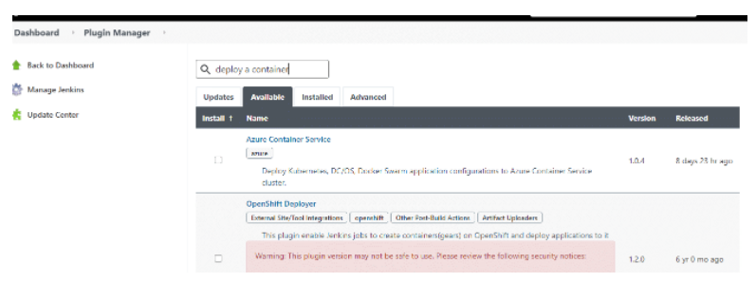

Here we see that the searched plugin is not available. If it was available, then we install it and click on **Go back to the top page**.

Now that it is not available, we again search it under the "**Installed**" tab. We can see the listed plugin below

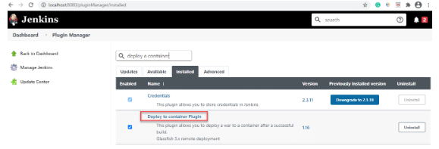

If the installation of the plugin does not finish, install it by following the on-screen instructions.

**How to add deployment steps to Jenkins**

Once the installation of the plugin completes, we can then run the build by deploying the war/ear file to the container.

**Step 1**: Go to your created build project and click on the Configure option from the left side of the panel.

**Step 2:** The next step is to scroll down on the configuration page and click on Add post-build action button. Select **Deploy war/ear to a container** option.

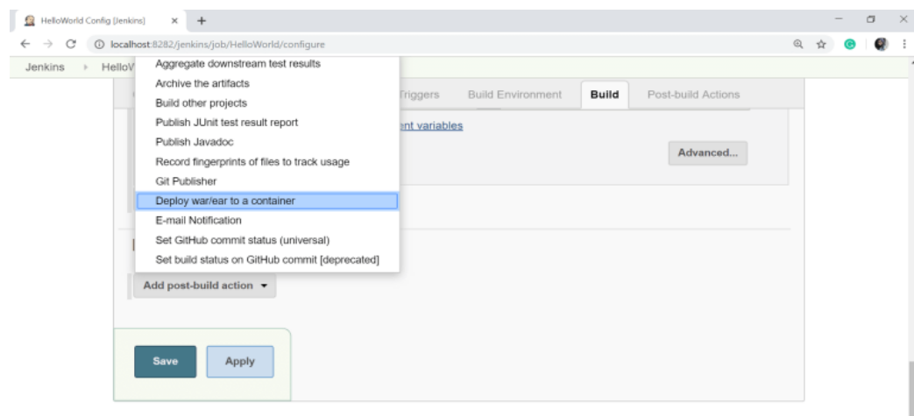

In the above screen, we select the "**Deploy war/ear to a container**" option and then click on the **Save** button.

**Step 3**:In the**Deploywar/ear to a container**section we enter the server information on which we need to deploy the files. We can see it on the following screen.

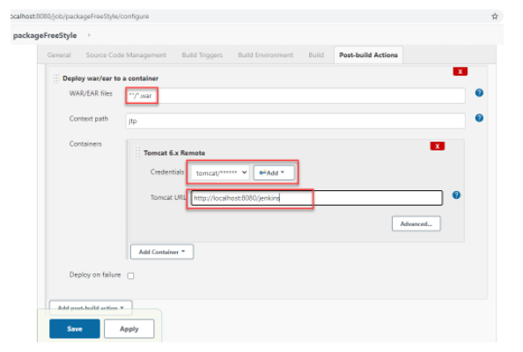

Here along with other details, we select *the*appropriate container (Tomcat in the above screen*)* and then provide its credentials and URL*.*

**Step 4:** Click on the **Save**button.

***Step 5***: Once everything finishes, we go to the first screen of the selected project and select **Build Now**.

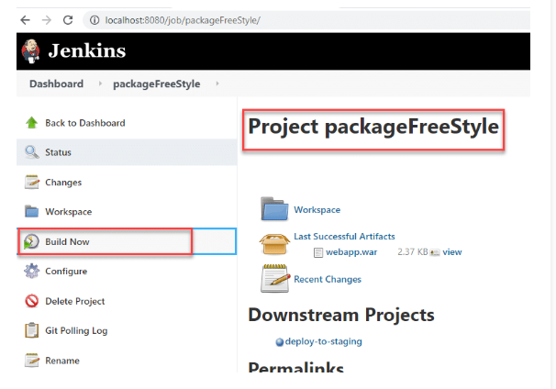

The above steps ensure that the container has all the required files after the successful build.