LAB EXPERIMENT RECORD
SET 1: MONTHLY SALES DATA
Department | AIML
Course Code / Course Name | DSA0601 / Data Handling and Visualization
Experiment | Data Visualization using R
Name | N. Harshith
Register Number | 192325078
Date / Day | 29 September 2026 / Tuesday

Aim
To visualize monthly sales data using a line chart, bar chart, and scatter plot, and to build an interactive dashboard using R and Shiny.
PROGRAM 1: Line Chart of Monthly Sales
Create a line chart to visualize the monthly sales. Label the axes and title the chart appropriately.
# Dataset
month <- c("January", "February", "March", "April", "May")
sales <- c(15000, 18000, 22000, 20000, 23000)
# Line Chart
plot(sales,
type = "o",
xaxt = "n",
xlab = "Month",
ylab = "Sales ($)",
main = "Monthly Sales")
axis(1, at = seq_along(month), labels = month)
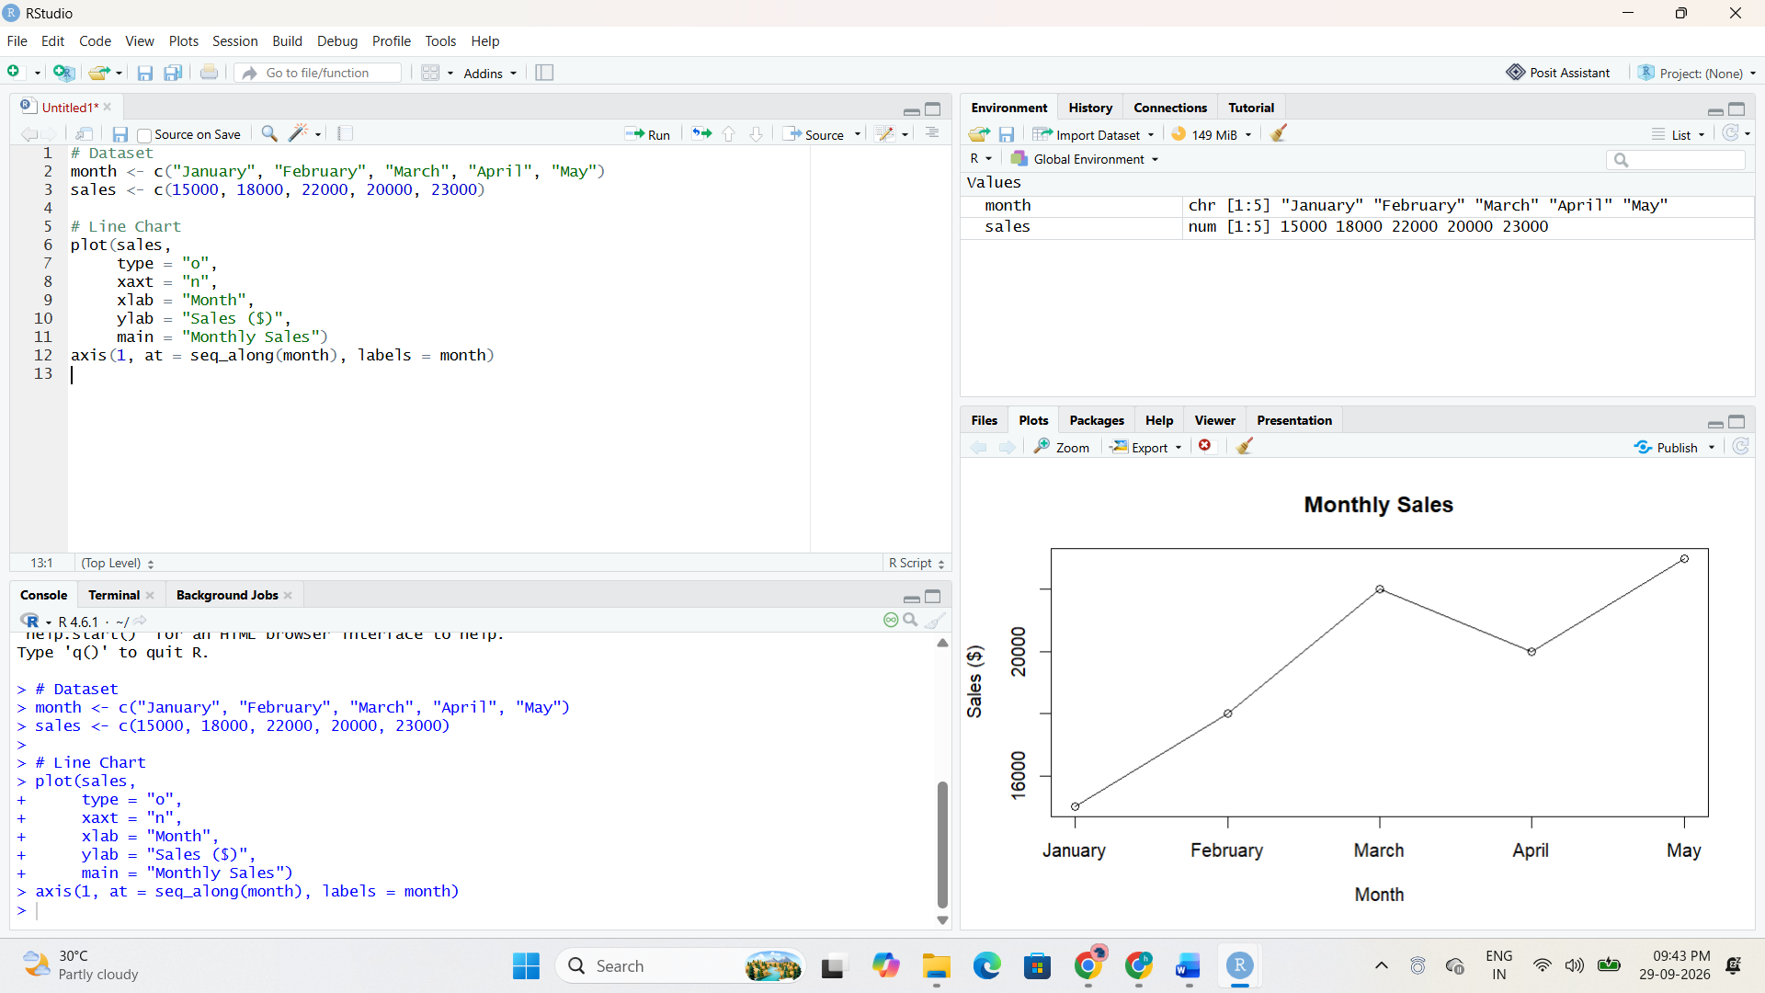
Output 1: Monthly Sales Line Chart
Observation: Sales increase from January to March, decrease slightly in April, and reach the highest value in May.

PROGRAM 2: Bar Chart of Sales
Generate a bar chart to display the sales values for the available months and label the chart elements.
# Dataset
month <- c("January", "February", "March", "April", "May")
sales <- c(15000, 18000, 22000, 20000, 23000)
# Bar Chart
barplot(sales,
names.arg = month,
xlab = "Month",
ylab = "Sales ($)",
main = "Monthly Sales")
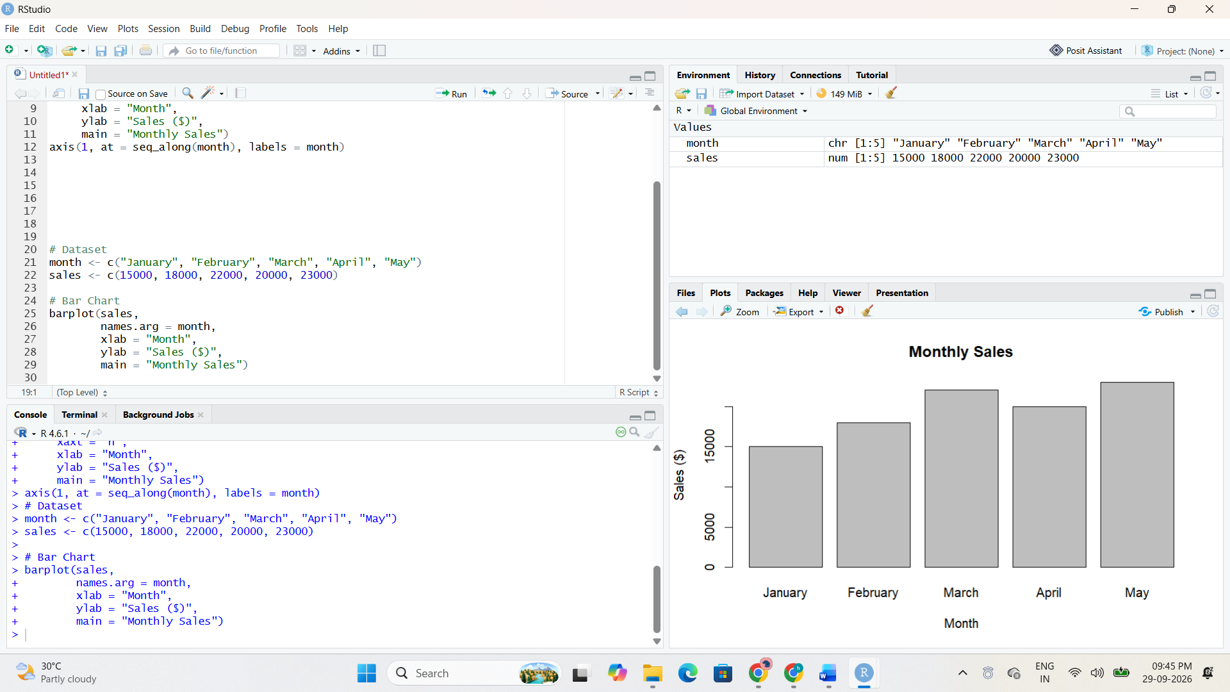
Output 2: Monthly Sales Bar Chart
Observation: The bar chart makes it easy to compare the sales of each month. May has the highest sales and January has the lowest.

PROGRAM 3: Scatter Plot of Advertising Budget vs Monthly Sales
Develop a scatter plot to explore the relationship between advertising budget and monthly sales.
# Dataset
sales <- c(15000, 18000, 22000, 20000, 23000)
advertising <- c(5000, 6000, 7000, 8000, 9000)
# Scatter Plot
plot(advertising, sales,
main = "Advertising Budget vs Monthly Sales",
xlab = "Advertising Budget ($)",
ylab = "Monthly Sales ($)",
pch = 19)
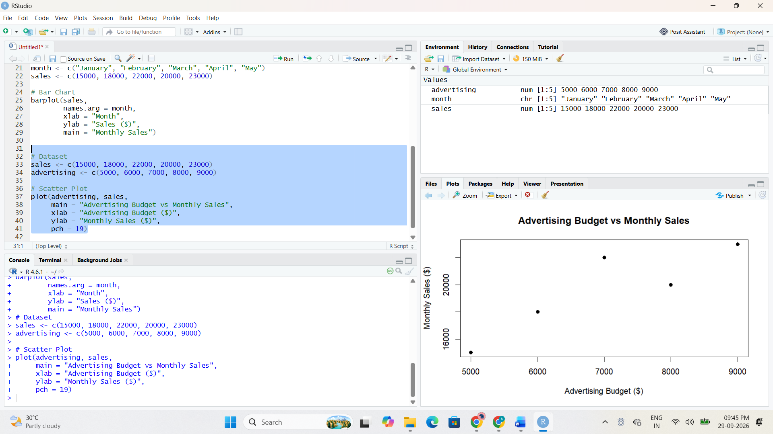
Output 3: Advertising Budget vs Monthly Sales Scatter Plot
Observation: The plotted points show a generally positive relationship: as the advertising budget increases from $5,000 to $9,000, monthly sales also generally increase.

PROGRAM 4: Interactive Sales Dashboard
Build an interactive dashboard combining the line chart and bar chart using the Shiny package.
library(shiny)
month <- c("January", "February", "March", "April", "May")
sales <- c(15000, 18000, 22000, 20000, 23000)
ui <- fluidPage(
titlePanel("Monthly Sales Dashboard"),
sidebarLayout(
sidebarPanel(
selectInput("chart",
"Select Chart:",
choices = c("Line Chart", "Bar Chart"))
),
mainPanel(
plotOutput("salesPlot")
)
)
)
server <- function(input, output) {
output$salesPlot <- renderPlot({
if (input$chart == "Line Chart") {
plot(sales,
type = "o",
xaxt = "n",
xlab = "Month",
ylab = "Sales ($)",
main = "Monthly Sales")
axis(1, seq_along(month), month)
} else {
barplot(sales,
names.arg = month,
xlab = "Month",
ylab = "Sales ($)",
main = "Monthly Sales")
}
})
}
shinyApp(ui, server)
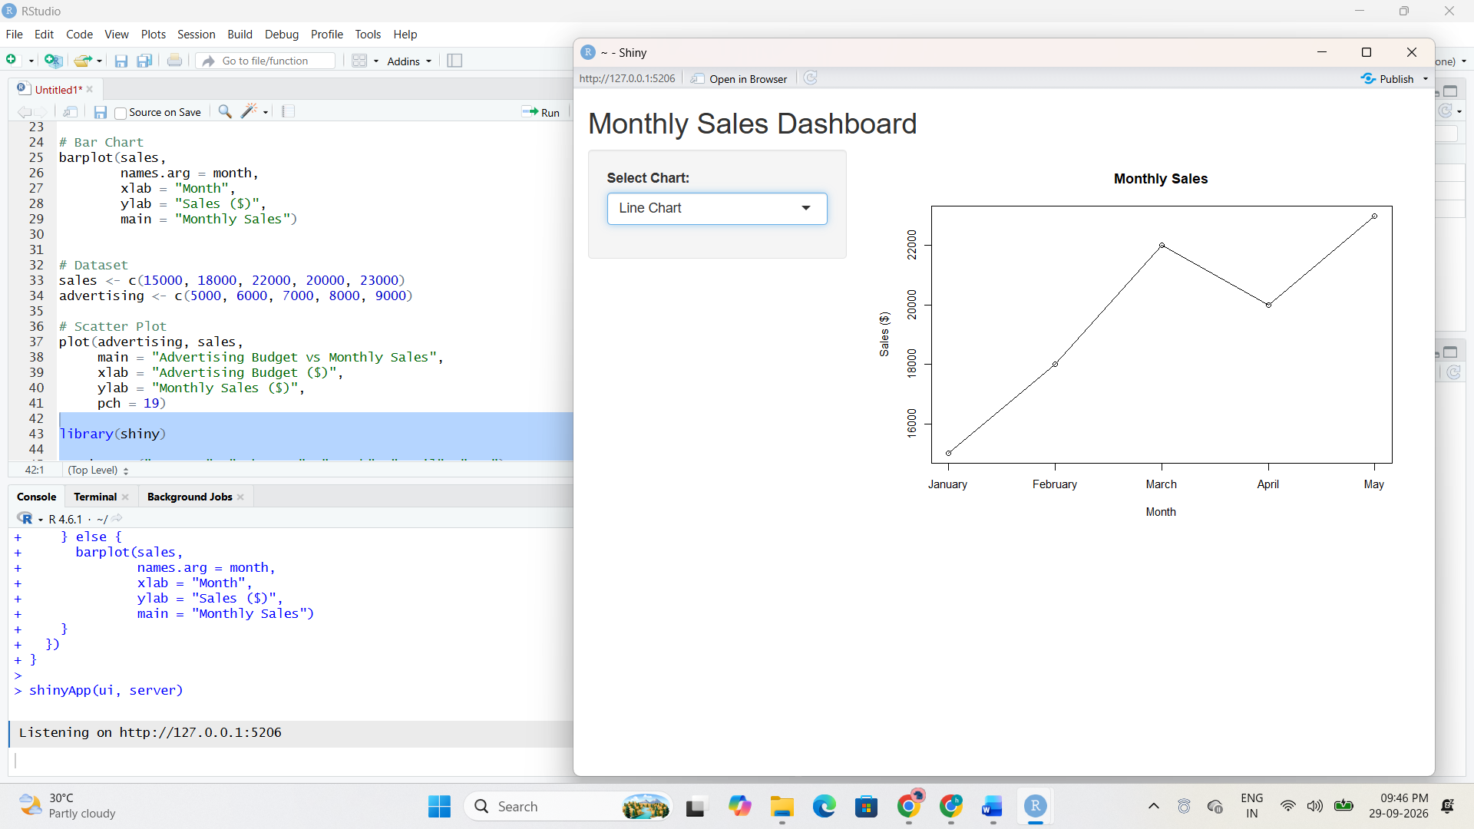
Output 4: Interactive Monthly Sales Dashboard
Observation: The dashboard provides a chart-selection control. Selecting Line Chart displays the monthly trend, while selecting Bar Chart displays the monthly sales comparison.

SET 1 PROCEDURE
1. Create the required data vectors in R.
2. Run each visualization program separately and verify the output.
3. Capture the RStudio code and output screenshots and insert them in the indicated placeholders.
4. For interactive programs, run the application and verify the available controls.
5. Record the observation and result for each program.
SET 1 RESULT
The required data visualization programs were executed successfully and their outputs were recorded.

