LAB EXPERIMENT RECORD
SET 2: CUSTOMER FEEDBACK ANALYSIS
Department | AIML
Course Code / Course Name | DSA0601 / Data Handling and Visualization
Experiment | Data Visualization using R
Name | N. Harshith
Register Number | 192325078
Date / Day | 29 September 2026 / Tuesday

Dataset: Customer Satisfaction
Customer ID | Age | Satisfaction Score
1 | 25 | 4
2 | 30 | 5
3 | 35 | 3
4 | 28 | 4
5 | 40 | 5
PROGRAM 1: Histogram of Customer Ages
Create a histogram to represent the distribution of customer ages. Label the axes and title the chart.
# Dataset
age <- c(25, 30, 35, 28, 40)
# Histogram
hist(age,
main = "Distribution of Customer Ages",
xlab = "Age",
ylab = "Frequency")
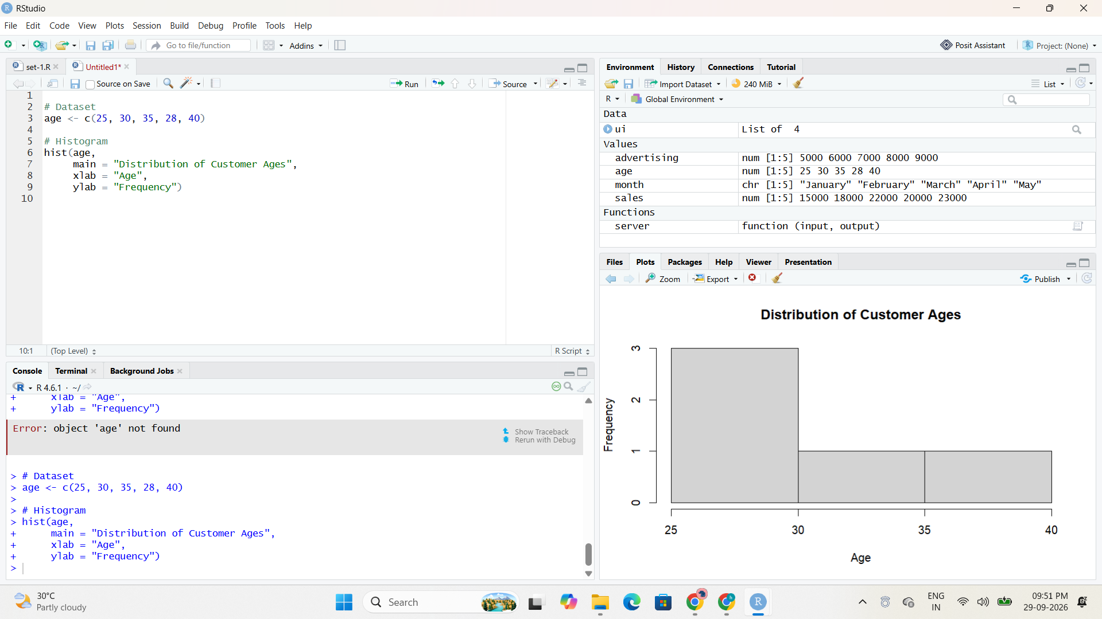
Output 1: Distribution of Customer Ages
Observation: The histogram represents the distribution of the five customer ages in the given dataset.

PROGRAM 2: Pie Chart of Satisfaction Scores
Generate a pie chart to display the overall distribution of customer satisfaction scores and include labels.
# Satisfaction scores
satisfaction <- c(4, 5, 3, 4, 5)
# Calculate frequency
score_count <- table(satisfaction)
# Pie Chart
pie(score_count,
labels = paste(names(score_count), "Score"),
main = "Customer Satisfaction Scores")
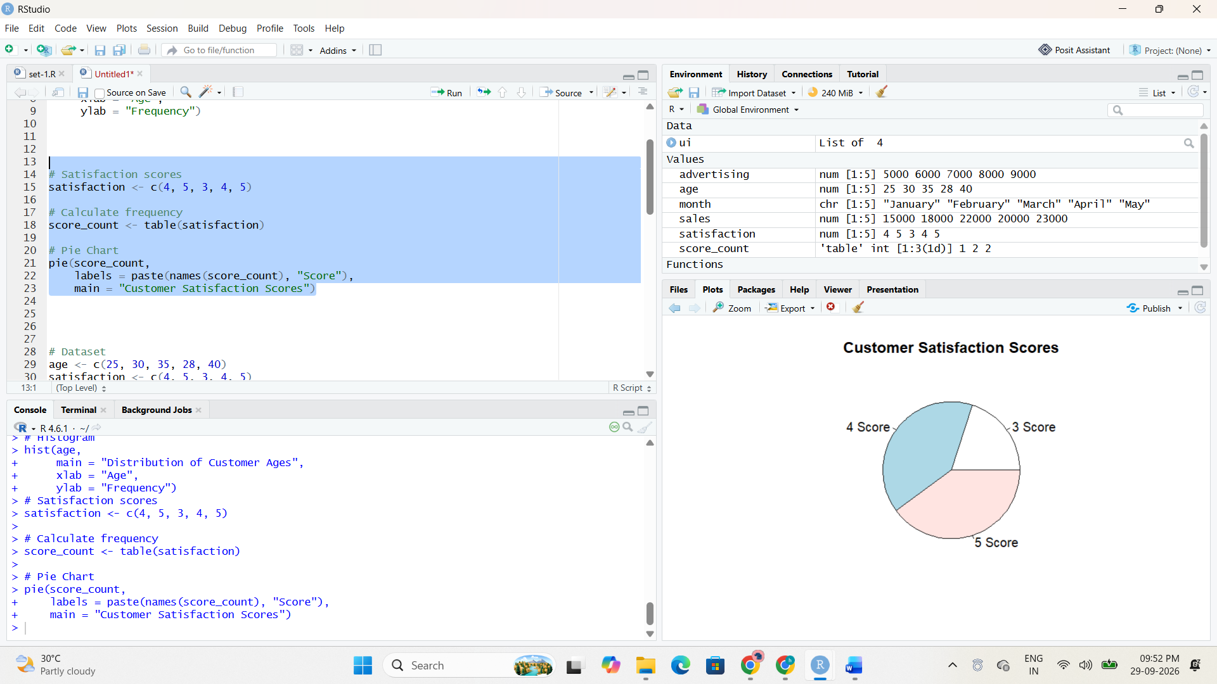
Output 2: Customer Satisfaction Scores Pie Chart
Observation: Scores 4 and 5 each occur twice, while score 3 occurs once.

PROGRAM 3: Stacked Bar Chart by Age Group
Build a stacked bar chart to visualize the distribution of customer satisfaction scores by age group.
# Dataset
age <- c(25, 30, 35, 28, 40)
satisfaction <- c(4, 5, 3, 4, 5)
# Create age groups
age_group <- cut(age,
breaks = c(20, 29, 39, 49),
labels = c("20-29", "30-39", "40-49"))
# Create table
data <- table(age_group, satisfaction)
# Stacked Bar Chart
barplot(data,
beside = FALSE,
main = "Satisfaction Scores by Age Group",
xlab = "Age Group",
ylab = "Number of Customers",
legend.text = TRUE)
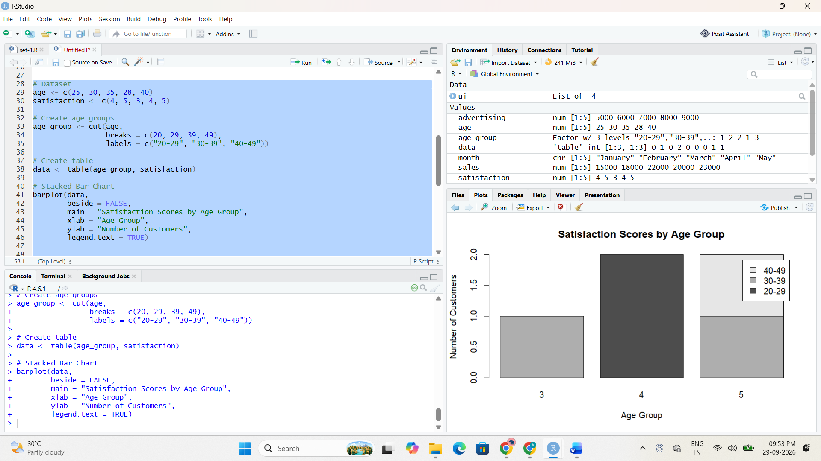
Output 3: Satisfaction Scores by Age Group
Observation: The code creates three age groups and stacks the satisfaction-score frequencies for each group.

PROGRAM 4: Word Cloud of Customer Feedback
Develop a word cloud from open-ended customer feedback to identify prevalent customer sentiments.
library(wordcloud)
library(RColorBrewer)
feedback <- c(
"good service",
"excellent service",
"good experience",
"friendly staff",
"excellent service"
)
words <- unlist(strsplit(tolower(feedback), " "))
word_count <- table(words)
wordcloud(names(word_count),
freq = word_count,
min.freq = 1,
scale = c(3, 0.5),
colors = brewer.pal(8, "Dark2"),
random.order = FALSE)
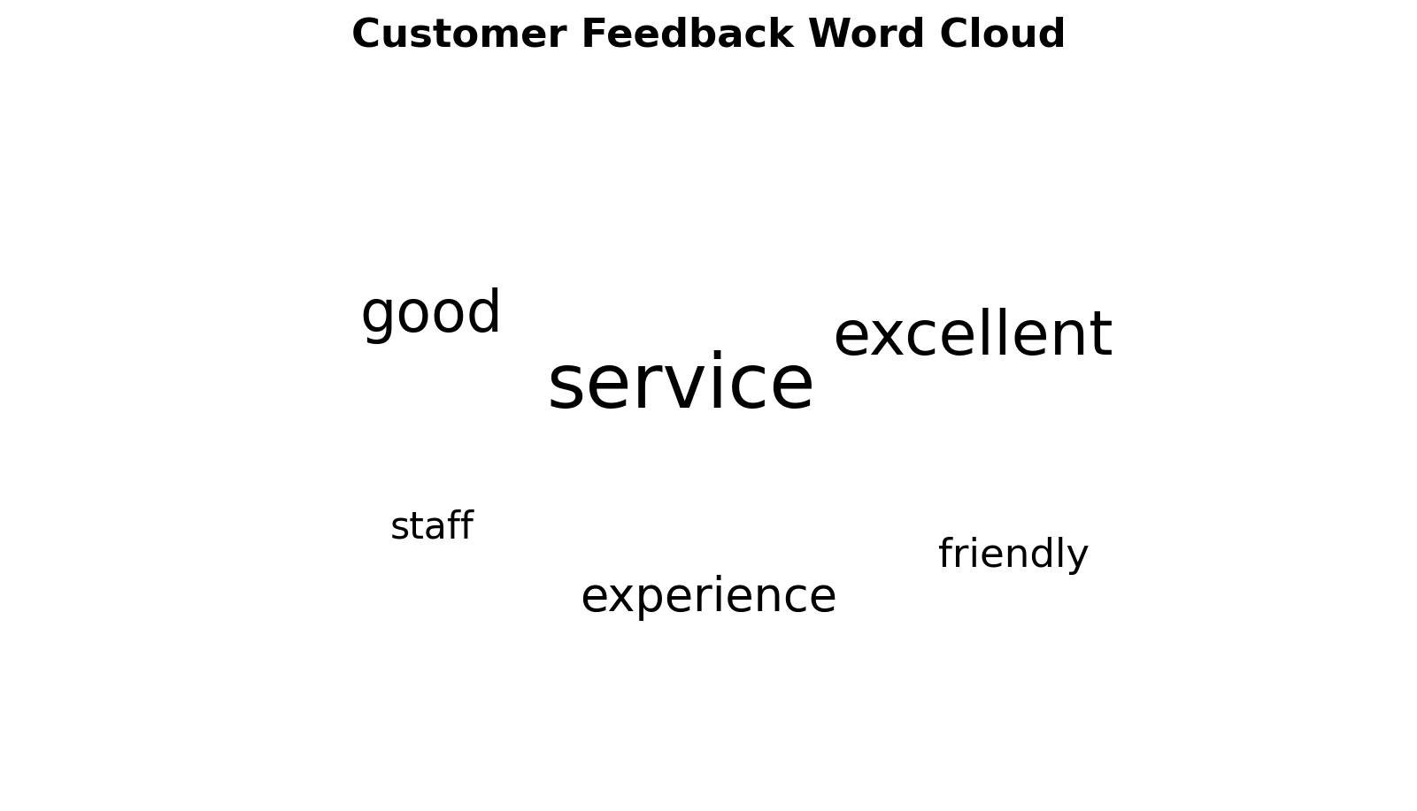
Output 4: Customer Feedback Word Cloud
Observation: The word cloud highlights frequently occurring terms in the supplied sample feedback, including service, excellent, good, friendly, and experience.

SET 2 PROCEDURE
1. Create the required data vectors in R.
2. Run each visualization program separately and verify the output.
3. Capture the RStudio code and output screenshots and insert them in the indicated placeholders.
4. For interactive programs, run the application and verify the available controls.
5. Record the observation and result for each program.
SET 2 RESULT
The required data visualization programs were executed successfully and their outputs were recorded.

