LAB EXPERIMENT RECORD
SET 3: EMPLOYEE PERFORMANCE EVALUATION
Department | AIML
Course Code / Course Name | DSA0601 / Data Handling and Visualization
Experiment | Data Visualization using R
Name | N. Harshith
Register Number | 192325078
Date / Day | 29 September 2026 / Tuesday

Dataset: Employee Performance
Employee ID | Department | Years of Service | Performance Score
1 | Sales | 5 | 85
2 | HR | 3 | 92
3 | Marketing | 7 | 78
4 | Sales | 4 | 90
5 | HR | 2 | 76

PROGRAM 1: Line Chart of Employee Performance
Create a line chart to visualize the performance trend of employees over time. Include a legend and labels.
# Employee performance data
employee_id <- c(1, 2, 3, 4, 5)
performance <- c(85, 92, 78, 90, 76)
# Line Chart
plot(employee_id, performance,
type = "o",
pch = 16,
xlab = "Employee ID",
ylab = "Performance Score",
main = "Employee Performance Trend")
legend("topright",
legend = "Performance Score",
lty = 1,
pch = 16)
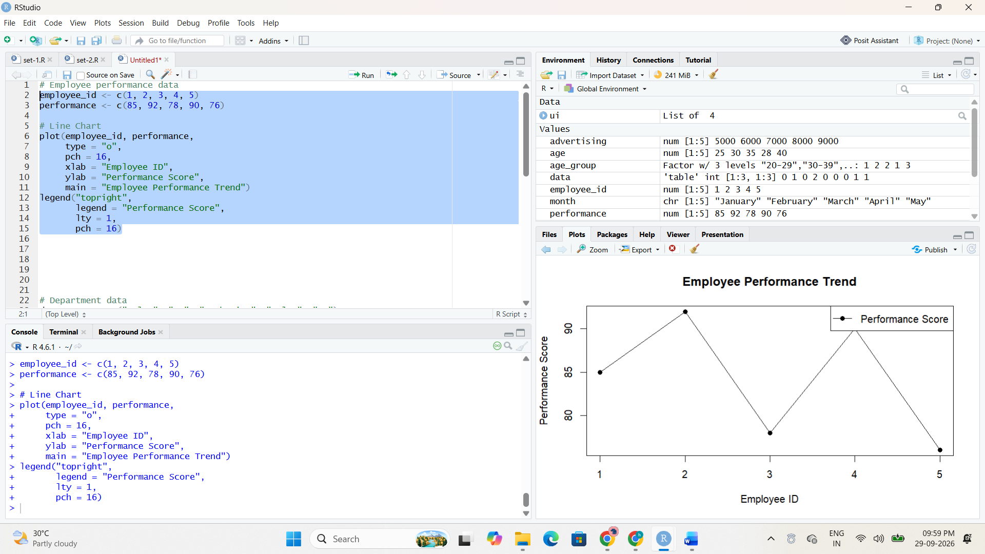
Output 1: Employee Performance Line Chart
Observation: The line chart shows the performance score of each employee. Employee 2 has the highest score, while Employee 5 has the lowest score.

PROGRAM 2: Bar Chart of Employees by Department
Generate a bar chart showing the distribution of employees across different departments. Label the chart elements.
# Department data
department <- c("Sales", "HR", "Marketing", "Sales", "HR")
# Count employees in each department
department_count <- table(department)
# Bar Chart
barplot(department_count,
names.arg = names(department_count),
xlab = "Department",
ylab = "Number of Employees",
main = "Employees by Department")
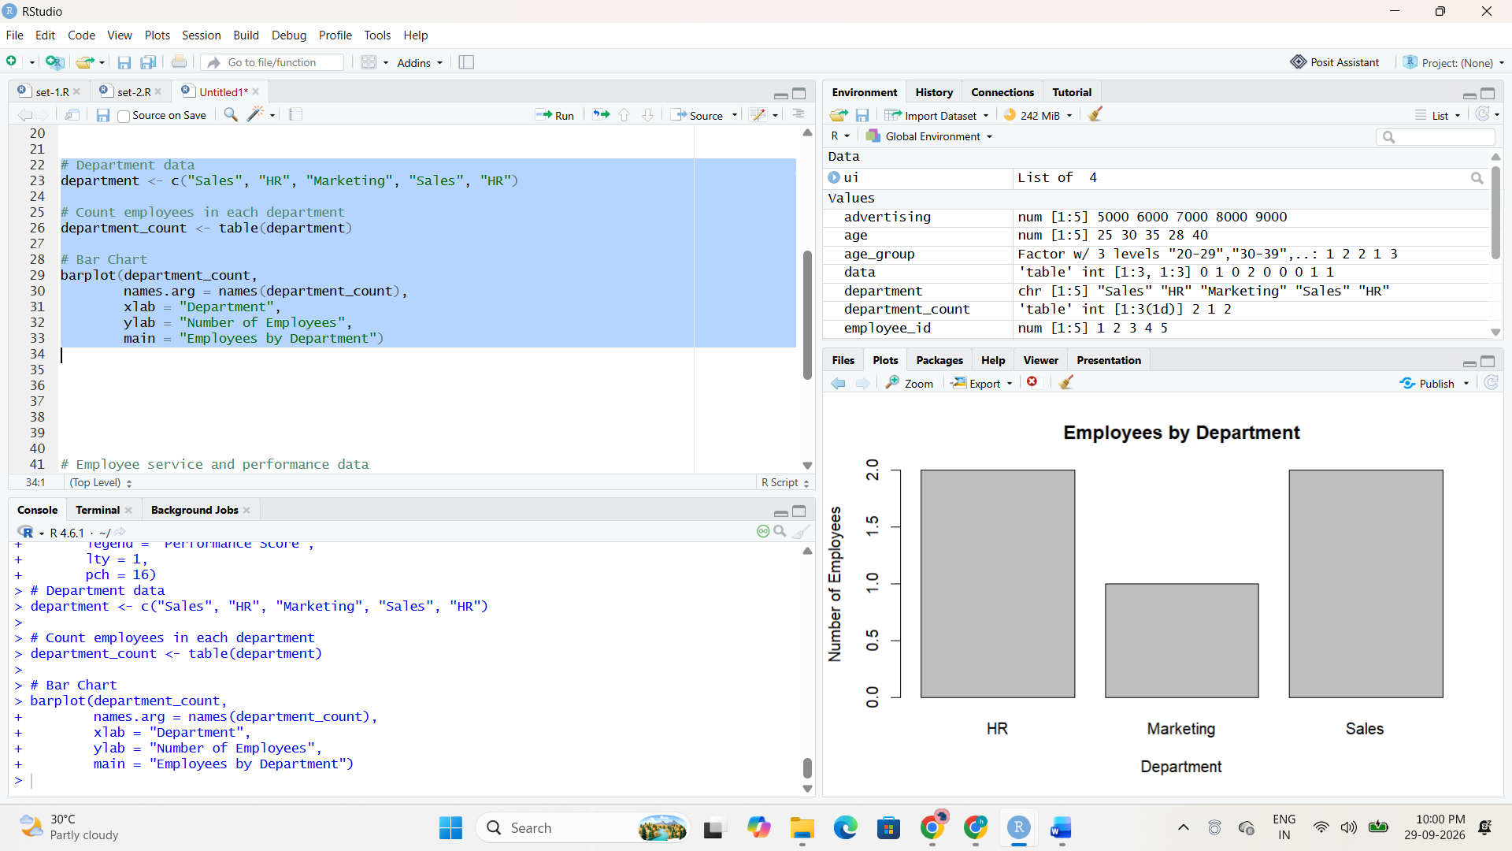
Output 2: Employee Distribution by Department
Observation: Sales and HR each contain two employees, while Marketing contains one employee.

PROGRAM 3: Years of Service vs Performance Score
Build a scatter plot to analyze the correlation between years of service and performance scores. Explain any insights.
# Employee service and performance data
years_service <- c(5, 3, 7, 4, 2)
performance <- c(85, 92, 78, 90, 76)
# Scatter Plot
plot(years_service, performance,
pch = 19,
xlab = "Years of Service",
ylab = "Performance Score",
main = "Years of Service vs Performance")
# Add a trend line
abline(lm(performance ~ years_service), lty = 2)
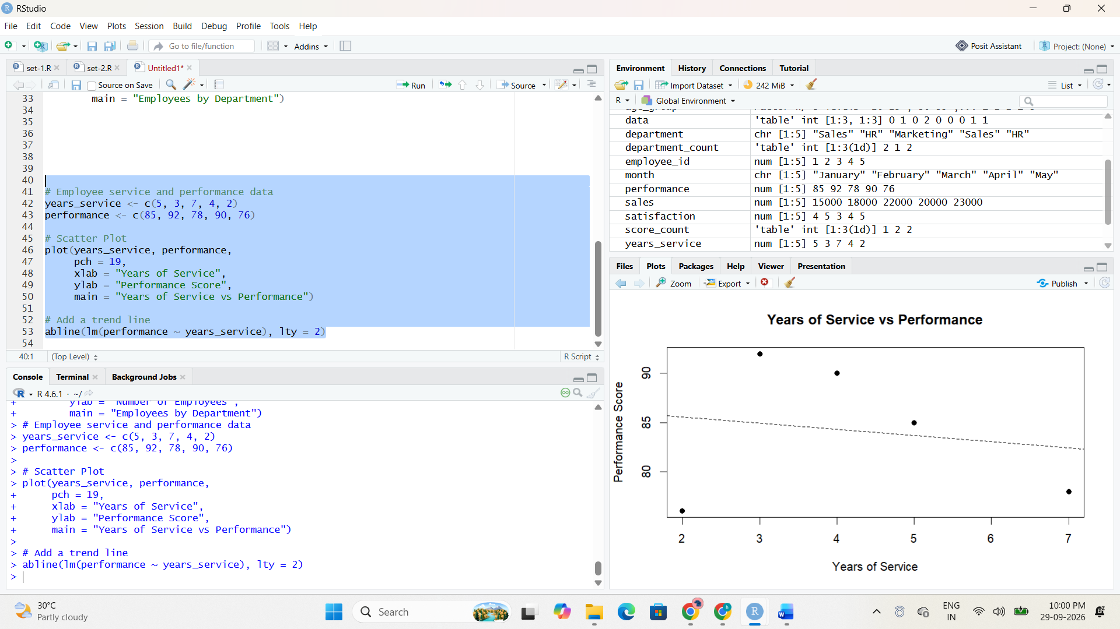
Output 3: Years of Service vs Performance Scatter Plot
Observation: The plotted values do not show a simple positive relationship between years of service and performance score. The trend line helps visualize the overall direction of the supplied observations.

PROGRAM 4: Employee Performance Tableau Dashboard
Develop a Tableau dashboard with the line chart and bar chart for interactive exploration.
TABLEAU STEPS
1. Open Tableau and connect to the Employee Performance dataset.
2. Create a worksheet named "Performance Trend".
3. Place Employee ID on Columns and Performance Score on Rows.
4. Change the Marks type to Line and add Employee ID/Performance Score labels.
5. Create another worksheet named "Department Distribution".
6. Place Department on Columns and Employee ID on Rows.
7. Change the aggregation to Count and select Bar.
8. Create a new Dashboard.
9. Drag both worksheets into the dashboard.
10. Add filters or interactive controls as required.
11. Save the dashboard as "Employee Performance Dashboard".
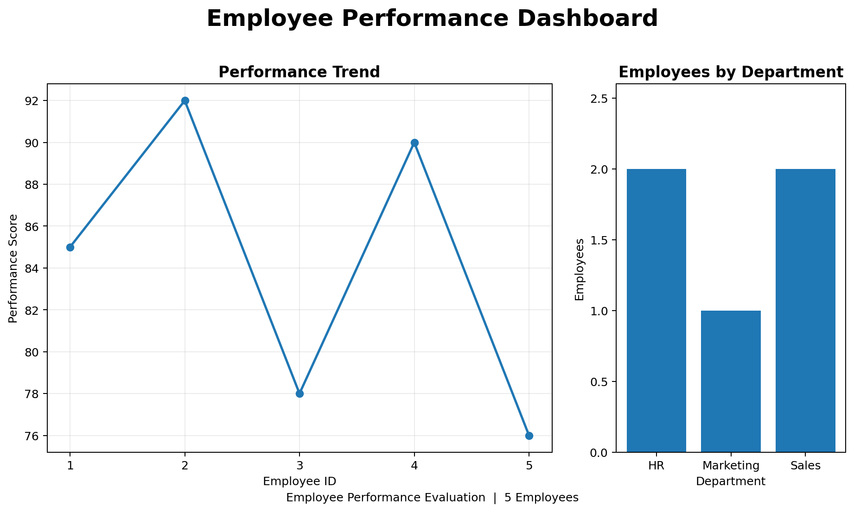
Output 4: Employee Performance Tableau Dashboard
Observation: The Tableau dashboard combines the performance trend and department distribution views so that the employee data can be explored interactively.

SET 3 PROCEDURE
1. Create the Employee Performance dataset in R.
2. Use the appropriate R plotting functions to generate the line, bar, and scatter charts.
3. Run each program separately and verify the generated output.
4. Create the Tableau dashboard by combining the required worksheets.
5. Capture the outputs and insert the screenshots in the indicated placeholders.
SET 3 RESULT
The Employee Performance data was successfully visualized using line, bar, and scatter charts, and a Tableau dashboard was prepared for interactive exploration.

