Yordan Nikolov

Contact
Address:
8 Bevin Court, Crediton, UK

Phone:
+447 405 608 112
Email:
nlotoo93@gmail.com

LinkedIn:
https://www.linkedin.com/in/yordan-nikolow-84b98a1a9/

GitHub:
https://github.com/nlotoo

Languages:

Bulgarian – Native
English – B2
German – A1

Driving licence
- Category B

Hobbies
- Programing
- Traveling

Experience

My experience in the bar business is last 8+ years, and in the area of sales 10+ described in detail below.

Education / Certifications

Sudied to be a Software Engineer at „Software University“ –
Sofia, Bulgaria

Geo Milev High School – Varna, Bulgaria
▪ Profile - Mathematics and Informatics
▪ Acting and sporting dances

Certificates from:

CERTIFICATES -Programming Basics JS - June 2020 „Software University“ – Sofia, Bulgaria
CERTIFICATES –Fundamentals JS - September 2020 „Software University“ – Sofia, Bulgaria
CERTIFICATES –Advanced JS- January 2021 „Software University“ – Sofia, Bulgaria
CERTIFICATES –Application JS - February 2021 „Software University“ – Sofia, Bulgaria
CERTIFICATES –JS Back-end - May 2021 „Software University“ – Sofia, Bulgaria
Now I am studying - ReactJS - юни 2022 „Software University“ –
Sofia, Bulgaria“

My digital skills :
HTML,CSS,JS,ReactJS,Angular,Boostrap,MUI,Node,js Express.js,MongooDB,Firebase,npm, Git, Postman, Mocha,Chai,React Testing Library

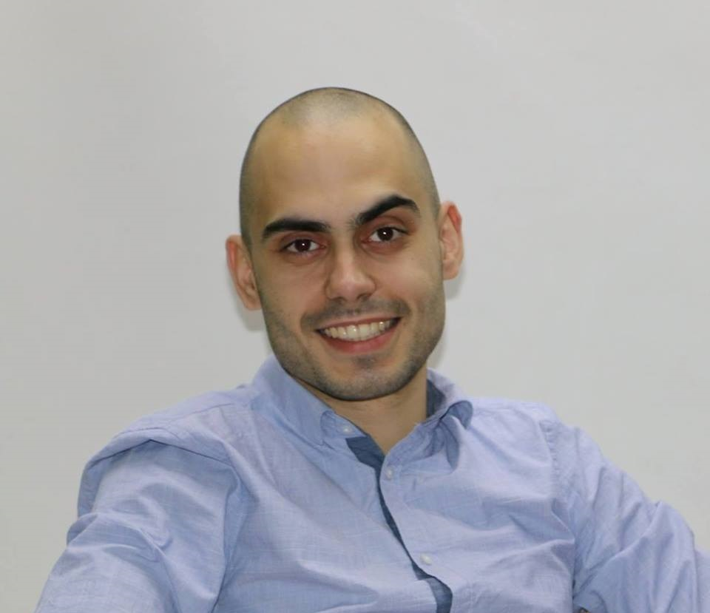

(01.04.2022 - sitll)  (1.04.2020 - 02.03.2022)  (15.10.2020 – 24.02.2021)  ( 23.10.2019 – 13.03.2020)  (10.06.2020 - 25.09.2020)  ( 01.04.2020 – 05.06.2020) | Amazon driver  Amazon – Exeter, UK  • Excellent organizational skills.  • Strong interpersonal and problem-solving abilities.  • Highly responsible & reliable.  • Ability to work well under pressure in a fast-paced environment.  • Ability to work cohesively as part of a team.  Fast food driver  Domino`s – Newquay, UK  • Excellent organizational skills.  • Strong interpersonal and problem-solving abilities.  • Highly responsible & reliable.  • Ability to work well under pressure in a fast-paced environment.  • Ability to work cohesively as part of a team.  Line operative worker  Keter – Redruth, UK  • Finishing products, for example applying protective coatings.  • Monitoring the production process and carrying out basic testing and quality checks.  • Storing goods and raw materials in the factory or warehouse.  • Using lifting equipment.  • Packing goods ready for shipment.  • cleaning and maintaining work areas and machinery.  Bartender / Barista  Memento NDK – Sofia Bulgaria  • Works with the coffee machine and other bar equipment.  • Pours drinks and prepares cocktails.  • Managed morning rush of over 60 customers daily with efficient, levelheaded customer service.  • It respects the sanitary and hygienic norms and rules and the weight of the output  • Making orders for the supply of beverages and other goods sold at the bar.  • Performs other specific assignments related to the job  • Reduced process lags by effectively training new hires on best practices and protocols.  • Attended specialised product trainings to educate associates on industry trends.  Business or sector: Tourism  Store Assistant
 | DAR (supermarket) -- Sofia, Bulgaria
• Welcomes and serves customers in the store and offers information and advice in the company's store.
• Assists customers in choosing goods, taking into account certain requirements.
• Maintains his workplace in a commercial form suitable for working with clients.
• Arranges the goods during work.
• Before opening and after closing for customers of the store clears the shopping area
•Stocked and rotated inventory regularly.
Business or sector: Trade

(29.06.2018 – 01.09.2018)  (29.06.2018 – 01.09.2018)  (09.09.2018 – 15.10.2019 )  (29.02.2018 – 20.06.2018) | Waiter  Planet Club (Varna)  Planet Club (St.Vlas)
 | Planet Club (Plovdiv) -- Bulgaria
• Serves its designated area
- Provides quality and promptness of service.
- Maintains hygiene in the designated area
- Serves and cares in accordance with technological standards
- Forms the relevant monetary documents for the services rendered.
• Takes into account the daily turnover of the activity. It also performs other specifically
assigned tasks related to the work.
• Reduced process lags by effectively training new hires on best practices and protocols.
• Attended specialised product trainings to educate associates on industry trends.

Business or sector: Tourism

Order Picker

Coletta & Tyson Ltd.-- Cottingham, East Yorkshire
• Еxecuting queries as arranged by type
• Тracking product quality
• Performs other specific assignments related to the job.

Business or sector: Production

(10.10.2015 – 02.05.2016)  (25.02.2017 07.12.2017) | Bartender
(10.10.2015 – 02.05.2016)  (25.02.2017 07.12.2017) | The Garden bar - Varna Bulgaria
(10.10.2015 – 02.05.2016)  (25.02.2017 07.12.2017) | • Pours drinks and prepares cocktails.  • Works with the coffee machine and other bar equipment  • It respects the sanitary and hygienic norms and rules and the weight of the output  • Making orders for the supply of beverages and other goods sold at the bar.  • Performs other specific assignments related to the job.  • Reduced process lags by effectively training new hires on best practices and protocols.  • Attended specialised product trainings to educate associates on industry trends  Business or sector: Tourism

(08.06.2015 – 09.09.2015) | Bartender
(08.06.2015 – 09.09.2015) | CaLnibani beach bar – Varna Bulgaria
(08.06.2015 – 09.09.2015) | • Pours drinks and prepares cocktails.  • Works with the coffee machine and other bar equipment  • It respects the sanitary and hygienic norms and rules and the weight of the output  • Making orders for the supply of beverages and other goods sold at the bar.  • Performs other specific assignments related to the job.  • Reduced process lags by effectively training new hires on best practices and protocols.  • Attended specialised product trainings to educate associates on industry trends.  Business or sector: Tourism
(15.04.2015 - 08.06.2015)  (02.07.2014 - 03.09.2014)  two seasons | Bartender
 | Makalali beach bar – Varna Bulgaria
• Pours drinks and prepares cocktails.
• Works with the coffee machine and other bar equipment
• It respects the sanitary and hygienic norms and rules and the weight of the output
• Making orders for the supply of beverages and other goods sold at the bar.
• Performs other specific assignments related to the job

 | Business or sector: Tourism

(03.09.2014-10.04.2014) | Bartender
(03.09.2014-10.04.2014) | Bamboo bar – Varna Bulgaria
(03.09.2014-10.04.2014) | • Pours drinks and prepares cocktails.  • Works with the coffee machine and other bar equipment  • It respects the sanitary and hygienic norms and rules and the weight of the output  • Making orders for the supply of beverages and other goods sold at the bar.  • Performs other specific assignments related to the job  • Bar manager in Bamboo.  • Reduced process lags by effectively training new hires on best practices and protocols.  • Attended specialised product trainings to educate associates on industry trends.
(03.09.2014-10.04.2014) | Business or sector Tourism

(20.03.2014 - 02.07.2014)  (02.04.2013 - 30.09.2013)  (16.04.2012 - 30.09.2012)  3 seasons | Waiter
 | Summer theatre -- Varna, Bulgaria
• Serves its designated area
- Provides quality and promptness of service.
- Maintains hygiene in the designated area
- Serves and cares in accordance with technological standards
- Forms the relevant monetary documents for the services rendered.
• Takes into account the daily turnover of the activity. It also performs other specifically assigned tasks related to the work.

 | Business or sector: Tourism

EDUCATION AND TRAINING  (2019-still)  (2008 - 2012) | Sudied to be a Software Engineer at „Software University“ – Sofia, Bulgaria  Secondary education -- Geo Milev High School – Varna, Bulgaria  ▪ Profile - Mathematics and Informatics  ▪ Acting and sporting dances

Mother tongue(s) | Bulgarian
PERSONAL SKILLS
Other language(s) | UNDERSTANDING |  | SPEAKING |  | WRITING
Other language(s) | Listening | Reading | Spoken interaction | Spoken production
English | B1 | B1 | B1 | B1 | B1

Communication skills | ▪ Good communication skills acquired during my work in the field of direct sales

Organisational / managerial skills | - A proven ability to be able to work under pressure to tight deadlines  - An ability to show initiative and establish positive working relationships with colleagues  - Excellent communication and customer care skills  - Excellent organisation and administration skills  - IT literate  - Understanding and adoption of the Firm’s values and behaviours.

Digital skills | SELF-ASSESSMENT
Digital skills | Information processing | Communication | Content creation | Safety | Problem solving
 | Proficient | Proficient | Proficient | Proficient | Proficient
- good command of office suite (Microsoft Office ( Outlook, OneDrive, Word, Excel, PowerPoint; Vsiual Studio and other )
- good command of photo editing software ( Photoshop, Adobe illustrator and other. )
- fluency in programming languages (JavaScript and CSS, C#, HTML , )

