## Anagram Detection

For the sake of simplicity, we will assume that the two strings in question are of equal length and that they are made up of symbols from the set of 26 lowercase alphabetic characters. Our goal is to write a boolean function that will take two strings and return whether they are anagrams.

### Checking off

def anagramSolution1(s1,s2):  
 stillOK = True  
 if len(s1) != len(s2):  
 stillOK = False  
  
 alist = list(s2)  
 pos1 = 0  
  
 while pos1 < len(s1) and stillOK:  
 pos2 = 0  
 found = False  
 while pos2 < len(alist) and not found:  
 if s1[pos1] == alist[pos2]:  
 found = True  
 else:  
 pos2 = pos2 + 1  
  
 if found:  
 alist[pos2] = None  
 else:  
 stillOK = False  
  
 pos1 = pos1 + 1  
  
 return stillOK  
  
print(anagramSolution1('abcd','dcba'))

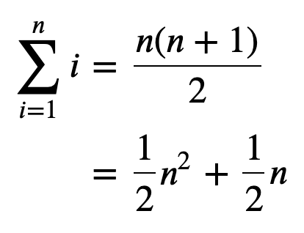

### Sort and compare

def anagramSolution2(s1,s2):  
 alist1 = list(s1)  
 alist2 = list(s2)  
  
 alist1.sort()  
 alist2.sort()  
  
 pos = 0  
 matches = True  
  
 while pos < len(s1) and matches:  
 if alist1[pos]==alist2[pos]:  
 pos = pos + 1  
 else:  
 matches = False  
  
 return matches  
  
print(anagramSolution2('abcde','edcba'))

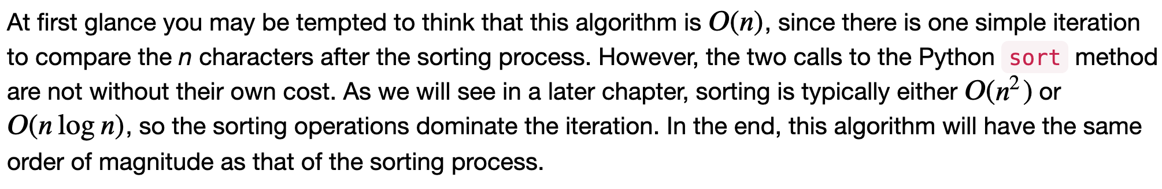

### Brutal force

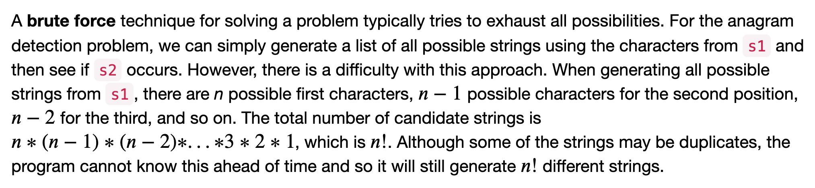

### Count and Compare

def anagramSolution4(s1,s2):  
 c1 = [0]*26  
 c2 = [0]*26  
  
 for i in range(len(s1)):  
 pos = ord(s1[i])-ord('a')  
 c1[pos] = c1[pos] + 1  
  
 for i in range(len(s2)):  
 pos = ord(s2[i])-ord('a')  
 c2[pos] = c2[pos] + 1  
  
 j = 0  
 stillOK = True  
 while j<26 and stillOK:  
 if c1[j]==c2[j]:  
 j = j + 1  
 else:  
 stillOK = False  
  
 return stillOK  
  
print(anagramSolution4('apple','pleap'))

Again, the solution has a number of iterations. However, unlike the first solution, none of them are nested. The first two iterations used to count the characters are both based on n. The third iteration, comparing the two lists of counts, always takes 26 steps since there are 26 possible characters in the strings. Adding it all up gives us 𝑇(𝑛)=2𝑛+26 steps. That is 𝑂(𝑛). We have found a linear order of magnitude algorithm for solving this problem.

Before leaving this example, we need to say something about space requirements. Although the last solution was able to run in linear time, it could only do so by using additional storage to keep the two lists of character counts. In other words, this algorithm sacrificed space in order to gain time.

This is a common occurrence.

### Stack

class Stack:  
 def __init__(self):  
 self.items = []  
  
 def isEmpty(self):  
 return self.items == []  
  
 def push(self, item):  
 self.items.append(item)  
  
 def pop(self):  
 return self.items.pop()  
  
 def peek(self):  
 return self.items[len(self.items)-1]  
  
 def size(self):  
 return len(self.items)